Differences in affective polarization, need for closure, intellectual humility, identity strength, and authoritarianism among Liberals and Conservatives: A secondary data analysis of McMurtrie (2024).
Brandon McMurtrie¹
- School of Psychology, Massey University. Corresponding author (B.McMurtrie@massey.ac.nz)

Abstract
Research has shown that affective polarization has been increasing in many countries around the world, not least in the U.S. The differences in psychology and personality between the two broad ‘wings’ of political ideology has also been a major focal point in psychological research, as psychologists seek to understand why group members believe, think, and behave the way they do, and how this contributes to polarization. This study explores differences in affective polarization, need for closure, intellectual humility, identity strength, and authoritarianism between American liberals (n = 170) and conservatives (n = 161). Using data from McMurtrie et al. (2024), we conducted t-tests and regression analyses to compare liberals and conservatives on these constructs, and to investigate how they predict affective polarization. Conservatives exhibited significantly higher need for closure and lower intellectual humility compared to liberals. Surprisingly, conservatives also demonstrated lower affective polarization across all measures, including social distance, aversion, and incivility. Regression analyses showed that intellectual humility predicted lower affective polarization for both groups. Need for closure predicted higher affective polarization only for conservatives, while authoritarianism strongly predicted higher affective polarization for liberals. Identity strength was a significant predictor of higher affective polarization for both groups. The results highlight the complex interplay between cognitive styles, identity, and political attitudes, contributing to the understanding of affective polarization in the American context.
Keywords: affective polarization, ideological polarization, need for closure, intellectual humility, authoritarianism, political psychology, identity strength.

Introduction
Political polarization has long been a focal point of research in psychology. With the recent rise of a more contentious style of politics throughout the West and with the waging of the “culture war”, this area of research continues to grow. Affective polarization is one construct which has received a great amount of attention in academic literature recently. Affective polarization is a type of political polarization which refers to the level of antipathy or negative affect one holds towards their ideological outgroup and its members (Hetherington et al., 2016; Iyengar et al., 2012). This is in contrast to ideological polarization which refers to the divergence of ideological groups in terms of their substantive policy positions and beliefs about the world and society (Abramowitz & Saunders, 2008; Fiorina et al., 2008). While ideological and affective polarization are related and likely reciprocally affect each other, they are different constructs, and studying these two types of polarization separately has proven to be illuminating (Mason, 2013, 2015).
Research has shown that affective polarization between the left and right wing, broadly, has been increasing in many countries around the world, especially in the United States (Boxell et al., 2022; Iyengar et al., 2012; Kekkonen & Ylä-Anttila, 2021; Orriols & León, 2020; Wagner, 2024). This may be partly due to processes of social sorting and the emphasis on political social identities (Harteveld, 2021; Mason, 2016, 2018; Rawlings, 2022). Identity strength—the degree to which one identifies strongly with a political orientation or group as a social identity—is thought to be one factor contributing to the rise in affective polarization (Greene, 1999; Iyengar et al., 2012; Iyengar & Westwood, 2015; Luttig, 2018; Westwood et al., 2018). On the other hand, intellectual humility is thought to buffer against affective polarization and is associated with lower affective polarization and political prejudice (Bowes et al., 2020; Krumrei-Mancuso & Newman, 2020; Nadelhoffer et al., 2020; Stanley et al., 2020).
The differences in psychology and personality between leftists and rightists has also been a major focal point in psychological research as psychologists seek to understand why members of each group believe, think, and behave the way they do, and how this contributes to polarization. The “rigidity of the right” hypothesis is one of the foundational ideas in this domain. It asserts that rightists display a more rigid cognitive style, featuring an aversion to uncertainty and a higher need for cognitive closure which drives higher rates of authoritarianism and political prejudice, as it makes them more reactive to threats posed to their identity and worldview (Jost et al., 2003; Jost & Kende, 2020). However, in recent years this idea has been the subject of debate with studies identifying common issues in the literature (Malka et al., 2017), and with large met-analyses and an adversarial collaboration being somewhat inconclusive (Bowes et al., 2023; Costello et al., 2023; Van Hiel et al., 2016). Some authors assert that the field of psychology has a left-wing bias, and that this is reflected in the theories and explanations such as the rigidity of the right hypothesis (Clark et al., 2023; Ditto et al., 2019; Duarte et al., 2015; Jussim et al., 2023; Jussim & Honeycutt, 2023).
Studies have now increasingly found evidence to support a “rigidity of the extreme” hypothesis instead of (or as well as) the rigidity of the right hypothesis, which asserts that hard-line leftists and rightists show similar levels of rigidity, dogmatism, and prejudice (Luttig, 2017, 2018; Zmigrod, 2020; Zmigrod et al., 2020). Other studies have shown that bias and political prejudice is bipartisan and reasonably common even among non-extreme members (Chambers et al., 2013; Crawford, 2014; Crawford & Brandt, 2020; Ditto et al., 2019), and that group members of any tribe will engage in motivated epistemology and react negatively to threats to ones worldview (Brandt & Crawford, 2020; Clark & Winegard, 2020).
This shift in perspective on the profiles of leftists and rightists has also been reflected in the study of authoritarianism. Authoritarianism has long been thought to be a feature of the political right, primarily. Thus, the default measures of authoritarianism in psychological research have been right wing versions, such as Altemeyer’s (1996) right wing authoritarianism (RWA) scale. Multiple studies over decades of research showed that RWA is (perhaps unsurprisingly) a feature of the political right, more so than the left. However, as many authors have pointed out, the RWA scale contains items that capture both authoritarianism and right-wing ideology of a non-authoritarian form—that is to say, it is confounded with political orientation and thus the literature incorrectly paints rightists as more authoritarian (Costello et al., 2022). A more valid investigation of authoritarianism among leftists was needed to truly be able to quantify the differences between leftists and rightists in authoritarianism.
Recently, the study of LWA was reinvigorated by a large study developing a new measure of LWA (Costello et al., 2022; Costello & Patrick, 2022), building upon earlier efforts (Conway et al., 2018; Van Hiel et al., 2006). These and subsequent studies support what Conway called the authoritarianism symmetry hypothesis. LWA has repeatedly been shown to correlate with left-wing absolutism and dogmatism, dark-triad personality traits, and measures of cognitive rigidity, in much the same manner as has RWA (Conway et al., 2018; Costello & Patrick, 2022; Krispenz et al., 2024; Krispenz & Bertrams, 2023). Both LWA and RWA have been found to correlate with affective polarization (Costello et al., 2022; Luttig, 2017; McMurtrie et al., 2024).

The Present Study
Relevant to the literature described above, McMurtrie et al. (2024) collected data on need for closure, identity strength, intellectual humility, RWA, LWA, and affective polarization from a sample of American Liberals and Conservatives but did not perform a full exploratory analysis looking at (a)symmetries and the relationships between these constructs. In the present study, I address this by performing a secondary analysis on the data from study 3 in McMurtrie et al. (2024). Doing so represents a small contribution to the larger body of research and adds to the published data available to be used in meta-analyses. I first perform a series of t-tests looking at the differences in scores between Liberals and Conservatives, reporting Cohen’s d effect sizes. I then perform regression analyses, looking at predictors of affective polarization in Liberals and Conservatives.

Methods

Participants
The sample consisted of 331 American Prolific users, recruited for a simple convenience sample survey. For a full description of the study design and recruitment process, and the small number (10) of participant exclusions, as well as aggregate sample demographics, see study 3 in McMurtrie et al. (2024). For this study, we present here the demographics of the sample split by political orientation.
The sample consisted of 161 Conservatives (M_{age} = 44.0, SD = 14.1) and 170 Liberals (M_{age} = 39.1, SD = 14.3). While age was similar in both groups, the gender distribution between Liberals and Conservatives showed less similarity. Among the Conservative participants 50 (31.1%) were female, 108 (67.1%) male, one was non-binary/third gender, one preferred not to state their gender, and 1 response was missing. Among Liberal participants 103 (60.6%) were female, 59 (34.7%) were male, and 8 (4.7%) were non-binary/third gender.

Measures

Feeling Thermometer
Participants rated their feelings of warmth towards their ideological outgroup on a 101-point scale, from Cold (0) to Warm (100).

Affective Polarization
Affective polarization was measured using the Affective Polarization scale (McMurtrie, 2024). The scale (α = .96) consisted of 15 items, five each of which measured dimensions called Social Distance, Aversion, and Incivility. The Affective Polarization total score was calculated as participants average response to all 15 items, the Social Distance, Aversion, and Incivility scores were calculated by taking participants’ average responses of the five corresponding items. Responses were collected on a 7-point Likert scale.

Need for Closure
Need for closure was measured using the 15-item version (α = .91) of the Need for Closure Scale (Roets & Van Hiel, 2011). It is a unidimensional scale and contains items such as “I dislike questions which could be answered in many different ways”. Responses were collected on a 7-point Likert scale.

Intellectual Humility
Intellectual humility was measured using the nine-item specific intellectual humility scale (Hoyle et al., 2016). This scale (α = .92) measures intellectual humility in a specific domain with items such as ‘I am open to new information in the area of Politics that might change my view’. Responses were collected on a 7-point Likert scale.

Identity Strength
A four-item measure of identity strength (α = .88) from Huddy et al. (2015) was used. Items include “When talking about [participants’ in-group], how often do you use ‘we’ instead of ‘they’?”. Responses were collected on a 5-point scale from not at all to a great deal.

RWA
RWA was measured with Altemeyer’s (1996) 22 item scale (α = .92). It contains items such as “Our country will be destroyed someday if we do not smash the perversions eating away at our moral fibre and traditional beliefs”. Responses were collected on a 7-point Likert scale.

LWA
LWA was measured using the LWA-25 scale (α = .91). It contains items such as “We need to replace the established order by any means necessary” (Costello & Patrick, 2022).

Data Analysis
All analyses were performed in R version 4.2.2. Analyses were not pre-registered as the author already had access to, and had seen the data, before the study was conceived. The data for this study can be found at the repository for the original project by McMurtrie et al. (2024): https://osf.io/bgx2r/?view_ only=9d0429f3502d49c2940a3913bd7a64e3. The R code for the analyses in this paper can be found at: https://osf.io/xdp2r/?view_only=8a67bcbc70964bafb691ec40a06e963c.

Results

Feeling thermometer
A two-tailed Welch’s independent samples t-test was conducted to compare Liberals’ and Conservatives’ rating of each other on the feeling thermometer (all the subsequent t-tests reported are two-tailed Welch’s independent samples t-tests). The results indicated a significant difference between the two groups (t(299.86) = 3.92, p < .001, d = 0.43). Specifically, the mean feeling thermometer rating by Conservatives (M = 33.97) was significantly higher than that of the Liberal group (M = 23.56), with a mean difference of 10.41 points (95% CI 5.19, 15.63).
Of Liberal respondents, 85.1% rated their level of warmth towards Conservatives below the midpoint. Of Conservative respondents, 69.6% rated their level of warmth towards Liberals below the midpoint (Figure 1).
Figure 1
Boxplots showing distribution of feeling thermometer ratings of the opposite group for Liberals and Conservatives. Higher scores represent warmer feelings towards the opposite group.
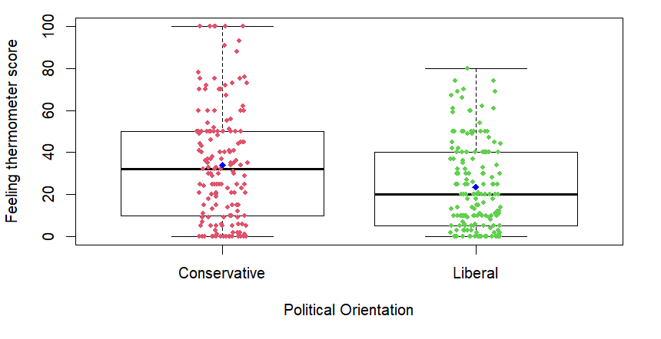

Affective Polarization Total Score
A significant difference (t(326.71) = -3.05, p = 0.002, d = 0.34) was found, with Conservatives (M = 3.37) displaying significantly lower affective polarization scores than Liberals (M = 3.83), with a mean difference of -0.46 (95% CI = -0.761, -0.164).
Of Liberal respondents, 45.9% scored above the neutral point on the 7-point Likert scale (that is, indicated some level of agreement on average with the affective polarization items). Of Conservative respondents, 31.7% did the same (Figure 2).
Figure 2
Boxplots showing distribution of affective polarization scores for Liberals and Conservatives.
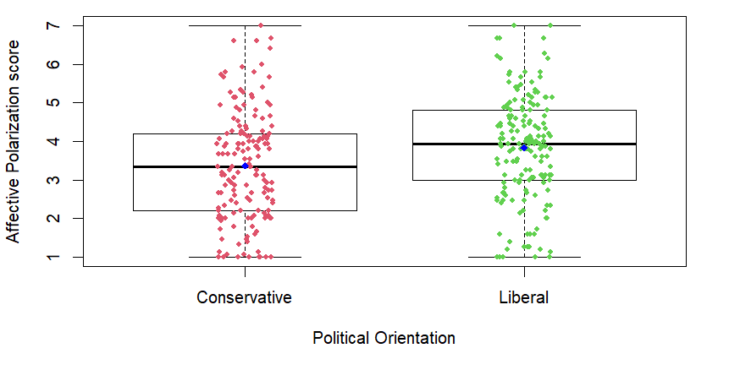

Social Distance
There was a significant difference between Conservatives and Liberals (t(328.94) = -3.61, p < .001, d = 0.40) on Social Distance. Conservatives (M = 3.11) reported lower levels of desire for social distance compared to Liberals (M = 3.75) with a mean difference of -0.63 (95% CI -0.978, -0.288). Among Liberal respondents, 44.1% scored above the neutral midpoint on Social Distance, while 23.0% of Conservatives did the same (Figure 3).
Figure 3
Boxplots showing distribution of social distance scores for Liberals and Conservatives.
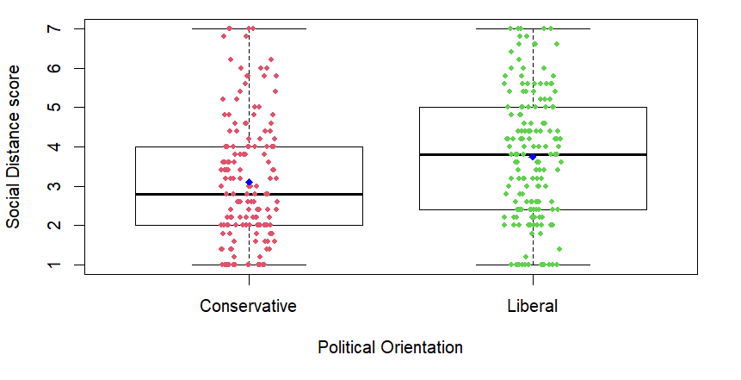

Aversion
Though Conservatives (M = 3.94) again scored lower than Liberals (M = 4.28) on aversion (M_{diff} = -0.34, 95% CI -0.677, 0.0003), the difference was not significant (t(321.47) = -1.97, p = .05, d = 0.22). Among Liberal respondents, 60.0% scored above the neutral midpoint on Aversion, while 44.1% of Conservatives did the same (Figure 4).
Figure 4
Boxplots showing distribution of aversion scores for Liberals and Conservatives.

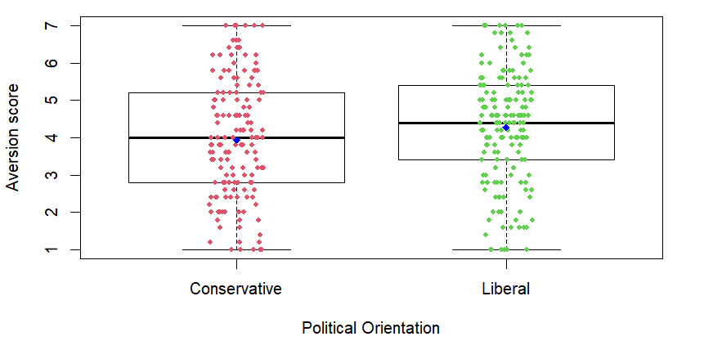

Incivility
A significant difference was found between Conservatives and Liberals in incivility (t(326.37) = -2.65, p = .009, d = 0.29). Conservatives (M = 3.05) reported lower levels of incivility compared to Liberals (M = 3.47), with a mean difference of -0.42 (95% CI -0.727, -0.107). Among Liberal respondents, 34.1% scored above the neutral midpoint on Incivility, while 23.0% of Conservatives did the same (Figure 5).
Figure 5
Boxplots showing distribution of incivility scores for Liberals and Conservatives.
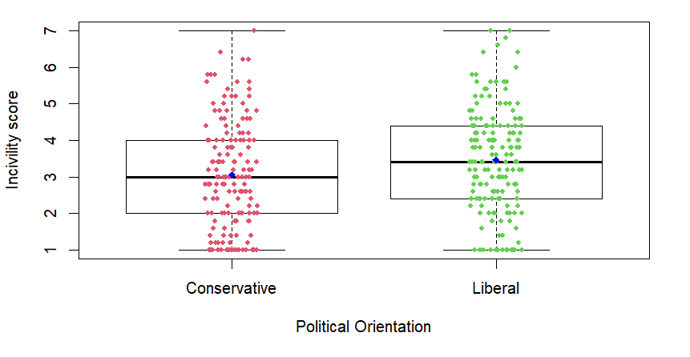

Need for Closure
Conservatives and Liberals differed significantly in need for closure (t(318.48) = 2.82, p = .005, d = 0.31). Conservatives (M = 4.66) reported higher levels of NFC compared to Liberals (M = 4.35) on average, with a mean difference of 0.31 (95% CI 0.099, 0.523). The majority of both Liberals (67.1%) and Conservatives (76.4%) scored above the neutral midpoint on need for closure (Figure 6).
Figure 6
Boxplots showing distribution of need for closure scores for Liberals and Conservatives.
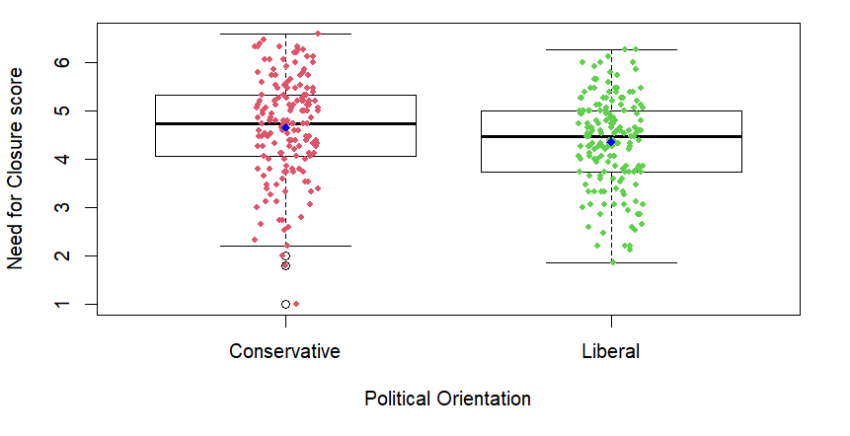

Intellectual Humility
A significant difference was observed between Conservatives and Liberals in intellectual humility (t(313.66) = -2.26, p = .025, d = 0.25). Conservatives (M = 4.63) reported lower levels of intellectual humility compared to Liberals (M = 4.92), with a mean difference of -0.29 (95% CI -0.554, -0.038). The majority of both Liberals (79.4%%) and Conservatives (71.4%) scored above the neutral midpoint (Figure 7).
Figure 7
Boxplots showing distribution of intellectual humility scores for Liberals and Conservatives.
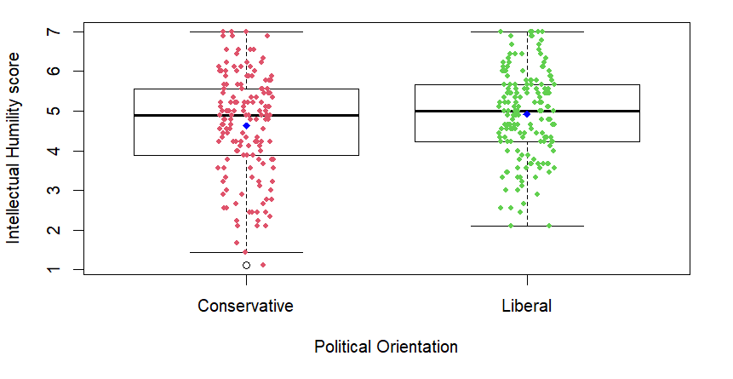

Identity Strength
No significant difference was found between Conservatives and Liberals in identity strength (t(329) = 0.71, p = 0.4785, d = 0.08). Conservatives (M = 3.23) scored slightly higher than Liberals (M = 3.15) in our sample, with a mean difference of 0.08 (95% CI -0.142, 0.302).
Figure 8
Boxplots showing distribution of identity strength scores for Liberals and Conservatives.
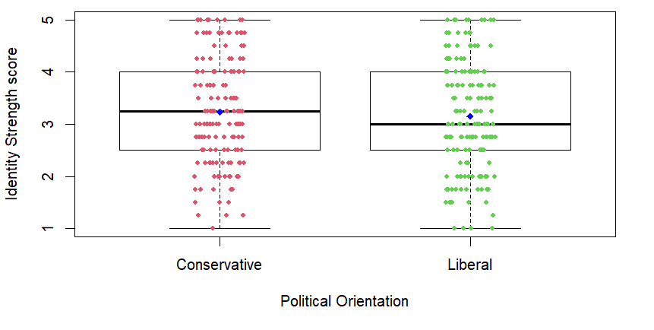

Authoritarianism
McMurtrie et al. (2024) measured authoritarianism in Liberals using the Left-wing Authoritarianism scale, and in Conservatives using the Right-wing Authoritarianism scale. This means that reporting inferential tests for group differences in authoritarianism, and reporting effect sizes for that difference, is not appropriate in this case. We present this data as purely descriptive.
The average RWA score among Conservatives was 4.09 (SD = 1.07), and the average LWA score among Liberals was 3.88 (SD = 0.95). Of Liberal participants, 43.5% scored above the neutral point on the LWA scale, while 54.0% of Conservatives scored above the neutral point on the RWA scale (Figure 9).
Figure 9
Boxplots showing authoritarianism scores for Liberals and Conservatives. Liberals’ authoritarianism was measured by their responses to the Left-wing Authoritarianism scale, Conservatives’ scores were based on their responses on the Right-wing Authoritarianism scale.
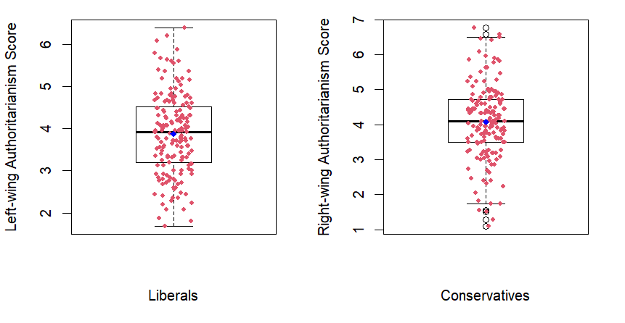
Some surprising results were found here. Though Conservatives scored significantly higher on need for closure, significantly lower on intellectual humility, and essentially the same on identity strength, they still displayed less affective polarization across all measures of affective polarization, though the difference was not significant for aversion. (Table 1).
Table 1
Table displaying the Cohen’s d effect sizes and p values for the average difference between Liberals and Conservatives. Positive effect sizes indicate Conservatives scored higher. As no inferential test was performed for authoritarianism, we report the mean difference (on a 7-point Likert scale).
Variable | Effect size (d) | p value
Feeling thermometer | 0.43 | <.001
Affective Polarization | -0.34 | .002
Social distance | -0.40 | <.001
Aversion | -0.22 | .05
Incivility | -0.29 | .009
Need for closure | 0.31 | .005
Intellectual humility | -0.25 | .025
Identity strength | 0.08 | 0.48

Predicting Affective Polarization
In order to investigate the ability to predict affective polarization based on the relevant variables included in this study, I performed multiple regressions of affective polarization total scores on need for closure, intellectual humility, authoritarianism, and identity strength both for Liberals (F(4,165) = 38.12, p = <.001, R² = .48) and Conservatives (F(4,156) = 15.25, p = <.001, R² = .28). Table 2 shows the coefficients and p values for these regression models. Though some of the predictors did significantly predict affective polarization, as indicated by the R-squared values a large amount of the variance remained unexplained for both groups (though more for conservatives). This suggests that much of the variance of affective polarization is yet to be explained by variables not in our study, such as personality traits or measures pertaining to actual ideological beliefs and perceived ideological polarization.
Table 2
Table displaying the regressions coefficients and their corresponding p values, from regressions predicting affective polarization scores for liberals and conservatives.
 | Liberals |  | Conservatives
Predictor | β | P value | β | P value
Need for closure | 0.09 | .30 | 0.21 | .03*
Intellectual humility | -0.18 | .01* | -0.31 | <.001*
Authoritarianism | 0.87 | <.001* | 0.19 | .09
Identity strength | 0.16 | .03* | 0.24 | .03*
Note: * Indicates significance (p = <.05). Authoritarianism was measured using RWA for conservatives, LWA for liberals.
Intellectual humility was associated with lower affective polarization for both Liberals and Conservatives, though the effect was stronger for Conservatives. Need for closure was significantly associated with higher affective polarization in Conservatives but not Liberals, whereas Authoritarianism was strongly associated with higher affective polarization among Liberals, but not among Conservatives. This suggests that aside from the average group differences on these constructs, the constructs themselves relate to affective polarization differently in liberals and conservatives, which perhaps indicates heterogeneity in processes that produces affective polarization. Identity strength significantly predicted higher affective polarization to a similar degree among both groups.

Discussion
The present study explored the differences in cognitive and personality traits between American Liberals and Conservatives, and their relationship with affective polarization. Using data from study 3 in McMurtrie et al. (2024), I examined differences in need for closure, intellectual humility, identity strength, authoritarianism, and investigated their ability to predict affective polarization.
The overall pattern of group differences goes against conventional wisdom regarding these constructs. Notably, while Conservatives scored significantly higher on need for closure, and lower on intellectual humility, they exhibited significantly lower affective polarization across multiple dimensions compared to Liberals. Specifically, Conservatives reported lower levels of polarization on the feeling thermometer, social distance, incivility, and overall affective polarization measures (effect sizes were largest for feeling thermometer and social distance scores), though the difference in negative trait ratings (Aversion) was marginally non-significant. While it was perhaps unexpected that the group that was lower in intellectual humility also had lower affective polarization, regression analyses did show that for both groups, intellectual humility was associated with significantly lower affective polarization which is consistent with past findings (Bowes et al., 2020; Krumrei-Mancuso & Newman, 2020).
Identity strength did not significantly differ between Liberals and Conservatives, results showed that strong political identity is a common feature in both Liberals and Conservatives. The regression analyses showed that identity strength predicted higher affective polarization to a very similar degree in both groups.
The finding that Conservatives scored significantly higher on need for closure aligns with the "rigidity of the right" hypothesis, which posits that Conservatives have a stronger preference for order and certainty (Jost et al., 2003). However, the observation that Conservatives displayed lower affective polarization despite this higher need for closure is, again, counterintuitive. Typically, high need for closure is thought to be associated with higher levels of affective polarization and various forms of outgroup prejudice (Luttig, 2018). The regression analyses did however show that need for closure was associated with higher affective polarization in conservatives, whereas this was non-significant in Liberals.
The authoritarianism scores, while merely descriptive due to the use of different scales (RWA for Conservatives and LWA for Liberals), showed that both groups exhibit reasonably high levels of authoritarianism on average, though conservatives more so (43.5% of Liberals and 54.0% of Conservatives had an average authoritarianism score above the neutral midpoint on the 7-point Likert scale). Authoritarianism strongly predicted higher affective polarization among Liberals but not Conservatives.
While these findings contribute to the nuanced understanding of the psychological underpinnings of affective polarization, and the results highlight the complexity of this phenomenon, the strength of the conclusions drawn are limited by the small convenience sample. Future research should employ larger, more representative samples to further investigate the mechanisms through which these constructs relate to one another, how they differ across the political spectrum, and how they influence political attitudes and behaviours.

References:
Abramowitz, A. I., & Saunders, K. L. (2008). Is Polarization a Myth? The Journal of Politics, 70(2), 542–555. https://doi.org/10.1017/S0022381608080493
Bowes, S. M., Blanchard, M. C., Costello, T. H., Abramowitz, A. I., & Lilienfeld, S. O. (2020). Intellectual humility and between-party animus: Implications for affective polarization in two community samples. Journal of Research in Personality, 88, 103992. https://doi.org/10.1016/j.jrp.2020.103992
Bowes, S. M., Clark, C. J., Conway, L. G., Costello, T. H., Osborne, D., Tetlock, P., & Van Prooijen, J.-W. (2023). An Adversarial Collaboration on the Rigidity-of-the-Right, Rigidity-of-Extremes, or Symmetry: The Answer Depends on the Question. Psy ArXiv. https://doi.org/10.31234/osf.io/4wmx2
Boxell, L., Gentzkow, M., & Shapiro, J. M. (2022). Cross-country trends in affective polarization. The Review of Economics and Statistics, 1–60. https://doi.org/10.1162/rest_a_01160
Brandt, M. J., & Crawford, J. T. (2020). Worldview conflict and prejudice. In B. Gawronski (Ed.), Advances in Experimental Social Psychology (Vol. 61, pp. 1–66). Elsevier. https://doi.org/10.1016/bs.aesp.2019.09.002
Chambers, J. R., Schlenker, B. R., & Collisson, B. (2013). Ideology and Prejudice: The Role of Value Conflicts. Psychological Science, 24(2), 140–149. https://doi.org/10.1177/0956797612447820
Clark, C. J., Jussim, L., Frey, K., Stevens, S. T., al-Gharbi, M., Aquino, K., Bailey, J. M., Barbaro, N., Baumeister, R. F., Bleske-Rechek, A., Buss, D., Ceci, S., Del Giudice, M., Ditto, P. H., Forgas, J. P., Geary, D. C., Geher, G., Haider, S., Honeycutt, N., … Von Hippel, W. (2023). Prosocial motives underlie scientific censorship by scientists: A perspective and research agenda. Proceedings of the National Academy of Sciences, 120(48), e2301642120. https://doi.org/10.1073/pnas.2301642120
Clark, C. J., & Winegard, B. M. (2020). Tribalism in War and Peace: The Nature and Evolution of Ideological Epistemology and Its Significance for Modern Social Science. Psychological Inquiry, 31(1), 1–22. https://doi.org/10.1080/1047840X.2020.1721233
Conway, L. G., Houck, S. C., Gornick, L. J., & Repke, M. A. (2018). Finding the Loch Ness Monster: Left-Wing Authoritarianism in the United States: Left-Wing Authoritarianism in the United States. Political Psychology, 39(5), 1049–1067. https://doi.org/10.1111/pops.12470
Costello, T. H., Bowes, S. M., Baldwin, M. W., Malka, A., & Tasimi, A. (2023). Revisiting the rigidity-of-the-right hypothesis: A meta-analytic review. Journal of Personality and Social Psychology, 124(5), 1025–1052. https://doi.org/10.1037/pspp0000446
Costello, T. H., Bowes, S. M., Stevens, S. T., Waldman, I. D., Tasimi, A., & Lilienfeld, S. O. (2022). Clarifying the structure and nature of left-wing authoritarianism. Journal of Personality and Social Psychology, 122(1), 135–170. https://doi.org/10.1037/pspp0000341
Costello, T. H., & Patrick, C. (2022). Development and Initial Validation of Two Brief Measures of Left-wing Authoritarianism: A Machine Learning Approach. Journal of Personality Assessment, 105(2), 187–202. https://doi.org/10.1080/00223891.2022.2081809
Crawford, J. T. (2014). Ideological symmetries and asymmetries in political intolerance and prejudice toward political activist groups. Journal of Experimental Social Psychology, 55, 284–298. https://doi.org/10.1016/j.jesp.2014.08.002
Crawford, J. T., & Brandt, M. J. (2020). Ideological (A)symmetries in prejudice and intergroup bias. Current Opinion in Behavioral Sciences, 34, 40–45. https://doi.org/10.1016/j.cobeha.2019.11.007
Ditto, P. H., Liu, B. S., Clark, C. J., Wojcik, S. P., Chen, E. E., Grady, R. H., Celniker, J. B., & Zinger, J. F. (2019). At Least Bias Is Bipartisan: A Meta-Analytic Comparison of Partisan Bias in Liberals and Conservatives. Perspectives on Psychological Science, 14(2), 273–291. https://doi.org/10.1177/1745691617746796
Duarte, J. L., Crawford, J. T., Stern, C., Haidt, J., Jussim, L., & Tetlock, P. E. (2015). Political diversity will improve social psychological science. Behavioral and Brain Sciences, 38, e130. https://doi.org/10.1017/S0140525X14000430
Fiorina, M. P., Abrams, S. A., & Pope, J. C. (2008). Polarization in the American Public: Misconceptions and Misreadings. The Journal of Politics, 70(2), 556–560. https://doi.org/10.1017/S002238160808050X
Greene, S. (1999). Understanding Party Identification: A Social Identity Approach. Political Psychology, 20(2), 393–403. https://doi.org/10.1111/0162-895X.00150
Harteveld, E. (2021). Ticking all the boxes? A comparative study of social sorting and affective polarization. Electoral Studies, 72, 102337. https://doi.org/10.1016/j.electstud.2021.102337
Hetherington, M. J., Long, M. T., & Rudolph, T. J. (2016). Revisiting the Myth: New Evidence of a Polarized Electorate. Public Opinion Quarterly, 80(S1), 321–350. https://doi.org/10.1093/poq/nfw003
Hoyle, R. H., Davisson, E. K., Diebels, K. J., & Leary, M. R. (2016). Holding specific views with humility: Conceptualization and measurement of specific intellectual humility. Personality and Individual Differences, 97, 165–172. https://doi.org/10.1016/j.paid.2016.03.043
Huddy, L., Mason, L., & Aarøe, L. (2015). Expressive Partisanship: Campaign Involvement, Political Emotion, and Partisan Identity. American Political Science Review, 109(1), 1–17. https://doi.org/10.1017/S0003055414000604
Iyengar, S., Sood, G., & Lelkes, Y. (2012). Affect, not ideology. Public Opinion Quarterly, 76(3), 405–431. https://doi.org/10.1093/poq/nfs038
Iyengar, S., & Westwood, S. J. (2015). Fear and loathing across party lines: New evidence on group polarization: fear and loathing across party lines. American Journal of Political Science, 59(3), 690–707. https://doi.org/10.1111/ajps.12152
Jost, J. T., Glaser, J., Kruglanski, A. W., & Sulloway, F. J. (2003). Political conservatism as motivated social cognition. Psychological Bulletin, 129(3), 339–375. https://doi.org/10.1037/0033-2909.129.3.339
Jost, J. T., & Kende, A. (2020). Setting the record straight: System justification and rigidity‐of‐the‐right in contemporary Hungarian politics. International Journal of Psychology, 55(S1), 96–115. https://doi.org/10.1002/ijop.12631
Jussim, L., & Honeycutt, N. (2023). Psychology as Science and as Propaganda. Psychology Learning & Teaching, 22(3), 237–244. https://doi.org/10.1177/14757257231195347
Jussim, L., Honeycutt, N., Paresky, P., Careem, A., Finkelstein, D., & Finkelstein, J. (2023). The Radicalization of the American Academy. In J. P. Zúquete (Ed.), The Palgrave Handbook of Left-Wing Extremism, Volume 2 (pp. 343–366). Springer Nature Switzerland. https://doi.org/10.1007/978-3-031-36268-2_19
Kekkonen, A., & Ylä-Anttila, T. (2021). Affective blocs: Understanding affective polarization in multiparty systems. Electoral Studies, 72, 102367. https://doi.org/10.1016/j.electstud.2021.102367
Krispenz, A., & Bertrams, A. (2023). Understanding left-wing authoritarianism: Relations to the dark personality traits, altruism, and social justice commitment. Current Psychology. https://doi.org/10.1007/s12144-023-04463-x
Krispenz, A., Hautle, L., Schmid, B. M., & Bertrams, A. (2024). Shining the light on left-wing authoritarianism in austria, germany, and switzerland. https://doi.org/10.31219/osf.io/8756d
Krumrei-Mancuso, E. J., & Newman, B. (2020). Intellectual humility in the sociopolitical domain. Self and Identity, 19(8), 989–1016. https://doi.org/10.1080/15298868.2020.1714711
Luttig, M. D. (2017). Authoritarianism and affective polarization. Public Opinion Quarterly, 81(4), 866–895. https://doi.org/10.1093/poq/nfx023
Luttig, M. D. (2018). The “Prejudiced Personality” and the Origins of Partisan Strength, Affective Polarization, and Partisan Sorting: Prejudiced Personality and Polarization. Political Psychology, 39, 239–256. https://doi.org/10.1111/pops.12484
Malka, A., Lelkes, Y., & Holzer, N. (2017). Rethinking the rigidity of the right model. In J. T. Crawford & L. Jussim (Eds.), The politics of social psychology (pp. 116–135).
Mason, L. (2013). The rise of uncivil agreement: Issue versus behavioral polarization in the american electorate. American Behavioral Scientist, 57(1), 140–159. https://doi.org/10.1177/0002764212463363
Mason, L. (2015). “I disrespectfully agree”: The differential effects of partisan sorting on social and issue polarization: American Journal of Political Science, 59(1), 128–145. https://doi.org/10.1111/ajps.12089
Mason, L. (2016). A cross-cutting calm: How social sorting drives affective polarization. Public Opinion Quarterly, 80(S1), 351–377. https://doi.org/10.1093/poq/nfw001
Mason, L. (2018). Losing Common Ground: Social Sorting and Polarization. The Forum, 16(1), 47–66. https://doi.org/10.1515/for-2018-0004
McMurtrie, B., Philipp, M., Hebden, R., & Williams, M. (2024). Development and Validation of the Affective Polarization Scale. International Review of Social Psychology, 37(1), 11. https://doi.org/10.5334/irsp.926
Nadelhoffer, T., Graves, R., Skorbug, G., Leary, M., & Sinnott-Armstrong, W. (2020). Partisanship, Humility, and Epistemic Polarization. In A. Tanesini & M. Lynch (Eds.), Partisanship, Humility, and Epistemic Polarization. Routledge.
Orriols, L., & León, S. (2020). Looking for Affective Polarisation in Spain: PSOE and Podemos from Conflict to Coalition. South European Society and Politics, 25(3–4), 351–379. https://doi.org/10.1080/13608746.2021.1911440
Rawlings, C. (2022). Becoming an Ideologue: Social Sorting and the Microfoundations of Polarization. Sociological Science, 9, 313–345. https://doi.org/10.15195/v9.a13
Roets, A., & Van Hiel, A. (2011). Item selection and validation of a brief, 15-item version of the Need for Closure Scale. Personality and Individual Differences, 50(1), 90–94. https://doi.org/10.1016/j.paid.2010.09.004
Stanley, M. L., Sinclair, A. H., & Seli, P. (2020). Intellectual humility and perceptions of political opponents. Journal of Personality, 88(6), 1196–1216. https://doi.org/10.1111/jopy.12566
Van Hiel, A., Duriez, B., & Kossowska, M. (2006). The Presence of Left-Wing Authoritarianism in Western Europe and Its Relationship with Conservative Ideology. Political Psychology, 27(5), 769–793. https://doi.org/10.1111/j.1467-9221.2006.00532.x
Van Hiel, A., Onraet, E., Crowson, H. M., & Roets, A. (2016). The Relationship between Right–wing Attitudes and Cognitive Style: A Comparison of Self–report and Behavioural Measures of Rigidity and Intolerance of Ambiguity. European Journal of Personality, 30(6), 523–531. https://doi.org/10.1002/per.2082
Wagner, M. (2024). Affective polarization in Europe. European Political Science Review, 1–15. https://doi.org/10.1017/S1755773923000383
Westwood, S. J., Iyengar, S., Walgrave, S., Leonisio, R., Miller, L., & Strijbis, O. (2018). The tie that divides: Cross-national evidence of the primacy of partyism: the tie that divides. European Journal of Political Research, 57(2), 333–354. https://doi.org/10.1111/1475-6765.12228
Zmigrod, L. (2020). The role of cognitive rigidity in political ideologies: Theory, evidence, and future directions. Current Opinion in Behavioral Sciences, 34, 34–39. https://doi.org/10.1016/j.cobeha.2019.10.016
Zmigrod, L., Rentfrow, P. J., & Robbins, T. W. (2020). The partisan mind: Is extreme political partisanship related to cognitive inflexibility? Journal of Experimental Psychology: General, 149(3), 407–418. https://doi.org/10.1037/xge0000661

