POSITIVE MOOD, RISK AVERSION, AND AMBIGUITY AVERSION IN INVESTMENT CHOICE
Phung, Thai Minh Trang¹, Murray MacRae², Nguyen, Huu Tho³, Nguyen, Van Hoa³
¹Department of Accounting and Finance, Hoa Sen University, Vietnam.
²School of Communication, Journalism and Marketing, Massey University, New Zealand.
³School of Management, University of Economics Ho Chi Minh City, Vietnam.

Abstract:
Mood, risk aversion, and ambiguity aversion all play a crucial role in investment choice, just as they do in everyday life. We investigate these factors in an emerging market, developing scales, then testing and deploying them via 400 online and paper-based surveys to Vietnamese individual investors to develop a model of those roles in investment choice.
We undertook exploratory factor analysis, confirmatory factor analysis, and built and tested structural equation models. Significant direct relationships between positive mood, risk aversion, and ambiguity aversion and between those aversions and investment choice were uncovered. Those relationships between the factors were strongly significant even when controlling for demographic variables. We found no direct significant relationship between positive mood and investment choice, only via the risk aversion and ambiguity aversion, this relationship is significant.
Implicit in these results is that investors should be aware of the importance of positive mood in decision-making because a rise in positive mood leads to a decrease in the levels of risk and ambiguity aversion, and thus investments chosen are less safe. Advisors also have a role in understanding and reacting to aspects of mood and its impact on risk aversion, ambiguity aversion, as well as on investment choice of their clients.

I. INTRODUCTION
Mood differs from emotion, while an emotion is short-lived, intense and tend to be a response to situations, mood lasts longer, is less intense and has a “global effect” on individuals (Capra, 2004; Frijda, Scherer, & Sander, 2009). Aversion is a desire to avoid some elements of life, thus, risk aversion is described as a decreasing preference for an increasing risk (Hong, Karni, & Safra, 1987; Montesano, 1990). In a similar vein, ambiguity aversion (also known as uncertainty aversion) is a tendency to avoid choices with unknown risks over known risks (Ellsberg, 1961).
Recent literature find mood, risk aversion, and ambiguity aversion have a direct impact on the decision-making process (Dimmock, Kouwenberg, Mitchell, & Peijnenburg, 2016; Ellsberg, 1961; HuuTho, Trang, & Van Hoa, 2018; Kahneman & Tversky, 1979; Shimp & Bearden, 1982) (Johnson & Tversky, 1983; Lucey & Dowling, 2005; Nygren, Isen, Taylor, & Dulin, 1996; Schwarz, 2000; Trang, Khuong, & Tho, 2016). People in a good mood tend to buy more stock or take more risk (Grable & Roszkowski, 2008; Lucey & Dowling, 2005). Risk-averse people prefer a choice with certainty over an uncertain choice, even when the expected value of the latter choice is greater (Kahneman & Tversky, 1979). Ambiguity-averse investors tend to choose situations for which they have more information (Ellsberg, 1961). However, it appears that no investigation of the mediating effects of mood on investment decisions has taken place, so, our study fills this gap.
We argue that investors in a positive mood take more risk through the mechanism of their mood reducing risk aversion and ambiguity aversion. We, therefore, tested the mediating roles of risk aversion and ambiguity aversion in the relationship between positive mood and investment choice. We employed semi-structured interviews with experienced investors to identify what factors were important to investors in this context. What we learnt led us to develop a bank of scales for the research. These scales were tested and modified in a pilot test, and then data was collected in online and paper-based surveys. After exploratory factor analysis (EFA) and confirmatory factor analysis (CFA), structural equation models (SEM) were developed. SEM was chosen as the primary investigation tool because of its capability to examine a series of dependence relationships simultaneously, that is, it identifies direct and mediating relationships between the factors in a model. Other techniques (e.g. multiple regression, multivariate analysis of variance, discriminant analysis) can examine only a single relationship at a time (Hair, Black, Babin, & Anderson, 2014).
We find that a positive mood does not directly affect investment choice, but has an indirect (mediating) effect on investment choice through risk aversion and ambiguity aversion. Risk aversion and ambiguity aversion both significantly mediated the relationship between a positive mood and investment choice even when controlling for demographics. The implication is that investors with increasingly positive mood only choose less safe investments if they reduce their risk aversion and ambiguity aversion. Investors should take note of the important roles of good mood, risk aversion and ambiguity aversion in the decision-making process. The literature review, hypotheses, methods, findings, discussion, further research, limitations, and conclusions follow.

II. LITERATURE REVIEW
2.1 Mood and investment choice
Lucey and Dowling (2005) note individuals in a positive mood make more optimistic judgments while individuals in a negative mood make more pessimistic judgments. Similarly, a sunny day makes people feel happier, buy more stock and surprisingly, have higher stock returns than when it rains (Rind, 1996; Saunders, 1993). Critically, people in positive (negative) mood may overestimate (underestimate) the probability of positive outcomes and underestimate (overestimate) the likelihood of negative outcomes (Johnson & Tversky, 1983; Nygren et al., 1996; Schwarz, 2000). Overall, a happy mood is positively associated with risk taking (Grable & Roszkowski, 2008; Mehra & Sah, 2002; Yuen & Lee, 2003) and a bad mood is positively associated with risk aversion (i.e. a depressive mood heightens risk aversion) (Carton, Jouvent, Bungener, & Widlöcher, 1992). Based on those findings, this study hypothesizes that an increase in positive mood leads to a decrease in risk aversion and ambiguity aversion.

H1- H2: There are negative relationships between a positive mood, risk aversion, and ambiguity aversion, respectively.
2.2 Risk aversion, ambiguity aversion, and investment choice
Behavioural economists argue that investors are not fully rational (Shefrin, 2001; Statman, 2005), that is, they exhibit behavioural bias in the decision-making process (Kahneman & Tversky, 1979). Risk-averse investors generally prefer certainty of return (e.g. being sure to receive $90) to an uncertain option with a high probability of gains (e.g. 95% chance to receive $100), even though the mathematically expected value of the sure choice might be lower than that of the uncertain choice. This is because they fear disappointment (Kahneman & Tversky, 1979) and feel threatened by risky or uncertain situations (Shimp & Bearden, 1982). HuuTho et al. (2018) found risk-avoiding investors tend to choose safe investments. In addition, a rise in positive mood negatively affects risk aversion (Grable & Roszkowski, 2008; Mehra & Sah, 2002; Yuen & Lee, 2003). Given this evidence, it is possible that risk aversion has a direct positive relationship with safe investment choice and mediates the relationship between a positive mood and investment choice, with the following hypotheses:
H3: There is a positive relationship between risk aversion and safer investment choice.
H4: Risk aversion plays a significant mediating role in the impact of positive mood on investment choice.
Ambiguity-averse people prefer to choose situations having more information (Ellsberg, 1961) , and that are familiar, for example, they would like to buy local stocks or stocks owned by their company employers (Pompian, 2006). Rising ambiguity aversion induces less diversification in their portfolio and a tendency to sell rather than buy stocks (Dimmock et al., 2016). Ambiguity-avoiding investors are more likely to choose safe investments (HuuTho et al., 2018). Like risk aversion, we hypothesize that ambiguity aversion positively affects safe investment choice and mediates the relationship between a positive mood and investment choice:
H5: There is a positive relationship between ambiguity aversion and safer investment choice.
H6: Ambiguity aversion plays a significant mediating role in the impact of positive mood on investment choice.
2.3 Demographic effects on investment decisions
Women are, in general, more loss-, regret- and risk- averse than men (Borghans, Heckman, Golsteyn, & Meijers, 2009; Charness & Gneezy, 2012; Lin, 2011; Rau, 2014; Seiler, Seiler, Traub, & Harrison, 2008). However, while women are less risk-taking than males in gain domain gambles, they demonstrate more risk-taking than males in the loss domain (Schubert, Brown, Gysler, & Brachinger, 1999).
Single individuals take more risk than do married individuals (Dohmen et al., 2011; Hallahan, Faff, & McKenzie, 2004; Roussanov & Savor, 2014). Higher educated, more experienced, higher income and older people are less likely to be biased in decision-making (Dhar & Zhu, 2006; Feng & Seasholes, 2005; Goetzmann & Kumar, 2008; Korniotis & Kumar, 2011; List, 2003). However, some scholars find no association between age and risk-taking behaviour (Grable & Lytton, 1999; Guiso & Paiella, 2008; HuuTho et al., 2018; Weber, Weber, & Nosić, 2012) and between education and risk-taking behaviour (Hallahan, Faff, & McKenzie, 2003; HuuTho et al., 2018). People who participate in investment courses tend to avoid risk and ambiguity (HuuTho et al., 2018).

III. METHODS
3.1 Data
The Vietnam economy is an emerging market and the stock market was founded relatively recently (2000). The Vietnamese economy had, around the time of this research, experienced a decrease in interest rates, an increase in foreign direct investment, and growth of credit and of stock prices (from a low price often under 50 cents US). Importantly, according to Bloomberg analysts, the Vietnam stock market attracts strong local and international support from investors because its status as the fastest growing market in Asian 2017. The share market capitalization made up approximately 82 percent of Vietnam GDP in April 2018. Unlike developed markets where institutional investors rather than individual investors dominate the financial markets, Vietnamese individual investors are key traders, constituting 99 percent of total investors in the stock market. Thus, they contribute substantially to the growth on the Vietnam stock market and hence Vietnam’s economy. Our motivations for this market are the possibility that the behaviour of Vietnamese individual investors model those of individual investors in other emerging stock markets. The following techniques to collect data were used:
3.2 In-depth interviews and scale development
In-depth interviews were undertaken in November 2016 with ten investors to develop scales of risk aversion and ambiguity aversion. We developed the scales for risk aversion and ambiguity aversion in English and Vietnamese. Also, original scales for positive mood (Watson, Clark, & Tellegen, 1988) and investment choice (Pasewark & Riley, 2010) were employed (see in Appendix A). Vietnamese wording for these scale questions were developed and discussed in the interviews.
While there are scales of risk aversion and ambiguity aversion (Cavatorta & Schröder, 2016; Ellsberg, 1961; McLain, 1993), they do not focus on the financial field. Prospect theory describes the way people choose between probabilistic alternatives involving risk (Kahneman & Tversky, 1979). Risk-averse people prefer a sure gain (e.g. 100% for sure to receive US $900) rather than a high probability of gain (e.g. 95% chances to receive US $1000). In contrast, in a loss situation, risk-averse people prefer a high probability of loss (e.g. 95% chances to lose US $1000) to a sure loss (e.g. 100% for sure to lose US $900). Ambiguity-averse people prefer situations with more information (Ellsberg, 1961). Thus, we developed new scales for risk aversion and ambiguity aversion on this basis with the English language version reported below (also see in Appendix A):
The risk aversion scale:
Thinking about investing in two stocks (A and B):
(i) Stock A: You have 95% chance to gain x% (e.g. 10%) over purchase price next month.
(ii) Stock B: You have 100% chance to gain ……% (must be below x %) over purchase price next month. (Other factors relating to these two stocks are the same).
What percentage of gain (must be below x %) makes you decide to choose stock B for your portfolio?
I decide to invest in stock B if I am sure to gain: | Totally disagree | Disagree | Neither agree nor disagree | Agree | Totally agree
Between 10% and 7% | 1 | 2 | 3 | 4 | 5
Between 7% and 5% | 1 | 2 | 3 | 4 | 5
Between 5% and 3% | 1 | 2 | 3 | 4 | 5
Between 3% and 0% | 1 | 2 | 3 | 4 | 5

We determined that investors are more likely averse to risk if they choose 4 or 5 (agree or totally agree), neutral to risk aversion (3), not likely averse to risk if they choose 1 and 2 (totally disagree and disagree).
The ambiguity aversion scale:
Thinking about investing two stocks (C and D), both stocks you do not know their future outcomes. However, stock C has more information than stock D. Do you decide to choose stock C even though stock D had the following strong points? (Except the following different characteristics of these two stocks, others are the same.)
My choice between stock C and stock D: | Totally disagree | Disagree | Neither agree nor disagree | Agree | Totally agree
I choose stock C even though stock D’s price is cheaper. | 1 | 2 | 3 | 4 | 5
I choose stock C even though stock D’s trading volume is higher. | 1 | 2 | 3 | 4 | 5
I choose stock C even though stock D’s returns are higher. | 1 | 2 | 3 | 4 | 5
I choose stock C under any circumstances. | 1 | 2 | 3 | 4 | 5

We defined that investors are more likely averse to ambiguity if they choose 4 or 5 (agree or totally agree), neutral to ambiguity aversion (3), not likely averse to ambiguity if they choose 1 and 2 (totally disagree and disagree).
3.3 The pilot test
Table 1: A summary of the results of the pilot test (N=50)
The results of validity and reliability of items (N=50) | Corrected item-total correlation | Cronbach’s alpha if item deleted | Cronbach’s alpha
I/ Investment choice (INVE) |  |  | 0.604
INVE1: I choose stocks that have high degrees of safety. | .649 | .261 | INVE1
INVE2: I choose stocks that have lower risk compared to the market in general. | .427 | .482 | INVE2
INVE3: I choose stocks that have recently reported results that were significantly better than expected. | .260 | .784 | INVE3
II/ Risk aversion (RISK): I invest in stock B if I am sure to gain: |  |  | 0.858
RISK1: Between below 10% and 7% | .833 | .761 | RISK1
RISK2: Between below 7% and 5% | .855 | .750 | RISK2
RISK3: Between below 5% and 3% | .862 | .746 | RISK3
RISK4: Between below 5% and over 0% | .305 | .943 | RISK4
III/ Ambiguity aversion (AMB): Stock C has more information than stock D |  |  | 0.770
AMB1: I choose stock C even though stock D’s price is cheaper. | .678 | .662 | AMB1
AMB2: I choose stock C even though stock D’s trading volume is higher. | .654 | .674 | AMB2
ABM3: I choose stock C even though stock D’s returns are higher. | .652 | .673 | AMB3
AMB4: I choose stock C under any circumstances. | .365 | .841 | AMB4
IV/ Positive mood (MOD): In general, when investing in stocks, |  |  | 0.758
MOD1: I feel cheerful. | .710 | .550 | MOD1
MOD2: I feel happy. | .667 | .580 | MOD2
MOD3: I feel excited. | .420 | .860 | MOD3

Fifty investors were surveyed in December 2016 to test the reliability and face validity of all items and variables. The reliability and validity of the scales with respect to their contributing items was tested against the following guidelines: (i) The item-to-total correlations exceed 0.50, (ii) The inter item correlations exceed 0.3; (iii) Reliability coefficient (Cronbach’s alpha) is 0.6 or more; Items, not meeting the criteria, were removed because they were not considered strongly related to their parents construct (Hair et al., 2014).
3.4 Sample size for surveys and methods to test the structural relationships.
Hair et al. (2014) propose that the greater the number of observations, the more generalized the sample size is to the total population. So, they recommend a ratio of observations to items of 15:1. The sample size was set at 225 (15x 15 items) on that basis. To ensure this ratio was exceeded, the questionnaires were sent to 450 investors trading in the Vietnam stock exchange and 400 valid questionnaires were returned. The survey was undertaken from January to June 2017.
The data was analysed with SPSS, AMOS and Statwiki software. First, Exploration Factor Analysis (EFA) was undertaken with Principal Factor Analysis using Promax rotation with Kaiser Normalization to test reliability and validity of the factors. After analysis of factor loadings, Confirmation Factor Analysis (CFA) was applied to retest discriminant and convergent validity of the factors and a model fit, and then structural equation modelling (SEM) was used to test the hypotheses. Hair et al. (2014) recommend that a model meet guidelines for: fit, validity, errors, and potential for improvement as described below:
(1) Model fit measures: the value of Chi-square (X²) is not zero (# 0); degree of freedom (df): X²/df $≤$ 0.5; Goodness-of-fit index (GFI) > 0.9; Tucker-Lewis index (TLI) > 0.9; Comparative Fit Index (CFI) > 0.9; Root Mean Square Error of Approximation (RMSEA) <0.07.
(2) Convergent validity and discriminant validity: For the convergent validity, the standardized loading estimates should be 0.5 or higher, preferably 0.7 or higher. Average variance extracted (AVE) value of a variable should be 0.5 or greater. Construct reliability (CR) should be 0.7 or higher to indicate adequate convergent (internal consistency). For discriminant validity, (i) AVE > its maximum shared variance (MSV), and (ii) ($\sqrt{AVE}$_{i} > β_{i}).
(3) Standardized residuals less than the absolute value of 2.5 ($\left|2.5\right|$) do not suggest a problem, but greater than the absolute value of 4.0 ($\left|4.0\right|$) suggest a potentially unacceptable degree of error that may call for the deletion of an offering item. Standardized residuals for any pair of items between $\left|2.5\right|$ and $\left|4.0\right|$ deserve some attention, but may not suggest changes to the model if no other criteria fail for those two items.
(4) A modification index (MI) of approximately 4.0 or greater suggests that the fit could be improved significantly by freeing the corresponding path to be estimated.

IV. RESULTS of final surveys (N=400)
4.1 Investor characteristics
As can be seen in Table 2 below, males made up about 59% of investors and nearly 80% of investors were aged from 18 to 35 years old. In comparison with the Vietnamese population in November 2018 , we see a bias towards males of 10% (49.4% in the population) and toward younger investors (69.3% aged from 15 to 64 in the population). Moreover, over 80% of investors held a university degree. Most had 5 years or less of investment experience. Around 75% had per annum income less than 240 million VND (< 12,000 USD). The Vietnam GDP per capita was 2,343 USD in 2017.
Table 2: A summary of investor characteristics
Characteristics (N=400) | No. investors | % |  | Characteristics (N=400) | No. investors | %
I/ Gender |  |  |  | VI/ Income per month (VND)
 |  |  |  | < 6 million | 111 | 27.8
Male | 235 | 58.8 |  | 6-12 million | 179 | 44.8
Female | 165 | 41.2 |  | > 12 -20 million | 62 | 15.4
 |  |  |  | >20 million | 48 | 12.0
II/ Age |  |  |  | VII/ Investment experience
18-25 | 117 | 29.3 |  | < 1 year | 120 | 30.0
26-35 | 198 | 49.5 |  | 1-3 years | 125 | 31.3
36-55 | 72 | 18.0 |  | > 3 – 5 years | 86 | 21.5
>55 | 13 | 3.2 |  | > 5 – 10 years | 59 | 14.8
 |  |  |  | > 10 years | 10 | 2.5
III/ Marital status |  |  |  | VIII/ Places for living
Single | 198 | 49.5 |  | Ho Chi Minh City | 323 | 80.8
Married | 177 | 44.3 |  | Ha Noi | 36 | 9.0
Divorced | 25 | 6.3 |  | Others | 41 | 10.2
IV/ Education |  |  |  | IX/ Investment courses
High school | 15 | 3.3 |  | Attended | 248 | 62.0
College | 61 | 15.3 |  | No attendance | 152 | 38.0
University | 282 | 70.5 |  | X/ Investment amount (VND)
Master | 41 | 10.3 |  | < 100 million | 185 | 46.3
Others | 3 | 0.06 |  | 100-300 million | 104 | 26.0
V/ Work experience |  |  |  | > 300-600 million | 37 | 9.3
<5 years | 201 | 50.2 |  | > 600 – 1 billion | 18 | 4.5
5-10 years | 160 | 40.0 |  | > 1-3 billion | 27 | 6.8
> 10 years | 39 | 9.8 |  | > 3 billion | 29 | 7.1

4.2 Exploratory factor loadings (EFA)
Exploratory factor analysis (EFA) revealed a model with six constructs: REG with four items, LOSS with three items, MOD with three items, RISK with four items, AMB with three items and INVE with two items, as indicated in Table 3 below. The factor loadings for all items were greater than 0.5. Tests of reliability (Cronbach’s alpha), correlations between the items, data suitability (KMO’s and Bartlett’s test), communalities, total variance, scree criterion (see in Appendix B), all indicated the model had sufficient reliability and validity.
Table 3: Factor loadings (pattern matrix)
 | 1 | 2 | 3 | 4
RISK1 | .959
RISK2 | .934
RISK3 | .888
MOD1 |  | .896
MOD2 |  | .877
MOD3 |  | .667
AMB1 |  |  | .828
AMB2 |  |  | .666
AMB3 |  |  | .643
INVE1 |  |  |  | .859
INVE2 |  |  |  | .797
Extraction Method: Principal Axis Factoring.
Rotation Method: Promax with Kaiser Normalization.
RISK: risk aversion, MOD: positive mood, AMB: ambiguity aversion, INVE: investment choice

The correlations between the factors are shown in Table 4. Most factors were significantly inter-correlated but at low levels. MOD is negatively correlated with RISK at -0.125 and with AMB at -0.224. It can be interpreted that an increase (decrease) in MOD leads to a decrease (increase) in RISK or AMB. MOD had no significant correlation with INVE, indicating that MOD was not likely to strongly affect INVE. Overall, no correlations between the factors were greater than 0.7, indicating the model had satisfactory validity.
Table 4: Factor correlation matrix between the factors
 | RISK | MOD | AMB | INVE
RISK | 1.000
MOD | -.125* | 1.000
AMB | .205** | -.224** | 1.000
INVE | .225** | 0.002 | .161** | 1.000
* Correlation is significant at the 0.05 level (2-tailed).
** Correlation is significant at the 0.01 level (2-tailed).
RISK: risk aversion, MOD: positive mood, AMB: ambiguity aversion, INVE: investment choice
4.3 Results of Confirmatory factor analysis (CFA)
Construct reliability (CR) for all factors was greater than 0.7, and average variance extracted (AVE) of factors was all greater than 0.5. In addition, Maximum shared variance (MSV) estimates was all smaller than their respective AVE estimates. The $\sqrt{AVE}$for each factor was greater than its component correlations with any other factor (β).
In addition, standardized residual covariance between the items in this model was less than$\left|2.5\right|$, indicating an acceptable degree of error in model fit to the data. Similarly, in terms of modification indices, the results found all items were above$\left|4.0\right|$, indicating all factors contribute well to the fit of the model.
Taken altogether, these result indicated that the CFA model had adequate fit as well as convergent and discriminant validity to permit development and testing of a structural equation modelling, see Table 5 below for detail.
Table 5: A summary of construct reliability, convergent and discriminant validity
Factors | Validity measures |  |  |  | Correlations
 | CR | AVE | MSV | $$\sqrt{AVE}$$ | 1 | 2 | 3 | 4
1.AMB | 0.758 | 0.512 | 0.063 | 0.716 | 1.000
2.MOD | 0.856 | 0.669 | 0.063 | 0.818 | -0.251 | 1.000
3.RISK | 0.947 | 0.857 | 0.064 | 0.926 | 0.236 | -0.125 | 1.000
4.INVE | 0.813 | 0.686 | 0.064 | 0.828 | 0.212 | 0.040 | 0.252 | 1.000
CR: construct reliability, AVE: average variance extracted, MSV: maximum shared variance, AMB: ambiguity aversion, MOD: positive mood, RISK: risk aversion, INVE: investment choice

Figure 1 below provides a complete specification of the CFA model in which there are four constructs: MOD, RISK, AMB, and INVE. The CFA results met all criterion; Chi-square: 60.278, degree of freedom (df): 38, GFI = 0.973, TLI = 0.986, CFI = 0.991and RMSEA = 0.038 (See details in Appendix C). Overall, given the CFA results, this measurement model provides a reasonably good fit, and thus it is suitable to proceed to further examination of the model results

Figure 1: A model of confirmation factor loadings (CFA model)

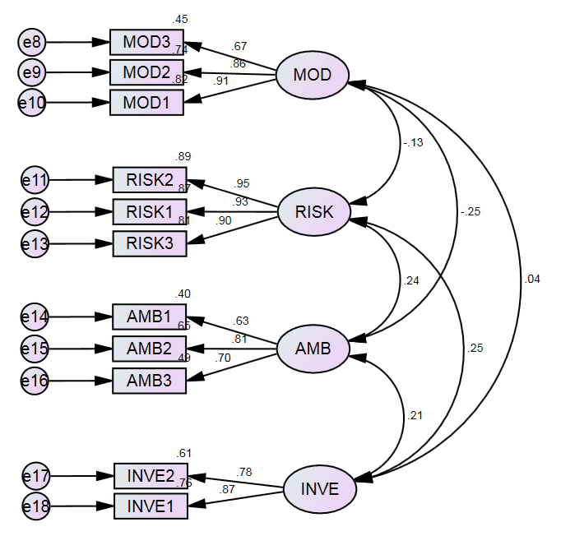

4.4 Results of structural equation modelling 1 (SEM1)
Figure 1 illustrates model 1 (SEM1) in which RISK and AMB act as mediating factors in the relationship between MOD and INVE. SEM1 was well fitted to the data (e.g. Chi-square = 73.354, df = 39, Normed chi-square = 1.881, GFI = 0.967, TLI = 0.979, CFI = 0.985, RMSEA = 0.047) (See details in Appendix C).
SEM1, as described in Table 6 below, demonstrated direct negative relationships between MOD, RISK and AMB. When MOD increases by one standard deviation, RISK decreases by 0.132 (p<0.05), and AMB decreases by -0.254 (p<0.001). The next direct positive associations relate to RISK, AMB and INVE. An increase in RISK and in AMB by one standard deviation leads to an increase INVE by 0.209 and 0.190 (p<0.001), respectively. There was no significant direct relationship between MOD and INVE.

Figure 2: The structural equation model 1 (SEM1)

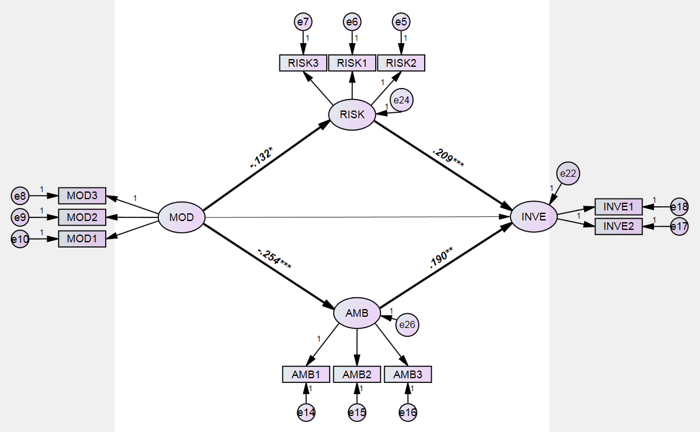
MOD: positive mood, RISK: risk aversion, AMB: ambiguity aversion, INVE: investment choice.
Table 6: Results of structural relationships of SEM1
Structural relationships |  |  | Unstandardized Regression weights | Standardized Regression weights | Standard error | Critical value | P-value
RISK | <-- | MOD | -0.192 | -0.131 | 0.08 | -2.395 | 0.017*
AMB | <-- | MOD | -0.161 | -0.251 | 0.041 | -3.955 | 0.000***
INVE | <-- | RISK | 0.144 | 0.234 | 0.037 | 3.846 | 0.000***
INVE | <-- | MOD | 0.106 | 0.117 | 0.056 | 1.875 | 0.061
INVE | <-- | AMB | 0.268 | 0.19 | 0.099 | 2.705 | 0.007**
*: p<0.05, **: p<0.01, ***: p<0.001, MOD: positive mood, RISK: risk aversion, AMB: ambiguity aversion, INVE: investment choice.
Moreover, SEM1 uncovered a significant indirect (mediating) relationship between MOD and INVE through RISK and AMB (H4 and H6). That is, MOD did not affect INVE directly, but MOD affected INVE through RISK and AMB. The equations of these relationships are as follows, with standardized coefficients: (*: p<0.05, **: p<0.01, ***: p<0.001)
Equation 1: The direct relationship between MOD and RISK
RISK = -0.132 MOD* (1)
Equation 2: The direct relationship between MOD and AMB:
AMB = -0.254 MOD** (2)
Equation 3: The direct relationship between RISK, AMB, and INVE:
INVE = 0.209 RISK*** + 0.19 AMB** (3)
Equation 4: The mediating roles of RISK and AMB in the impact of MOD on INVE:
Substituting equation 1 and 2 into equation 3, we have equation 4:
INVE = 0.209 (-0.132 MOD + -0.254 MOD)
INVE = - 0.08 MOD (4)
Equation 4 mathematically describes that MOD significantly affected INVE at - 0.08 through RISK and AMB. This also means that RISK and AMB significantly mediated the relationship between MOD and INVE at -0.08.
4.5 Results of structural equation modelling 2 (SEM2)
We tested the correlations between MOD, RISK, AMB, INVE and five demographic variables. Most demographics had low correlations with four main factors (MOD, RISK, AMB and INVE), for instance, PAR and INVE at 0.141 (p<0.01), INC and MOD at -0.204 (p<0.01). In particular, GEN had no significant correlations with these four main factors. EDU significantly correlated with only INVE at 0.168 (p<0.01). Table 7 below shows this in detail.

Table 7: Correlations between the factors and key demographics
 | INVE | MOD | RISK | AMB | GEN | EDU | EXP | INC | PAR
INVE | 1.000
MOD | .002 | 1.000
RISK | .225** | -.125* | 1.000
AMB | .161** | -.224** | .205** | 1.000
GEN | .064 | -.054 | .016 | -.073 | 1.000
EDU | .168** | -.004 | .030 | -.003 | -.036 | 1.000
EXP | .068 | -.111* | .119* | .063 | .076 | .100* | 1.000
INC | .108* | -.204** | .079 | .113* | .019 | .301** | .491** | 1.000
PAR | .141** | -.053 | .069 | .090 | .060 | .257** | .027 | .157** | 1.000
**. Correlation is significant at the 0.01 level (2-tailed).
*. Correlation is significant at the 0.05 level (2-tailed).
INVE: investment choice, MOD: positive mood, RISK: risk aversion, AMB: ambiguity aversion, GEN: gender, EDU: education, EXP: work experience, INC: income, PAR: participation in investment courses

We also developed a second structural equation model (SEM2), including four main factors (MOD, RISK, AMB and INVE) and five demographic variables: (GEN), education levels (EDU), work experience (EXP), income (INC), and participation in investment courses (PAR). SEM2 tested how strong the effects of MOD on RISK, AMB and INVE were when demographic characteristics included. SEM2 met criteria of a model fit, for example, Chi-square = 148.973, df = 95, Normed chi-square = 1.568, GFI = 0.961, TLI = 0.971, CFI = 0.982, RMSEA = 0.038 (see details in Appendix C). Figure 3 below demonstrates this model.
Figure 3: The structural equation model 2 (SEM2)
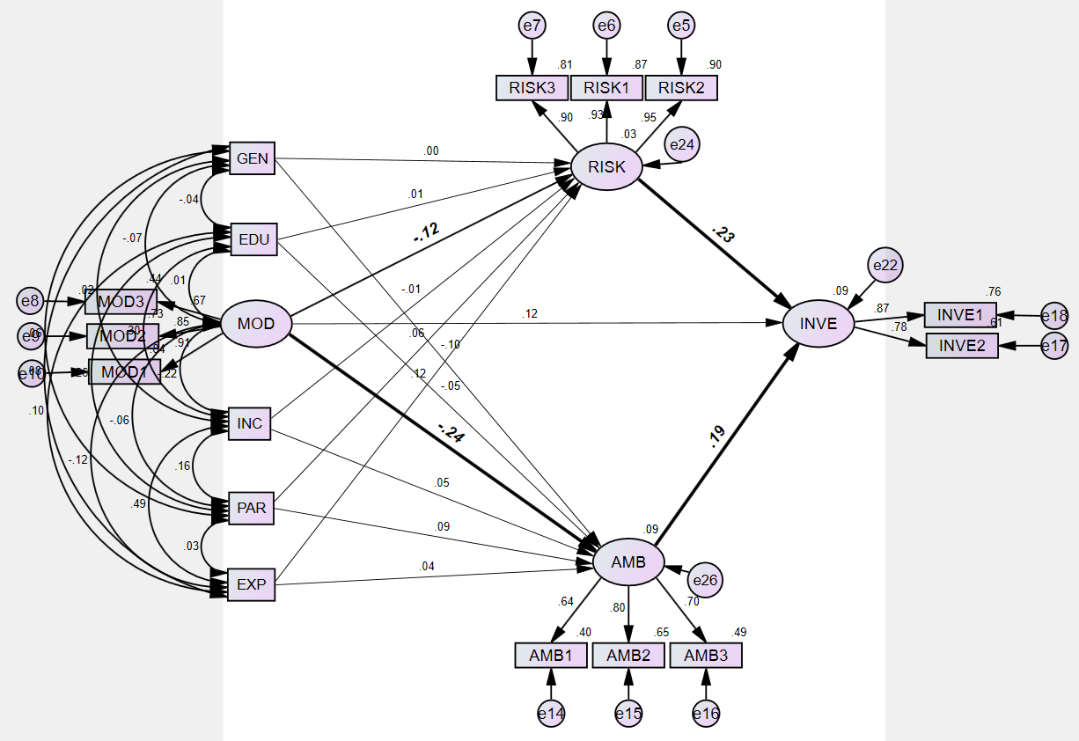
GEN: gender, EDU: education, MOD: positive mood, INC: income, PAR: participation in investment courses, EXP: work experience, RISK: risk aversion, AMB: ambiguity aversion, INVE: investment choice.
Like SEM1’s results, SEM2 found that when the five demographic variables included, the relationships between MOD and RISK, between MOD and AMB, between RISK and INVE and between AMB and INVE were still significant. Of five demographics, we found only EXP affected RISK at 0.116 (p<0.05). This model (SEM2) served to illustrate the performance of our first model (SEM1) when controlling for variables.
Table 8: Results of structural relationships of SEM2
 |  |  | Standardized coefficient | Unstandardized coefficient | Standard error | Critical value | P value
RISK | <--- | GEN | -0.002 | -0.004 | 0.099 | -0.04 | 0.968
RISK | <--- | EDU | 0.01 | 0.015 | 0.082 | 0.183 | 0.855
RISK | <--- | MOD | -0.117 | -0.173 | 0.082 | -2.096 | 0.036
RISK | <--- | INC | -0.014 | -0.014 | 0.063 | -0.221 | 0.825
AMB | <--- | INC | 0.052 | 0.023 | 0.03 | 0.758 | 0.449
AMB | <--- | PAR | 0.09 | 0.077 | 0.05 | 1.549 | 0.121
AMB | <--- | EXP | 0.04 | 0.025 | 0.04 | 0.63 | 0.529
AMB | <--- | GEN | -0.099 | -0.084 | 0.048 | -1.767 | 0.077
AMB | <--- | EDU | -0.045 | -0.03 | 0.039 | -0.756 | 0.449
RISK | <--- | PAR | 0.056 | 0.111 | 0.104 | 1.066 | 0.286
RISK | <--- | EXP | 0.116 | 0.168 | 0.084 | 1.988 | 0.047
AMB | <--- | MOD | -0.238 | -0.153 | 0.041 | -3.72 | 0.000
INVE | <--- | RISK | 0.234 | 0.144 | 0.037 | 3.857 | 0.000
INVE | <--- | AMB | 0.19 | 0.269 | 0.1 | 2.691 | 0.007
INVE | <--- | MOD | 0.116 | 0.106 | 0.057 | 1.865 | 0.062
RISK: risk aversion, GEN: gender, EDU: education, MOD: positive mood, EXP: work experience, INC: income, PAR: participation in investment courses, AMB: ambiguity aversion, INVE: investment choice.

V. Robustness checks

To ensure the results of this study with structural equation modelling are robust, we applied additional techniques such as multiple regression and weighted ordinary least squares (OLS) regression to retest the direct relationships between MOD and RISK, between MOD and AMB and between MOD RISK and AMB for both cases with and without demographics. The results are shown in Table 9 below. Both these techniques found the direct relationships in the model are significant (p<0.05), except the relationship between MOD and INVE. These consequences are the same as the SEM results.

Table 9: Additional tests of the direct relationships
No. | Structural relationship | Multiple regression equations | Weighted OLS regression equations
1 | MOD-> RISK | RISK = -.125MOD* | RISK = -.139MOD**
2 | MOD and (GEN, EDU, EXP, INC and PAR) -> RISK | RISK = -.112MOD* - .002GEN + .006EDU + .109EXP - .008INC + .06PAR. | RISK = -.137MOD* - .002GEN - .017EDU + .109EXP + .013INC + .063PAR.
3 | MOD -> AMB | AMB = -.224MOD*** | AMB = -.246MOD***
4 | MOD with (GEN, EDU, EXP, INC and PAR) -> AMB | AMB = -.210MOD*** - .094GEN - .051EDU + .017EXP + .065INC + .087PAR. | AMB = -.2360MOD*** - .103GEN* - .043EDU + .028EXP + .063INC + .105PAR*.
5 | MOD, RISK, AMB -> INVE | INVE = .058MOD + .205RISK*** + .132AMB** | INVE = .041MOD + .264RISK*** + .127AMB*
6 | MOD, RISK, AMB (GEN, EDU, EXP, INC and PAR) -> INVE | INVE = .073MOD + .193RISK*** + .133AMB** + .074GEN + .135EDU* + .005EXP + .036INC + .075PAR. | INVE = -.073MOD + .637RISK*** - .630AMB*** + .194GEN*** + .303EDU*** + .144EXP*** - .308INC*** - .073PAR**.
*: p<0.05,, **: p< 0.01, ***: p< 0.001; MOD: positive mood, RISK: risk aversion, AMB: ambiguity aversion, INVE: investment choice, GEN: gender, EDU: education, , EXP: work experience, INC: income, PAR: participation in investment courses.

We also based on software of mediation analysis by Hayes and Preacher (2010) to test mediating roles of risk aversion and ambiguity aversion in the impact of mood on investment choices. The first model includes INVE (named as Y), MOD (X) and RISK (M). The second model involves INVE (Y), MOD (X) and AMB (M). The significance levels (p<0.05) reported by the mediation analysis in Table 10 below indicate that RISK and AMB mediate significantly the relationship of mood and investment choices.

Table 10: Results of indirect effects of mood on investment choices through risk aversion and ambiguity aversion
Indirect effects | Value | SE | lowerCI | UpperCI | Z | p-value
1st model  (MOD, RISK and INVE) | -.0220 | .0101 | -.0418 | -.0022 | -2.1767 | .0295*
2nd model  (MOD, AMB and INVE) | -.0293 | .0110 | -.00508 | -.0077 | -2.6659 | .0077**

(MOD, RISK and INVE)
*: p<0.05,, **: p< 0.01, ***: p< 0.001; MOD: positive mood, RISK: risk aversion, AMB: ambiguity aversion, INVE: investment choice, GEN: gender, EDU: education, , EXP: work experience, INC: income, PAR: participation in investment courses.

VI. Discussions, implications, limitations and further research
6.1 Support for our hypotheses
A positive mood was found to have significant direct negative associations with risk aversion and ambiguity aversion. The hypotheses (H1-H2) were supported, in which a rise in positive mood results in a decrease in risk aversion and ambiguity aversion. These findings are consistent with prior scholars (Carton et al., 1992; Grable & Roszkowski, 2008; Mehra & Sah, 2002; Yuen & Lee, 2003). Additionally, the more the risk aversion and ambiguity aversion, the more the choice of safe investment (H3 and H5 were supported). These consequences are also in line with (Ellsberg, 1961; HuuTho et al., 2018; Kahneman & Tversky, 1979; Shimp & Bearden, 1982). Risk- and ambiguity-averse investors tend to choose safe investments. Advisors should take note of this when they consult their clients. Finally, the results also supported H4 and H6 - the significant mediating role of risk aversion and ambiguity aversion in the impact of a positive mood on investment choice. This consequence implies that investors who are in a good mood tend to have a decrease in their levels of risk and ambiguity aversion, and thus their investment choices are less safe.
6.2 Positive mood, risk aversion, and ambiguity aversion
As Table 11 below illustrates, it is surprising that only about 21% investors agreed or totally agreed that they felt cheerful, happy, or excited in general when investing in stocks. In addition, Table 7 above showed that AGE significantly negatively correlated with MOD, that is, the older investors are the less the positive mood. These findings alert not only investors, but also lay people to re-consider the impact of their mood on their investing. Advisors should consider advising older investors about the tendency to have a less optimistic view of investment safety to ensure they do not invest in an overly averse manner.
To test risk aversion, investors were asked to choose between two stocks. With stock A they had 95% chance to gain 10% over purchase price next month. They are sure to gain ……% (must be less than 10%) over the purchase price next month if they invest in stock B. 65% agreed or totally agreed to choose stock B if they were sure to gain between 0% and up to but not including 10% percent.
In testing ambiguity aversion, 59% agreed or totally agreed to choose stock C rather than stock D because stock C has more information than stock D, even though stock D has some stronger points than stock C, for example, cheaper prices, higher trading volume, and return. Table 11 also showed that the number of investors who neither disagreed nor agreed with the questions relating to risk aversion was about 25% and to ambiguity aversion was around 36%, and 10% investors are not likely to be risk averse while only about 6% of investors are not likely to be ambiguity averse. The findings imply that certainty and information are of much interest to investors. Further research should take note of these observations and include these finding in their designs, to provide further validation.
Table 11: The levels of positive mood, risk aversion and ambiguity aversion of individual investors (N=400)
The level of | Positive mood | Risk aversion | Ambiguity aversion
Totally disagree and disagree | 43.92% | 10.25% | 5.75%
Neither disagree nor agree | 35.17% | 24.63% | 35.56%
Totally agree or agree | 20.91% | 65.12% | 58.69%

Regarding demographics (gender, education, work experience, income, and participation in investment courses) acted as control variables. When these demographics variables are involved, the relationships between the factors are still strongly significant. Demographic factors did not affect the relationships between the main factors in a model, indicating that the main factors (positive mood, risk aversion, ambiguity aversion, and investment choices) are important factors in decision-making.
5.3 Limitations and further research
Although we used EFA, CFA, and SEM to test the reliability and validity of all items, and then investigated the structural relationships, it is also inevitably subject to some limitations. We focused only on the Vietnam stock markets, thus, it is necessary to expand this model and the scales of risk aversion and ambiguity aversion to overseas markets.
We found no significant direct relationship of a positive mood with investment choice, but we did find there is a significant relationship of mood and investment choice through risk aversion and ambiguity aversion. Further research should test the direct relationship. Perhaps, with different groups of investors or with a larger scale test. We also note we only investigated positive mood, further studies, therefore, should investigate both positive and negative mood to understand fully the role of mood on decision-making.

VI. Conclusions
We developed scales of risk aversion and ambiguity aversion and two models (SEM1 and SEM2): SEM1 included four main factors and SEM2 added five demographic variables along with these key factors. SEM2 aimed to test how strong the significant relationships found in SEM1 are when demographics included.
The reliability and validity of all items in the model were carefully tested through exploratory factor analysis (EFA) and confirmatory factor analysis (CFA). In EFA, the reliability of the scales was assessed via reliability coefficients - Cronbach’s alpha, then the correlations between the scales (items). The scales met requirements of validity through results of data suitability, communalities, total variance explained, scree plot, and factor loading analysis. In CFA, the scales were tested logically and systematically, reflecting a model fit. The model also achieved criteria of convergent and discriminant validity, standardized residuals and modification indices. SEM1 and SEM2 were also tested logically and systematically to meet criteria about a model fit and reported the relationships between the factors.
SEM1 found significant relationships between a positive mood with risk aversion and ambiguity aversion, and between risk aversion and ambiguity aversion with investment choice. SEM1 also uncovered the significant mediating roles of risk aversion and ambiguity aversion in the impact of positive mood on investment choice. SEM2 confirmed most relationships between factors in SEM1 are strongly significant even when controlled by demographic variables.
The robustness check is applied to this study. Results of the direct and indirect relationships tested by other techniques such as multiple regression and weighted OLS regression and mediation analysis by Hayes and Preacher (2010) matched with those of SEM models.
Acknowledgement
This research is funded by University of Economics Ho Chi Minh City, Vietnam. We thank the university’s support. Correspondence concerning this article should be addressed to Trang Phung. E-mail: trang.phungthaiminh@hoasen.edu.vn

References

Borghans, L., Heckman, J. J., Golsteyn, B. H., & Meijers, H. (2009). Gender differences in risk aversion and ambiguity aversion. Journal of the European Economic Association, 7(2-3), 649-658. doi:https://doi.org/10.1162/JEEA.2009.7.2-3.649
Capra, M. C. (2004). Mood-driven behavior in strategic interactions. American Economic Review, 94(2), 367-372. doi:10.1257/0002828041301885
Carton, S., Jouvent, R., Bungener, C., & Widlöcher, D. (1992). Sensation seeking and depressive mood. Personality and individual differences, 13(7), 843-849. doi:https://doi.org/10.1016/0191-8869(92)90059-X
Cavatorta, E., & Schröder, D. (2016). Measuring ambiguity preferences: A new ambiguity preference module. doi:http://dx.doi.org/10.2139/ssrn.2659596
Charness, G., & Gneezy, U. (2012). Strong evidence for gender differences in risk taking. Journal of Economic Behavior & Organization, 83(1), 50-58. doi:https://doi.org/10.1016/j.jebo.2011.06.007
Dhar, R., & Zhu, N. (2006). Up close and personal: Investor sophistication and the disposition effect. Management Science, 52(5), 726-740. doi:https://doi.org/10.1287/mnsc.1040.0473
Dimmock, S. G., Kouwenberg, R., Mitchell, O. S., & Peijnenburg, K. (2016). Ambiguity aversion and household portfolio choice puzzles: Empirical evidence. Journal of financial economics, 119(3), 559-577. doi:https://doi.org/10.1016/j.jfineco.2016.01.003
Dohmen, T., Falk, A., Huffman, D., Sunde, U., Schupp, J., & Wagner, G. G. (2011). Individual risk attitudes: Measurement, determinants, and behavioral consequences. Journal of the European Economic Association, 9(3), 522-550. doi:https://doi.org/10.1111/j.1542-4774.2011.01015.x
Ellsberg, D. (1961). Risk, ambiguity, and the Savage axioms. The quarterly journal of economics, 643-669. doi:10.2307/1884324
Feng, L., & Seasholes, M. S. (2005). Do investor sophistication and trading experience eliminate behavioral biases in financial markets? Review of Finance, 9(3), 305-351. doi:https://doi.org/10.1007/s10679-005-2262-0
Frijda, N. H., Scherer, K. R., & Sander, D. (2009). Emotion definitions (psychological perspectives). The Oxford companion to emotion and the affective sciences, 142-144.
Goetzmann, W. N., & Kumar, A. (2008). Equity portfolio diversification. Review of Finance, 12(3), 433-463. doi:https://doi.org/10.1093/rof/rfn005
Grable, J. E., & Lytton, R. H. (1999). Financial risk tolerance revisited: the development of a risk assessment instrument☆. Financial Services Review, 8(3), 163-181. doi:https://doi.org/10.1016/S1057-0810(99)00041-4
Grable, J. E., & Roszkowski, M. J. (2008). The influence of mood on the willingness to take financial risks. Journal of Risk Research, 11(7), 905-923.
Guiso, L., & Paiella, M. (2008). Risk aversion, wealth, and background risk. Journal of the European Economic Association, 6(6), 1109-1150. doi:https://doi.org/10.1162/JEEA.2008.6.6.1109
Hair, J., Black, W., Babin, B. J., & Anderson, R. (2014). Multivariate Data Analysis, 7th Edition: Harlow, UK: Pearson Education Limited.
Hallahan, T., Faff, R., & McKenzie, M. (2003). An exploratory investigation of the relation between risk tolerance scores and demographic characteristics. Journal of Multinational Financial Management, 13(4), 483-502. doi:https://doi.org/10.1016/S1042-444X(03)00022-7
Hallahan, T., Faff, R., & McKenzie, M. (2004). An empirical investigation of personal financial risk tolerance. Financial Services Review, 13(1), 57-78.
Hayes, A. F., & Preacher, K. J. (2010). Quantifying and testing indirect effects in simple mediation models when the constituent paths are nonlinear. Multivariate behavioral research, 45(4), 627-660.
Hong, C. S., Karni, E., & Safra, Z. (1987). Risk aversion in the theory of expected utility with rank dependent probabilities. Journal of economic theory, 42(2), 370-381. doi:https://doi.org/10.1016/0022-0531(87)90093-7
HuuTho, N., Trang, P. T. M., & Van Hoa, N. (2018). Avoidance of Risk, Ambiguity and Uncertainty in Investment Choices. Asian Journal of Scientific Research, 11, 522-531.
Johnson, E. J., & Tversky, A. (1983). Affect, generalization, and the perception of risk. Journal of Personality and social Psychology, 45(1), 20. doi:http://dx.doi.org/10.1037/0022-3514.45.1.20
Kahneman, D., & Tversky, A. (1979). Prospect theory: An analysis of decision under risk. Econometrica: Journal of the econometric society, 47(2), 263-291. doi:https://doi.org/10.1142/9789814417358_0006
Korniotis, G. M., & Kumar, A. (2011). Do older investors make better investment decisions? The Review of Economics and Statistics, 93(1), 244-265. doi:https://doi.org/10.1162/REST_a_00053
Lin, H. W. (2011). Elucidating the influence of demographics and psychological traits on investment biases. World Academy of Science, Engineering and Technology, 77, 145-150. doi:urn:dai:10.1999/1307-6892/13900
List, J. A. (2003). Does market experience eliminate market anomalies? The quarterly journal of economics, 118(1), 41-71. doi:https://doi.org/10.1162/00335530360535144
Lucey, B. M., & Dowling, M. (2005). The role of feelings in investor decision‐making. Journal of economic surveys, 19(2), 211-237. doi:10.1111/j.0950-0804.2005.00245.x
McLain, D. L. (1993). The MSTAT-I: A new measure of an individual's tolerance for ambiguity. Educational and psychological measurement, 53(1), 183-189. doi:https://doi.org/10.1177/0013164493053001020
Mehra, R., & Sah, R. (2002). Mood fluctuations, projection bias, and volatility of equity prices. Journal of Economic Dynamics and Control, 26(5), 869-887. doi:https://doi.org/10.1016/S0165-1889(01)00035-5
Montesano, A. (1990). On the definition of risk aversion. Theory and Decision, 29(1), 53-68. doi:https://doi.org/10.1007/BF00134104
Nygren, T. E., Isen, A. M., Taylor, P. J., & Dulin, J. (1996). The influence of positive affect on the decision rule in risk situations: Focus on outcome (and especially avoidance of loss) rather than probability. Organizational behavior and human decision processes, 66(1), 59-72.
Pasewark, W. R., & Riley, M. E. (2010). It’sa matter of principle: The role of personal values in investment decisions. Journal of Business Ethics, 93(2), 237-253. doi:10.1007/s10551-009-0218-6
Pompian, M. M. (2006). Behavioral finance and wealth management: How to build optimal portfolios for private clients: John Wiley & Sons, Inc.
Rau, H. A. (2014). The disposition effect and loss aversion: Do gender differences matter? Economics Letters, 123(1), 33-36. doi:https://doi.org/10.1016/j.econlet.2014.01.020
Rind, B. (1996). Effect of beliefs about weather conditions on tipping. Journal of applied social psychology, 26(2), 137-147. doi:10.1111/j.1559-1816.1996.tb01842.x
Roussanov, N., & Savor, P. (2014). Marriage and managers' attitudes to risk. Management Science, 60(10), 2496-2508. doi:https://doi.org/10.1287/mnsc.2014.1926
Saunders, E. M. (1993). Stock prices and Wall Street weather. The American economic review, 83(5), 1337-1345. doi:http://www.jstor.org/stable/2117565
Schubert, R., Brown, M., Gysler, M., & Brachinger, H. W. (1999). Financial decision-making: are women really more risk-averse? American Economic Review, 89(2), 381-385. doi:10.1257/aer.89.2.381
Schwarz, N. (2000). Emotion, cognition, and decision making. Cognition & Emotion, 14(4), 433-440. doi:https://doi.org/10.1080/026999300402745
Seiler, M., Seiler, V., Traub, S., & Harrison, D. (2008). Regret aversion and false reference points in residential real estate. Journal of Real Estate Research, 30(4), 461-474.
Shefrin, H. (2001). Do investors expect higher returns from safer stocks than from riskier stocks? The Journal of Psychology and Financial Markets, 2(4), 176-181. doi:https://doi.org/10.1207/S15327760JPFM0204_1
Shimp, T. A., & Bearden, W. O. (1982). Warranty and other extrinsic cue effects on consumers' risk perceptions. Journal of consumer research, 9(1), 38-46. doi:https://doi.org/10.1086/208894
Statman, M. (2005). Normal investors, then and now. Financial Analysts Journal, 61(2), 31-37. doi:https://doi.org/10.2469/faj.v61.n2.2713
Trang, P. T. M., Khuong, M. N., & Tho, N. H. (2016). The big five traits, moods, and investment decisions in emerging stock markets. International Journal of Business Research, 16(5), 99-108. doi:http://dx.doi.org/10.18374/IJBR-16-5.8
Watson, D., Clark, L. A., & Tellegen, A. (1988). Development and validation of brief measures of positive and negative affect: the PANAS scales. Journal of Personality and social Psychology, 54(6), 1063.
Weber, M., Weber, E. U., & Nosić, A. (2012). Who takes risks when and why: Determinants of changes in investor risk taking. Review of Finance, 17(3), 847-883. doi:https://doi.org/10.1093/rof/rfs024
Yuen, K. S., & Lee, T. M. (2003). Could mood state affect risk-taking decisions? Journal of affective disorders, 75(1), 11-18. doi:https://doi.org/10.1016/S0165-0327(02)00022-8

Appendix A

The scales for risk aversion: Thinking about investing in stocks (A and B)

(i) Stock A: You have 95% chance to gain x% (e.g. 10%) over purchase price next month.

(ii) Stock B: You have 100% chance to gain ……% (must be below x %) over purchase price next month. (Other factors relating to these two stocks are the same).

What percentage of gain (must be below x %) makes you decide to choose stock B for your portfolio?

I decide to invest in stock B if I am sure to gain: | Totally disagree (1) | Disagree (2) | Neither agree or disagree (3) | Agree (4) | Totally agree (5)
Between 10% and 7% | 1 | 2 | 3 | 4 | 5
Between 7% and 5% | 1 | 2 | 3 | 4 | 5
Between 5% and 3% | 1 | 2 | 3 | 4 | 5
Between 3% and 0% | 1 | 2 | 3 | 4 | 5

The scales for ambiguity aversion: Thinking about investing two stocks (C and D), both stocks you do not know their future outcomes. However, stock C has more information than stock D. Do you decide to choose stock C even though stock D had the following strong points? (Except the following different characteristics of these two stocks, others are the same.)

My choice between stock C and stock D: | Totally disagree (1) | Disagree (2) | Neither agree or disagree (3) | Agree (4) | Totally agree (5)
I choose stock C even though stock D’s price is cheaper. | 1 | 2 | 3 | 4 | 5
I choose stock C even though stock D’s trading volume is higher. | 1 | 2 | 3 | 4 | 5
I choose stock C even though stock D’s returns are higher. | 1 | 2 | 3 | 4 | 5
I choose stock C under any circumstances. | 1 | 2 | 3 | 4 | 5

Scales of positive mood: In general, to what extent do you feel cheerful, happy, or excited when investing in stocks?
In general, when investing in stocks | Totally disagree (1) | Disagree (2) | Neither agree or disagree (3) | Agree (4) | Totally agree (5)
I am cheerful. | 1 | 2 | 3 | 4 | 5
I am happy. | 1 | 2 | 3 | 4 | 5
I am excited. | 1 | 2 | 3 | 4 | 5

positive mood (Watson, Clark, & Tellegen, 1988)

Scales of investment choice: Thinking about your investment portfolio, what kinds of stocks do you choose for your portfolio?

In my investment portfolio, | Totally disagree (1) | Disagree (2) | Neither agree or disagree (3) | Agree (4) | Totally agree (5)
I choose stocks that have high degrees of safety. | 1 | 2 | 3 | 4 | 5
I choose stocks that have lower risk compared to the market in general. | 1 | 2 | 3 | 4 | 5
I choose stocks that have demonstrated high rates of earnings growth in the past 5–10 years. | 1 | 2 | 3 | 4 | 5

APPENDIX B
A summary of reliability and validity test of six factors in the model (N=400)
Items/factor | Scale Mean if Item Deleted | Scale Variance if Item Deleted | Corrected Item-Total Correlation | Cronbach's Alpha if Item Deleted
I/ Investment choice (INVE) |  |  |  | 0.809
INVE1 | 3.885 | .573 | .682
INVE2 | 3.842 | .494 | .682
II/ Risk aversion (RISK) |  |  |  | 0.947
RISK1 | 11.140 | 6.201 | .856 | .788
RISK2 | 11.158 | 6.158 | .864 | .784
RISK3 | 11.048 | 6.146 | .824 | .800
III/ Ambiguity aversion (AMB) |  |  |  | 0.752
AMB1 | 7.470 | 1.533 | .539 | .713
AMB2 | 7.395 | 1.367 | .640 | .598
AMB3 | 7.430 | 1.353 | .565 | .689
IV/ Positive mood (MOD) |  |  |  | 0.849
MOD1 | 5.285 | 3.232 | .782 | .731
MOD2 | 5.145 | 2.986 | .758 | .751
MOD3 | 5.425 | 3.623 | .625 | .874

Correlations between the items

Test of data suitability:
KMO and Bartlett's Test
Kaiser-Meyer-Olkin Measure of Sampling Adequacy. |  | .731
Bartlett's Test of Sphericity | Approx. Chi-Square | 2376.661
Bartlett's Test of Sphericity | df | 55
Bartlett's Test of Sphericity | Sig. | .000

Test of communalities
 | Initial | Extraction
INVE1 | 0.481 | 0.645
INVE2 | 0.482 | 0.723
RISK1 | 0.811 | 0.872
RISK2 | 0.823 | 0.901
RISK3 | 0.764 | 0.804
AMB1 | 0.315 | 0.413
AMB2 | 0.426 | 0.674
AMB3 | 0.382 | 0.480
MOD1 | 0.652 | 0.808
MOD2 | 0.630 | 0.751
MOD3 | 0.426 | 0.478
Extraction Method: Principal Axis Factoring.

Test of total variance explained

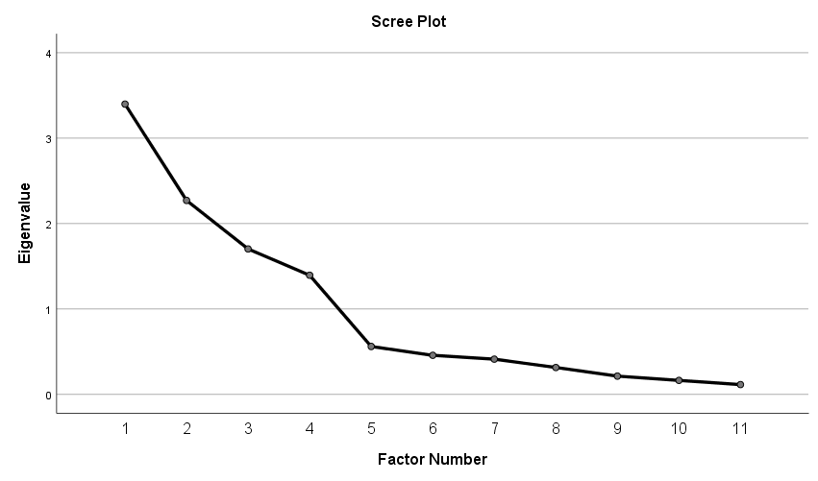

APPENDIX C
A summary of goodness-of-fit measures
 | CFA | SEM1 | SEM2 | Guideline by (Hair et al., 2014)
Chi-square (X²)
Chi-square | 60.278 | 73.354 | 148.973
Degree of freedom (df) | 38 | 39 | 1.568
Absolute Fit Measures
Goodness-of-fit index (GFI) | 0.973 | 0.967 | 0.961 | Above .90
Root mean square error of approximate (RMSEA);  90% confidence interval of RMSEA | 0.038 | 0.047 | 0.038 | below .07
Adjusted goodness-of-fit index (AGFI) | 0.953 | 0.944 | 0.929 | Above .90
Root mean square residual (RMR) | 0.032 | 0.049 | 0.032 | below .07
Standardized root mean residual (SRMR) | 0.041 | 0.066 | 0.048 | .08 or less
Normed chi-square | 1.586 | 1.881 | 1.568 | below 5
Incremental Fit Indices
Normed fit index (NFI) | 0.975 | 0.969 | 0.953 | Above .90
Tucker-Lewis index (TLI) | 0.986 | 0.979 | 0.971 | Above .90
Comparative fit index (CFI) | 0.991 | 0.985 | 0.982 | Above .90
Relative fit index (RFI) | 0.964 | 0.957 | 0.925 | Above .90
Parsimony Fit Indices
Parsimony- adjusted NFI (PNFI) | 0.674 | 0.687 | 0.592 | Above 0.5
Parsimony- adjusted CFI (PCFI) | 0.684 | 0.699 | 0.610 | Above 0.5

According to electronic newspaper (Cafef.vn): http://cafef.vn/bloomberg-chung-khoan-viet-nam-hot-nhat-chau-a-ke-tu-dau-nam-den-nay-20170906153111216.chn
According to electronic newspaper (ndh.vn): http://ndh.vn/von-hoa-thi-truong-chung-khoan-viet-nam-dat-hon-183-ty-usd-chiem-82-gdp-20180403012344674p4c146.news
According to baomoi.com: http://www.baomoi.com/nha-dau-tu-ca-nhan-chiem-den-99-tren-thi-truong-chung-khoan/c/18421199.epi
Convergent and discriminant validity test: Statwiki: http://statwiki.kolobkreations.com/index.php?title=Main_Page
βi = the correlation between a construct i with its other factors
According to Vietnamese population: https://countrymeters.info/en/Vietnam#age_structure
According to data of world bank: https://data.worldbank.org/indicator/NY.GDP.PCAP.CD?locations=VN
Where: RISK: risk aversion, MOD: positive mood, AMB: ambiguity aversion, INVE: investment choice

