Supplemental Fig. 1
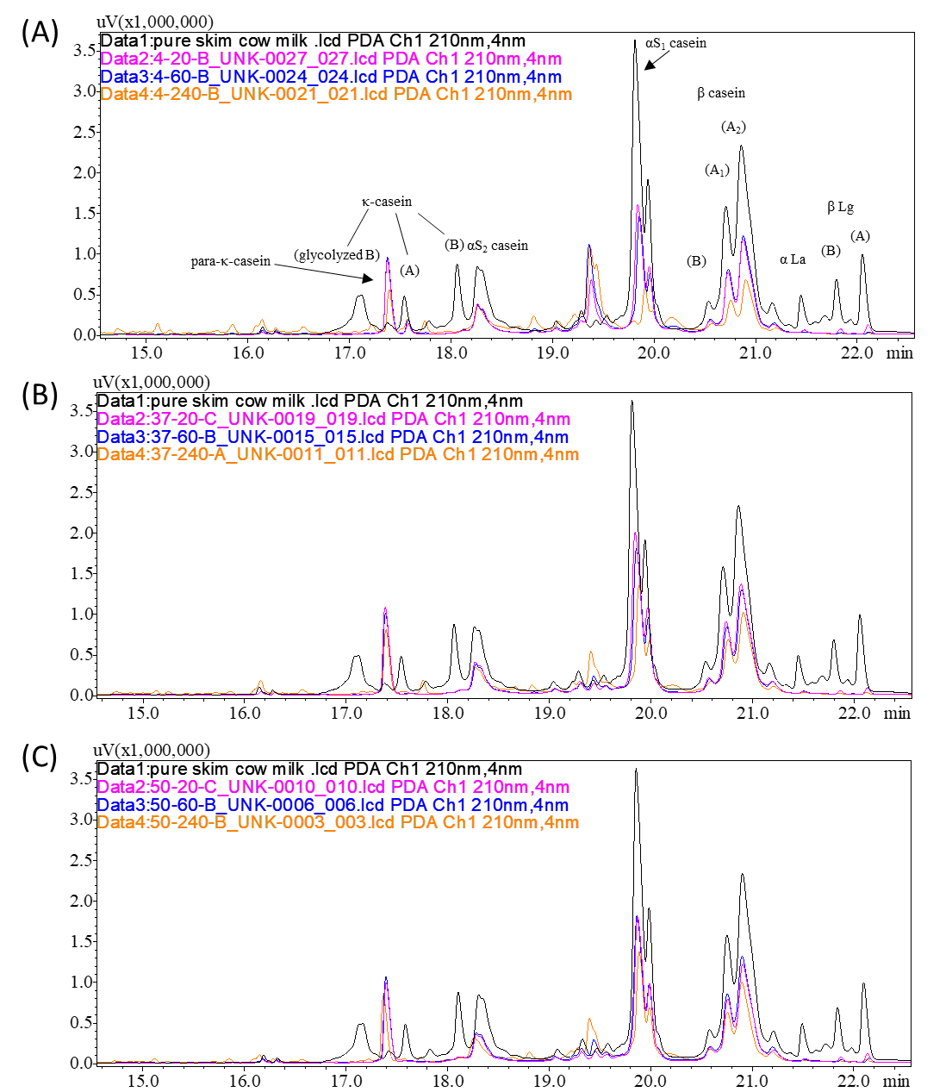
Supplemental Fig. 1 Overlay of UV chromatograms analyzing the protein profiles of skim milk (−) and the coagulum that formed after 20 min (−), 60 min (−), and 240 min (−) of digestion. All major milk proteins were identified: (A) cold milk; (B) control milk; (C) warm milk.
Supplemental Fig. 2
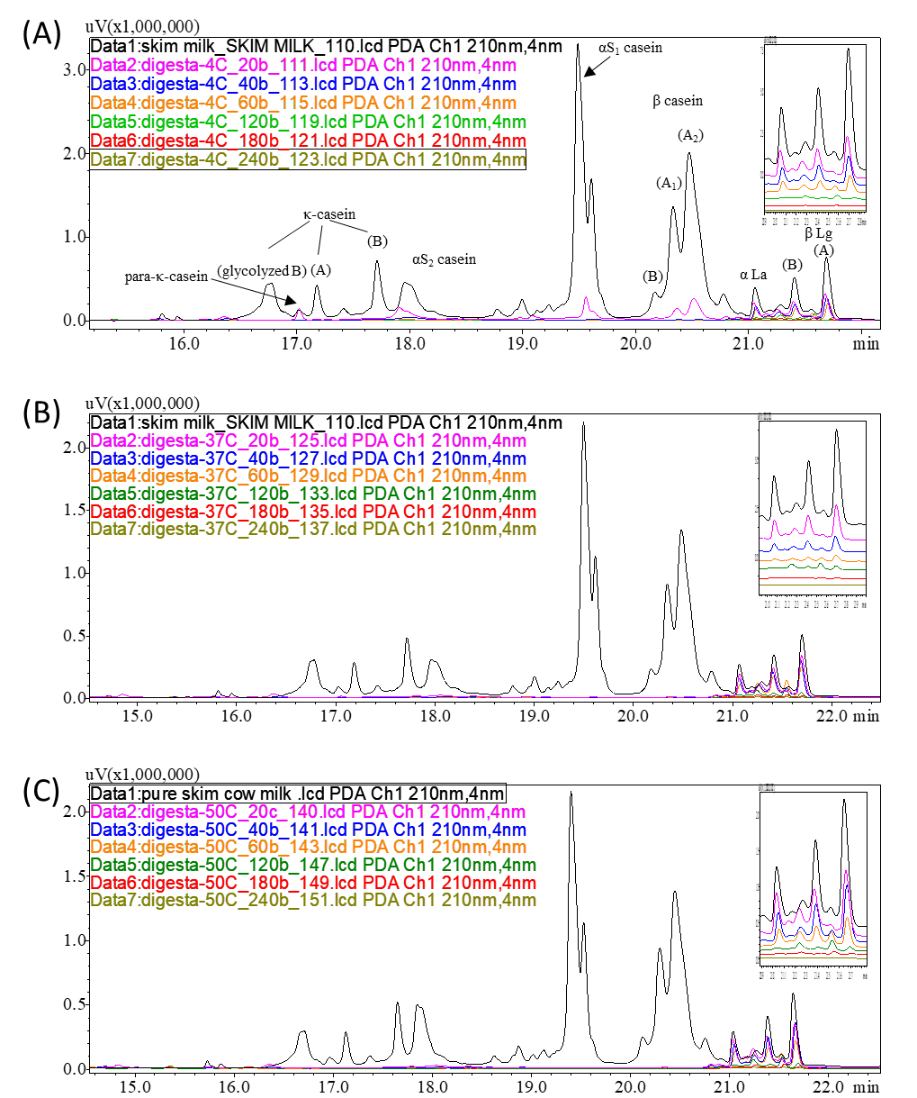
Supplemental Fig. 2 Overlay of UV chromatograms analyzing the protein profiles of skim milk (−) and the emptied digesta: 20 min (−), 40 min (−), 60 min (−), 120 min (−), 180 min (−), 240 min (−). All major milk proteins were identified: (A) 4 °C milk; (B) 37 °C milk; (C) 50 °C milk.

