December 2018
“I still look back fondly on my time at Massey and those who taught me. The skills I developed through the Bachelor of Communications set me up well for a great career. I believe it’s one of the best career choices for the creative and curious.”
Massey University Communication Graduates: An Overview 2006 to 2017

Authors:
Frank Sligo, School of Communication, Journalism & Marketing, Malcolm Rees, Student Survey and Evaluation Unit,
Judith Naylor, Student Survey and Evaluation Unit.
Massey University
Contents
EXECUTIVE SUMMARY 4
INTRODUCTION 6
AIM 7
RESULTS 7
1. What Motivated Students to Enrol in This Degree? 7
2. Enrolment Motivations by College of Major 8
3. In Which Industries Are BC Graduates Working? 10
4. What Do Graduates’ Job Titles Reveal About Their Work? 12
5. What Are Graduates’ Workplace Roles? 17
6. What is Graduates’ Employment Status? 19
7. Employment: Full-time, Part-time, Not Working 19
8. Where Are BC Graduates Located? 20
9. BC Graduates’ Salary Outcomes 21
10. Employment by Gender 23
11. How Long Do Graduates Remain in Their Roles? 23
12. What Did Graduates Learn From Their Degree? 25
13. What Skills or Other Attributes that Graduates Needed Did the BC Not Provide? 29
14. Would BC Graduates Study the Same Qualification Again? 34
15. How to Improve Transition into the Workforce? 34
16. Did Graduates Undertake Further Study After Completion? 36
REFERENCES 37
Acknowledgements 38
Appendix 1. Panel and Respondent Characteristics 39
Appendix 2. All BC Completions by Major 40
Appendix 3. BC Graduate Occupations 41
Appendix 4. The 60 Most-Used Terms in BC Graduates’ Job Titles 44
Appendix 5. Coding Framework Bachelor of Communication Skills Learned 45
Appendix 6. Skills, knowledge, qualities, and/ or characteristics not addressed in your degree. 46

Figure 1. Ranked Motivation to Undertake BC. 8
Figure 2. Enrolment Motivations by College of Major 8
Figure 3. Motivation to Undertake the Bachelor of Communication by Gender 9
Figure 4. Industries in which BC Graduates are Employed 10
Figure 5. Top 5 Industries in Which BC Graduates are Employed by Years After Completion. 11
Figure 6. Most-Used Specialist Area Words in Job Titles 15
Figure 7. Communication (Singular) and Communications (Plural) in Job Titles 16
Figure 8. Most-Used Workplace Role Words in Job Titles 17
Figure 9. Manager/Head: Job Title by Year of Completion 18
Figure 10. Journalist/Reporter: Job Title by Year of Completion 18
Figure 11. Employment Status for all Respondents 19
Figure 12. Employment Status by College of Major 20
Figure 13. Job Location by Year of Completion: Auckland, Wellington and Manawatū -Whanganui 20
Figure 14. Salary Range One Year or Less to Three Years, and Four+ Years After Completion 21
Figure 15. Salary Range by Year of Completion 22
Figure 16. Employment by Gender 23
Figure 17. Average Duration in a Job Position after Completion 24
Figure 18. BC Graduates as Possessing Skills That Benefit the Workplace or Community 25
Figure 19. Personal and Interpersonal Skill Development Coding Structure 26
Figure 20. Aspects of Communication Skills Development 28
Figure 21. Skills Development. Communication Industry Awareness 29
Figure 22. Skills Not Provided in the BC Degree 29
Figure 23. Skills Missing Curriculum-based Sub-theme 30
Figure 24. Skills Missing Personal Attributes 31
Figure 25. Frequency of Job Seek Support Comments 33
Figure 26. Would Graduates Study the Same Qualification Again? 34
Figure 27. What Could Massey University do to Improve Transition into the Workforce (by Primary Study Location)? 34
Figure 28. What could Massey University do to Improve Transition intothe Workforce (by Completion Year)? 35
Figure 29. Further Study After Completion 36
Figure 30. Qualification or Programme of Further Study After Completion 36

EXECUTIVE SUMMARY
Following the emergence of the first Bachelor of Communication (BC) graduates some 12 years ago, it became clear that good employment outcomes were available, but little has been known about what motivated graduates to enrol in the degree, what industries they were employed in, the nature of the work that they were doing, their job locations, salaries, or their tenure in positions. Similarly, we had little information on what skills graduates thought they had gained, skills they thought they lacked, career-related support they sought from the university, or their experience in further study. Accordingly, in 2018 we invited all BC graduates to respond to a survey on their employment and 398 (33%) did so.
In respect of motivation to enrol, we learned that Massey Business School (MBS) majors were more oriented to enhancing job prospects, while College of Humanities and Social Sciences (CoHSS) majors sought broader skills and capability development. In motivational factors by gender, males were attracted to the degree first to gain employment, then for the intrinsic interest in the subject matter, then broad skill-building. Females were more strongly attracted by the degree’s intrinsic interest to them, followed by its good employment outcomes, then enhanced job prospects.
We also learned that BC graduates are employed in a very diverse array of industries, though five industries account for up to three-quarters of their employment (Information, Media and Telecommunications; Professional, Scientific, Technical, Administrative and Support Services; Other Government Department; Education and Training; Arts, Recreation and Other Services). Some industry sector shift occurs as graduate experience increases.
Graduates’ job titles were very diverse: however, breaking down job titles into specialist area and workplace role, we found certain specialist terms recurring, especially communication(s), marketing, digital, content, media, account and service(s). By far the most prevalent of graduates’ workplace roles was manager, with advisor and coordinator also both strongly represented. Graduates may enter positions with manager in the title by about year three and after year five about a third of graduates are so designated.
We learned that graduates’ overall employment rate was 91% (84% full-time, 7% part-time). The full-time rate is much higher than usually found in other open-entry undergraduate degrees (often around 72% FT and 18% PT). Graduates’ consistent and stable pattern of full-time employment signals that over time demand for communication graduates has been exceeding supply. Predictably, new communication qualifications are currently emerging, such as at the University of Auckland (2017) and VUW and Canterbury University (2019).
The median salary for graduates in their first three years is $51K-$60K, while for four-plus years the median rises to $61K-$70K. No substantial salary differences emerged by gender. Salaries show a steady upward trajectory over the first seven years and, while this continues into years 8 and 9, some graduates then exit this trend, earning a lesser amount, which may indicate their entering part-time work for family reasons.
We learned that graduates are highly mobile across jobs, averaging just 1.5 years per position, though job tenure increases somewhat with years after completion. We report on research which suggests that movement across jobs, workplaces and industries may be associated with the building of personal and professional resilience and adaptability to change.
Eighty per cent of graduates were positive about how the BC equipped them for the workplace. When asked what the BC had taught them, most strongly represented were personal and interpersonal skills, followed by what we called aspects of communication, then communication industry awareness. In the report we comment on how graduates’ report on skills learned may assist the university to reflect further on the graduate attributes that it seeks to create, and we use leadership as an instance of this.
A little over half of respondents reported an absence of certain skills in their degree, though skills not learned (n=475) were fewer than skills learned (n=962). Skills not learned were especially pertaining to business and management, digital and other technology, social media, applied learning, and a collection of personal attributes and skills.
When asked if they would study the same degree again, 80% of MBS graduates were likely or extremely likely to do so, while CoHSS graduates reported a 69% likelihood. While both these outcomes are regarded as good, we observe that the fifth most popular industry for BC graduates is Arts and Recreation. We comment on how everyday realities in the “gig economy” of somewhat precarious arts-related work may encourage some to reflect on the nature of their previous degree study. Nevertheless, MBS and CoHSS graduates showed little difference in their full-time employment outcomes: both are equally employed.
When asked what Massey could do to assist transition into the workplace and when we assessed the responses both by campus/mode of prior study and by years after completion, graduates across campuses/study mode and across yearly cohorts were highly consistent in their belief that the university could do much more to provide internships, other forms of experiential learning, career advice and connections with industry and the community. They also noted the need for more emphasis on digital skills, but the overwhelming majority of comments comprised a call for the university to make a substantial turn towards students’ experiential learning and occupational relevance.
Last, graduates showed a strong commitment to undertaking further study, a rising engagement being evident in that over a quarter of them were engaged in further study by years 2-3, half by years 6-7, and 70% by years 8-12. However, the very strong employment outcomes immediately post-degree and the increasing interest in further study in the following years provide good information on when exactly the university should pitch masters-level study to these graduates.

INTRODUCTION
The Massey University Bachelor of Communication (BC) was launched in 2004 and the first three students graduated in 2006 after having earlier university study credited. Unlike in a number of other countries, communication degrees (at least at that point) were uncommon in New Zealand so it was unclear how well we matched international expectations of how a communication degree should function, such as in its employment outcomes. Accordingly, we sought international scrutiny of the degree via application for accreditation with ACEJMC, the US-based Accrediting Council for Education in Journalism and Mass Communications.

Our application process was unusually protracted since ours was the first three-year degree that ACEJMC had agreed to consider in its 100-plus year history. After a very detailed, multi-year assessment, in 2016 the degree became Asia-Pacific’s first and the world’s only three-year degree to achieve this accreditation, the other 111 programmes all comprising four years. An important element in the accreditation was the assessors’ confirmation that our graduates were well-regarded for their industry and community service.

Nevertheless, it was still unclear what kind of work our graduates were obtaining and if the curriculum we offer was still relevant to that employment. By 2017, the BC had become the university’s fifth largest undergraduate degree and the number of programme completions had risen to over 1200. While Massey’s annual graduate destination surveys were revealing that our BC degree employment rates were considered to be very good (around 84% in full-time employment and seven percent in part-time employment within six months of degree completion), little was known about what kind of work our graduates were engaged in.

Further, it was evident from anecdotal sources and online recruitment services (e.g., via the Seek (n.d.) website) that while there appeared to be substantial opportunities for and strong uptake of communication graduates, so far as could be discovered no work had been done in this country to explore systematically what work they were mainly undertaking.

Accordingly, it was decided to undertake a survey of all Massey University BC graduates 2006-2017. A group comprising colleagues in the three Massey schools involved in offering the degree (Communication, Journalism & Marketing, English & Media Studies, and Humanities) collaborated with personnel from the University’s Student Survey and Evaluation Unit, and a survey was sent in 2018 to the 1224 graduates using the contact email addresses currently available. The number of useable responses was 398, a 33% response rate.
As this was a census rather than a sample survey, the results contain no sampling error; nevertheless, with a response rate of 33%, there is inevitably the possibility of non-response bias. There was a slightly higher proportion of female respondents than in the original survey population and there were fewer Auckland-based respondents than in the population. However, these differences are small and are likely to have had little effect on survey estimates (see the respondent characteristics data at Appendix 1).

AIM
Our aim was to get deep insights into the industries in which our graduates were being hired and what kind of work they were doing. We wanted to explore the characteristics and conditions of graduates’ work and the nature of their organisational roles within what we understood to be almost certainly a fast-changing field of communication and related areas. Changes in the nature of communication work (broadly defined) in industries and in the community are anticipated to accelerate with a fast-increasing and more sophisticated employment of communications technology (Zammuto et al., 2007). We considered that this study could create baseline data against which future investigations of communication graduates’ work could be compared, plus identifying what changes might be made to the curriculum to address this ever-changing work environment.

RESULTS
Degree Completions by Major Overall

Completions from the BC degree have spanned 11 majors, seven of which are still currently offered (see Appendix 2). Completions increased gradually over the period 2006 – 2012 and then stabilised from that point until 2017 to approximately 150 per year. A slight decline was observed in 2017 down to n = 128 (the 2018 year was incomplete at the time of survey administration).

There has been speculation that lower BC enrolments in any given year result from relatively lesser promotional work that had recently taken place to publicise the degree. This is possible given that communication degrees are probably not yet well known in this country.
The survey population included all those who completed since 2006. The greatest representation, however, came from the period 2012 – 2017 period. The table at Appendix 2 shows the frequency of completions by major in descending order.

What Motivated Students to Enrol in This Degree?

Surveys of first year students entering the BC had been carried out most years since 2005. From them we had received consistent information that students were attracted to the BC especially for two reasons – an enthusiasm for the subject matter, and a belief that job outcomes post-degree were likely to be positive. However our understanding of why students enrolled was not much more developed than this, thus in the 2018 graduate survey we asked “What motivated you to undertake the Bachelor of Communication qualification?” This was followed by an expanded series of options that can be seen in Figure 1 below, which shows the proportion of respondents who ranked each motivation in first place.
Figure 1. Ranked Motivation to Undertake BC.
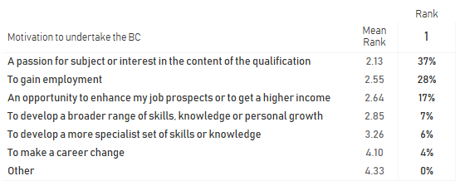
“A passion for subject…” is the top motivation, ranked number 1 by 37% of respondents, with “To gain employment” in second place also a strong motivator. “Enhance job prospects/ income” is also noteworthy in third place, while the other options of skills enhancements or career change appear much less often as primary motivators.

These results largely confirmed our earlier understanding about the dual attraction of intrinsic interest in the degree subject, coupled with good employment outcomes, but strengthened our understanding of students’ motivations. In particular, enhancing job prospects or income emerged as important for some.

We wanted to know if students attracted to the Massey Business School (MBS) majors (Communication Management, Journalism, Public Relations, and Marketing) showed any motivational differences from those who undertook the majors in the College of Humanities and Social Sciences (CoHSS) (Expressive Arts, Linguistics, and Media Studies). These results are shown in Figure 2.

Enrolment Motivations by College of Major

Figure 2. Enrolment Motivations by College of Major
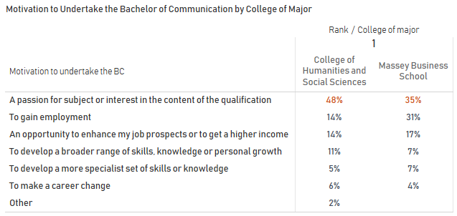
We found that enrolment motivations were similar across college majors in that “A passion for subject...” ranked as the first motivation in both colleges. However, for MBS graduates, gaining employment was much stronger than for CoHSS majors and enhancing job prospects was also somewhat stronger. Putting together gaining employment and enhancing job prospects accounted for 48% of primary motivators for enrolment by MBS majors while the figure for CoHSS majors was 28%. So while passion for subject is a powerful motivator across colleges, MBS majors appear more oriented to employment and job prospects.

A further difference appeared in that CoHSS graduates showed a greater inclination to broad development of skills, knowledge or personal growth, compared to MBS majors. Amalgamating passion for subject and broad capability development amounts to 59% of primary motivators for CoHSS students while the comparable figure for MBS majors is 42%.

Next, given that males typically constitute only around 20% of BC enrolments, we wanted to discover if motivation enrolment differed by gender (see Figure 3).

Figure 3. Motivation to Undertake the Bachelor of Communication by Gender
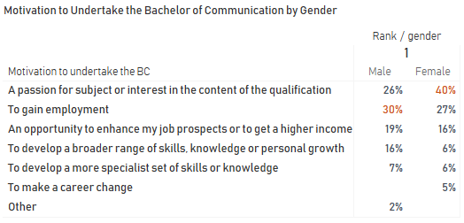

A clear difference appeared by gender with males more attracted to this qualification in the first instance to gain employment, followed by passion for the subject, then job prospects, then broad capability-building. Females show a stronger attraction to the degree on account of its intrinsic interest, followed by what they understand to be its good employment outcomes, followed by enhanced job prospects.

Promoting the degree to females might accordingly emphasise that the BC contains intrinsically interesting content, plus it has very good employment and job prospects/ income possibilities. A pitch to males might focus on excellent employment prospects, followed by the intrinsic interest factor, then the degree’s potential to build broad skills and knowledge.

In Which Industries Are BC Graduates Working?

We asked graduates what industry or industries they were presently working in, from a list provided; they could “select as many as apply” (see Figure 4). A small number of respondents identified more than one industry, and accordingly the total percentage below amounts to more than 100%.

Figure 4. Industries in which BC Graduates are Employed
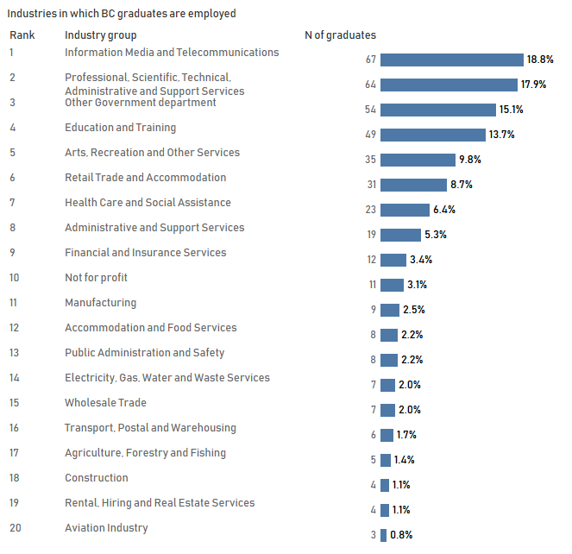
The Information, Media and Telecommunications field appears in first place, accounting for 19% of responses, but is closely followed by Professional, Scientific, Technical, Administrative and Support Services, then Other Government Department. In fourth place is Education and Training, followed by Arts and Recreation at around 10% of responses.

These first five industries account for a substantial proportion of the respondents, around three quarters of the sample. While BC graduates appear to have knowledge-work as a unifying factor, nevertheless they do not appear to be overly dependent on any particular industry. Their skills seem to be broadly relevant to the needs of diverse industries where opportunities exist for BC graduates to employ their skills.

Figure 5 next returns to the five top industries in which BC graduates are employed. It indicates employment for years after graduation (0-1 years, 2-3 years, 4-5 years, 6-7 years, and 8-9 years). This shows sector shift as graduate experience rises.

Figure 5. Top 5 Industries in Which BC Graduates are Employed by Years After Completion.
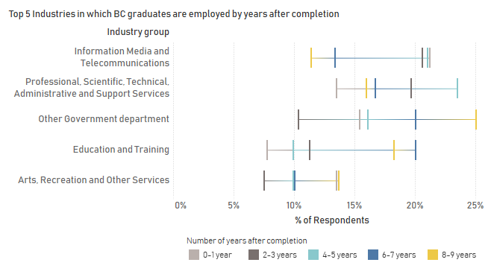
Some observations about each of the industries and their graduates are as follows:
Information, media and telecommunications: The predominant years of graduates are in this order: 0-1 year group, 4-5 year, 2-3 year, then at some distance, the 6-7 year group followed by the 8-9 year group. This suggests that this industry is more likely to attract recent graduates rather than those long-graduated, and if so the industry will be serving as an important training ground for graduates.

Indications are that this industry is less successful in retaining or does not seek to retain more experienced communication graduates.

Professional, scientific … services: Here the 4-5 year group is predominant, with the 2-3 year group in second place. This suggests that graduates enter this industrial group at an intermediate stage in their careers but may not expect to stay there long-term.

Other government department: This industry shows a different pattern, with the most visible group those having graduated 8-9 years after completion. Those at 6-7 years after completion are in second place. Further research would be needed to explore the kind of work that experienced BC graduates are undertaking in government service that calls for enhanced knowledge or capability.

Education and training: The longer-graduated, those at 6-7 years followed by 8-9 years, are the predominant BC graduates employed in this industry.

Arts, recreation: This industry has a mixture of long-graduated and recent graduates.

What Do Graduates’ Job Titles Reveal About Their Work?

Having obtained some insights into where graduates are to be found within multiple industries and their possible movement across industries, we sought to learn more about the nature of the work graduates do in their workplaces.

The survey asked graduates to provide their job title and 358 respondents did so. The range of titles showed extreme diversity, featuring 288 different job titles (see Appendix 3).

Clearly, this multiplicity of titles needed detailed analysis, but our initial approach was to discover how jobs were categorised by official government sites. We aimed to determine whether standard forms of government classification would permit insights into the shape or dimensions of communication work.

A government department, Ministry of Business, Innovation and Employment (MBIE), maintains an advisory website called Occupation Outlook (2018) that classifies jobs into six categories (Construction & Infrastructure, Creative Industries, Manufacturing & Technology, Primary Industries, Service Industries, and Social & Community). Within the Social & Community grouping the most relevant entry for a communication degree seemed to be Journalists & Public Relations Professionals.

The description of these jobs on the Occupation Outlook (Journalists & Public Relations Professionals) site confines itself to these two occupational groups, though a signal is given about a connection to marketing work with the statement that “According to the latest information from the New Zealand and Australian online job ads, some of the top skills employers look for include marketing and communication skills” (Occupation Outlook (Journalists & Public Relations Professionals), 2018, par. 5).

The MBIE site further notes that “According to a 2016 Public Relations Institute of New Zealand (PRINZ) survey, about three out of four public relations professionals hold a tertiary degree” (Occupation Outlook (Journalists & Public Relations Professionals), 2018, par. 9).

Looking next at the MBIE site for Marketing and Advertising Professionals, the basic qualification indicated there for this kind of role is a commerce degree, though “Related qualifications are also accepted, such as communications, media studies or psychology” (Occupation Outlook (Marketing & Advertising Professionals), 2018, par. 5).

Before we did more to analyse job titles, we looked at the standard overview of job titles in New Zealand, as recorded by ANZSCO, the Australian and New Zealand Standard Classification of Occupations:

ANZSCO Australian and New Zealand Standard Classification of Occupations
- Managers  - Professionals  - Technicians and trades workers  - Community and personal service workers | - Clerical and administrative workers  - Sales workers  - Machinery operators and drivers  - Labourers.
This, however, did not seem very useful since what had emerged as a broad array of job titles for BC graduates meant they could be located within several of these eight categories, in particular, the first six categories, with some categories more likely than others. Preliminary assessment of the graduates’ job titles indicated that a few graduates may have been in category #3 (such as with “technical” in their job title) while a larger number possibly were in category #4, such as those with “community” or “engagement” in their job title. However, on inspection of categories 1, 2, 5 and 6, these appeared likely to us to hold a substantial proportion of the graduates as we began to assess the job titles.

ANZSCO assigns journalists and public relations professionals to its three codes of 2122 – Authors, and Book and Script Editors, 2124 – Journalists and Other Writers, and 2253 – Public Relations Professionals.

Given what we were starting to recognise as a wide spread of BC graduates across several categories, the ANZSCO standard classification with its rather reductionist approach to description of jobs did not seem to take us very far in our attempting to understand the fields in which BC graduates worked.

Studying the job titles showed that commonalities appeared, so we employed a concordance study (Greenhill & Fletcher, 2009) of the words graduates had used to describe their job titles in order to list them in sequential order. This resulted in a ranking of all words that appeared three or more times (see Appendix 4, The 60 Most-Used Terms in BC Graduates’ Job Titles).

From this we then saw that the job titles could be broken down in two ways: first, by identifying the specialist area in which a person appeared to be working and then designating the workplace role that they appeared to have. We knew that these distinctions would not be hard and fast, but thought that a differentiation of this nature might give some insights into both the nature of the work that graduates are doing and the character of the roles they are occupying.

For example, instances of what we saw as specialist areas and workplace roles are shown below, so that jobs such as Marketing Coordinator or Communication Manager and others as below could be viewed as follows:

Specialist Area and Workplace Role
Specialist Area | Workplace Role
Marketing | Coordinator
Communication | Manager
Media | Advisor
Community | Coordinator
Recruitment | Consultant
Campaign | Manager
Marketing | Executive
Engagement | Specialist
Digital content | Producer
MSD | Officer

We also found that some job titles will occur exclusively either in a specialist area or in a workplace role:

Specialist Area | Workplace Role
 | Executive assistant
Journalist
 | Business coordinator
 | Part owner/ Admin
Quality assurance

In some instances it could be debated as to whether a given term fits better in the specialist area listing or among the collection of workplace roles. A case in point could be “project” which on balance we decided to include as a specialist area rather than as a workplace role. Looking at the words that designate specialist areas, we found the following:

Figure 6. Most-Used Specialist Area Words in Job Titles

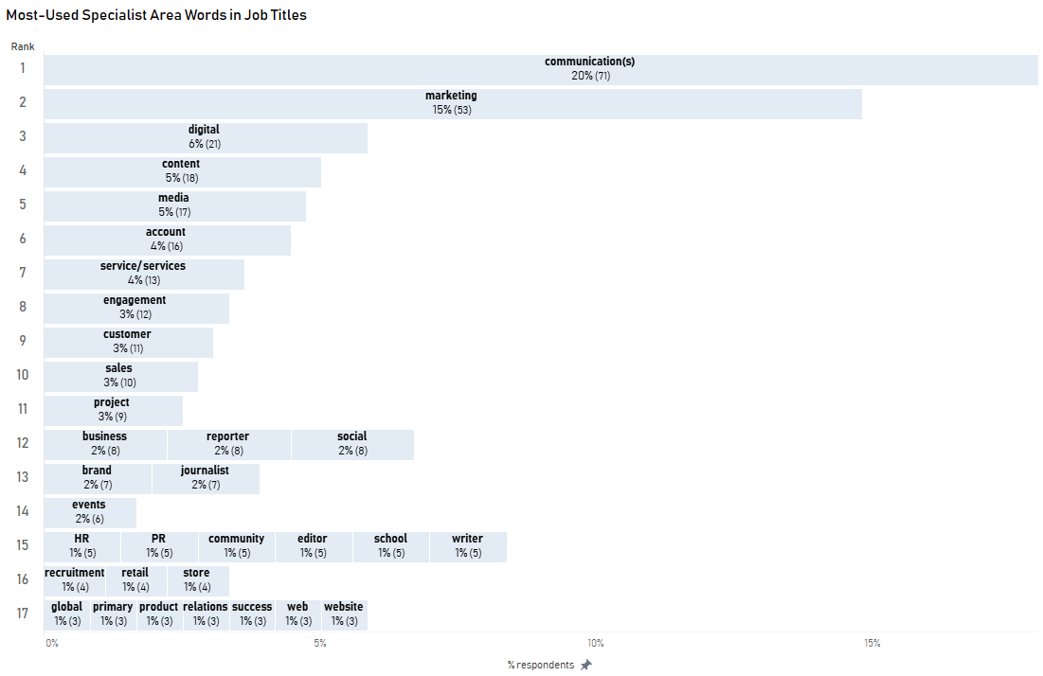
Each term in Figure 6 occurred three or more times in the job titles. Note, however, that many job titles include two or more of these words, e.g., “Media & Content Specialist” or “Communications & Marketing Advisor”, so in these instances the specialist area will be counted more than once in the figure.

Some may have the assumption that communication graduates are headed more to media work than to any other area, but the emphasis among these graduate job titles is clearly on communication (of course a broad term probably meaning different things in different organisations and industries) and on marketing. These two terms together comprise about half of the listing in Figure 6. Digital, content, media, account, service(s), engagement, customer and sales account for the remaining more widely-used terms.

Closer insights into the nature of these graduates’ work could be obtained by aggregating some of the terms, so, for example, while neither reporter nor journalist features strongly in the listing of job terms, if these two terms were aggregated, together they would rank seventh in the specialist word list.

It is possible that further analysis of job titles along these lines, assessing combinations of words often associated, would reveal more insights into the particular character of graduates’ work.
It is interesting to note how PR appears only near the end of the listing in 15th equal place, along with community, editor, HR, school, and writer. It seems evident that the job market is avoiding use of the term public relations. While it is almost certainly the case that many BC graduates with jobs employing the term communication(s) (and possibly marketing) will be “doing” PR, they are not calling it by that name.

This suggests an interesting line of research into why a term that has been a standard one in industry at least since the 1920s (along with many earlier instances of public relations work (Cutlip, 1994)) apparently now is being shunned. If it is true that “PR has a PR problem” (O’Brien, 2005, par. 6), then depending on outcomes of possible research into this topic, do any implications exist for qualifications such as communication degrees’ PR majors or their constituent courses?

Communication or Communications

For the sake of this job title analysis, we have aggregated the words communication and communications, but it is noteworthy that the singular form hardly appears in job titles (see Figure 7).

Figure 7. Communication (Singular) and Communications (Plural) in Job Titles
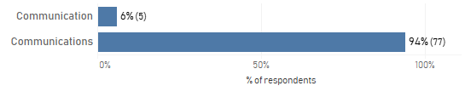
Massey University, along with the great majority of other universities offering a communication degree, uses the singular form of the noun rather than the plural for the name of its degree and many courses within it. The plural generally refers to telecommunications, along with radio, television, and film, plus engineering and computer networks, often with a somewhat technical orientation. Hence the plural is regarded as having a relatively restricted focus, compared to communication singular.

Studies in communication (singular) are held to potentially include all forms of human communication, employing a basis of theory that sustains an examination of processes and practices in many varying contexts of human interaction, including intrapersonal, interpersonal, group, organisational, public and electronically mediated communication.

This distinction is stressed throughout a student’s degree, and hence it is interesting to note how industry terminology as expressed in job titles has so decisively parted company with the differentiation held as normal in the academy.

What Are Graduates’ Workplace Roles?

Looking next at workplace roles, Figure 8 shows the most frequent occurrences of what we had designated as work roles.

Figure 8. Most-Used Workplace Role Words in Job Titles
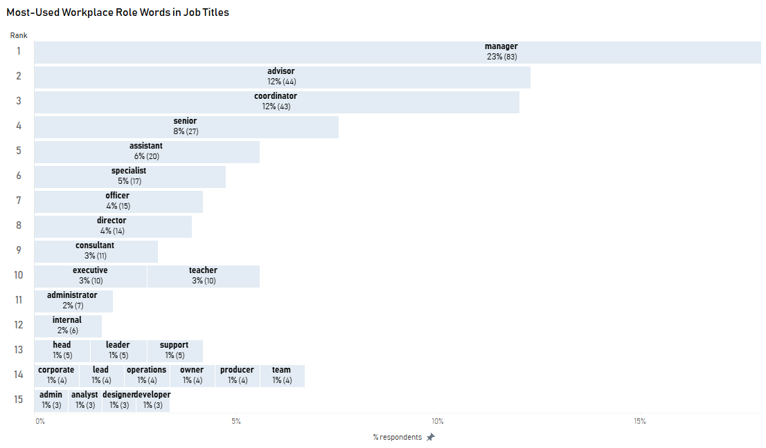
Together, the first three items, manager, advisor, and coordinator, account for something approaching half of the workplace roles. In fourth place is the term ‘senior’, which is not seen as a role as such and perhaps can be taken as designating a level of work rather than a role. However, it seemed a better fit here than in the category of specialist areas. Further down the figure in tenth equal place is the term ‘teacher’, which is included here as it is also considered to be more like a role than a specialism. If we were to delve further into this term, then particular specialisations associated with the teacher role might be discerned, such as the nature of what is taught or the level at which it is taught.

Collectively, these terms provide some indication of organisational level and the nature of the workplace activity occurring.

Given the importance of the term ‘manager’ in the workplace roles, we wanted to get some sense as to when a person’s work might be characterised as managerial, so we combined ‘manager’ and ‘head’ to track the emergence of these terms over time.

Figure 9. Manager/Head: Job Title by Year of Completion
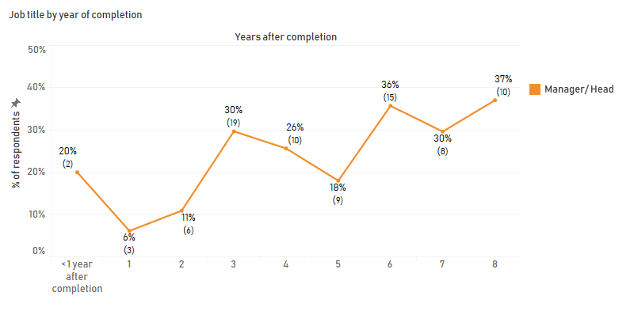
Jobs including the word ‘manager’ or ‘head’ first appear in any substantial sense in year three after degree completion, and thereafter around 30% of the sample on average have a position with that in the title, or more than a third of respondents following year five. The term ‘manager’ might or might not include supervision of staff, but a job with that designation may reflect some more advanced organisational responsibilities and standing than other common role terms such as advisor, coordinator or assistant (see Figure 9).

Another topic of past discussion among colleagues had to do with reporter/journalist. Anecdotal commentary had indicated that individuals did not stay in their first news media roles very long, but we wondered if there was any support for this perspective (see Figure 10).

Figure 10. Journalist/Reporter: Job Title by Year of Completion
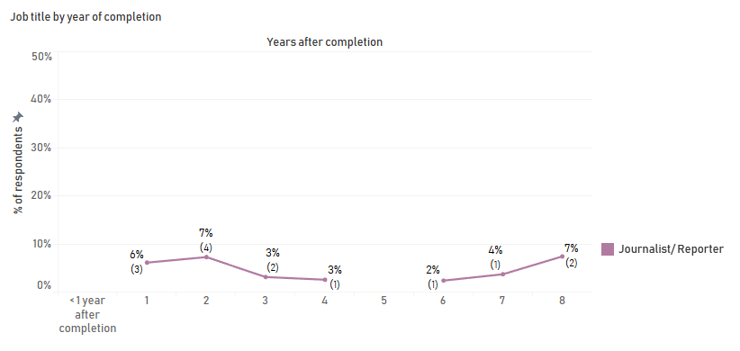
Employment in the role of journalist/reporter does not vanish a few years after graduation, but nor are there any indications that this role is an especially enduring one for BC graduates. Around 19% of BC graduates overall have completed the journalism major but the employment outcomes for these majors are currently unclear and warrant further research.

What is Graduates’ Employment Status?

The overall reported employment rate for respondents was 91%, made up of 84% in full-time employment and 7% in part-time employment (see Figure 11). This full-time employment rate is much higher than for other degrees where typically up to three-quarters of graduates are employed six months after degree completion. Given this level of full-time employment for BC graduates, it is not surprisingly that there is a correspondingly lower part-time employment rate compared with the 17% seen elsewhere.

Employment: Full-time, Part-time, Not Working

The unemployment rate of 2% (not working and looking for work) is considered relatively very low and accounts for only one or two respondents each year across this entire sample. More respondents (4%) reported not being employed and not seeking further work than those not in work and seeking further work. Those in the 4% group presumably include graduates at home with family responsibilities or those travelling.

Figure 11. Employment Status for all Respondents
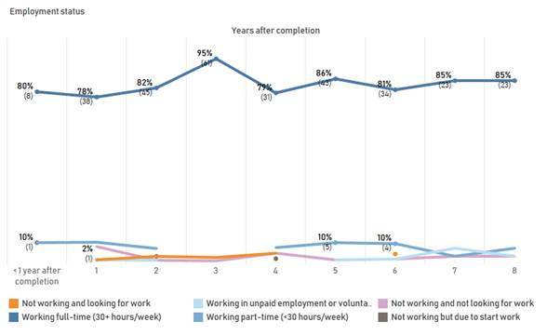
Figure 11 shows a very consistent and stable pattern of full-time employment of approximately 84% since this programme began. There was a modest increase in year three towards full-time work, however, no part-time employment at all was reported for that year. Graduate respondent numbers were too small to report beyond year eight post-degree completion.

Disaggregation by college showed that graduates majoring from the two colleges offering the degree showed minimal difference in their full-time employment outcomes (see Figure 12).

Figure 12. Employment Status by College of Major
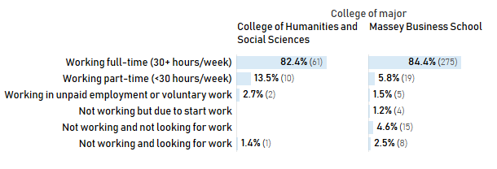

The degree’s strong full-time employment status indicates that demand for communication graduates has consistently been exceeding supply. Predictably, therefore, at the time of writing new communication programmes are emerging. These include the communication major in the University of Auckland BA (2017) and new bachelor of communication degrees being launched at the University of Canterbury and the Victoria University of Wellington (2019).

Where Are BC Graduates Located?

Eighty-three percent of respondents reported that they were based in New Zealand; the three top geographical areas were Wellington region (42%), then the Auckland region (29%), followed by Manawatū-Whanganui (15%) (see Figure 13). However, these percentages are not definitive, since New Zealand-based respondents could select more than one area in which they work. Hence the results should be taken as indicating general trends rather than serving as a precise indication of work location.

Figure 13. Job Location by Year of Completion: Auckland, Wellington and Manawatū -Whanganui
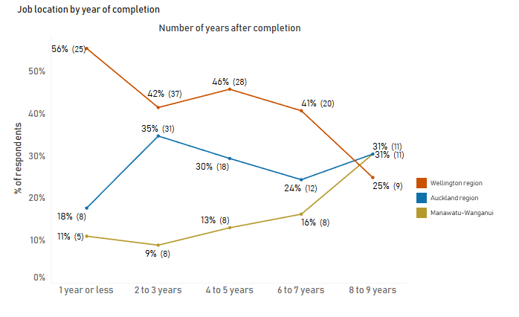
It is interesting to note that the three locations start off separated but then converge over time. There appears to be something of a trend for Auckland to become a more important destination for both Wellington and Manawatū-Whanganui graduates, though this observation has to be treated with some caution given the small numbers involved. Nevertheless, a possible trend towards graduates’ convergence on Auckland should be noted for future research. If there is any substance to this view, then we could regard Wellington as a strong training ground for young graduates, where they can build their experience base, but it may not necessarily be their place of long-term residence.

BC Graduates’ Salary Outcomes

We had had little information on graduates’ salaries so to provide an initial overview we first looked at salaries at years one to three, followed by four years plus (see Figure 14).

Figure 14. Salary Range One Year or Less to Three Years, and Four+ Years After Completion
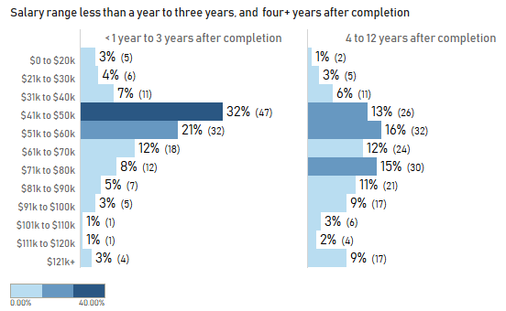
The median salary for graduates in their first three years after degree completion is in the $51K – $60K band. Around half of these graduates can expect to be earning $41K to $60K, with a further 20% in the $61K to $80K band. About 14% are earning less than $40K.

For graduates of 4+ years the median salary range rises to $61K-$70K. Around 14% earn over $100K.
Next, to provide some more detailed insights into salary by year of completion, we looked at the graduates’ salary by one year or less, 2-3 years, 4-5 years, 6-7 years, then 8-9 years after completion (see Figure 15).

Figure 15. Salary Range by Year of Completion
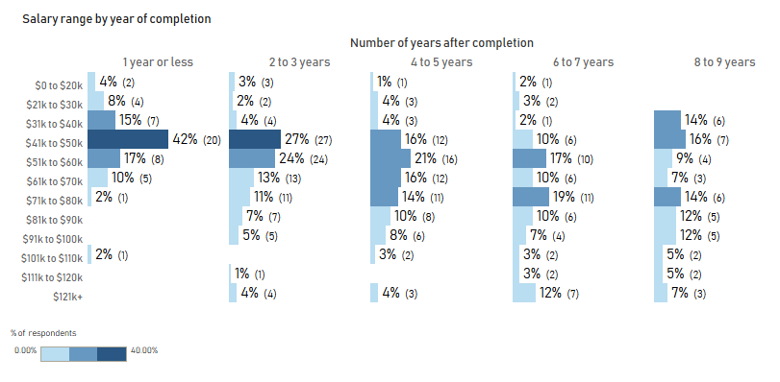
Figure 15 indicates a steady upward income trajectory over the first seven years following completion. This movement continues into the 8/9 year, but a proportion of graduates appears as having exited this trend and as earning a lesser amount. We infer that this may reflect some graduates, about 80% of whom are women, entering part-time work for family reasons.
There may also be some effect on years 4-5 given that there are more females in part-time employment over that period.

Employment by Gender

We wanted to explore employment by gender but also sought to take into account different kinds of workforce engagement such as full-time, part-time, and the other options as shown in Figure 16 below.
Figure 16. Employment by Gender
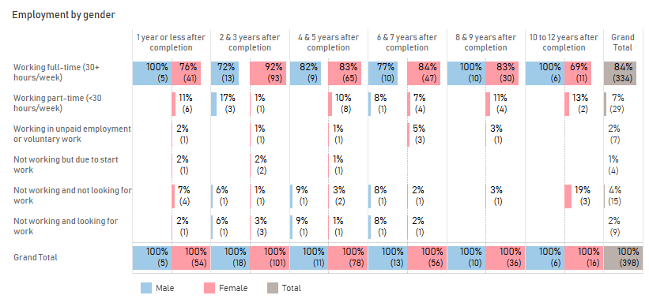

Very few respondents were working part-time or not working and a much smaller proportion again are males. Across the whole sample, just four individuals were not working but were due to start work, while only seven respondents reported they were engaged in unpaid employment or voluntary work. Nine respondents were not working and looking for work, while 15 (12 women and 3 men) were not working and not looking for work, this latter group possibly having family responsibilities. The part-time cohort amounts to 29 individuals, 25 women and four men, while those working full-time total 334, 281 women and 53 men. No substantially different employment outcomes by gender seem apparent from Figure 16 across these graduate years.

Clearly, the Massey BC has proven much more attractive to women than to men. The reasons for this deserve further investigation and differing motivations by gender to enrol have been discussed in this report in section 2 (above).

How Long Do Graduates Remain in Their Roles?

We had anecdotal information that our graduates were moving quickly between roles, but no empirical data on the possible extent of such mobility. We asked, “How many job positions have you held since you completed your BC qualification?” (See Figure 17).

Figure 17. Average Duration in a Job Position after Completion
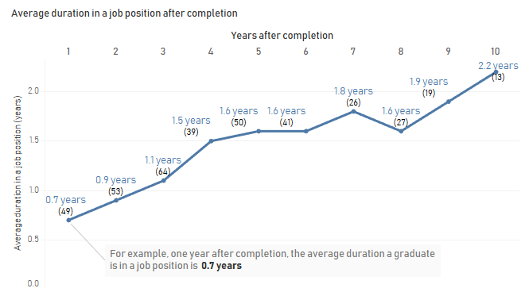
Figure 17 shows a gradual extension of tenure over time from about year 4, but still the overwhelming impression is of fast movement between roles. Note that the survey question asked graduates about movement between job positions. Previous evidence discussed in this report (Figure 5) also suggested frequent mobility between industrial groups. This evidence supports the view that BC graduates are highly mobile across organisations and, in many instances, there is a rapid transition into management-related positions.

Further research into this issue is desirable in several respects. One question might be whether push factors or pull factors, or both, are operating here. In respect of push, are graduates mainly employed on short-term contracts that require them to keep mobile? Or are there pull factors such as attractive alternative opportunities that encourage rapid movement between jobs? The salary progression that seems to occur in successive years post-degree would add support to the second possibility.

Then, considering the wide range of industries in which BC graduates are employed, does graduate movement across industries suggest they are building personal flexibility and operational capability in disparate workplace contexts? Some have argued that resilience is associated with successful adaptation to changing environmental circumstances (e.g., Quinlan et al., 2016). If graduates become more resilient and responsive to different opportunities via their engagement in successive workplaces and industries, then both personal and professional capability-building under conditions of change could be seen as future-proofing capabilities conferred by the degree and the sequential forms of employment that build on it.

What Did Graduates Learn From Their Degree?

We next sought to obtain insights into what graduates understood to be the skills and attributes they thought they had gained from their degree, including the ability of degree holders to make a contribution in their work settings or the community more broadly.

Skills Learned in the Degree: Qualitative Comments
This section of the report summarises the findings from the two qualitative questions in the survey relating to skills learned and content missing from the current curriculum. The skills learned question was presented in two parts: “Do you believe graduates from the Bachelor of Communication have special skills, knowledge, characteristics or qualities which add value in the workplace and/ or in the community?” (Yes/ No/ Don’t know). If the response to this question was “Yes”, the respondents were able to list up to four examples (see Figure 18).

Figure 18. BC Graduates as Possessing Skills That Benefit the Workplace or Community
 | Number of respondents | % respondents
Yes | 318 | 80%
No | 25 | 6%
Don't know | 47 | 12%
Blank | 8 | 2%
Grand Total | 398 | 100%
Eighty per cent of respondents were positive about the way in which BC graduates are equipped to add value in the workplace or beyond, with 6% disagreeing. Overall, this suggests a good level of concurrence among graduates that their degree is well-oriented to produce practical outcomes.

What Examples Did Graduates Provide of Skills Learned?

Of the 398 respondents, 277 provided one or more comments about skills learned; the majority provided four (the maximum permitted) responses. In many instances, this consisted of one-word or one-sentence responses, which were each coded, using NVivo, into themes. In some instances, a sentence could be coded into more than one theme so each respondent could be coded to just one theme or many themes, depending on the detail of their responses. This analysis resulted in 962 coded comments. The overall coding framework is included at Appendix 5.

Personal and Interpersonal Skill Development

A theme called Personal and Interpersonal Skill Development was the largest by frequency coded (n = 433 comments), or just under half (45%) of all the coded content about skills development. A smaller number (n = 353 or 36%) related to Aspects of Communication, and a small group again (n = 176 or 18%) commented about Communication Industry Awareness (see Figure 19). These three high level themes are discussed in more detail below.

Self-management was the most frequently cited skills development sub-theme followed by Enterprise and then Leadership.

Figure 19. Personal and Interpersonal Skill Development Coding Structure
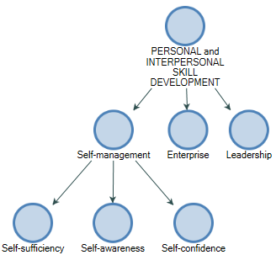

Self-management
215 comments (22% of all coded comments) related to various aspects of self-management. Respondents frequently mentioned self-sufficiency, e.g., the individual application of skills such as teamwork, time management, planning, motivation and relationship building, self-awareness through being flexible and adaptable, and to a lesser extent the development of self-confidence.

Enterprise
Enterprise, the second sub-theme within interpersonal skills development, accounted for 17% of all the skills development comments (n = 161), referring to thinking skills such as strategy development or critical thinking, research skills such as analytic skills or creativity. Finally, examples of industry-based technical skills included statistics, proofing, risk management and design skills.

Leadership
The least-frequent comments related to leadership, with only 6% or n = 57 responses relating to the various elements of leadership, e.g., cultural awareness, leadership and management, professionalism or people skills.

Among the graduate attributes that universities seek to create in their degrees, typically leadership is cited as one of the most important. In this context, it is worth noting that among the present survey responses leadership is one of the least-reported attributes learned.

Nevertheless, since leadership necessarily involves other people (leaders do not exist without followers) leadership can be seen as a more complex and multidimensional construct (Oc, 2018) than the personal and interpersonal capabilities graduates describe, such as self-sufficiency or critical thinking. Hence, leadership is a more complicated capability for graduates to describe as they reflect on what they learned from a degree.

If leadership as a relatively complex construct comprises a collection of sub-elements, then it may be appropriate for the university to define exactly what leadership attributes are important and then set about focusing specifically on those that may be achievable within a programme like the BC.
Moreover, if leadership is context-dependent, then graduates from varying degrees in the university who enter disparate workplace or community environments might be exposed to quite different expectations as to the kind of leadership that different sectors need.

For example, Uhl-Bien, Marion and McKelvey (2007) have argued that older leadership models deriving from traditional industries often appear ill-equipped to match the kind of leadership required for environments that mainly feature knowledge-oriented work. If situation-specific forms of leadership are required in rapidly-evolving workplace contexts, then presumably it is incumbent on universities to attempt to understand what is needed as they create their graduate attributes.

Aspects of Communication

Aspects of Communication was the second largest group of comments about skills learned and accounted for 36% of all the skills development comments reported (see Figure 20).

Figure 20. Aspects of Communication Skills Development
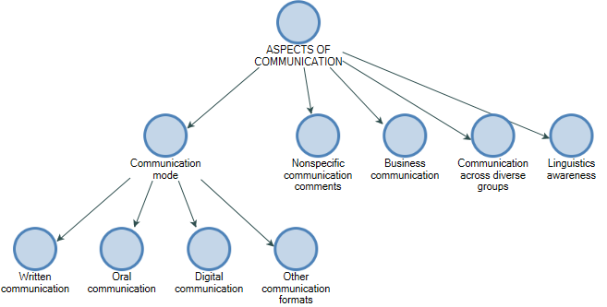
Communication mode refers to the different types of communication. By far the most frequent skill reported was written communication. Oral communication was the next most frequent, followed by digital communication, and then a smaller group referred to as other formats that included observational, reading, and cross-cultural understanding. Nonspecific communication comments were also frequent, mostly stating just one word “communication” and did not offer any more detail. Business communication included comments such as “Helping businesses communicate clearly” or “Strong understanding of business communication and structures” as examples.

A small group mentioned communication across diverse groups as an important skill learned - “Communication skills with all different types of people”.

Another small group of comments referred to Linguistic Awareness, the knowledge of linguistics -“Knowledge of the linguistics / brain processes - or a passion for the subject - “Passion for language” (a full list of responses is available on request).

Communication Industry Awareness

The final high-level theme relating to Communication Industry Awareness was the least described of all the three major themes (n = 176, or 18% of all skills development comments) (see Figure 21). The largest sub-theme within this group, called industry customer or stakeholder awareness, included examples of comments such as client relationships “awareness of audience/client perspective” and stakeholder engagement.

Figure 21. Skills Development. Communication Industry Awareness
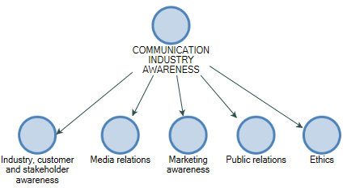

Media relations, marketing awareness and public relations were mentioned less frequently than overall industry awareness. However, within these three themes comments often related to content, law, knowledge, theory, awareness and understanding.

Finally, a very small number (n = 6) of graduates commented about ethics, best practice or industry standards.

What Skills or Other Attributes that Graduates Needed Did the BC Not Provide?

Following these insights into what respondents felt they had received, we wanted to know what the possible omissions were in the programme, from the vantage point of degree graduates.

The question asked was “Are there skills, knowledge, qualities, and characteristics, Bachelor of Communication graduates need which were not addressed in your degree?” Question responses are shown in Figure 22.

Figure 22. Skills Not Provided in the BC Degree
 | Number of respondents |  | % respondents
Yes | 215 |  | 54%
No | 157 |  | 39%
Blank | 26 |  | 7%
Grand Total |  | 398 | 100%
A little over half of the respondents thought that their degree did not provide certain skills, knowledge, qualities or characteristics that they needed, and they were invited to identify up to four. We employed NVivo to organise and find insights and themes within the graduates’ data.
Whereas in the skills learned section most respondents provided four skills learned, most of the respondents for this section provided only one response. This resulted in a much smaller number of skills-not-learned comments (n= 475) than skills learned (n= 962). This suggests that most graduates perceive their degree has equipped them well in needed skills.

The results for this analysis separated into three different high-level themes; namely, curriculum-based recommendations, personal attributes and job-seek support. A detailed analysis of each is included below. A detailed coding framework is included at Appendix 6. The italicised comments are direct quotations.

Curriculum-based Comments
The main theme, called curriculum–based comments, accounted for 76% of all the skills-missing comments. Within this theme, there were 12 different sub-themes (see Figure 23).
Figure 23. Skills Missing Curriculum-based Sub-theme

Figure 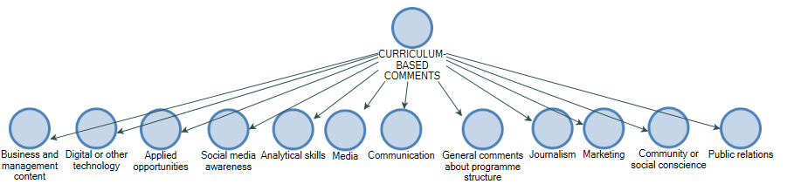

Business and management was the largest sub-theme (n=85 comments) and included a range of omissions such as budgeting “Business knowledge to do with financials e.g. how to oversee a budget”, organisational tactics, change and crisis management, project management and general business acumen “General business acumen /knowledge would be helpful for any sector”.

A sub-theme relating to Digital and other technology (excluding social media) also attracted a similar number of responses (n=81). These comments were largely about digital tools in marketing or media “Digital media (emerging) - major focus was traditional”, “eDM and direct marketing focus”, plus mention of a broad range of applications pertinent to communication, including the Adobe suite of tools, video production tools, Photoshop, web page coding, and even Microsoft tools.

Social media awareness, coded separately from the digital technologies, emphasised the deficiency of content within the current curriculum relating to this contemporary communication medium. For some graduates, social media was not very prevalent when they studied whereas that is no longer the case “Social media but that's because it wasn't much of a thing back then!” Some recommended much more content on the subject even to the extent of suggesting it should be a core paper, “Social media (or at least not enough taught around this), Social Media Training (can't believe this wasn't taught at all!)”, “Social media as a core paper”, were examples of comments provided.

The need for more applied learning opportunities was another popular sub-theme, with graduates emphasising the need for more authentic, practical learning opportunities in the BC through placements or internships. “Real work experience/placement/internship”, “More internship or on the job based opportunities”, “Practical knowledge of media analytics”, were all comments relating to this activity.

A frequently-described sub-theme related to a lack of analytical skills such as: statistics, evaluation, Excel expertise, Google analytics, data entry, and analytics generally.

Responses about Media were often about pitching, production, processes and liaison.

Comments about Communication often included responses relating to “Crisis communications”, or “communication planning”.

Journalism, Marketing and Public Relations were all smaller sub-themes. Journalism was often about the need for more options in the curriculum, “Please more classes for the journalism students”, “Equal to every other major”. Marketing was frequently associated with the digital or technologies theme with only a few references to other aspects of marketing, such as brands or plans. There were also very few comments about deficiencies in the curriculum specifically in relation to public relations.

A small number of general comments about the degree structure covered a broad range of ideas or suggestions regarding its structure, majors or courses. These are available on request.

Personal attributes or skills not addressed in the degree
The second high-level theme that related to personal attributes or skills that could be improved attracted n = 88 or 19% of coded responses (see Figure 24).

Figure 24. Skills Missing Personal Attributes
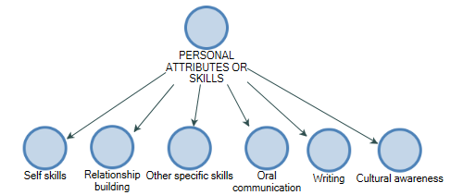

The sub-theme called self-skills referred to a broad range of personal attributes such as group skills, workload management, humility, planning, thinking, time management, agility, creativity and independence.

Relationship building exists as a separate sub-theme because of the frequency of comments (n=22). This refers to relationship building, networking, client communication and influencing. Both oral and written communication appear on the list of both skills learned and skills missing. For the oral communication skills missing respondents mostly referred to negotiating, pitching and influencing. Written skills mainly referred to matters of style “Writing for the web”, “Broader idea of writing for different audiences”, “How to write in a journalistic style”.

Other specific skills included a broad range of skills such as shorthand, interviewing skills, and professionalism.

A very small group raised the need for more cultural awareness through communication and engagement, “Cross cultural communication”, “Iwi engagement”. This deserves further investigation in light of the university’s Te Tiriti aspirations.

Overall, the omissions in the curriculum or skills-not-learned related to business content, digital technologies, in particular social media, applied opportunities, analytical skills and a variety of personal attributes. There was relatively little comment about core subject content currently offered within the degree. There was not a great deal mentioned about the structure of the degree from the perspective of majors, minors or even courses, perhaps with the exception of journalism courses and social media.

Job-seek Support for Graduates

The final high-level theme related to job-seek support for graduates. Further pertaining to the survey question, “Are there skills, knowledge, qualities, and characteristics, Bachelor of Communication graduates need which were not addressed in your degree?”, respondents identified a collection of support measures that they thought the university could provide to assist them in their career progression. We designated the suggestions they made as “job-seek support”.
Although the University Careers and Employability Services (CES) aspires to support graduates, especially through admitting graduates to membership of courses offered on campus, this activity is not actively promoted. These results suggest that there is a need for greater awareness of this service as it appears that, beyond completion, some graduates (5%) struggled with issues relating to employment, e.g., “How to get into the industry” or, “How to market yourself”.

However, if job-seek support is desirable for some graduates a few years after degree completion, then further scaling and or timing of the available CES support may be necessary, along with further promotion of existing services. Fortunately the vast majority of graduates appear to change jobs frequently without the need for such support.

More precise insights into if and when job-seek assistance is sought may be obtained through additional graduate surveying.

Figure 25. Frequency of Job Seek Support Comments
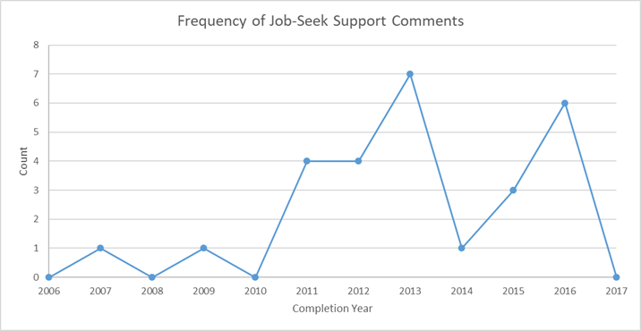

Compared with curriculum-based omissions in the BC, job-seek support comments accounted for a very low proportion, 5% or n = 27 job-seek support comments versus 76% or n = 360 curriculum-based skills comments. Graduates making such suggestions came from all BC majors, with no majors more evident than others (see Figure 25).

The nature of the suggestions permitted us to speculate that some graduates were not aware of the support available to them while they were students. Typical comments were, “More focus and support to help with career opportunities”, “How to get into the industry”, “CV/resume work, how to get hired once you’ve finished Uni”.

Given that the survey had also revealed a high frequency of job change (ranging from between every 1.0 – 2.2 years, and on average a job change every 1.5 years), it is probable that most graduates achieve their desired employment outcomes without further assistance from Massey’s Career and Employability Services. It should be noted, however, that those requesting support did not come from the 2017 cohort, raising the possibility that BC graduates immediately post-degree may not have much further need for university assistance at that point.

We have observed in section 5 above that up to a third of graduates are likely to make a transition into work that is designated as “manager”, possibly from about their third or fourth year post-degree. The assistance to which graduates refer may have to do with support perceived as needed to move into more senior communication-related work. It may, therefore, be the case that graduates will become more open to suggestions from the university that their careers could benefit from masters-level study at around their third or fourth year post-bachelor, rather than immediately on BC completion.

Would BC Graduates Study the Same Qualification Again?

Figure 26. Would Graduates Study the Same Qualification Again?
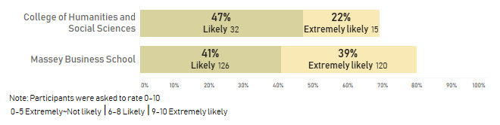

When asked the question “Thinking back now, would you study the same qualification again?” most graduates responded positively, with either a ‘likely’ or ‘extremely likely’ response (see Figure 26). The combined 69% for the CoHSS-based majors is less than the 80% for the Business-based majors, but is still viewed as a good outcome. Reflecting on the reasons why many graduates might not respond positively could be part of any ongoing redevelopment of the programme. In this context, it may be that CoHSS graduates, such as those from the Expressive Arts major, are attracted to work in the arts fields, often featuring portfolio careers or the “gig economy” (e.g., Bögenhold, Klinglmair, & Kandutsch, 2017). As indicated above in section 3, the industry group Arts and Recreation represents the fifth most prevalent industry in which BC graduates are employed. Hence, it is conceivable that as graduates come to terms with arts-related, usually more precarious forms of employment, they will be more likely than those in “permanent” positions to reflect on the nature of their previous educational preparation.

15. How to Improve Transition into the Workforce?
The survey then sought to discover the desired university support for a transition into work.
Figure 27. What Could Massey University do to Improve Transition into the Workforce (by Primary Study Location)?
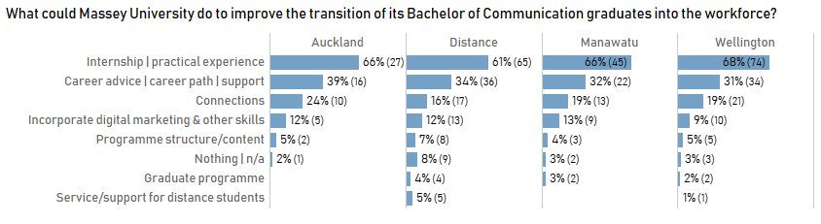
Figure 27 shows very consistent results were found across study location. All four groupings of Auckland, Distance, Manawatū and Wellington graduates placed a great deal of emphasis on how more needs to be done to provide internships and other forms of student experiential learning, more career advice, and more connections with industry and the community. Together these suggestions around external relationship-building and community-facing university practices comprise a call for the university to make a substantial turn toward experiential or service learning. It is also worth noting that these suggestions greatly outweigh proposals for other kinds of improvements in the curriculum.
The only main exception to this focus on relationships external to the university is in respect of students’ digital learning, such as digital marketing capabilities.
Next, graduates’ views on how the university could assist graduates’ transition into work showed little change by year of cohort.
Figure 28. What could Massey University do to Improve Transition intothe Workforce (by Completion Year)?
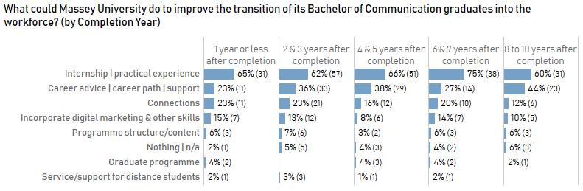
Graduates’ emphasis on the importance of internships and practical experience remained very strong, regardless of year of completion. The provision of career advice or support was also stressed, mainly remaining in second place. The most recent graduates called for this kind of support least. It may be that the four earlier groupings of cohorts have become more aware of the importance for their professional development of an in-depth understanding of careers in industry and in the community (see Figure 28).
The graduates’ focus on building community relationships strongly reinforces Massey’s strategy that refers to “Ensuring our graduate attributes include entrepreneurial capability by maximising work-integrated learning and students’ access to innovation precincts”.
It should be noted that the colleges which offer the BC are at the date of writing further operationalising their commitment to student experiential learning. For example, the Massey Business School at its College Board recently clarified that MBS students should be permitted to take up to 60 credits (four courses equivalent) of internship courses in their undergraduate degrees. For its part the College of Humanities and Social Sciences is working to provide internship and other applied learning opportunities for its students.

16. Did Graduates Undertake Further Study After Completion?

Figure 29. Further Study After Completion
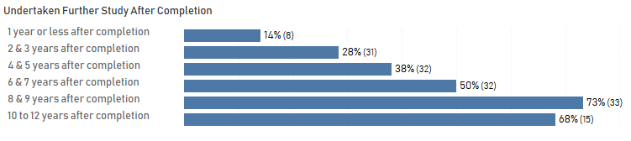
It is revealing to note how engagement in further study increases successively by graduating cohort (see Figure 29). A little over a quarter of graduates had undertaken further study by their second or third year, half of them by years six or seven, and around 70% by years eight to 12 post their bachelor’s degree. This reinforces the importance of the university generally and the colleges that offer the degree in particular maintaining enduring connections with BC graduates to ensure that they understand what the masters-level opportunities are for them (e.g., Master of Communication, Master of Management in Communication, Master of Creative Writing, Master of Journalism, Master of Arts) and the potential value of completing post-graduate study.
However, as mentioned already in this report, there is not much point in the university seeking to reach out to communicate the value of masters-level study within the first few years following graduation. This is because new graduates’ employment outcomes are strong and their attention will be on learning the basics of their professional knowledge work in the varieties of industries in which they are engaged.
Figure 30. Qualification or Programme of Further Study After Completion
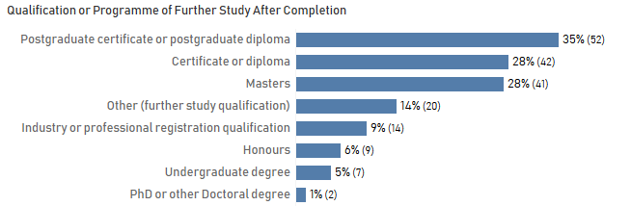
The kind of programme undertaken is worth noting (see Figure 30). Only 9% has to do with an industry qualification and the greatest proportion of the qualifications sought are provided by universities. There is, of course, substantial competition among universities both within New Zealand and beyond to attract postgraduate students. However, the evident readiness of communication graduates to engage in postgraduate study suggests that ongoing efforts to maintain strong connections to the BC graduate cohort would pay off in postgraduate enrolment.

REFERENCES
Australian Bureau of Statistics. (201)3. 1220.0 - ANZSCO -- Australian and New Zealand Standard Classification of Occupations, Version 1.2. Available at http://www.abs.gov.au/AUSSTATS/abs@.nsf/DetailsPage/1220.02013,%20Version%201.2?OpenDocument
Bögenhold, D., Klinglmair, R., & Kandutsch, F. (2017). Solo-self-employment, human capital and hybrid labour in the gig economy. Foresight and STI Governance, 11, 23-32.
Cutlip, S. (1994). The unseen power: A history of public relations. Lawrence Erlbaum Associates.
Greenhill, A., & Fletcher, G. (2009). Spaceless concordancer. Brisbane: Griffith University. Available at: http://www.spaceless.com/concordancer.php
O’Brien, T. L. (2005). Spinning frenzy: PR’s bad press. The New York Times, February 13.
Oc, B. (2018). Contextual leadership: A systematic review of how contextual factors shape leadership and its outcomes. Leadership Quarterly, 29, 218-235.
Occupation Outlook. (2018). Available at http://occupationoutlook.mbie.govt.nz/service-industries/journalists-and-public-relations-professionals/
Quinlan, A. E., Berbés‐Blázquez, M., Haider, L. J., & Peterson, G. D. (2016). Measuring and assessing resilience: broadening understanding through multiple disciplinary perspectives. Journal of Applied Ecology, 53, 677-687.
Seek (New Zealand) (n.d.). Available at https://www.seek.co.nz/communicator-jobs/in-All-New-Zealand
Uhl-Bien, M., Marion, R., & McKelvey, B. (2007). Complexity leadership theory: Shifting leadership from the industrial age to the knowledge era. The Leadership Quarterly, 18, 298-318.
Zammuto, R. F., Griffith, T. L., Majchrzak, A., Dougherty, D. J., & Faraj, S. (2007). Information technology and the changing fabric of organization. Organization Science, 18, 749-762. https://doi.org/10.1287/orsc.1070.0307

Acknowledgements
Particular thanks go to Dr Phil Gendall, Senior Research Fellow at the University of Otago and Emeritus Professor of Massey University, for his careful assessment of research methodology and survey results. We are grateful to Dr Ian Huffer, School of English & Media Studies, Dr Anthony Fisher, School of Humanities, and Drs Elizabeth Gray, Erika Pearson and Luk Swiatek of the School of Communication, Journalism & Marketing, for their input into survey planning and design. We also thank Dr Elspeth Tilley of the School of English & Media Studies for her prior work on a precursor survey of BC graduates in 2013 and for her concordance analysis of qualitative data in the present study. Of course all errors and omissions in this report are the entire responsibility of the authors.

Appendix 1. Panel and Respondent Characteristics
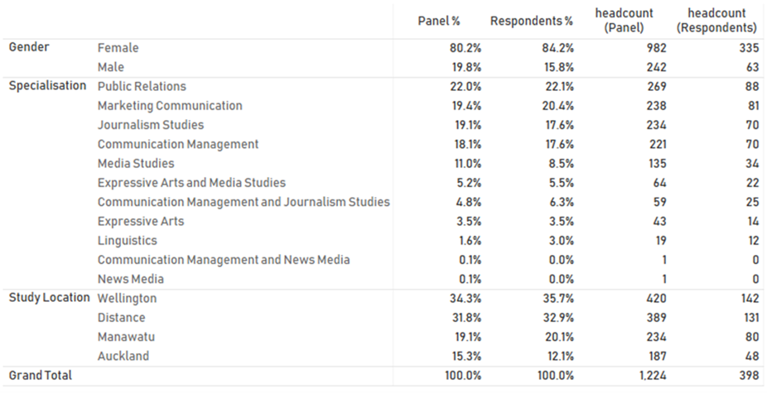

Appendix 2. All BC Completions by Major
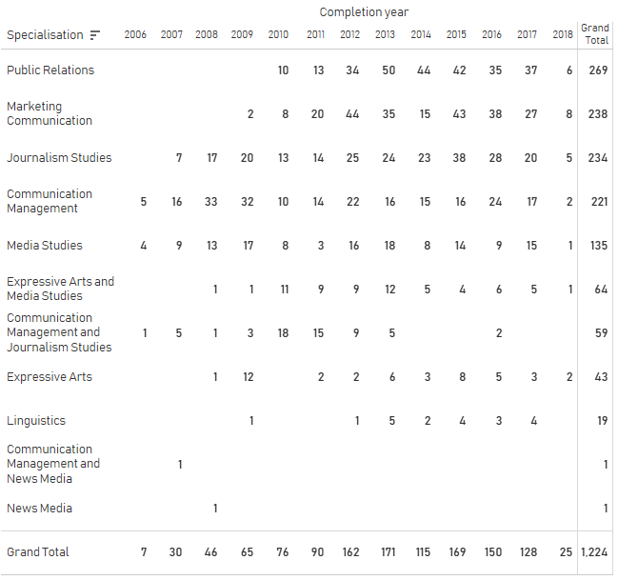

Appendix 3. BC Graduate Occupations
Account Director | Customer Access Representative | Liaison Advisor | Referral and Placement Officer
Account Executive | Customer Care Comms Coordinator | Librarian | Regional Mktg and Comms Consultant
Account manager | Customer Service | Library Manager | Reporter
Accountant | Customer Service Officer | Management Consultant - Manager | Reporting Consultant
Acting Team Leader | Customer Service Representative | Manager Internal Comms and Connections | Residential Youth Worker
Actor | Customer Services Assistant | Managing Director | Retail assistant
Admin Operations | Customer Success Specialist | Marketing & Communications Coordinator | Retail manager
Administration Manager | Customer Success Specialist/Casting Manager | Marketing & Events Manager | Retail Sales Executive
Administration/Owner/Creative Director | Data + Insights Manager | Marketing Administrator | Sales and service manager
Administrator | Designer | Marketing Advisor | Sales Coordinator
Advisor - Engagement | Digital Analytics Lead | Marketing and Comms Manager | Sales director
Alumni relations manager | Digital Communications Advisor | Marketing and Communications Advisor | Sales Manager
Ambassador | Digital Communications Specialist | Marketing and Communications Manager | Secondary school teacher
Assessment advisor | Digital Content Manager | Marketing and Communications Specialist | Senior Account Manager
Assistant Language Teacher | Digital Content Producer | Marketing and Human Resources Advisor | Senior Advisor
Assistant librarian | Digital Marketing Assistant | Marketing Assistant | Senior Billing Specialist
Assistant Store Manager | Digital Marketing Coordinator | Marketing Communications Manager | Senior communications advisor
Bar Owner | Digital Marketing Manager | Marketing Coordinator | Senior Comms and Engagement Advisor
Barista | Digital Marketing Specialist | Marketing Executive | Senior Comms and Media Advisor
Brand Communications Advisor | Digital media coordinator | marketing lead | Senior Communications Manager
Brand manager | Digital media executive | Marketing Manager | Senior internal communications advisor
Brand Marketing Manager | Digital Media Planner | Marketing Pitch Advisor | Senior Journalist
Brand Specialist | Digital producer | Marketing Specialist | Senior Manager - Brand & Comms
Business Coordinator | Digital Services Website Content Publisher | Marketing, Events & Communities Coord | Senior marketing coordinator
Business improvement analyst | Direct & Digital Marketing Manager | Media Assistant | Senior Marketing Executive, Brand
Business Innovation and Ops Manager | Director | Media Relations Executive | Senior media advisor
Business Manager | Director/Manager | Media Studies Tutor/Filmmaker | Senior PR Officer - Europe
Campaign Manager | Duty centre manager | Merchandiser | Senior Project Manager
Casting Assistant | Easy Read Translator | Ministry of social development officer | Senior public affairs advisor
Change Manager | Editor for the European Astronaut Centre | Multimedia Journalist | Senior Publicist
Checkout Operator. | Editorial assistant | Musician | Senior Reporter
Chief Design Communicator | Engagement Assistant | National Communication Manager | Senior Security Advisor
Client Relationship Manager | Event developer & volunteer coordinator | National Sales and Admin Coordinator | Senior Writer
Commercial Content Writer | Events Manager | New Vehicles, Direct Operations | Service Coordinator
Commis Pastry chef | Executive Assistant | News Editor | Service Designer
Comms Advisor & CEO | Executive Officer | NZ and Australia sales assistant | Showroom Manager
Communication Advisor | Facebook Marketing Expert | Magazine staff writer and social media editor | Social Community Coordinator
Communications account manager | Football writer and sports data reporter | Occupation | Social media and content specialist
Communications and engagement advisor | Founder and Managing Director | Office Supervisor | Social Media Coordinator
Communications and Engagement Manager | Founder/Director | Online Content Developer | Social Media Specialist
Communications and events coordinator | Freelance writer | Outreach Manager | Software Developer
Communications and Marketing Advisor | Fundraising Coordinator | Own business- Client Success Director | Speech Language Therapist
Communications and Marketing Coordinator | Fundraising Events Manager | PA / Owner, Director | Store Manager
Communications and Marketing Manager | General Manager | PA/Marketing Coordinator | Strategic Account Manager
Communications and Media Advisor | Global digital marketing manager | Para Consultant | Studio Coordinator
Communications and Planning Advisor | Global Engagement Administrator | Parliamentary MP Support | Studio Manager
Communications and Sales specialist | Global Head of Marketing | Part owner/admin | Stuff political reporter
Communications Assistant | Golf Professional Trainee | Payments Manager | Sub-editor
Communications Consultant | Grants Support Officer | Performance media lead | Supply Chain Officer
Communications Coordinator | Graphics and Merchandising | Personal & Business Banker | Support Administrator
Communications Director | Grocery Assistant | Pitch & Marketing Coordinator | Support Tutor
Communications Manager | Group content engagement specialist | Portfolio Manager | Teacher
Communications Officer | Head of Brand & Communications | PR Account Executive | Teacher/Across School Leader
Community and Strategy Operations Officer | Head of Marketing | PR Account Manager | Team Leader Sector Engagement
Community Engagement Coordinator | Head of marketing and customer service | PR Assistant | Technical Pricing Specialist
Community Investment Analyst | HR & Recruitment Coordinator | Primary school teacher | Technician
Community services administrator | HR Administrator | Primary Teacher | Test Analyst
Consultant | HR Coordinator | Product Director | TV/ Digital Sales Account Manager
Content Coordinator | HR Talent Manager | Product Manager | Veterinary Nurse
Content creator | Immigration Officer | Product, Marketing & Website Coordinator | VFX Production Coordinator
Content creator and social media manager | Information and Media Coordinator | Production co-ordinator | Web Content Manager
Content designer | Information Team Leader | Program Manager | Web Services Advisor
Content editor | Innovation Manager | Project Administrator | Website Content Assistant
Content Lead & Account Manager | Integrated advisor | Project Coordinator
Content Management Specialist | Intermediate School Teacher | Project Development Associate
Content Manager | Intermediate Teacher | Project Manager
Content Marketing Manager | Internal comms and engagement coordinator | Project Officer
Copywriter | International Relations Coordinator | Project Officer
Copywriter/Audio Engineer | International Student Support Officer | Promotions Specialist
Corporate Affairs Manager | Journalist | Publications and Web Editor
Corporate and internal Comms manager | Junior reporter | Publicist
Corporate communications Manager | Key account and communication manager | Quality Assurance
Corporate internal communications officer | Key Account Manager Internal Comms | Real Estate Agent
Course and Offer Specialist | Lecturer | Receptionist
Creative, Digital and Projects Manager | Lending consultant - banking | Recruitment Consultant

Appendix 4. The 60 Most-Used Terms in BC Graduates’ Job Titles
Word | Frequency | Word | Frequency | Word | Frequency
manager | 83 | executive | 10 | lead | 4
communications | 66 | project | 9 | operations | 4
marketing | 53 | reporter | 8 | producer | 4
advisor | 44 | business | 8 | team | 4
coordinator | 43 | social | 8 | corporate | 4
senior | 27 | administrator | 7 | recruitment | 4
digital | 21 | journalist | 7 | store | 4
assistant | 20 | brand | 7 | retail | 4
content | 18 | internal | 6 | owner | 4
specialist | 17 | events | 6 | relations | 3
media | 17 | editor | 5 | analyst | 3
account | 16 | head | 5 | primary | 3
officer | 15 | communication | 5 | global | 3
director | 14 | writer | 5 | admin | 3
service/ services | 13 | community | 5 | success | 3
engagement | 12 | school | 5 | product | 3
customer | 11 | HR | 5 | developer | 3
consultant | 11 | support | 5 | web | 3
teacher | 10 | leader | 5 | website | 3
sales | 10 | PR | 5 | designer | 3

Appendix 5. Coding Framework Bachelor of Communication Skills Learned
Name | References | Description
PERSONAL and INTERPERSONAL SKILL DEVELOPMENT | 433 | The range of personal and interpersonal skills
Self-management | 215 | Working independently, taking responsibility, planning and organisation. Having confidence and self-awareness.
Self-sufficiency | 153 | An individual's application of skills i.e. time management, decision making or planning
Self-awareness | 49 | Self-awareness through being flexible and adaptable
Self-confidence | 13 | Gaining confidence through independent responsibility
Enterprise | 161 | Thinking skills, creativity, innovation and reflection
Leadership | 57 | Working confidently and collaboratively with a group of people and as a leader where necessary
ASPECTS OF COMMUNICATION | 353 | Any form of communication such as written, oral, digital or other non-specific comments about communication
Communication mode | 208 | Written, oral, digital and other forms of communication. Non-specific comments are coded elsewhere.
Written communication | 132 | Any aspect or written communication including writing for different audiences, business writing or editing. Electronic communication is coded under digital communication theme
Oral communication | 44 | Any aspect of oral communication including public speaking, presentations or other face-to-face contact. Also includes connecting with different audiences
Digital communication | 26 | Digital communication or anything using the word digital or technology/ technological/ or computing/ computers/ data or possibly digital media but not media relations/media releases. Social or digital media is also coded here.
Other communication formats | 6 | Any other communication formats channels or modes e.g. reading and observation
Nonspecific communication comments | 95 | Non-specific comments about communication including professionalism and communication planning and just communication with no further reference. Communication in the work environment is coded at business communication.
Business communication | 19 | Any reference to business or workplace communication not specifically stating the mode of delivery
Communication across diverse groups | 18 | Communication across diverse groups or situations including international communication
Linguistics awareness | 13 | Any reference to linguistics, language or grammar
COMMUNICATION INDUSTRY AWARENESS | 176 | Broad theme describing communication industry, marketing, public relations and media relations
Industry, customer and stakeholder awareness | 83 | Industry awareness, strategy, customer awareness, audience segmentation. Communication to diverse groups coded elsewhere
Media relations | 39 | Media relations, content, knowledge and industry
Marketing awareness | 30 | Aspects of marketing including brand awareness
Public relations | 18 | Public relations including theory
Ethics | 6 | Ethics, principles and rules of conduct

Appendix 6. Skills, knowledge, qualities, and/ or characteristics not addressed in your degree.

Name | References | Description
CURRICULUM-BASED COMMENTS | 360 | Omissions from the current curriculum
Business and management content | 85 | Business management including stakeholder engagement, finance and budgeting, strategy development and organisational or workplace management and change management. Risk management, Campaign management, Self-employment, Law. Crisis comms coded elsewhere
Digital or other technology | 81 | Digital technologies, Adobe, Microsoft, Photoshop, editing, computer skills, Survey Monkey, web coding
Applied opportunities | 56 | Real world or other practical knowledge or skills. Authentic experience and active learning. Hands-on experience. Internships
Social media awareness | 40 | Any reference specifically to social media
Analytical skills | 26 | Including evaluation, Google analytics. Excel
Media | 18 | Reference to media, releases, auditing
Communication | 18 | Communication including crisis communication activities, plans, audits
General comments about programme structure | 16 | Any general comments about majors or minors. Currency of content
Journalism | 7 | Reference to journalism. Can also be coded elsewhere
Marketing | 6 | Not specifically digital
Community or social conscience | 3 | Community or social conscience. Also included alumni community
Public relations | 2 | Any specific mention of PR skills
Other | 2 | Student support and theory to practice
PERSONAL ATTRIBUTES OR SKILLS | 88 | Personal parent nodes
Self-skills | 23 | Thinking, planning, time management, humility, group, stick ability, work ethic
Relationship building | 22 | Different audiences networking and influencing people
Other specific skills | 18 | Such as interviewing, shorthand, event planning, content creation. Newsroom skills. Leadership & professionalism
Oral communication | 10 | Including negotiating difficult situations. Pitching ideas. Board room communications
Writing | 10 | Including writing style and structure. Shorthand coded elsewhere
Cultural awareness | 5 | Awareness of tikanga Māori or cross-cultural awareness
JOB SEEK SUPPORT | 27 | Employment seeking comments

All data is based on the year of completion of the programme, rather than the year of graduation

