Blockchain-aided information exchange records for design liability control and improved security
Abhinaw Sai ERRI PRADEEP^{a,∗}, Tak Wing YIU^{b}, Yang ZOU^{c}, Robert AMOR^{d}
(Authors’ names in ‘Given Name FAMILY NAME’ format)

∗ Corresponding author.
ª Department of Civil and Environmental Engineering, University of Auckland, Private Bag 92019, Auckland, New Zealand, 1142; email: aerr756@aucklanduni.ac.nz
^{b} School of Built Environment, Massey University, Private Bag 102904, Auckland, New Zealand, 0745; email: tyiu@massey.ac.nz
^{c} Department of Civil and Environmental Engineering, University of Auckland, Private Bag 92019, Auckland, New Zealand, 1142; email: yang.zou@auckland.ac.nz
^{d} School of Computer Science, University of Auckland, Private Bag 92019, Auckland, New Zealand, 1142; email: trebor@cs.auckland.ac.nz

Article Info

Keywords
Blockchain
Construction industry
Information exchange
Building Information Modelling (BIM)
Record-keeping
Design liability
Information security
Smart Contracts
Ethereum
Design science research
Prototype evaluation

Items preferred in colour for print
- Figure 2: Procedural diagram outlining the key steps of the study
- Figure 4: Data flow diagram: Aggregate of processes: Architectural Design
- Appendix A

Link to high-resolution figures from the manuscript

Abstract
With the recent advances in Information and Communication Technologies in the construction industry, information is exchanged digitally with little regard to the contracts that govern them. Although parties collaborating in project design are contracted to the client, they transact with each other when using BIM and other collaborative practices without any direct contractual relationship among themselves. This results in a lack of design liability control and an increase in claims and disputes. Further, the use of multiple software packages results in the exposure of data to third parties, data corruption and compromise in data privacy (using data for unintended purposes), data integrity (unauthorised access to sensitive data), and data longevity (loss of data post-handover). This study investigates blockchain technology (BCT) to address these issues using a design science research method. The current information exchange processes were mapped to identify the critical transactions that may benefit from record-keeping on the blockchain. Next, a prototype was designed to demonstrate and evaluate the proposed BCT integrated process models. Three key project processes, design review, design coordination and request for information; and two potential conflict scenarios during and post-construction were simulated as part of the evaluation. The prototype’s implementation exhibits BCT’s ability to record snapshots of individual design inputs to the overall project design and to enable a clear and long-term record of key exchange transactions. This improves the design liability control for contributing stakeholders and the auditability of the exchange records. Further, the proofs derived from such a system are independent of any third-party storage or subscription. Given the nature of records stored in a blockchain, the existence, integrity, and authenticity of information along with its associated metadata can be verified in the long-term as well. Therefore, BCT could be a supplementary technology that supports the existing information exchange systems.

Introduction
The construction industry is described a “complex product systems industry” (Winch, 1998) and its projects are characterised by their complexity, both in design and delivery (Khan, Flanagan, & Lu, 2016). It has gained notoriety for having a culture of “adversarial relationships” and “risk avoidance” (Succar, 2009). Evidence for these notions is partly substantiated by conflicts, claims and disputes that have swamped the industry (Gad, Momoh, Esmaeili, & Gransberg, 2015; Gebken & Gibson, 2006; Phillips-Alonge, 2019; Rajendran, Clarke, & Whelan, 2013). Mitkus and Mitkus (2014) believe that about 90% of the construction claims and disputes are due to poor communication between project participants. Unlike other industries, the teams engaged in construction projects with traditional and design-build procurement models do not co-locate to collaborate; moreover, they are contracted only with the client and not among themselves; thus leaving the collaboration and coordination to trust in relationships and unexpressed agreements between the teams (Ford & Sterman, 2003; Love, Holt, Shen, Li, & Irani, 2002; Tribelsky & Sacks, 2011).
To improve the communication systems on projects, the industry has looked towards the application of Information and Communication Technologies. A high-quality information management system that facilitates robust documentation and data exchange mechanisms have been identified as drivers for effective project communication (Kähkönen & Rannisto, 2015). With the advent of Building Information Modelling (BIM), information has taken the shape of object-based 3D models and other digital forms. One of the key barriers identified to BIM implementation is its perceived legal risks when integrated with the existing processes and using BIM in a multi-party collaborative environment. Various studies have identified and reviewed contractual and legal issues associated with the use of BIM (Abd Jamil & Fathi, 2018; Arensman & Ozbek, 2012; Beth & Chatswood, 2014; Fan, Lee, Chong, & Skibniewski, 2018; Foster, 2008; Simonian & Korman, 2010; F. W. H. Wong & Lam, 2010). A BIM database contains more information than Computer-aided Design (CAD) documents, including design parameters, assumptions, material properties and other supporting and analysis data created and used by multiple parties, sometimes simultaneously as the project develops. This has led to companies putting up massive disclaimers that keep their liabilities almost zero, thereby restricting the receiving party’s reliance on the model. This significantly reduces the overall efficiency of the BIM process and negatively impacts collaboration between parties (Arensman & Ozbek, 2012; Larson & Golden, 2007). Within liability, two of the top five software liability issues identified by Eadie, McLernon, and Patton (2015) were data transfer and data security. Studies have recognised that it is crucial to ensure that data is protected against “corruption, loss and manipulation” and that the data users place restrictions on data sharing and access, and establish insurance to cover any “possible financial losses associated with breaches of data security” (Hurtado & O Connor, 2008; Manderson, Jefferies, & Brewer, 2015).
To address these issues, we investigate the hypothesis that information exchange records in a project could leverage the benefits of blockchain technology (BCT) to tackle these challenges at the root level. BCT is fundamentally a digital information recording method, essentially a form of Distributed Ledger Technology (Giancaspro, 2017). Conte de Leon, Stalick, Jillepalli, Haney, and Sheldon (2017) and Erri Pradeep, Yiu, and Amor (2019) provided a comprehensive discussion of the concepts and properties surrounding blockchain technology.
The objectives of this study are threefold: first, diagnose the issues of design liability control and data security in information exchange processes, investigate the current practices and tools, and review the existing literature that discusses BCT in information exchange (Section 2); second, compose conceptual process models that leverage BCT for record-keeping of information exchange transactions (Section 4); and third, implement these models through a prototype system developed to validate the model (Section 5 and 6) and evaluate the system’s effectiveness in addressing the identified issues (section 7). The research methodology, strategy, and its chronology are presented in Section 3.

Literature Review

Design liability in the Information Exchange process
Design liability in BIM-based collaborative design can be described as “the extent to which participation may give rise to legal liability, even where no contractual relationship may exist” (McAdam, 2010). With designers using information as raw material for project design, the contributions of the parties authoring and distributing the information must be identified with certainty. However, Eadie et al. (2015) point out that in the case of conflicts and disputes, it is often difficult to determine the party liable for errors because information is exchanged between multiple parties, resulting in numerous points of potential modifications; and sometimes interoperability between software can change data during the BIM process. Eadie et al. (2015); (Fan et al., 2018) highlighted the significance of various design liability issues discussed in the literature. We identify a few core concepts in law that regulate the stakeholders’ control over their liability towards the information they produce or consume.
First is a concept found in Tort law, called “Standard of Care”. Acts such as delegation of work between parties or getting work approved do not relieve the authoring party from compliance with their licensure and Standard of Care towards their design input (Lupton, 2013). A survey by Pandey, Shahbodaghlou, and Burger (2016) showed that project participants were unclear about the interpretation of Standard of Care.
Second is the “Spearin Doctrine”. As per the doctrine, if a structure fails to meet the intended functionality requirement, it is not the builder’s responsibility due to the “owner’s implied warranty” towards the plans and specifications. However, with delivery methods such as “Construction Manager at Risk”, a collaborative design process is observed. In such a setting, parties provide input to each other and share and exchange models. Hence, the architects may assume some means and methods liability while the contractors might assume some design liability (Larson & Golden, 2007; Leone & Vornehm, 2017).
Third is the practice of holding independent “Professional Indemnity” (PI) insurances. Due to the multi-party nature and poor interoperability, it is challenging to keep the licensed design professionals responsible for authoring and modifications in models and other collaborative design outputs (Simonian & Korman, 2010). PI has been indicated as a significant concern for design professionals involved in a collaborative BIM environment (Abd Jamil & Fathi, 2019; Manderson et al., 2015).
Fourth is the concept of “Privity of Contract” and its counter concept of parties’ rights to rely on shared information. The Privity of Contract provides that only contracted parties have rights or obligations towards each other (Hsu, Hsieh, & Chen, 2015). Complications arise when participants in a project have access to a shared model, which gives them the right to rely on other participants’ contributions with whom there is not necessarily a contract. However, due to Privity, they do not have a right to make any claims against the authors of the model that might result from negligent errors or economic losses as there is no contract between them.

Security of data
As BIM becomes mainstream, information is being stored in a central data repository or a central cloud storage platform. This data might be exposed to third parties, data corruption or manipulation. In their studies, Olatunji (2011) and Al-Shammari (2014) warned about data corruption during transfer between design teams, and vulnerability of electronic files to worms and viruses, data theft, snooping and hacking. Mahamadu, Mahdjoubi, and Booth (2013) further cautioned that compliance with legal and contractual obligations does not protect from breaches of security and safety by data cloud providers that result in compromised data integrity and privacy. Moreover, information can also lose its longevity across a facility’s lifecycle and become lost due to events such as company mergers or bankruptcy (Rezgui, Beach, & Rana, 2013). Parn and Edwards (2019) compare the most popular topics discussed across industries with discussions in the built environment. For all sectors combined, global security accounted for more than 50% of discussions; for the built environment, it was only 20%.

Current Practices and Limitations

Recommended practices in literature
Literature has pointed towards Project Alliancing, Public-Private Partnerships and Integrated Project Delivery (IPD) models to address the issue of Privity of Contract and rights of participants to rely on third-party information (Gibbs, Emmitt, Lord, & Ruikar, 2015; Lahdenperä, 2012; RIBA, 2012; Scott et al., 2014). However, these models are reliant on affect-based trust (W. K. V. Wong, 2007), and they bring needless complication to projects (Heap-Yih, Su-Ling, Monty, & Shang-Hsien, 2017). The traditional PI insurance covers design based on individual practice, and this gets convoluted when work is carried out in an integrated BIM design environment. Therefore, it is suggested that it is a must that designers and construction managers in the construction industry must have PI insurance to explicitly cover collaborative practices (Ashcraft, 2008; Eadie et al., 2015). Further, studies have suggested the need to define in the contracts expressly the reliance on models, level of details and accuracy for project participants (Fan et al., 2018). Manderson et al. (2015) suggested recognising BIM processes in the GC21: General Conditions of Contract, Australia, and considering BIM models as a contract document. Other suggestions by Ghaffarianhoseini et al. (2017) included the use of contract addendums, sometimes referred to as BIM protocols that consider the legal issues of incorporating a process such as BIM into the project and using it as an amendment to the main contract. Although these amendments address a few issues such as reliance of data (Borrmann, König, Koch, & Beetz, 2018), they sometimes take varied approaches to other issues such as model corruption or integrity of files shared, and responsibilities of parties.
Effective Information Management (IM) has been regarded as a critical contributor to mitigating legal challenges. Participants in a study by Sheriff, Bouchlaghem, El-Hamalawi, and Yeomans (2012) mentioned losing information to poor IM systems and having landed themselves in legal troubles. Abd Jamil and Fathi (2018); Arensman and Ozbek (2012); Pandey et al. (2016) highlighted the importance of having a sound traceability mechanism that can track changes and exchanges of data among project members for auditing purposes, and to support conflicts and eventual litigation. It is possible to keep track of changes and data traceability for electronic documents using Electronic Document Management Systems (EDMS). Pilehchian, Staub-French, and Nepal (2015) thoroughly assessed existing literature that suggested systems for tracking changes. Al Qady and Kandil (2013a) discussed the different document management approaches ranging from document-centric to information-centric approaches, such as model-based systems. A Model Collaborations System (MCS) allows the reuse of the information directly from the models and expands the intra-disciplinary collaboration towards an integrated multi-disciplinary collaboration. It enables the essential functionalities of merging, checking for clashes, and revision control to view the latest changes and to restrict simultaneous edits. Shafiq, Matthews, and Lockley (2013) analysed some of the early versions of a few selected MCSs. A tool or platform that enables model-based project management is Common Data Environment (CDE). This term was coined by PAS-BSI (2013), and included in the new ISO 19650 (ISO, 2020a). CDE refers to the use of cloud technology to form a collaborative space for project participants. Studies in the past have credited EDMS and CDE platforms for version management and enabling an audit trail to ensure accountability (Hjelt & Björk, 2006; Preidel, Borrmann, Mattern, König, & Schapke, 2018). Koch and Firmenich (2011) have provided a brief review of the versioning of BIM models.
A few studies have proposed mechanisms to track design changes in a collaborative multi-disciplinary BIM environment. In the past, Hegazy, Zaneldin, and Grierson (2001); Mokhtar, Bédard, and Fazio (1998) developed information models that were intended to improve the coordination of design information through the management of design changes. Pilehchian et al. (2015) described a conceptual approach to coordinate and track design changes using a graph-based approach and dependency matrix. Zada, Tizani, and Oti (2014) proposed an extension to the Industry Foundation Classes (IFC) schema to support object versioning in a BIM model that would represent the history of changes to any object of the model and facilitate integration with earlier versions of the BIM model. Similarly, a standard proposed by buildingSMART, called BIM collaboration format (BCF), helps implement any design changes directly in the BIM-based data model of different disciplines (Treldal, Parsianfar, & Karlshøj, 2016). Another study by Jiao et al. (2013) proposed integrating BIM and Social Networking Services (SNS) to achieve a unified model containing a centralised single source data structure. The study proposed a ‘dynamic Generalised List series’ to address the file versioning issue for the recommended system.
Although there are many benefits of EDMS and CDE for information exchange and tracking, they present a few challenges. Björk (2002); Fernando, Hewavitharana, and Perera (2019) have explored some of these challenges. We review the challenges related to legal and security aspects in this study. Al Qady and Kandil (2013b) stressed that legal challenges mainly arise due to concerns over the integrity and security of documents shared. Electronically stored documents are susceptible to loss of data and alterations, that compromise the integrity of the stored files, leading to legal issues and users resorting to paper documents as a fallback. Pandey et al. (2016) conducted surveys to understand users’ experience of data loss, among other aspects. Almost half of the participants responded with ‘sometimes’ for data loss, and only a quarter of the participants indicated they had provisions for dealing with data loss. The authors also discussed a legal case ("Zubulake v. UBS Warburg LLC," 2004), which established a precedent that suggests that electronic information must be protected from loss and actively preserved by all parties if litigation is anticipated. Since litigation is an anticipated activity in construction, clear electronic records management policies need to be in place, and ‘key’ players involved in data creation and consumption need to be identified. Mahamadu et al. (2013); J. Wong, Wang, Li, and Chan (2014) stressed the effects of poor security and interoperability issues are legal challenges such as design liability control, copyright, model ownership, which need to be addressed to streamline IM on construction projects.
Standards such as the BS 1192-4:2014 (BSI, 2014) and ISO 19650-5:2020 (ISO, 2020b) make an attempt at standardising aspects of information exchange to achieve more secure data associated with BIM, but security of electronic information exchange has been sparingly addressed in AEC literature. Boyes (2013) regarded CDE’s ability to provide cyber-physical connectivity to be a potential ground for cyber-crime (Parn & Edwards, 2019). Ficco, Choraś, and Kozik (2017) mentioned that cyber-assailants could target critical infrastructures in the operation and maintenance stages through the digital portal facilitated by the CDE’s integral networked system. Parn and Edwards (2019) explained the gravity of the situation, stating how these risks affect the built environment industry and lead to physical destruction that harms the members of the public.

Supporting industry tools
The concept of managing documents and drawings for projects online goes back to 1995 and 1998 when software called eBuilder and Business Collaborator were founded, respectively (Wilkinson, 2018). Currently, several CDE platforms are commonly used, and Shafiq et al. (2013) discussed a few, including ProjectWise, Viewpoint, Aconex, Asite and SharePoint. Also, Preidel, Borrmann, Oberender, and Tretheway (2015) investigated Autodesk BIM 360, BIMcloud, BIM+ and Trimble Connect. Examples of BIM server technologies include Graphisoft BIMcloud, Autodesk Revit Server for Revit packages, and BIMServer.org, an open-source technology based on IFC (Afsari, Eastman, & Shelden, 2016). Another major software developer for construction projects, Bentley, uses iModels (native BIM model format), with the help of another concept called iModelHub, to hold information related to the history of changes in a project’s lifetime. The hub’s primary role is to maintain the sequence of “ChangeSets” that form the timeline for the iModel. Therefore, multiple users can save multiple copies anywhere they wish. They must access iModelHub only if they wish to synchronise their copies via subscription to iModelHub’s timeline of changes.
The CDE platform, Aconex, was evaluated through a case study and the challenges, benefits and requirements for Aconex were analysed (Fernando et al., 2019). The study showed that companies used a limited number of accounts to save on subscription costs. Some packages such as BIM+ and Trimble Connect employ API services that integrate the packages into any design authoring tools. In contrast, tools such as Autodesk 360 and BIMcollab limit their scope exclusively to the parent enterprise products (Preidel et al., 2015). Nonetheless, these tools and platforms raise some concerns. What happens to the information exchange history record stored on the central cloud database when the party primarily subscribed to the package withdraws or goes bankrupt? Further, is it feasible for all project participants to have a subscription to these packages, even though their involvement is only momentary in the facility's lifecycle? Next, how does the subscription model work for participants who only want to verify the authenticity of certain information? Moreover, a central cloud database might not hold up well with scalability due to the architecture of such databases. Besides, there is always a security concern when dealing with central cloud databases that are third-party based and do not have a direct contract with the party using the software platforms. Bentley’s ProjectWise avoids the centralised bottleneck through its system architecture. However, based on cloud storage in Azure, Bentley, in collaboration with Microsoft, aims to capitalise on the data stored from different firms for machine learning, which raises concern over data privacy. Day (2018) pointed out that the customers of a custom web application (built based on iModel bridges) must take up an iTwin subscription with Bentley to host the data in the iModelHub, like Autodesk’s subscription model. Furthermore, the author indicated that although the system is designed similar to a distributed ledger, the authentication chain is online and stored in a central location, rather than in every iModel file.
Heap-Yih et al. (2017) indicated that users want digital data to be secure and have complete data integrity. Further, the data added to a model must be regarded as contractual information and the authoring party must be responsible and liable for it. With parties relying on the accuracy of data stored and exchanged in a BIM environment, it is essential to note that this data is of legal significance. It can be used in conflicts, claims, and disputes (Turk & Klinc, 2017) and further reduce their likelihood of occurrence (Khan et al., 2016). Therefore, the key elements that help avoid conflicts and disputes are for information exchange processes to have trustworthy systems that enable the traceability of information and provide sufficient control over the contributing stakeholders' liabilities. In essence, improving system-based trust (W. K. V. Wong, 2007) in a project will help improve the much-needed collaboration between participants. Hudson (2016) recognised the importance of record-keeping and addressed it as an emerging theme going forward. Recent studies such as Bukunova and Bukunov (2020); Parn and Edwards (2019) indicated blockchain to be a solution to address the issues of cyber-crimes within the space of BIM and CDE, and called for an industry-academia collaboration to transform the existing practices.

Applications of Blockchain Technology for Information Management
Our first studies indicated that BCT shows potential for solving a few challenges during the project's design phase by clarifying liabilities, increasing the reliability of information, and enhancing the security of information flow (Erri Pradeep et al., 2019). The discussion around the potential applications of BCT in the construction industry is well presented in the literature. Kinnaird and Geipel (2017), Nguyen et al. (2019) and Penzes (2018) presented reports based on industry investigations that provide insightful knowledge on some of the use-cases and potential application scenarios, whereas recent studies by Li, Greenwood, and Kassem (2019), Perera, Nanayakkara, Rodrigo, Senaratne, and Weinand (2020) and Yang et al. (2020) discussed the existing landscape of scholarly articles surrounding the various reviews and use case applications conducted in the recent past. However, studies by Hunhevicz and Hall (2020) and Yang et al. (2020) suggested that due to the low maturity of the topic of application of blockchain technology to the construction industry, there have not been many use case studies.

Theoretical discussions
Li et al. (2019) and Turk and Klinc (2017) discussed the importance of knowing the who, what, and when of any project transaction. Reports by Kinnaird and Geipel (2017) and Nguyen et al. (2019) discussed the tamper-proof exchange of value and information. Further, BCT could support secure storage and management of different kinds of construction information: construction quality data, progress information and resource consumption (Wang, Wu, Wang, & Shou, 2017), certification, past achievements and qualifications (Kinnaird & Geipel, 2017; Li et al., 2019; Mathews, Robles, & Bowe, 2017; Nawari & Ravindran, 2019), building reputation (Mathews et al., 2017), equipment leasing information, and sustainable building design information (Yang et al., 2020). Penzes (2018) explained how recording different kinds of information on the blockchain become the first step towards enabling smart contract gated automated payments. Further, Graham (2019) pointed towards blockchain technology to facilitate collaboration between parties and consolidate information from different project management software to one place that can be shared between parties. Hunhevicz and Hall (2020) identified BCT’s capability of providing services similar to attestation or notarisation as one of the key features of using blockchain. Swan (2015) pointed towards the blockchain database as a document registry, calling it a new class of information technology. Lemieux (2016) suggested archival data to be stored in a blockchain, which means data can be validated even if the application used to create or modify it was discontinued. Furthermore, studies have suggested how this ability could be used to reduce or solve disputes in a project (Amaludin & Bin Taharin, 2018; Li et al., 2019; Penzes, 2018; Turk & Klinc, 2017). A study by Hunhevicz and Hall (2020) confirmed that the most mentioned use case is for recording changes in digital models, specifically in combination with BIM. Penzes (2018) promoted BIM as a single source of truth where an audit trail of design approvals, data verification and project management decisions can be added to a blockchain-based register. Nguyen et al. (2019) also mentioned potential benefits in security, liability, transferability, ownership and live data collection when blockchain technology is integrated with BIM.

Conceptual models and proof-of-concept works
Dounas and Lombardi (2018) first demonstrated a basic CAD-blockchain integration and explored the ability to capture the modelling history on an immutable record. The authors followed this up with a prototype for reaching consensus between architects working in collaboration or competition for optimisation problems on BIM platforms (Dounas, Lombardi, & Jabi, 2019). However, their work was limited only to recording action-based transactions from design authoring CAD applications, and did not encapsulate a more holistic project-based transaction record. Hasan and Salah (2018) provided a conceptual framework for proof-of-delivery of digital assets that allows for logging and tracking transactions related to digital assets in a project and stores the agreed terms between parties on a decentralised storage system. Other frameworks have been provided by Liu, Jiang, Osmani, and Demian (2019), who proposed a two-level framework that encompasses information flow and structure. Singh and Ashuri (2019) proposed a framework for registering and tracking design commands and events in the design stage of a project. Zheng et al. (2019) proposed a conceptual framework called bcBIM to track BIM data modifications by extending BIM and BCT to integrate mobile cloud data. Building on this work, Xue and Lu (2020) proposed using “semantic differential transactions” to tackle the problems of enormous file sizes of BIM models. In another study, Yang et al. (2020) demonstrated the use of public and private blockchain systems on industry cases. It was first of its kind to implement working models in real construction scenarios; however, the study’s results are limited to the specific business case processes and specific platforms used to validate their results. A study by Shojaei, Flood, Moud, Hatami, and Zhang (2020) proposed the implementation of smart contracts using Hyperledger Fabric, a private blockchain, with BIM. Their framework has been exposed to limited empirical testing with a sample construction project data, and does not provide enough evidence for the practicality of the proposed framework.
The discussion above demonstrates that relatively few studies have investigated the practical implementation of BCT for information exchange in the construction industry. A comparison between the studies discussed earlier, and this study's configuration is presented in Table 1. Although some conceptual solutions have been proposed for a few of the IM issues in construction, the applicability of BCT to address the legal challenges of information exchange has not yet been thoroughly investigated. Therefore, this study investigates the applicability and benefits of incorporating a blockchain-based solution to the existing information exchange processes to address the issues of design liability control and improve the security of record-keeping.
Attribute →  Study ↓ | Application area | Study type | Blockchain proposed | Other technical tools/services specified | Testing environment | Tests conducted
(Dounas & Lombardi, 2018) | CAD system integration – 1st level | Proof-of-concept | A blockchain written on Python (not distributed) | Rhino, Grasshopper | User-created tasks | Tests the feasibility of recording differences between two CAD objects
(Dounas & Lombardi, 2018) | CAD system integration – 2nd level | Proof-of-concept | A test network built on Ethereum | Rhino, Grasshopper, gHowl, Solidity | User-created tasks | In addition to above, the differences are evaluated on a smart contract and recorded on the blockchain.
(Hasan & Salah, 2018) | Proof-of-Delivery solution and framework for trading and delivery of digital assets | Proof-of-concept | Ethereum Blockchain | IPFS, Solidity, Remix IDE debugging, Oyente (smart contract code analysis) | User-created scenario-based experimentation and a security analysis | Request of digital content from a server through a smart contract
(Dounas et al., 2019) | Integration with BIM tools to collaborate or compete on optimising a design performance problem. | Proof-of-concept | Ethereum Blockchain | Interplanetary file system (IPFS), node.js, Grasshopper, | Simulated, user-created design problem | Finding optimised structural design between three agents
(Dounas & Lombardi, 2019) | Collaboration of grammarists to define new grammar. | Theoretical model proposal | Ethereum; uses the concept of DAO (decentralised autonomous organisations) | ARC and Alchemy (DAOstack.io’s DAO interface) | N/A | N/A
(Liu et al., 2019) | Sustainable building design coordination and collaboration in multiple building stages | Conceptual architecture proposal | N/A | N/A | Presented to and validated by industry experts and academics | N/A
(Singh & Ashuri, 2019) | Track and register design commands and events | Conceptual framework proposal | Peer-to-peer (P2P) network-based DLT (not specified further) | N/A | N/A | N/A
(Zheng et al., 2019) | BIM information security/modification audit in mobile cloud architecture | Theoretical model proposal | Private and public blockchain –generic application | N/A | N/A | N/A
(Xue & Lu, 2020) | Minimising information redundancy when integrating BIM and BCT | Proof-of-concept | Permissioned blockchain proposed | IFC, Python, ifc-convert, xmltodict, jsondiff, Autodesk Revit 2018 | Two pilot studies for validation, Tested on simulated BC on a webpage | Changing an element’s dimensions and collaborative design on a sample BIM model
(Yang et al., 2020) | Design decision/selection process and Procurement process | Real-world application | Hyperledger Fabric (permissioned) and Ethereum (public) | Java, Solidity | Two industry case studies (part simulation) | Business process of selecting the cladding of a large-scale apartment, procurement process of an important equipment of an international mega project.
(Shojaei et al., 2020) | Governing a construction project | Proposed framework | Hyperledger fabric | N/A | Limited empirical test | Theoretical development of an element in a sample BIM model
This study | Design liability control and security of information exchange transaction records | Proof-of-concept | Ethereum Blockchain | Ganache, Flask, Autodesk Revit, Dynamo, Solidity, Remix IDE, SQLite DB | User-created project use-case scenario-based evaluation | Design review, design coordination and request for information and two dispute scenarios
Table 1: Mapping attributes of related studies that propose BCT for information management against this study

Research Methodology
Our study uses an exploratory research methodological approach for analysing the problems and investigating the alternate courses of action which develops knowledge and contributes to the body of theory. In the next part we present an artefact that endeavours to be a potential solution to the identified problems, followed by the design and development of a prototype system to demonstrate the artefact. Finally, we evaluate the implementation and functionality of the prototype system to validate the proposed artefact. This requires a philosophy branching from the design sciences or the science of artificial, called the design science research (DSR) philosophy. DSR is a scientific knowledge production philosophy that seeks to develop innovative constructions that are intended to solve real-world problems and simultaneously make prescriptive scientific solutions (Dresch, Lacerda, & Antunes Jr, 2014). However, DSR does not yield optimal outcomes; instead, it aims to provide a satisfactory solution to a problem in its context (Simon, 1996). A comprehensive study of DSR methods of execution has been provided by Peffers, Rothenberger, Tuunanen, and Vaezi (2012). The strategy followed by our study takes a problem-centred initiation path adapted from Peffers, Tuunanen, Rothenberger, and Chatterjee (2007). Figure 1 outlines the steps taken as part of the research strategy. Figure 2 shows the procedural diagram and outline of this study, highlighting the key steps taken towards achieving the research goals. Evaluation is stressed as an integral part of DSR that needs to be well planned and considered from the beginning of a design process (Cleven, Gubler, & Hüner, 2009; Hevner, March, Park, & Ram, 2004; Venable, Pries-Heje, & Baskerville, 2016). We use the prototype method for evaluation and conducts tests on simulated project scenarios. Cleven et al. (2009) presented a morphological field that can be configured and used to ascertain the evaluation process. Table 2 shows the configuration of this study.
Figure 1: Research Strategy

Variable | Choice
Approach | Qualitative
Artefact Focus | Organisational
Artefact Type | Model & Instantiation
Epistemology | Positivism
Function | Development function
Method | Prototype
Object | Artefact
Ontology | Realism or Nominalism
Perspective | Deployment
Position | Internal
Reference point | Artefact against research gap
Time | Ex post
Table 2: Evaluation parameters applicable to this study (Cleven et al., 2009)
Figure 2: Procedural diagram outlining the key steps of the study

Conceptual Process Models

Process improvement objectives
Based on the literature, we define the objectives of the proposed blockchain-aided information exchange process models as follows:
- To enable better control of design liability for project participants
- To improve the security of the information exchange transaction records
- To create potential evidence for disputes and construction defects.
Conceptual process models are proposed as an artefact for our study as they provide a guideline for developing more sophisticated Application Programming Interfaces (APIs). A conceptual model potentially makes the definitions of APIs much richer for the purposes they are being built (Zhu & Augenbroe, 2006). APIs developed based on the proposed process models could be integrated into the existing AEC software to leverage blockchain technology for information exchange.

Mapping current processes
To develop blockchain-aided process models, we first needed to map the currently practised information exchange processes. Process or workflow mapping is an effective medium to describe, analyse, implement and manage business processes (Hevner et al., 2004). We used the SA/SNZ TR ISO 26122:2012: “Information and documentation - Work process analysis for record-keeping” (SNZ, 2012) and the New Zealand Construction Industry Council’s (NZCIC) Design Guidelines (NZCIC, 2016) as the procedural and knowledge reference, respectively.
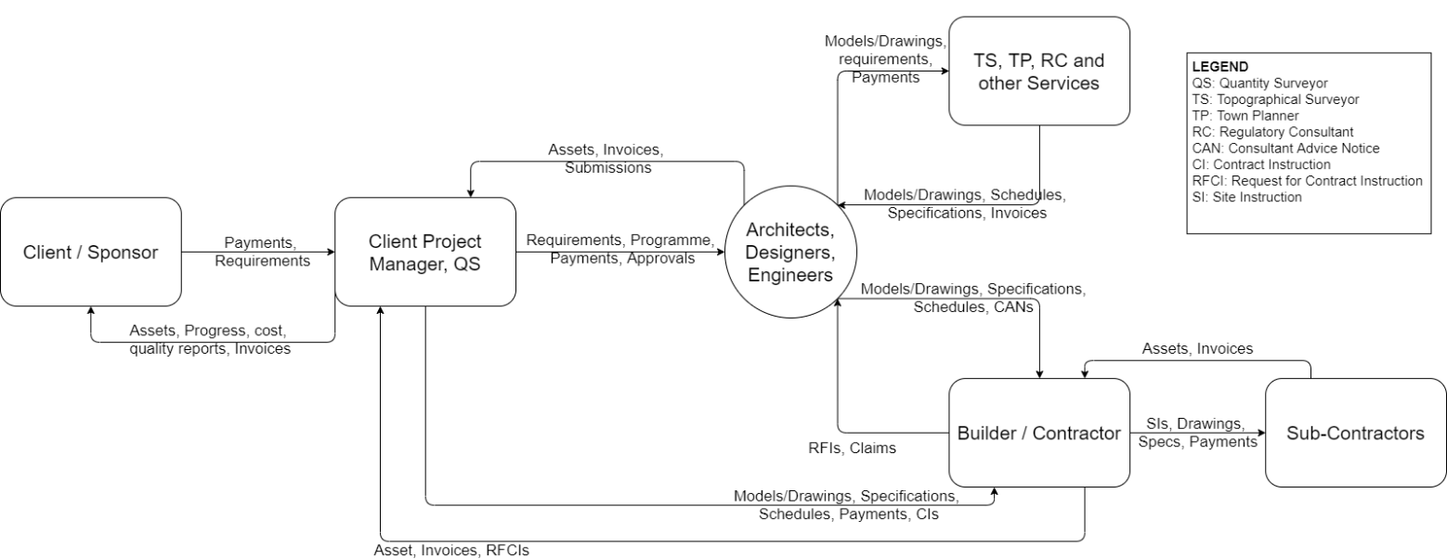
SNZ (2012) uses the hierarchy of Functions, Aggregate of Processes, Processes and Transactions to indicate different levels of analysis. The first step was to review the context within which the work processes take place. With Design as the key “Function” for process analysis, the contextual diagram establishes the context and boundaries of the system to be modelled along with the system’s relationship with the external agents. It provides the foundation for conducting a functional and sequential analysis. In this case, the central “system” is represented by the critical contributors to the project’s design information database—Architects, Designers and Engineers and the other parties involved in the project are represented as external agents, as shown in Figure 3.
Figure 3: Contextual Diagram for Design Function
Design in a project can include many disciplines depending on the nature and complexity of the project. However, three key “Aggregate of Processes” have been identified in this study as the significant contributors to achieving the design goals of a project; namely, Architectural, Structural and Building-services design. Therefore, these Aggregate of Processes were mapped and grouped as per the project phases using Data Flow Diagrams. Figure 4 illustrates the mapped Architectural process, while the other processes are placed for reference in Appendix A. Within these Aggregate of Processes, multiple “Processes” were observed to involve the contribution or collaboration of more than one party towards the outputs. Although the combination of parties involved and its deliverables are unique to each process, the tasks performed by the parties within these processes had common characteristics based on the nature of the process and the parties involved. Therefore, four common processes were identified:
- Processes that involve design coordination between external parties who contribute to the design authoring or modelling
- Processes that involve design review between multiple users who are responsible for design authoring or modelling
- Processes that involve both design coordination and review activity between the design authoring or modelling parties
- Processes initiated by the builder where they request for information (RFIs) from other external parties.

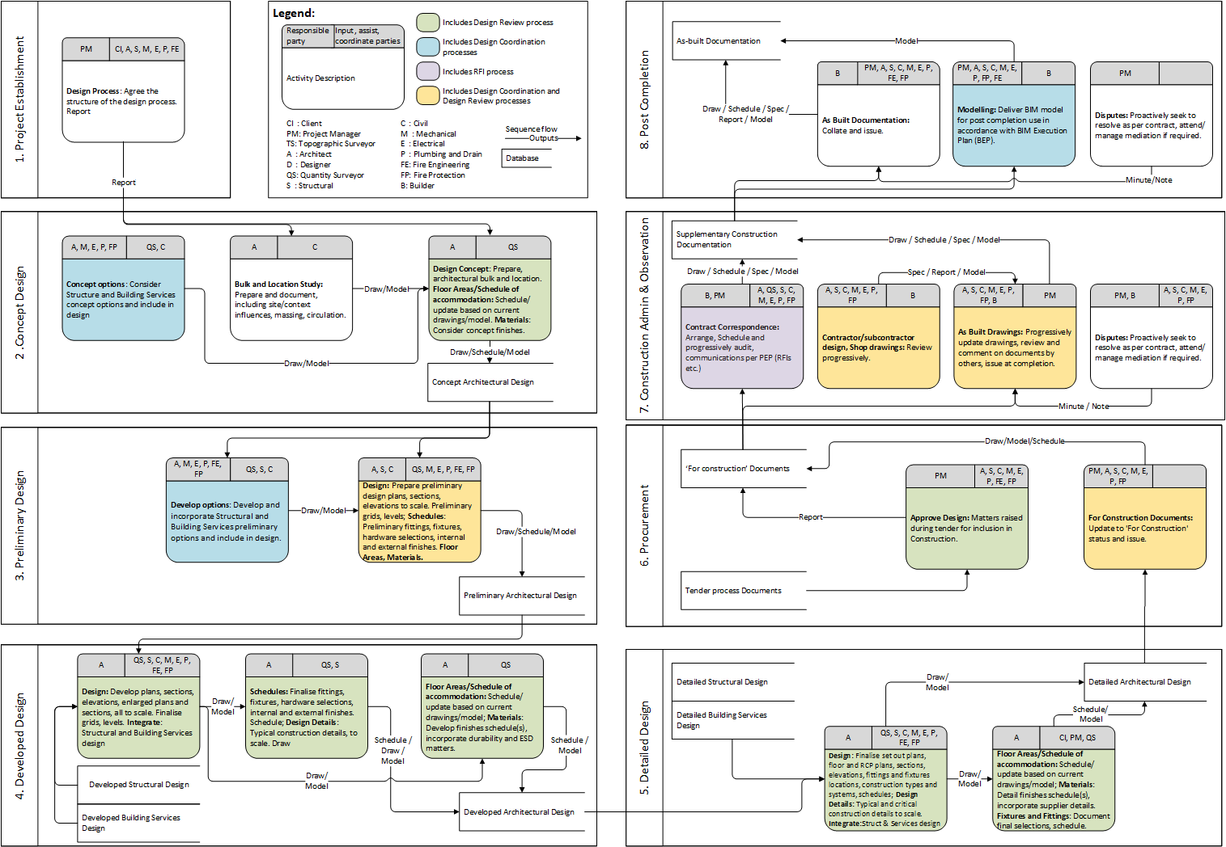
Figure 4: Data flow diagram: Aggregate of processes: Architectural Design

Blockchain integrated processes
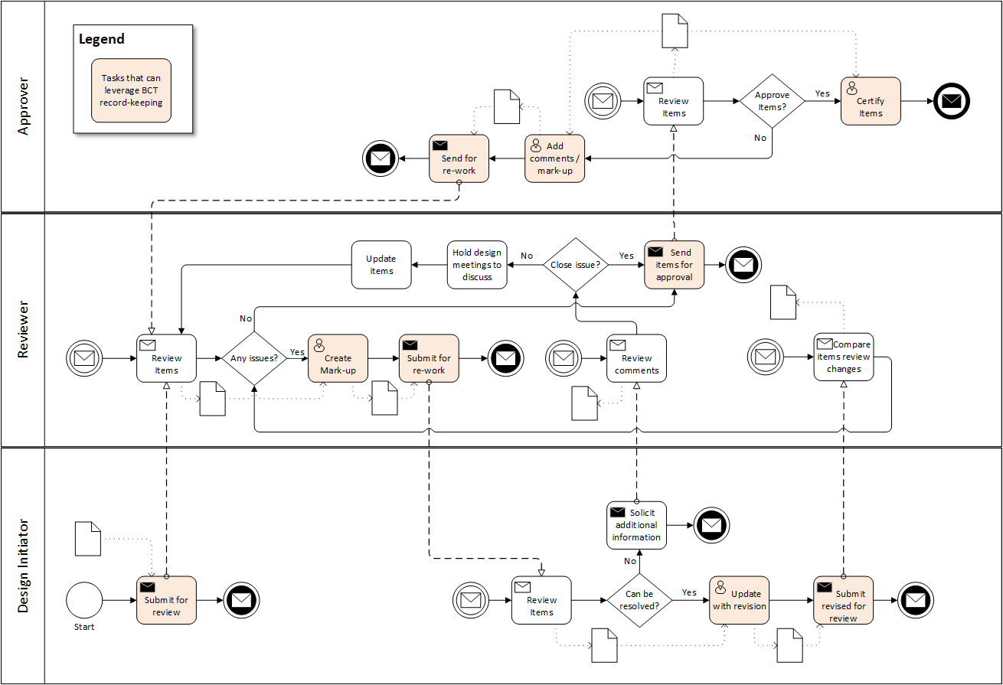
The four common processes identified were further decomposed to map the information flow within these processes and to isolate the “Transactions” that represent the information exchanged between the parties. Process maps based on BPMN notation were developed to represent the step-by-step process followed by the parties. Based on these developed process maps, we identifiy the integration points for Blockchain Technology. The process maps were analysed to identify the key information exchange transactions and decision points critical from a record-keeping perspective. These transactions and decision points were highlighted on the developed process map as shown in the below Figures 5-7. Therefore, recording these transactions on a blockchain database can potentially benefit the project in case of disputes, and further help the contributing and reviewing parties control their liabilities towards any contributions or decisions they make. Moreover, it can also guarantee the much-needed security of the actions that develop the project information.
Figure 5: Design Review process
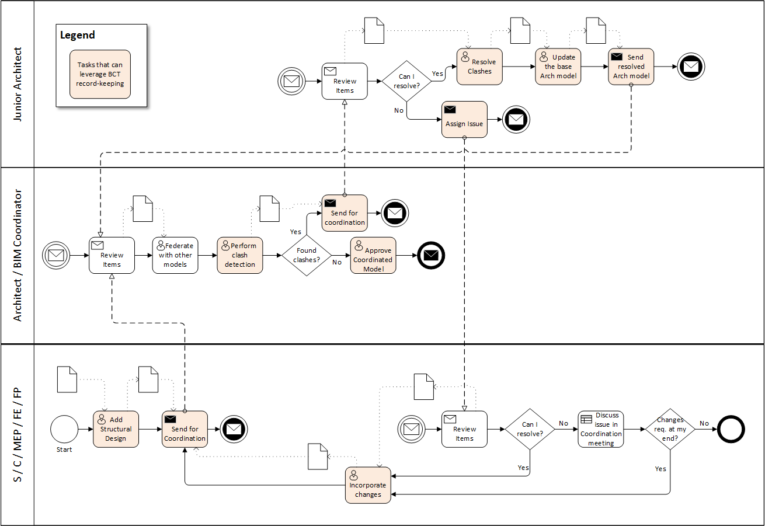
Figure 6: Design Coordination process
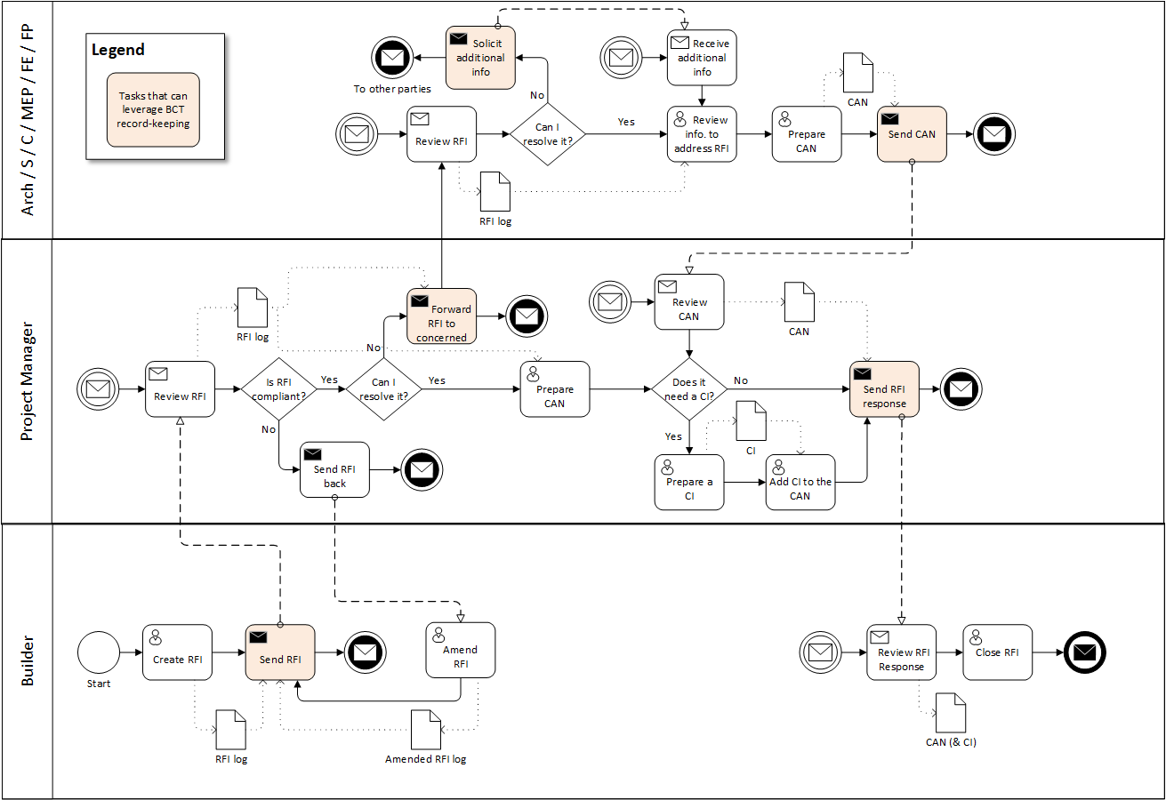
Figure 7: Request for Information (RFI) process

Prototype Development for Proof-of-Concept
In the mapped processes, the project participants may exchange information using their choice of tools, which include email, or a cloud-based information management system such as Autodesk BIM 360. However, whenever information is exchanged for tasks identified as critical, the participants must record these on the blockchain. Therefore, the prototype aims to enable this key functionality and thereby facilitate the testing of the proposed blockchain-aided process maps.

Key Requirements
The essential requirement of the prototype to be developed is that it accomplishes the following:
- It uses blockchain technology to record transactions between project participants so that the records are secure, immutable, and not third-party dependent.
- It enables parties to securely log into the system based on credentials stored on the blockchain verified through smart contracts, therefore providing security independent of any service provider.
- The transactions recorded on the blockchain must include the critical metadata associated with any piece of information for a complete snapshot of the transaction.
- The transaction records should record the hash (a unique fingerprint) of files of different sizes and formats that could be exchanged in a project, thereby allowing participants to record all kinds of file exchanges without any restrictions.
- It should exhibit the ability to record changes related to BIM models on the blockchain as they are one of the key dynamic documents.
- A party that aims to modify or integrate a received BIM model should be able to access its historical changes recorded on the blockchain to keep their liability limited to only what they modify or add to the model.
- Any party working on the project should be able to verify the existence, integrity and authenticity of information they hold through its records stored on the blockchain. In cases of conflicts between parties, this would allow the originator or modifier of the conflicting information to be traced, thereby preventing parties from acquiring liabilities.

System Architecture
For meeting the blockchain end of requirements Ganache, a development or sandbox blockchain that provides a built-in user interface for viewing user accounts, and examining transactions and blocks, was used for simulating Ethereum, a public blockchain. A public blockchain was chosen due to its superior security compared to private or consortium blockchains for record-keeping of legally critical information exchange transactions (Kinnaird & Geipel, 2017). Since Ethereum supports the development of decentralised applications (DApps) that are Turing complete (Xu et al., 2017), a smart contract was written with necessary gateway mechanisms to create and channel transactions to the blockchain. A web-based Integrated Development Environment called Remix was used for coding the smart contract.
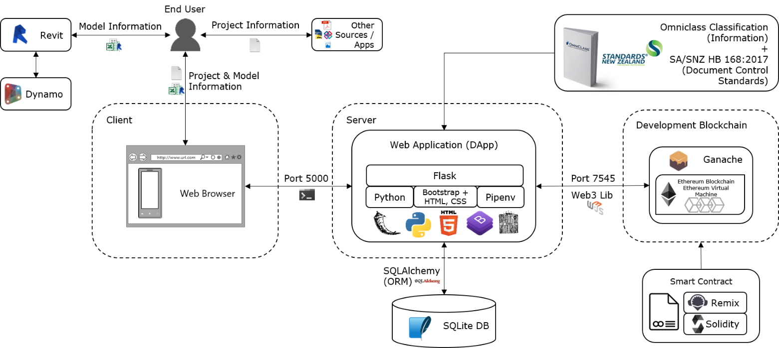
The prototype system uses Autodesk Revit 2020 as the example design authoring package as it provides connectivity with external databases which could be crucial for plug-ins development using Revit’s API. Moreover, we planned to use the Dynamo package that is compatible with Revit for extracting model-related data along with other metadata. Microsoft Excel was used as an interim data store for holding the extracted information from Revit and passing it on to the DApp. For the development of the DApp, we chose a web-based application built on the Flask framework that runs on Python programming language. In addition to using blockchain as a database, Flask-SQLAlchemy, an open-source SQL toolkit and object-relational mapper for use with Flask framework, was employed. Finally, Adobe XD was used to create a mock-up for demonstrating a potential integration of the developed application into a design authoring software such as Autodesk Revit through a plug-in type interface. Table 3 provides a summary of the technology choices, decisions taken and the rationale for the selection towards the development of the prototype system. To incorporate standardised terminology, we used OmniClass®, a comprehensive classification system for organising project information for the construction industry (CSI, 2012), and the SA/SNZ Document Control Standards (SNZ, 2017) for metadata and document status terminology. It was used as a complementary framework to align with the CIC design guidelines. Figure 8 illustrates the relationships between these different components.
Figure 8: System Architecture
Technological decision | Available choices | Selection criteria | Selected technology | Rationale for selection or rejection
Blockchain/DLT design | Public permissionless, Public permissioned, Private permissionless, Private permissioned (Hunhevicz & Hall, 2020) | Superior security for record-keeping of legally critical information exchange transactions, independent of any third-party | Public permissioned blockchain | - Information on a public blockchain is secure due to the security provided by its community of users and it is independent of any third-party.  - Smart contracts deployed on a public blockchain can control access to information recorded on the blockchain.
Type of public blockchain | Ethereum, Bitcoin | Turing completeness (Xu et al., 2017) | Ethereum | - Ethereum is the oldest and most popular public blockchain that supports decentralised applications that are Turing complete.  - Bitcoin blockchain records only the transactions of bitcoin cryptocurrency and is not suitable for other general purposes.
Testing network | Ethereum mainnet, Ethereum testnet, sandbox/local blockchains such as Ganache emulating Ethereum blockchain | Ability to demonstrate the proof-of-concept: run simulation tests, record, inspect and access state with an interface to view transactions. | Sandbox/locally emulated Ethereum blockchain using Ganache | - Ganache, a development or sandbox blockchain, emulates the Ethereum blockchain and provides a built-in user interface for viewing user accounts, examining transactions and blocks.  - Ethereum testnet is generally used for a more robust examination of smart contract execution to test the code’s efficiency and cost-effectiveness—which is not the scope of this study.  - Operation on Ethereum mainnet involves used of Ether, which can cost some money, so it is not ideal for development or testing purposes at prototype stages.
Smart contract language | Solidity, Vyper, Yul | Facilitate the delivery of key requirements of the prototype system, quick learning curve, availability of helpful resources and user community, familiarity of syntax | Solidity | - Solidity is the recommended language for writing smart contracts for a beginner as there many tutorials, learning tools and helpful developer community available (Ethereum.org, 2021b).
Integrated Development Environment (IDE) for smart contract scripting | Remix – web-based IDE, Visual Studio Code | An IDE that can debug the smart contract code, facilitate testing, and provide typical IDE features such as syntax recognition | Remix IDE | - Remix IDE does not require any installation as it can be used on the web browser, and it has modules for testing, debugging and deployment of the smart contract.
BIM design authoring package | Autodesk Revit, Rhinoceros, ArchiCAD, many other similar packages | Multi-discipline, parametric BIM modelling software that is used extensively and supports scripting | Autodesk Revit | - Autodesk Revit is generally well-known and accepted tool for BIM modelling in the industry. Revit models are used across disciplines for analysis and clashes identification.  - It lets users run scripts through Dynamo and Revit API that enables automation and helps streamline BIM workflows.
Model changes extraction | From an exported IFC file, using Dynamo scripts, creating a plug-in using Revit API | Capture adding, deleting or modification of elements in a BIM model to support proof-of-concept | Dynamo scripting | - Simple interface integrated within Autodesk Revit enables the creation of algorithms to extract contents of the BIM model and extracts any changes when the user runs the script.  - Extracting using the IFC model or Revit API plugins could also deliver similar results, but they are complicated and take away the focus from the blockchain part of the system architecture.
User facing application platform | Desktop application, Mobile application, Web application | Support connection to smart contracts and be accessible to all users regardless of the device or platform they use | Web application | - Web applications can run on almost any browser irrespective of the operating system or the device. They do not need any installation. This study did not explore other choices as it aims only to deliver a proof-of-concept.
Application framework | Flask, Django, Angular, React.js, Vue.js, many other similar libraries | A quick learning curve, support a web3 library integration, and enable the development of a simple interface that handles forms, login portal. Need not necessarily be scalable. | Flask framework | - Flask is based on Python, a simpler programming language than others, and we are proficient in its use.  - Python has a web3.py library, which is not as extensive as web3.js but has enough functionality for this proof-of-concept prototype system.
Supporting database manager | SQLite DB, MySQL, many others | Allow simple integration to store secondary information such as project information classification and relational data such as linking the username from blockchain to their profile picture | SQLite | - SQLite is an open-source tool that is free to use. The DB Browser for SQLite is an easy, free to use visual tool that helps in the development stage of applications.  - Other tools may perform the same functions as SQLite; however, this was chosen considering its ease of integration with Flask using SQLAlchemy, a python SQL toolkit and object-relational mapper (ORM) for using SQL DB with python.
Table 3: Selection and rationale for the technology choices made for the development of the prototype system

Development process
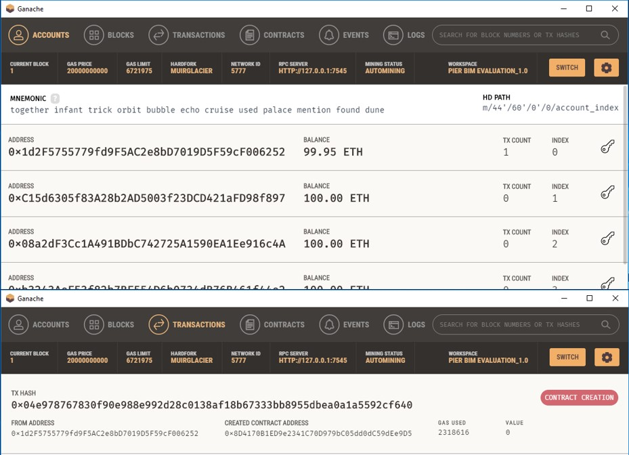
First, a smart contract was written to facilitate the storage of the transactional records on the Ethereum public blockchain. Smart contracts are deployed as bytecode on Ethereum; hence the DApp uses Application Binary Interface (ABI) code generated by Remix that facilitates the system’s interaction with the smart contract once it is deployed on the blockchain. Once the smart contract is deployed, Ganache reflects the contract creation as the first transaction on the blockchain (Figure 9).
Figure 9: Sandbox Ethereum blockchain generated on Ganache
One of the essential functional requirements is to export model-related information from Revit. To achieve this, algorithms were developed first to extract test data from a Revit model to an MS Excel file and then to update the exported file when the user changes the model. Dynamo was used to execute these algorithms by building dynamo graphs. Figure 10 shows the graph used to extract data from Revit and the user’s interface to do the same.
Second, a web-based DApp was created using Flask’s framework. The connection between the web application and the smart contract deployed on the blockchain is established using the previously generated ABI code.

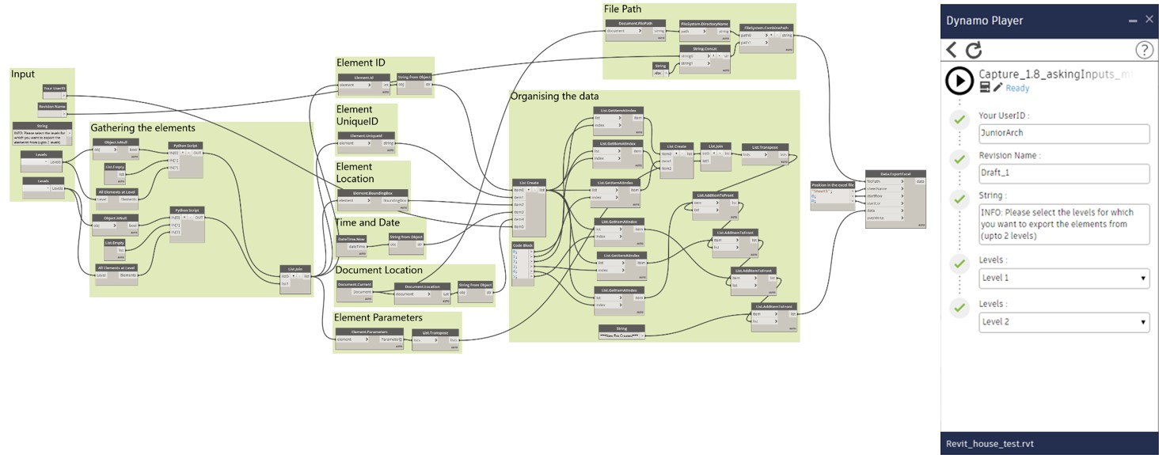
Functions of the Prototype System
Figure 10: Dynamo graph to extract data from Revit and user interface to execute the script
The prototype offers a few key functionalities that help in achieving the requirements stated in Section 5.1. These functionalities are:
First, adding wallets to approved lists (AW): The account used while deploying the smart contract activates the “Constructor function” which makes the holder of that account the Administrator of the project. The Administrator can add new wallets to the project using the web-based user interface (UI) shown in Figure 14, which can then be distributed to the other parties on the project for adding transaction updates to the DApp.
Second, register user (RU): Every user who wants to record transactions on the DApp needs to register using the approved wallet address provided by the Project Administrator. Figure 11 shows the procedural steps that need to be carried out, and Figure 15 shows the UI for carrying out this function.
Third, capture and extract BIM model data (CE): Once a user creates a BIM model on Revit, they can use the Dynamo player to capture the current state of the model. The function collects the geometrical properties, other parameters and unique IDs of every element of the model along with metadata such as the time, date and location of modification (changelog). This information is extracted to an MS Excel file and parked next to where the Revit model is stored. Figure 16 shows this demonstration in Revit.
Fourth, compare BIM model to its previous version and extract modifications (OE): In the scenario where a user receives a model and its changelog, and they wish to make modifications to this model, this action lets the user extract only the modifications that are a result of their actions. It inspects the changelog file and the modified BIM model to append the modifications that were created by the user to the existing changelog file. Figure 17 shows the execution of these functions in Revit.
Fifth, record a transaction (RT): With the user logged in, they can record a file-exchange transaction; and record a BIM model change log transaction (RBT). The users can record the contents of the changelogs extracted from Revit files to the blockchain. Figure 12 represents the process executed when the RBT function is called, and Figure 18 and Figure 19 show the UI for performing RT and RBT functions, respectively.
Sixth, trace or verify a file (TV): Any project user (registered or unregistered with the project) in possession of a document relating to the project, can trace the integrity, authenticity and chain of approvals of that file. This process is shown in Figure 13, and its UI is presented in Figure 20.
Seventh, project transaction updates (PTU): In the home page of the application, the transactions added by all the registered users are presented as “Project Transaction Updates” clearly and intuitively to the users (Figure 21) with hyperlinks to more specific streams of transactional records.
The tasks and data associations labelled in the process diagrams illustrated in Figures 11-13 are clarified through the detailed supplementary description inAppendix B. It includes information on the data storage variables used and the inputs, outputs and tasks carried out at the execution of the various functions that enable the DApp to achieve its functionalities. Storage on the blockchain is marked using “s(x)” and data stored for relational mapping are marked using “d(x)”. Smart contracts include Modifiers “m(x)” and Events “e(x)”in addition to Functions “f(x)”. Modifiers enable smart contracts to restrict user access to functions based on any predefined criteria, whereas events enable other applications to subscribe and listen to changes made to the smart contract. The DApp also includes Forms “fo(x)” that enable users to input data and other functions that carry out tasks to prepare the data before adding it to the blockchain.
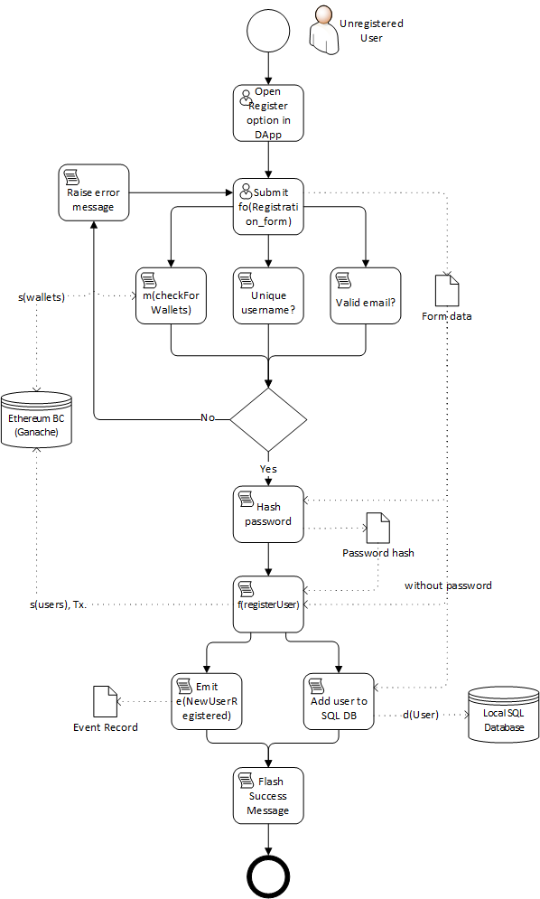
Figure 11: Function RU: Register User: Process diagram
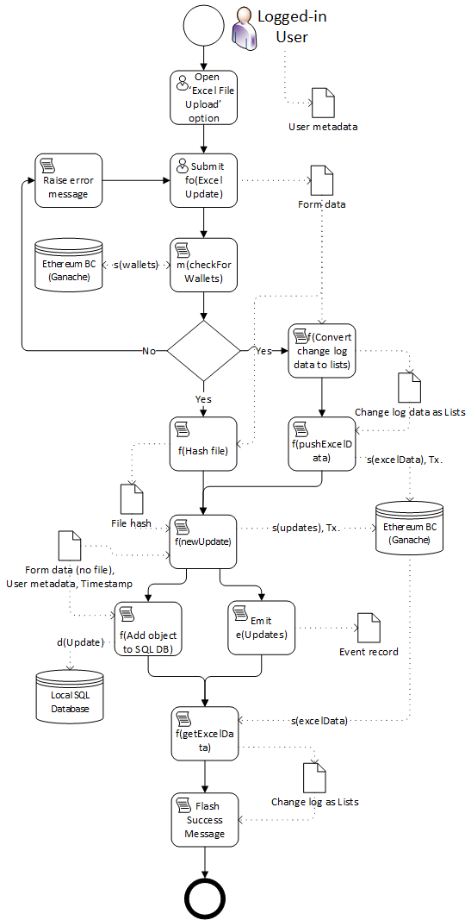
Figure 12: Function RBT: Record a BIM model change log: Process diagram
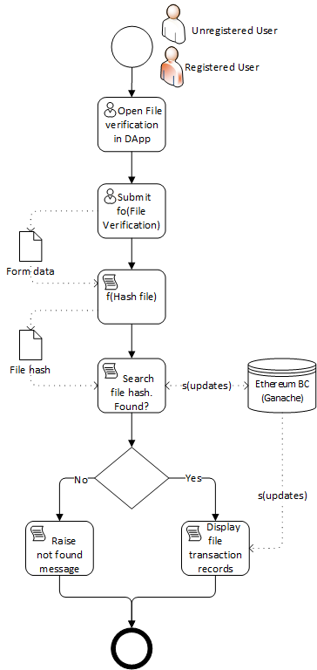
Figure 13: Function TV: Trace or verify a file: Process diagram

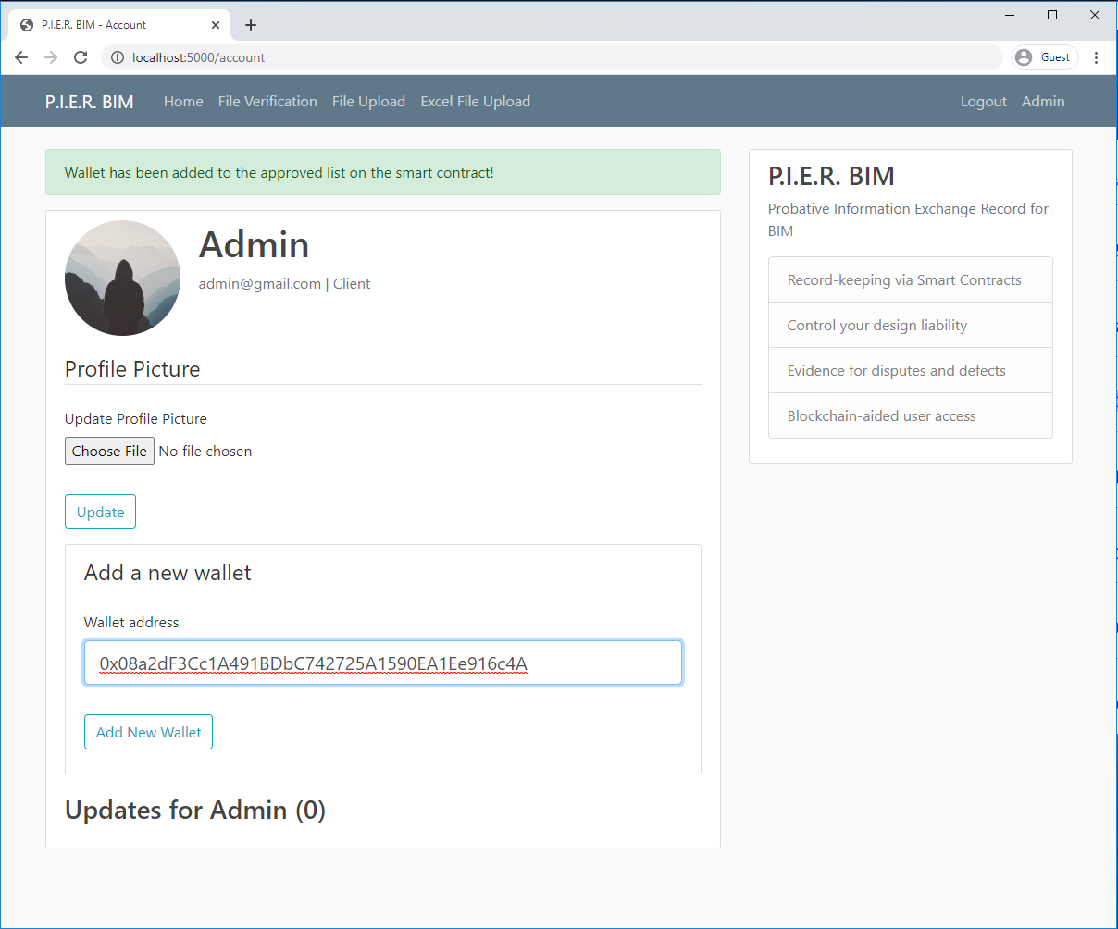
Figure 14: Function AW: Add wallets to approved list
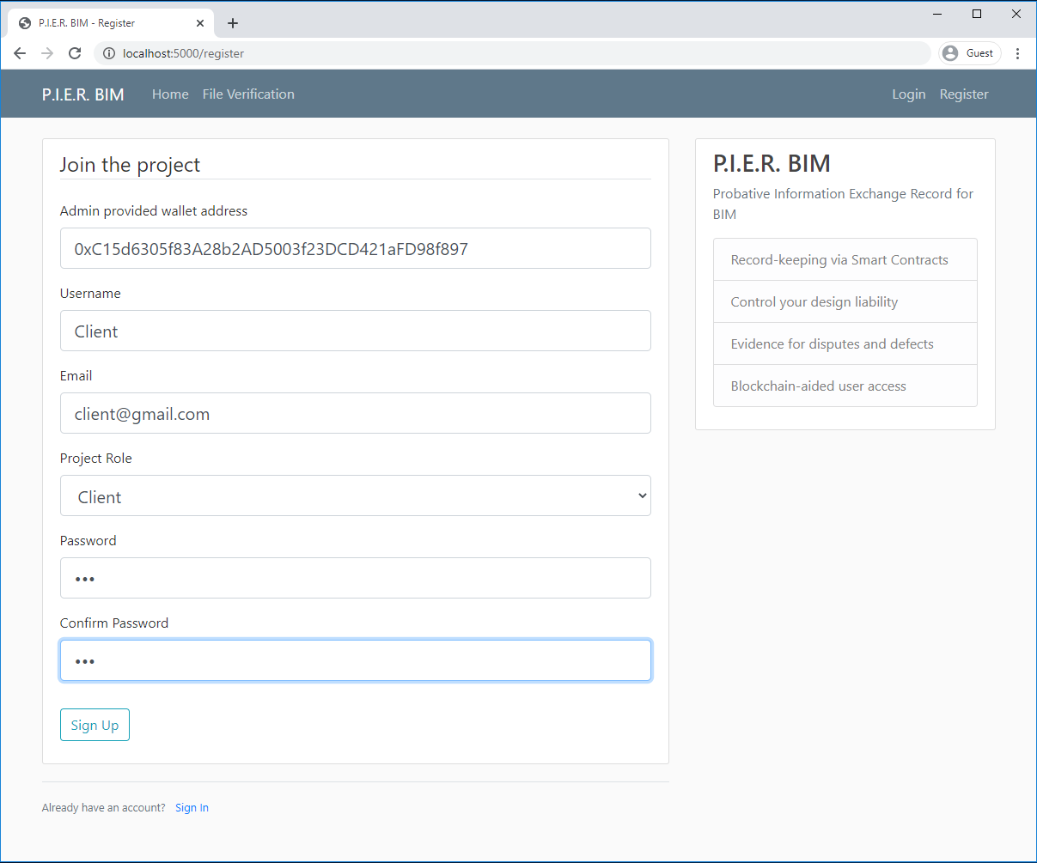
Figure 15: Function RU: Register User

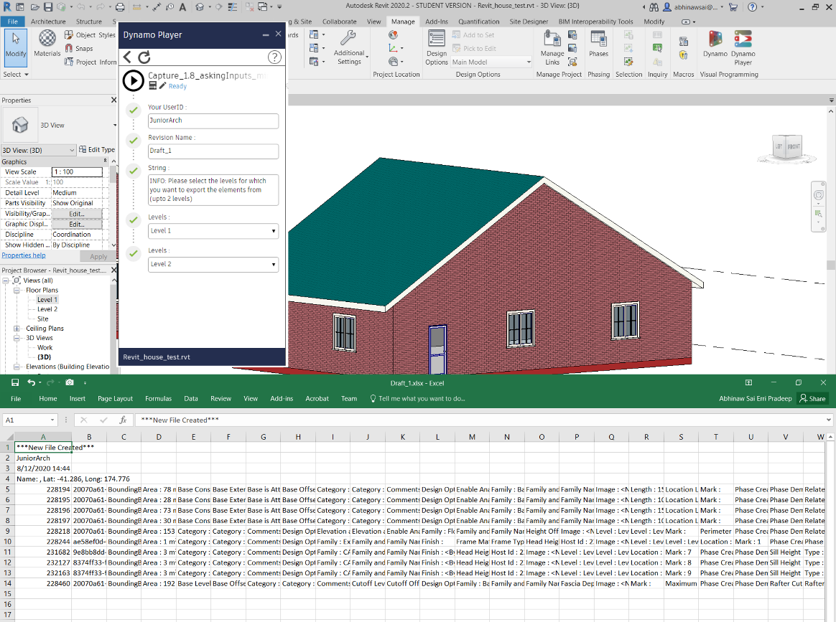
Figure 16: Function CE: Capture BIM model data
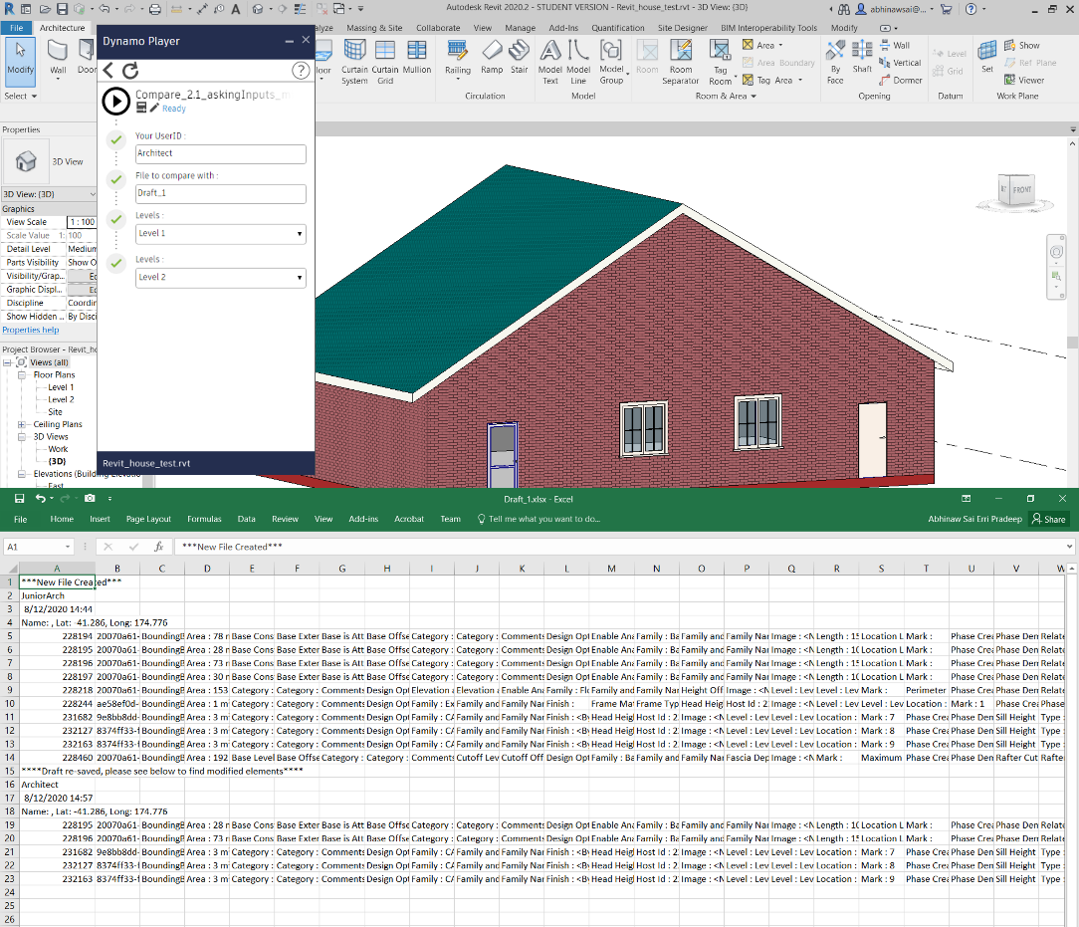
Figure 17: Function OE: Compare and capture BIM model modification data

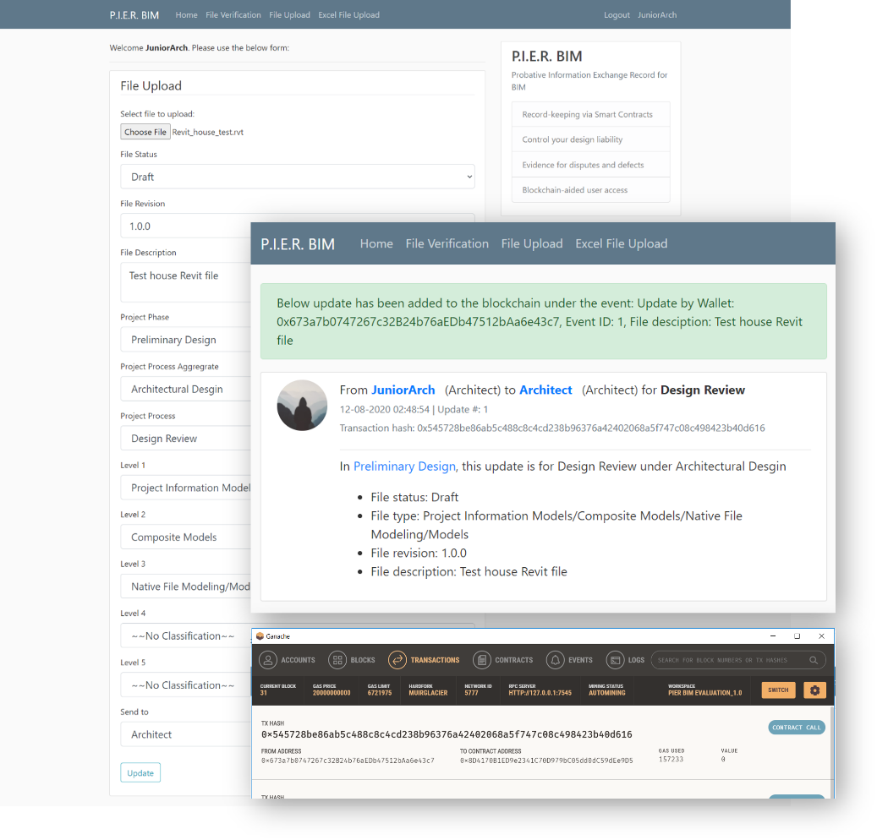
Figure 18: Function RT: Record a Transaction
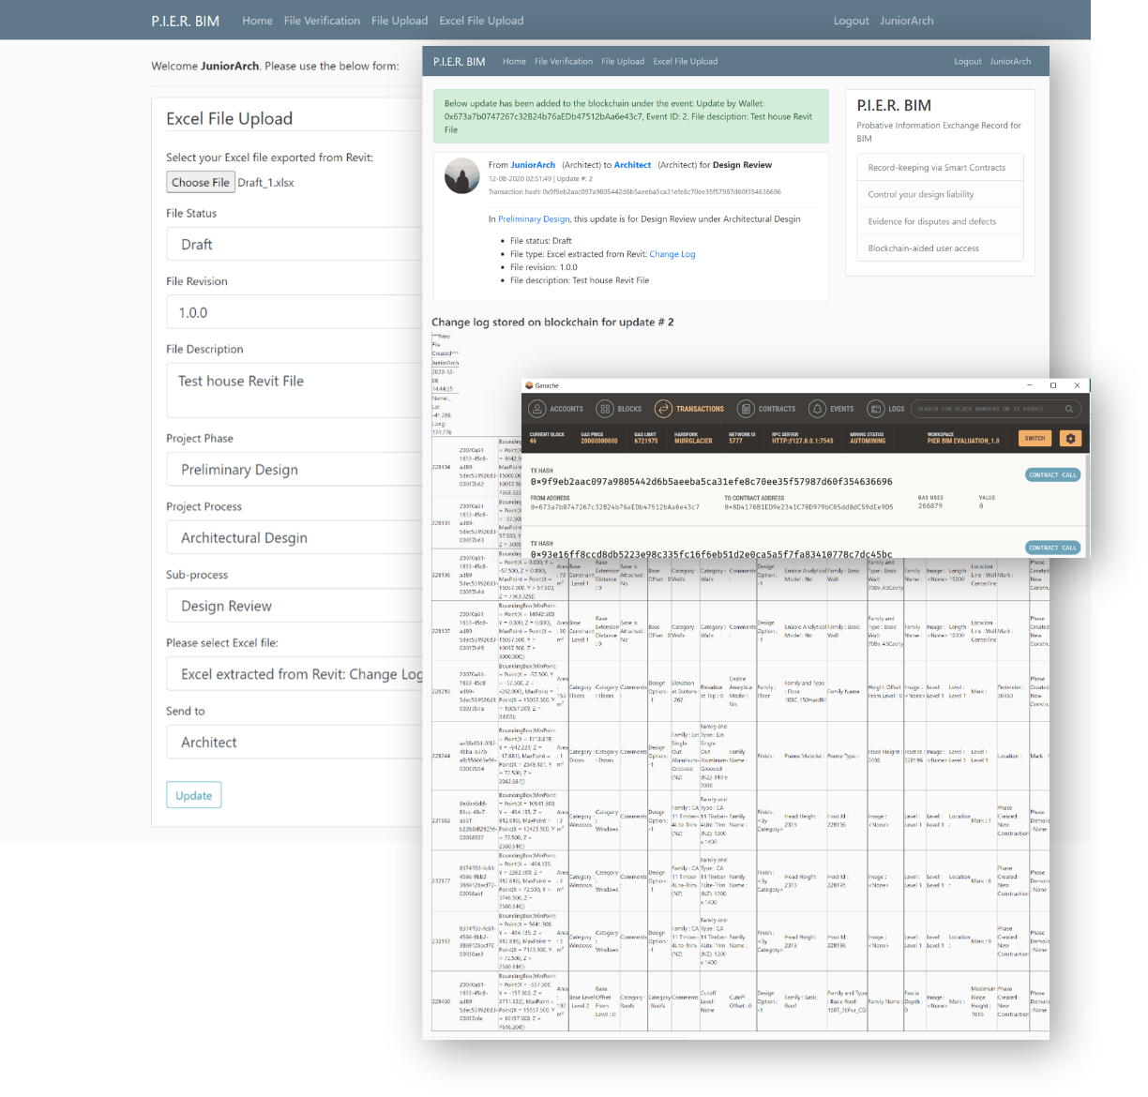
Figure 19: Function RBT: Record a BIM model change log
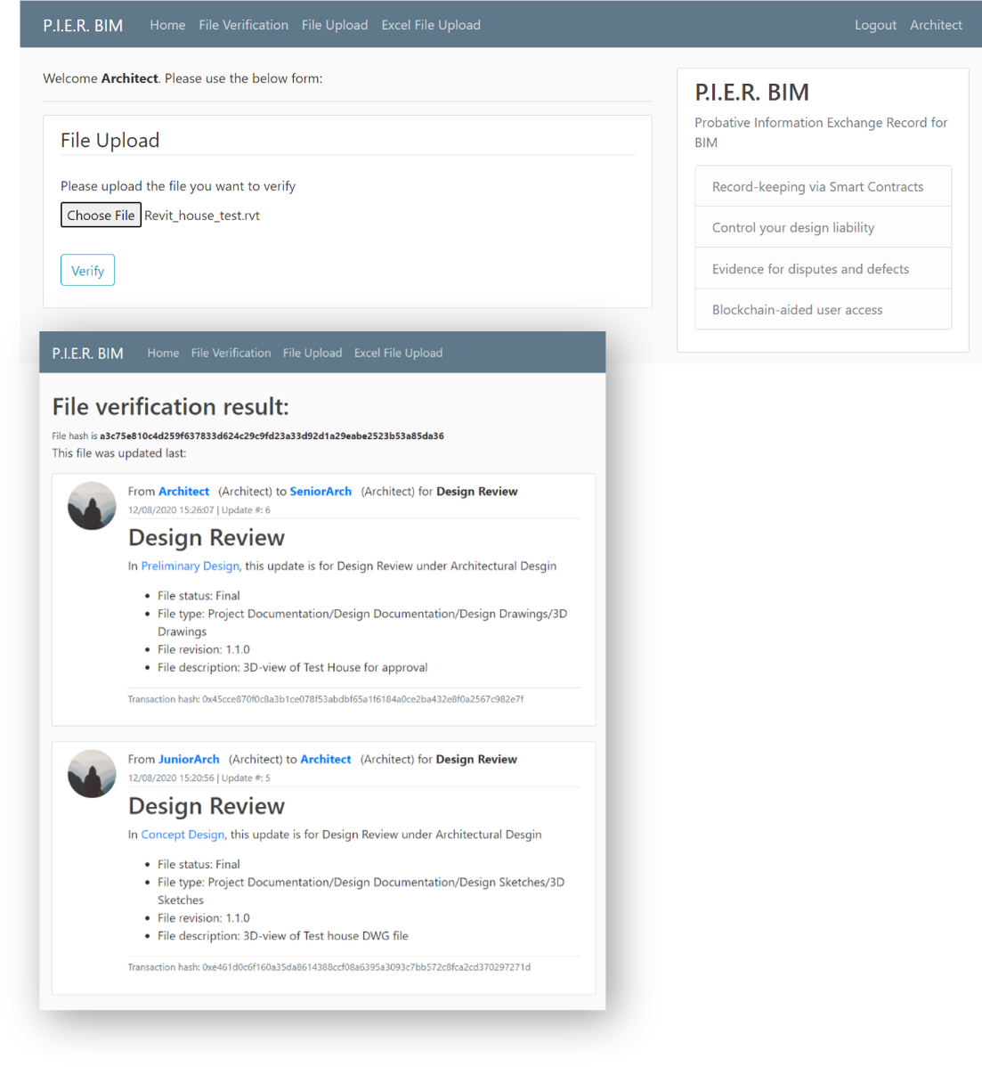
Figure 20: Function TV: Trace or verify a file
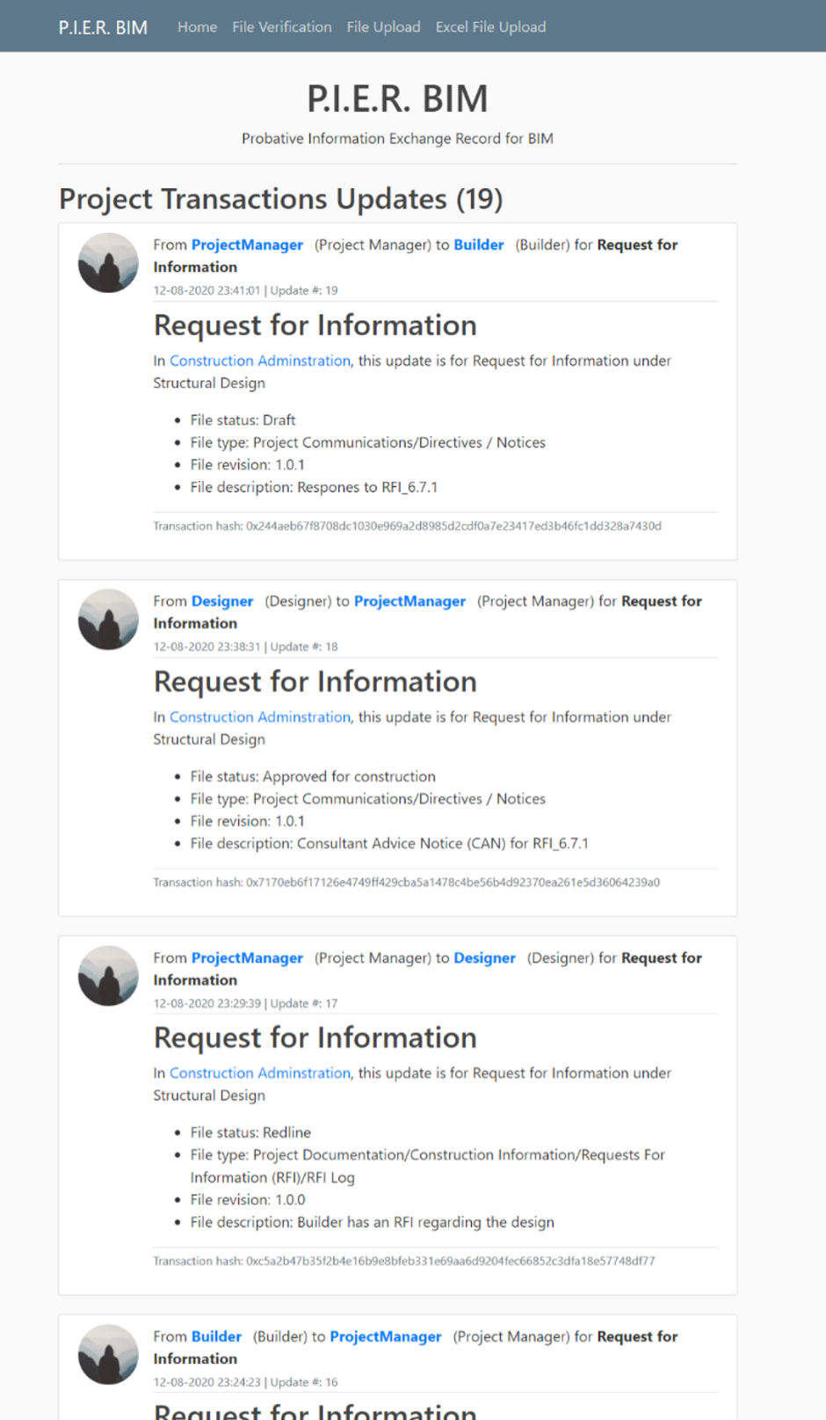
Figure 21: Function PTU: Project Transaction updates

Ideal workflow mock-up
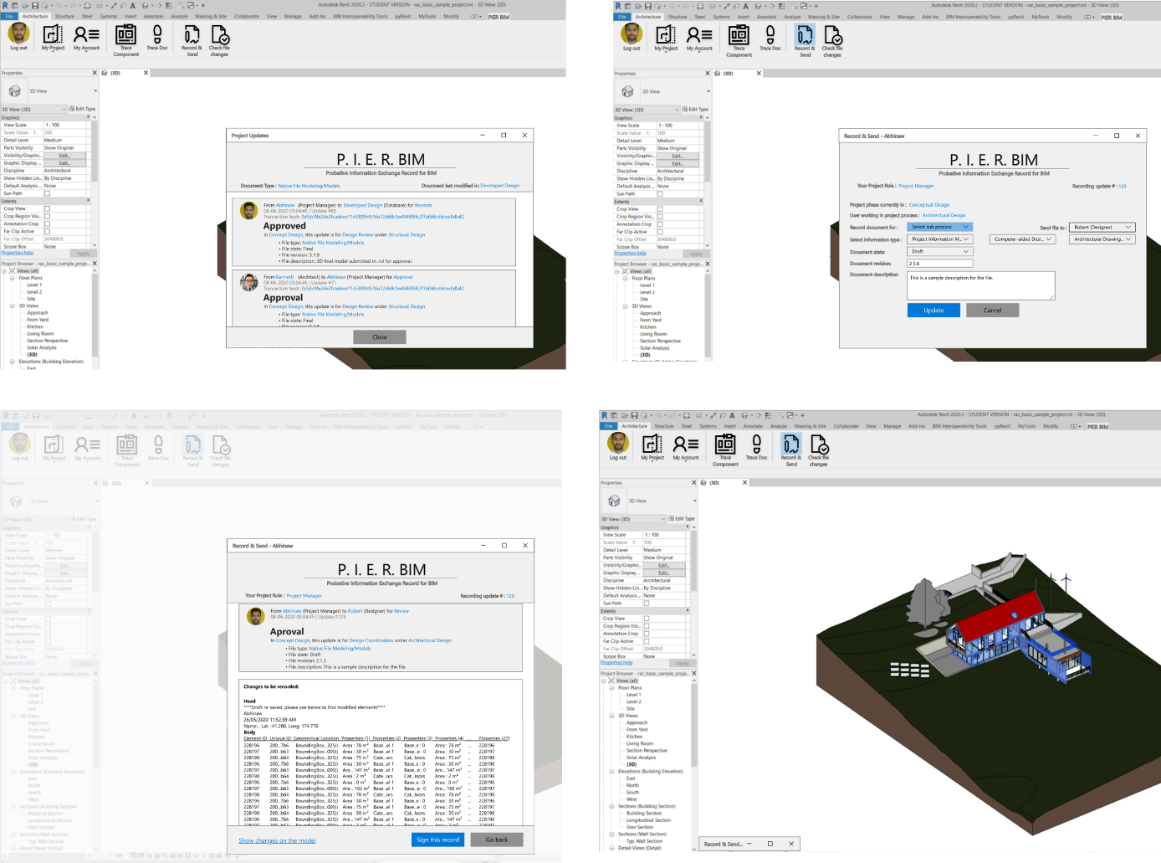
As this is a prototype, it does not aim at a commercial solution for integrating blockchain within a users’ daily workflows. However, blockchain technology is best when it is applied within the existing information authoring or exchange software architecture, and when it requires minimum additional user action to what is already performed (Erri Pradeep et al., 2019). Since the web-app demonstrates the functionality of the prototype, a mock-up for an add-in on Revit was created using Adobe XD to give the readers a visual representation of how the functionality of the prototype could look if it were developed as a plug-in for Revit (illustrated in Figure 22).
Figure 22: Use of BCT system within BIM tools mock-up

Implementation of Prototype & Validation of Proposed Process Model
Our study aimed to validate the proposed process model through the implementation and evaluation of the prototype system; evaluation based on a prototype has been regarded as an acceptable method for DSR studies (March & Storey, 2008). The prototype system requires multiple participants to be on-board for a reasonably long duration to test a technology that has not yet received mainstream adoption, especially in construction or related industries. Moreover, a complete evaluation of the proposed process model requires analysis over the whole project’s duration to help participants realise the artefact’s potential benefits. Therefore, considering the complexity of this requirement, we took a more straightforward yet practical approach of analysing with scenarios-based evaluation. Similar evaluation methods are seen in Bell, De Cesare, Iacovelli, Lycett, and Merico (2007), Ilhan and Yaman (2016), Lee, Wyner, and Pentland (2008), Ma, Zhang, and Li (2018) and Zhu and Augenbroe (2006).
A simulated project use-case was set up to evaluate the prototype. We acted in the role of participants to simulate project execution. The three project processes developed during the process modelling stage—design review, design coordination and request for information—were simulated by creating information exchange transactions. Additionally, two scenarios of potential conflicts during construction and post-construction stage (one scenario for each stage) are simulated. The next sub-section describes the simulations conducted. For the purposes of this demonstration, only the key exchange transactions that are of legal significance are simulated for the virtual project, leaving out any non-critical transactions that are part of the processes. However, in reality, projects will include other exchange transactions that are not legally significant, and the project stakeholders may record only the critical transactions identified in the proposed process maps illustrated in Section 4.3. Various functions of the prototype explained in Section 5.4 are cross-referenced with abbreviations summarised in Table 4.
Abbreviation | Function
AW | Add wallets to the approved list
RU | Register User
CE | Capture BIM model data
OE | Compare and capture BIM model modification data
RT | Record a Transaction
RBT | Record a BIM model change log
TV | Trace or verify a file
PTU | Project Transaction updates
Table 4: Functions’ abbreviations summary

Processes Simulations

Design Review
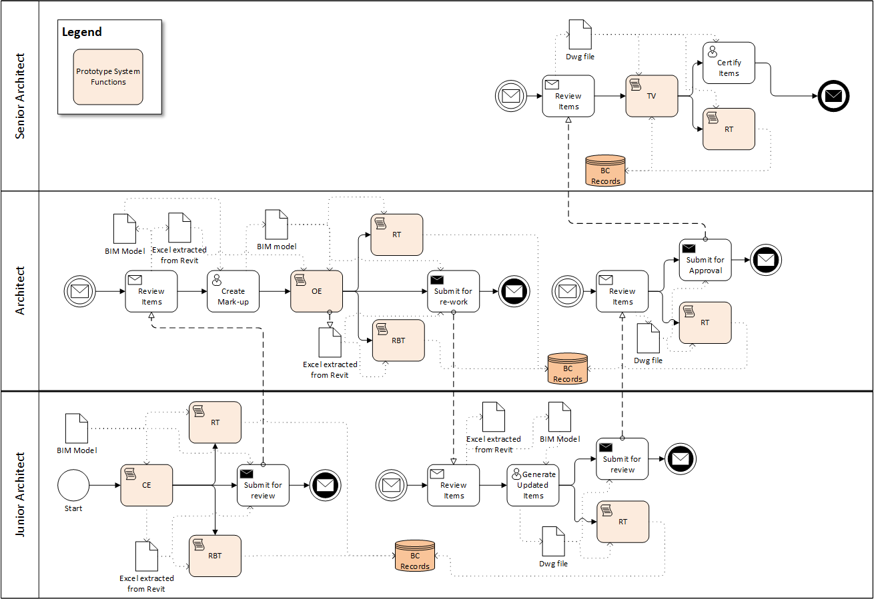
The scenario assumed is a junior architect needs the architect and the senior architect to review an architectural BIM model authored on Revit as part of preliminary design. The objective of this process is to obtain a certified drawing file from the BIM model (Figure 23). The junior architect first creates the model and extracts the changelog using the CE function. Next, the model file is sent to the architect, and the transaction and the changelog are recorded using the RT and RBT function. Next, when the architect logs in, the transactions show up on the DApp’s home screen (PTU) and in the account tab of the architect as well. In this scenario, the architect makes some changes to the Revit file. Next, they extract the changelog using OE function and use the RT and RBT functions to record the changes and send it back to the junior architect. The junior architect then includes or adopts these changes and extracts a DWG (drawing) file from Revit. The DWG file is sent to the architect for review and recorded to the project transaction updates using the RT function. The architect reviews the received file and further sends this file to the senior architect for approval using the RT function. The senior architect can verify and trace the origin of the file using the TV function before signing this off as approved. Finally, the file is sent to the project manager under “certified” file status and recorded on the blockchain using RT function. This completes the cycle of a design review process using the prototype.
Figure 23: Prototype implementation: Design Review

Design Coordination
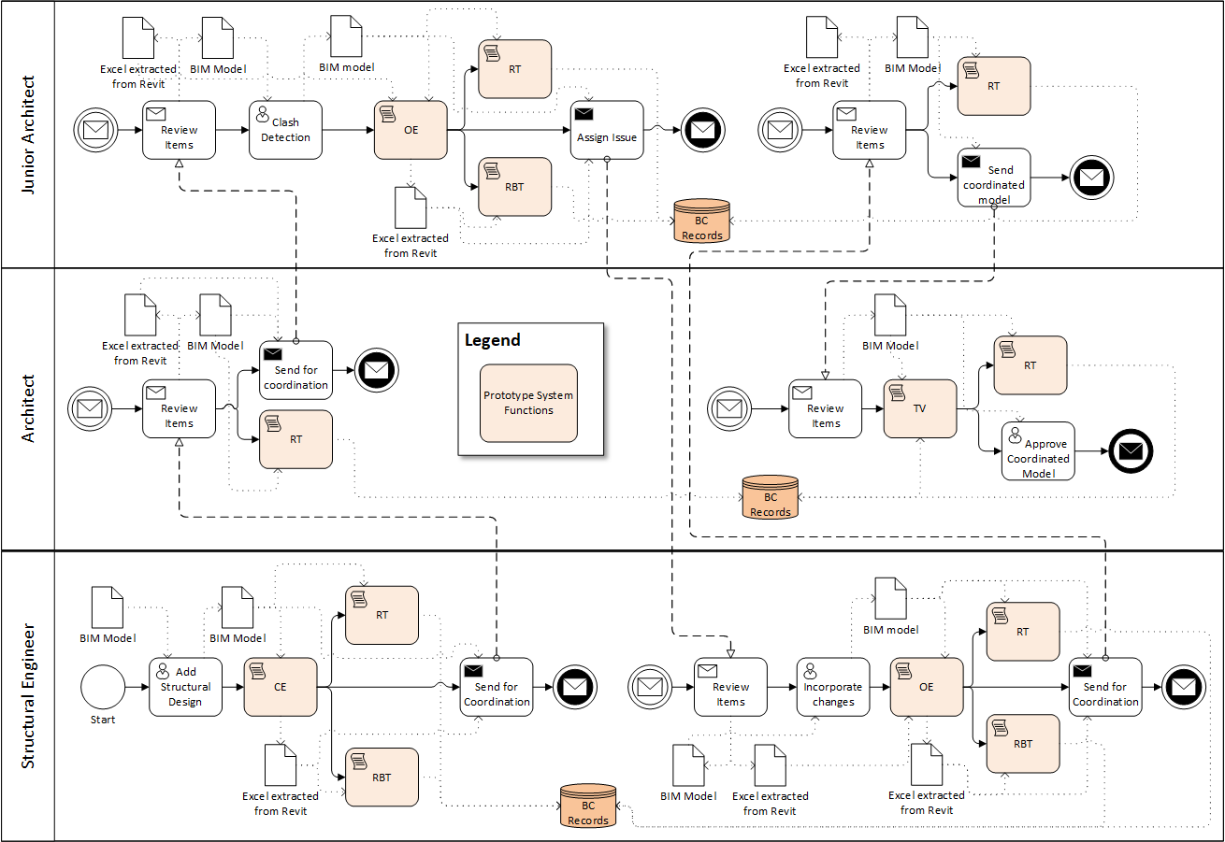
The scenario assumed here is that the structural engineers (SEs) have added structural design to the BIM model and they want to coordinate design clashes with the architects, who also take the role of BIM managers in this scenario. The objective of this scenario is for both the parties to have a coordinated certified BIM model (Figure 24). First, the SEs add their structural design to the model and send it to the architect to check for any clashes with other disciplines’ models. The SEs use functions CE, RT and RBT to record their contribution. Next, the architect forwards this to the junior architect for clash detection while performing RT function to record this exchange. The junior architect conducts clash detection and identifies issues and sends it the SEs. They perform actions OE, RT and RBT to record this transaction. The SEs make the necessary changes and perform functions OE, RT and RBT while sending the file back to the Junior Architect. Finally, the junior architect checks the resolved file and sends this back to the architect using the RT function. The architect can use function VT to trace the origin of the final file. Once verified, this is certified and sent to the Project manager and recorded using function RT.
Figure 24: Prototype Implementation: Design Coordination

Request for information (RFI)
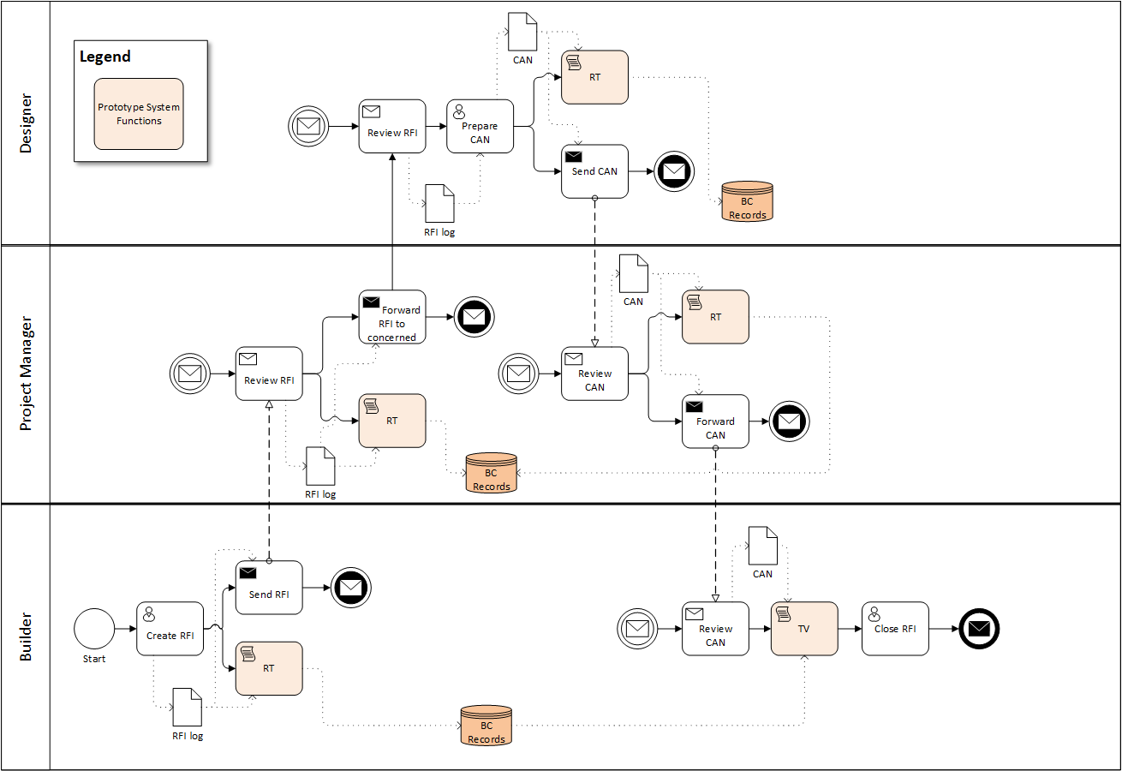
The scenario assumed here is between the builder, the project manager and the designer. The objective is to resolve an RFI raised by the builder with a response from the designer (Figure 25). First, the builder raises an RFI concern and sends the RFI log across to the PM, recording this exchange using the RT function. The PM reviews the log and sends it further to the designer as it requires input from them (RT function). In return, the designer prepares and send a Consultant Advice Notice (CAN) to the PM that provides the required information to address the RFI, again recording this using the RT function. In this scenario, the PM does not need to add a Contract instruction (CI) while returning the CAN to the builder; hence, the PM forwards this CAN to the builder and records this transaction using the RT function. Subsequently, the builder receives the requested information, and the RFI is closed.
Figure 25: Prototype Implementation: Request for Information

Dispute Scenario Simulations
Two scenarios are set up such that they result in a dispute and show how the prototype can help address these issues.

First scenario
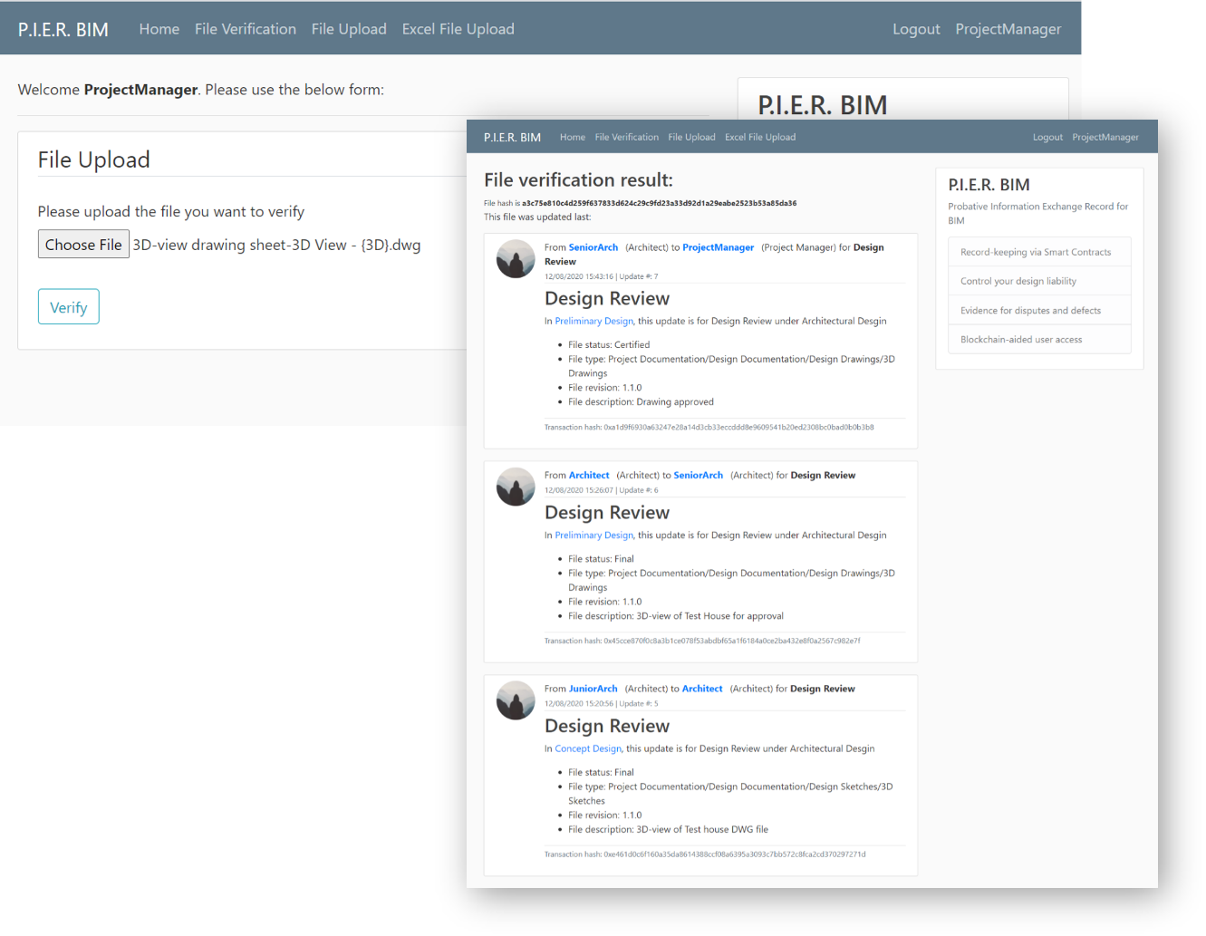
The architect makes specific changes in the BIM model to reflect client requirements. However, the updated change is not incorporated in the plan drawings passed on to the builders before construction begins. During construction, the client recognises a deviation from the agreed design. However, the builder insists that the construction was as per the approved architectural design. On the other hand, the architect insists that the final approved version had a few modifications that the builder did not comply with which has resulted in the deviation from the final design; thereby resulting in a dispute scenario. In this case, using the DApp, the builder uses the TV function (Figure 26) to check the traceability of the design plans available to them, and the system provides the thread of approvals from Junior Architect to the Senior Architect who had certified this plan. At the same time, the Architect does the same; however, this results in a message “The hash of this file is not recorded on the blockchain”, implying that either the Architect did not send the final revision to the builder or the drawing sent to the builder was an outdated version. Therefore, this helps establish evidence for the builder to resolve this dispute.
Figure 26: Dispute Scenario: PM finds the trail of drawing file under dispute

Second scenario
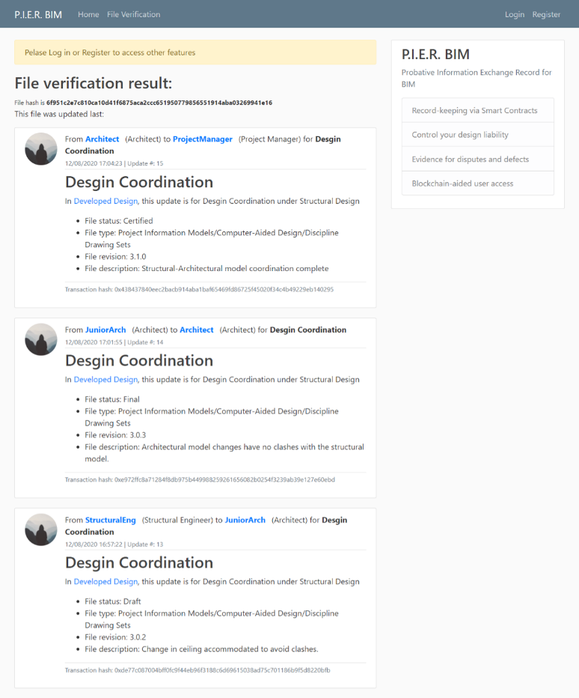
The scenario here is the structural engineer who provided the BIM structural design model has provided incorrect specifications for one of the structural elements. However, the client and the builder have no information about this during construction. Years after completing the project, the client observes a discrepancy with that structural element; however, they have no idea of what the cause for it is. The client (or building manager) hand over the issue to a team of experts to resolve the issue. Their first job is to verify if the structural design was at fault or the construction was not done to the required specifications. The project’s documentation, including models, drawings, specifications have been handed over to the client (or building management team) post-completion. Although the experts’ team was not part of the original project construction team, they can use the DApp to check the traceability of the BIM model file using the TV function (Figure 27). This function does not require the party verifying the file to have been registered to the project. Based on the results, the experts’ team find out the error was caused by the structural engineer, who provided the structural design BIM model with wrong specifications.
Figure 27: Dispute Scenario: Non-registered party traces the file development

Evaluation, Results & Discussion
This section first analyses the scenarios demonstrated using the DApp compared to the processes mapped in Section 4.2. Next, it evaluates the prototype system to validate if the proposed process models meet the process improvement objectives stated in Section 4.1.

Scenarios Analysis
It can be observed from the Design Review (Figure 5) and Design Coordination (Figure 6) process maps, that the existing processes do not facilitate the workflow initiators to record their independent contributions explicitly and securely. Moreover, when the reviewer sends the design items back for rework, the design engineers can only hope that the file received has not been subjected to any undocumented alterations. In the design coordination process, the coordinators are required to send changes back and forth between the different disciplines who make amendments to accommodate other design inputs. However, within the current process, both the activities of making amendments and coordinating clashes are susceptible to overlapping design liability, which does not serve well in case of conflicts. The final tasks in both the processes need the approver and the coordinator to finalise the design items and design coordination, respectively. However, before certification, the approver cannot reliably verify if the file reviewed is unaltered; they need to trust that the reviewer and the file exchange system to have upheld the integrity of the file without causing any unintended modifications to the design initiator’s original intent. Similarly, the design coordinator has no evidence to substantiate the origin of the file and attest to its unaltered state. They need to trust the coordination process and all the contributing parties to have not made any amendments that would have hampered others’ design inputs or caused any accidental modifications. The third process map shows the RFI process (Figure 7), which is critical during the construction stage of the project and impacts the project design realisation, schedule, and cost. Creating an RFI, sending a CAN and CI are legally critical transactions that need to be recorded. The current processes either use simple email workflows or incorporate systems that are dependent on subscription models and are reliant on third-party storage (as discussed in section 2). They are faced with the challenge of sustainability of records beyond the completion of the project and security concerns.
Upon contrasting these processes to the scenarios demonstrated using the DApp, the following benefits can be observed. The workflow initiators, the junior architect or the structural engineer (in Sections 6.1.1 and 6.1.2), limit their liability by recording their independent contributions and protect themselves against any model corruption by recording the state of the model when designed. Furthermore, they record indisputable proofs of the submission of design with the changelog from Revit, associated meta-data of the information exchange and a timestamp. Next, in the first scenario, the senior architect can verify and trace the origin of the DWG file created by the junior architect to ensure if the same version was reviewed by the architect and sent without any modifications. This improves the trust in the file for the senior architect before they certify it as approved. Similarly, in the second scenario, the coordinator can trace the file exchange history and limit liability to only the task of verification of the file before forwarding it to the project manager. This could result in higher confidence levels as they replace trust in people with trust in the system. In the third scenario, the builder, the project manager and the designer can record their respective exchange transactions on the blockchain using the DApp. Since these records are decentralised and under no single party or third-party service provider’s control, they enable the much-needed security and trust to sustain these critical records for all the project members, during and beyond the life of the project. In case of future disputes relating to either when an RFI was raised or on what input was received to resolve the RFI, these records can be vital.
In the first dispute scenario (Section 6.2.1), the approved design file available to the architect is different from the one available to the builder, and there is no evidence of whether the architect had exchanged the revised file to the builder. Therefore, based on the current systems and workflow, the client and the project manager may not be able to resolve the issue effectively. However, using the DApp, the project manager can trace the file in possession with the architect to verify if the file exchange transaction from the architect to the builder was recorded on the system to help resolve the dispute. The second dispute scenario (Section 6.2.2) is an instance of a situation where sometimes errors made to a design file remain unaccounted for and lead to disputes in the future, a long time after the project terminates. In this scenario, a third party is hired to resolve the issue based on the project documentation handed over at the end of the project. Since the issue was raised long after the project completion, they neither have access to the communication history nor access to any file management system the project team would have used. They would need to rely on the hand-over documentation and statements from the parties involved in the dispute. However, as they do have access to the documents under dispute, they can use the DApp as an unregistered user to trace the different files leading to the dispute, including the BIM models and identify the party at fault without the need to dig into threads of conversations and having to resort to trust in either of the parties based on their statements.
The scenarios exhibit the technology’s ability to record snapshots of individual design inputs to the overall project design and enable a clear and long-term record of key exchange transactions. The demonstrated ability to achieve these benefits using a blockchain-aided record-keeping system shows the potential of integrating such a technology into the existing information management systems and tools presented in Section 2.3.2. APIs designed can connect these tools to smart contracts on the blockchain and facilitate storage of critical transactions on the blockchain. Once the information exchange transaction records are added to the blockchain, they are detached from their association to their parent authoring software. This improves the auditability of the exchange records, and the proofs derived from such a system are independent of any third-party storage or the presence of a subscription with the authoring software. They can be retrieved and verified by any person in possession of the design file anytime in the future without the need to depend on the party that created or stored the exchange transactions. However, the pricing model for using a DApp can be different from the typical subscription model and leans towards a usage-based pricing model. The cost of using Ethereum blockchain can be highly variable and is dependent on multiple factors (Pierro & Rocha, 2019). We can assume the following settings for arriving at an indicative cost: a gas price of 37.14 Gwei with an exchange rate of USD 233.77/ETH. Both these values are an average of daily rates from the years 2019 and 2020 (Etherscan.io, 2021). Further, assume the ‘gas spent’, work done on the Ethereum Virtual Machine (Ethereum.org, 2021a), is 31500 units of gas. Based on these factors, we get a transaction cost of USD 0.30 (0.42 NZD) for adding one simple information exchange transaction to the blockchain.

Prototype evaluation and proposed process model validation
Evaluation of the implemented prototype was conducted against user-based defined prototype requirements stated under Section 5.1 and system characteristics stated in the Document Control standards (SNZ, 2017). User-based definitions are used when quality is seen as fitness for the intended use (Pries-Heje, Baskerville, & Venable, 2008). A combination of these two criteria enables a holistic evaluation of how the process model addresses the research challenges and evaluates the prototype as a supplementary record-keeping system.
- Prototype Requirements | Fulfilled?
A1. Blockchain recording: Record transactions of the information exchanged between project participants on a public blockchain. | Yes
A2. Secure logging: Enable secure login based on credentials stored on the blockchain and verified via the deployed smart contract. | Yes
A3. Record key metadata: The transactions must include the critical metadata associated with each information exchange transaction. | Yes
A4. Support all file formats: Should accept files of different sizes and formats, and store the unique fingerprint of the file. | Yes
A5. Support BIM model modification records: Should facilitate the recording of changes related to BIM models. | Yes
A6. Retrieve BIM model history: Should be able to access a BIM model’s historical records stored on the blockchain. | Partially
A7. Verify the existence, integrity and authenticity: Should be able to verify the existence, integrity and authenticity of information and demonstrate the ability to trace the originator or modifier of any conflicting information. | Yes
Table 5: Evaluation of the prototype system against the requirements set under Section 5.1
Table 5 summarises the evaluation of the prototype against its initial requirements. Employing a connection between the web application and the simulated Ethereum public blockchain, the prototype satisfies the requirements A1 and A2. Next, by incorporating the NZS Document Control standards’ metadata requirements and storing these details sequentially along with time stamp and user information, we satisfy the requirement A3. As the developed system accepts any file format to extract its file hash, we meet the requirement A4. With the Dynamo workflow and functions CE and OE, the system meets requirement A5. Next, the developed prototype provides functionality to trace a BIM model file but does not link the BIM model exchange transaction to its changelog; instead, two different transactions are needed to be recorded separately. Therefore, this shows only partial fulfilment of the requirement A6. However, Section 5.5 shows the potential possibility of integrating such a tool within a BIM modelling software, such as Revit, that will fulfil requirement A6 completely. During the dispute scenario simulations, this study has demonstrated the fulfilment of requirement A7.
Next, we evaluated the developed system against the system characteristics of a standard document control system (SNZ, 2017) in Table 6. However, as indicated earlier, the prototype developed is a supplement to any existing document control system; it is only intended to demonstrate the potential benefits of integrating blockchain technology to the existing systems.
- System Characteristics | Fulfilled?
B1. Reliability: The system should—  - capture all documents within the scope of the related business activities;  - organise documents in a way that reflects relevant business processes;  - protect documents from unauthorised alteration or disposal;  - function as the source of information for all actions documented in the documentation;  - provide ready access to all relevant documents and related metadata. | Yes  Yes  Yes  Yes  Partially
B2. Integrity: The system should clearly demonstrate the existence of controls such as  - access monitoring,  - user verification,  - authorised destruction and  - security. | Yes  Yes  No  Yes
B3. Compliance: The system should be managed in compliance with the requirements of the regulatory environment in which the business operates. | Needs more investigation
B4. Comprehensiveness: The system should cover documentation for the complete range of business activities performed by the organisation, relevant business unit or project. | Yes
B5. Consistency: The system should include accurately documented management processes, assigned responsibilities and procedures. | Partially
Table 6: Evaluation of the prototype system against Document Control System Standards (SNZ, 2017)
The standard proposes five desirable characteristics of a document control system. First, within B1, the developed prototype checks B1.a, B1.b and B1.d as it adopts CIC design guidelines project phases and OmniClass® information classification system. Quality B1.c characteristic can also be marked as fulfilled owing to the benefits of using blockchain as a ledger for recording. However, characteristic B1.e is partly fulfilled. The metadata is recorded based on SNZ document control requirements; however, the system does not provide access to the documents; instead, it only enables the verification of the existence and traceability of documents. Within B2, the prototype demonstrates B2.a using project admin functionality, B2.b and B2.d based on records stored on the blockchain. However, the system does not allow for the destruction of records (B2.c). For B3, this study does not verify the regulatory compliance of the developed system; hence, this will need further investigation, but it is outside of the scope of this study. Characteristic B4 is fulfilled based on its reliance on OmniClass® information classification and CIC design project phases. For B5, although the system includes a provision to record transactions as per defined processes and responsibilities, it does not include system-based procedures to track the process because transactions are recorded. Hence, this is fulfilled partially.
Therefore, the fulfilment of functional requirements and system characteristics enable the following improvements towards the information exchange process in construction projects (solution objectives proposed in Section 4.1):
- Better control of design liabilities for project participants: Results of the evaluation of requirements A3, A4, A5 and system characteristics B1.a, B1.d, B1.e, B4 and B5 reflect that the prototype system helps stakeholders to control their design liability. Every time a stakeholder signs and records an exchange transaction for documents sent to external stakeholders for review or coordination, they create immutable, permanent evidence of the state of the file exchanged, thus reducing the sender’s exposure to any modifications or corruption the file may undergo.
- Improved security of the IE transaction records: Results of the evaluation of requirements A1, A2 and system characteristics B1.c, B2.a, B2.b and B2.d provide evidence that the prototype improves the security of the system with the benefits of providing a blockchain ledger to record project information exchange transactions.
- Potential evidence for disputes and construction defects: The requirements A6, A7 and system characteristics B1.c, B1.d, B1.e and B5 enable the system to provide potential probative evidence for disputes and defects experienced during design, construction and in the long term, i.e., post-construction. This capability is of critical importance for participants who have contributed to the design, and the builder to have supporting evidence especially under the Limitation Act 2010 and Building Act 2004 in New Zealand where the parties are liable up to 6 to 15 years post-handover ("The Building Act 2004," 2004).
Therefore, the evaluation shows that the developed prototype demonstrates that the proposed process model resolves the challenges identified for this study. It also proves the hypothesis that a system aided with blockchain technology can address these challenges more effectively than the existing solutions.

Methodology Evaluation
Hevner et al. (2004) have proposed seven guidelines for DSR. Table 7 provides the evaluation of this study’s process against DSR guidelines for rigour and relevance Table 7.
Guideline | Description
Design as an Artefact | Information exchange process models that integrate blockchain technology is the key artefact.
Problem Relevance | Poor stakeholder liability control, limited information traceability and untrustworthy security systems are a recurring theme identified throughout the literature, and the fact that businesses are designing tools to address this issue signify the research problem relevance.
Design Evaluation | We conducted a study of the existing tools that aim to address the research problem. Moreover, this study involved an evaluation using a proof-of-concept prototype built and tested on a sample project to analyse the artefact against a pre-set requirement.
Research Contributions | The clear contributions of this research include the design artefact: the novel process models, the development of a prototype to implement the proposed process model and the methodology of its development.
Research Rigour | The use of existing industry standard guidelines, such as the CRC Design Guidelines, for creating a scaffold for the process map and ISO standards for mapping the processes and as evaluation criteria for the prototype ensure research rigour.
Design as a Search Process | This study navigated through industry tools to capture what is missing. Further, a thorough analysis of the business process requirement was conducted using industry guidelines and standards.
Communication of Research | This study intends to communicate with both the technical and managerial audiences. Although the description of the design of the prototype is mostly technical in content, it aims to address problems faced by a managerial audience who are involved in a construction project.
Table 7: DSR Evaluation (Hevner et al., 2004)

Limitations of the Study
This study used the prototype evaluation method, which was implemented through simulated project scenarios. Although this is an effective way to verify the validation of the proposed process model, evidence collected from implementing the prototype in real-world cases would be critical to give final judgement and substantiate the results generated in this study. However, even its application on a real project may not generalise its functionality to different environments as it would be just one of the many possible settings (Markus, Majchrzak, & Gasser, 2002). We used the conceptual process models based on only three aggregate of processes—Architectural, Structural and Building Services. Although they are considered the key processes in project design, other processes may include other sub-processes that are not included for analysis. Next, it can be argued that the proposed process model is only applicable to the conventional projects within the New Zealand construction industry as it is based on processes developed using the CIC design guidelines. However, it should be stated that processes in other regions may only vary minimally to what is mapped here.
This study does not run a cost-benefit analysis of running such a system as the scenarios cannot replicate realistic data transactions in projects. Moreover, as the prototype was developed in a sandbox blockchain, it does not mimic the complete network infrastructure that runs a public blockchain. Cost analysis was intentionally not chosen as one of the objectives for the study because we only aimed to build a workable prototype, not an optimised one that would reflect realistic costs of integrating blockchain to existing information management systems. An in-depth analysis of costs could be the next logical step for someone building an industry-ready tool.

Methodological Limitations
As indicated earlier, design science is focused on problem-solving; it is far from producing optimal outcomes. Hence, the solution presented here does not claim to be the most efficient possible solution. Moreover, Hevner et al. (2004) warn that DSR study could be biased towards technicality or behavioural-science, resulting in an imbalance between sound foundational theories and industry implementation. Due to its sole focus on problem-solving, DSR takes a simplistic view of the people and the organisational contexts (Hevner et al., 2004). The solution proposed in this study takes a more technical approach towards the problem identified with little regard to the behavioural aspects applicable to its implementation context. This could be a possible limitation for the study that would need further analysis and evaluation from a behavioural-science point of view.

Conclusion
This study investigated the hypothesis that information exchange records in a construction project can benefit from the use of blockchain technology to address the issues of design liability control and improve data security. It employed a Design Science Research strategy to present a potential integration of BCT in the current information exchange processes and to evaluate its suitability. First, literature concerning design liability and security of data was reviewed, followed by an analysis of solutions proposed in the literature and industry tools aimed at resolving these issues, along with current applications and proposals of BCT in information management. The literature highlighted the increasing concern over design liability control between stakeholders and the possible compromise on data security owing to the current systems in use. The recommended practices in the literature and industry tools either depend on technology solutions that only partly resolve the issues, or opted for mechanisms that allocate risk differently to what was previously practised. A lack of uniformity was observed in how projects have tried to resolve these issues, which is an indication of the incapability of the existing solutions in the industry. Based on this analysis, three solution objectives were formed that would help achieve this aim—conceptual process models that integrated BCT into three identified common processes of design review, design coordination and request for information. A prototype system to demonstrate the proposed integration in practice was designed and developed. Further, the prototype was implemented in simulated project and dispute scenarios to evaluate the simulated processes for any improvements against the existing mapped processes. Finally, based on the prototype evaluation, the proposed BCT integrated process models were validated.
The evaluation established that by using the prototype system, the design contributors could record their individual inputs to the overall project design and any critical file exchange transaction on a blockchain-powered system. Records stored on the blockchain can help identify liable parties in times of conflicts and disputes. It potentially improves the probative nature of these critical records as the evidence would not be stored under a single party or any third-party provider; instead, they would benefit from the security of a public blockchain system. Furthermore, the issue of dependence on subscriptions to a third party for access to critical records and user authentication are also addressed, as is the issue of loss of data due to events such as company mergers, bankruptcy, or any changes in policy with the data creator, modifier or the record-keeper. Therefore, the transactions recorded on such a system would be better purposed for audits, and offer data integrity, authenticity, and longevity. It increases trust in the project members by transforming affect-based trust to system-based trust, thereby potentially improving collaboration between stakeholders. The prototype system exhibits the fundamental potential of integrating blockchain record-keeping for information exchange transactions in construction. However, the study promotes the idea of seamless integration of record-keeping on a distributed public-blockchain databases through the means of APIs to the existing software packages. The user must not be required to interact with the blockchain directly; instead, the system must enable the benefits of a blockchain-powered system through its inherent design.
The results established in this study are based on an evaluation conducted in limited, simulated project scenarios and does not include investigation of behavioural-science aspects. The prototype developed was only a workable system and cannot be considered for cost-benefit analysis as that would need significant optimisation before conducting such studies. Despite these limitations, this study makes a significant contribution by developing and evaluating a blockchain integrated system in a simulated construction project. Future work can include comparing the developed prototype system’s framework against a system designed on a private or permissioned blockchain to analyse the difference in approach and its consequences. Further, testing the proposed prototype in a more realistic environment to investigate the change in behavioural-science aspects of the users would be a possible research direction.

References
Abd Jamil, A. H., & Fathi, M. S. (2018). Contractual challenges for BIM-based construction projects: a systematic review. Built Environment Project and Asset Management, 8(4), 372-385. https://doi.org/10.1108/BEPAM-12-2017-0131
Abd Jamil, A. H., & Fathi, M. S. (2019). Contractual issues for Building Information Modelling (BIM)-based construction projects: An exploratory case study. Paper presented at the IOP Conference Series: Materials Science and Engineering. https://doi.org/10.1088/1757-899X/513/1/012035
Afsari, K., Eastman, C. M., & Shelden, D. R. (2016). Cloud-based BIM Data Transmission: Current Status and Challenges. Paper presented at the ISARC. International Symposium on Automation and Robotics in Construction, Waterloo. https://doi.org/10.22260/ISARC2016/0129
Al-Shammari, M. A. (2014). An appraisal of the protocol that was published by the construction industry council (CIC) to facilitate the use of building information modelling (BIM) on projects. Paper presented at the 30th Annual ARCOM Conference, Portsmouth, UK. http://www.arcom.ac.uk/-docs/proceedings/ar2014-0623-0632_Al-Shammari.pdf, Accessed date: 25/01/2021
Al Qady, M., & Kandil, A. (2013a). Document Discourse for Managing Construction Project Documents. Journal of Computing in Civil Engineering, 27(5), 466-475. https://doi.org/10.1061/(ASCE)CP.1943-5487.0000201
Al Qady, M., & Kandil, A. (2013b). Document Management in Construction: Practices and Opinions. Journal of Construction Engineering and Management, 139(10), 6013002. https://doi.org/10.1061/(ASCE)CO.1943-7862.0000741
Amaludin, A. E., & Bin Taharin, M. R. (2018). Prospect of blockchain technology for construction project management in Malaysia. ASM Science Journal, 11(Special Issue 3), 199-205. https://www.akademisains.gov.my/asmsj/?mdocs-file=3845, Accessed date: 25/01/2021
Arensman, D. B., & Ozbek, M. E. (2012). Building information modeling and potential legal issues. International Journal of Construction Education and Research, 8(2), 146-156. https://doi.org/10.1080/15578771.2011.617808
Ashcraft, H. W. (2008). Building information modeling: a framework for collaboration. Construction Lawyer, 28(3), 5. https://link.gale.com/apps/doc/A205568011/AONE?u=learn&sid=AONE&xid=89d59b6f, Accessed date: 25/01/2021
Bell, D., De Cesare, S., Iacovelli, N., Lycett, M., & Merico, A. (2007). A framework for deriving semantic web services. Information Systems Frontiers, 9(1), 69-84. https://doi.org/10.1007/s10796-006-9018-z
Beth, C., & Chatswood, B. P. N. (2014). Legal implications where BIM is implemented on a project. http://search.proquest.com/docview/1641352083, Accessed date: 25/01/2021
Björk, B.-C. (2002). The impact of electronic document management on construction information management. Paper presented at the International Council for Research and Innovation in Building and Construction CIB w78 conference. https://itc.scix.net/pdfs/w78-2002-3.content.pdf, Accessed date: 25/01/2021
Borrmann, A., König, M., Koch, C., & Beetz, J. (2018). Building Information Modeling: Technology Foundations and Industry Practice: Springer International Publishing. ISBN: 9783319928623. https://doi.org/10.1007/978-3-319-92862-3
Boyes, H. A. (2013). Cyber security of intelligent buildings: A review. Paper presented at the 8th IET International System Safety Conference incorporating the Cyber Security Conference 2013. https://doi.org/10.1049/cp.2013.1698
BSI. (2014). BS 1192-4:2014 Collaborative production of information. Fulfilling employer’s information exchange requirements using COBie. Code of practice. https://shop.bsigroup.com/ProductDetail?pid=000000000030294672, Accessed date: 25/01/2021
The Building Act 2004 (2004). https://www.legislation.govt.nz/act/public/2004/0072/latest/whole.html, Accessed date: 25/01/2021
Bukunova, O., & Bukunov, A. (2020). Information Modelling as a Tool to Manage Construction Project Information Flows. Paper presented at the IOP conference series. Materials Science and Engineering. https://doi.org/10.1088/1757-899X/753/4/042030
Cleven, A., Gubler, P., & Hüner, K. M. (2009). Design alternatives for the evaluation of design science research artifacts. Paper presented at the 4th International Conference on Design Science Research in Information Systems and Technology. https://doi.org/10.1145/1555619.1555645
Conte de Leon, D., Stalick, A. Q., Jillepalli, A. A., Haney, M. A., & Sheldon, F. T. (2017). Blockchain: properties and misconceptions. Asia Pacific Journal of Innovation and Entrepreneurship, 11(3), 286-300. https://doi.org/10.1108/APJIE-12-2017-034
CSI. (2012). OmniClass®: Construction Specifications Institute. https://www.csiresources.org/standards/omniclass, Accessed date: 25/01/2021
Day, M. (2018). iModel unleashed. https://www.aecmag.com/component/content/article/59-features/1718-imodel-unleashed, Accessed date: 25/01/2021
Dounas, T., & Lombardi, D. (2018). A CAD-blockchain integration strategy for distributed validated digital design. Paper presented at the Computing for a better tomorrow: 36th International Conference on Education and Research in Computer Aided Architectural Design in Europe (eCAADe 2018), Lodz, Poland. http://papers.cumincad.org/data/works/att/ecaade2018_226.pdf, Accessed date: 25/01/2021
Dounas, T., & Lombardi, D. (2019). Blockchain grammars - Designing with DAOS. Paper presented at the Intelligent and Informed: 24th International Conference on Computer-Aided Architectural Design Research in Asia, CAADRIA 2019, Wellington, New Zealand. http://papers.cumincad.org/data/works/att/caadria2019_136.pdf, Accessed date: 25/01/2021
Dounas, T., Lombardi, D., & Jabi, W. (2019). Towards Blockchains for architectural design-Consensus mechanisms for collaboration in BIM. Paper presented at the Architecture in the Age of the 4th Industrial Revolution: 37th eCAADe and 23rd SIGraDi Conference, Porto, Portugal. http://papers.cumincad.org/data/works/att/ecaadesigradi2019_296.pdf, Accessed date: 25/01/2021
Dresch, A., Lacerda, D. P., & Antunes Jr, J. A. V. (2014). Design science research: A method for science and technology advancement: Springer. ISBN: 3319073745. https://doi.org/10.1007/978-3-319-07374-3
Eadie, R., McLernon, T., & Patton, A. (2015). An investigation into the legal issues relating to building information modelling (BIM). Paper presented at the RICS COBRA AUBEA 2015, Sydney, Australia. https://pure.ulster.ac.uk/en/publications/an-investigation-into-the-legal-issues-relating-to-building-infor-3, Accessed date: 25/01/2021
Erri Pradeep, A. S., Yiu, T. W., & Amor, R. (2019). Leveraging Blockchain Technology in a BIM Workflow: A Literature Review. Paper presented at the International Conference on Smart Infrastructure and Construction 2019 (ICSIC). https://doi.org/10.1680/icsic.64669.371
Ethereum.org. (2021a). Ethereum Virtual Machine (EVM). https://ethereum.org/en/developers/docs/evm/, Accessed date: 25/01/2021
Ethereum.org. (2021b). Smart Contract Languages. https://ethereum.org/en/developers/docs/smart-contracts/languages/, Accessed date: 25/01/2021
Etherscan.io. (2021). Ether Daily Price (USD) Chart, Ethereum Average Gas Price Chart. https://etherscan.io/, Accessed date: 25/01/2021
Fan, S.-L., Lee, C.-Y., Chong, H.-Y., & Skibniewski, M. J. (2018). A critical review of legal issues and solutions associated with building information modelling. Technological And Economic Development Of Economy, 24(5), 2098-2130. https://doi.org/10.3846/tede.2018.5695
Fernando, H., Hewavitharana, T., & Perera, A. (2019). Evaluation of Electronic Document Management (EDM) systems for construction organizations. Paper presented at the 2019 Moratuwa Engineering Research Conference (MERCon), Moratuwa, Sri Lanka. https://doi.org/10.1109/MERCon.2019.8818768
Ficco, M., Choraś, M., & Kozik, R. (2017). Simulation platform for cyber-security and vulnerability analysis of critical infrastructures. Journal of computational science, 22, 179-186. https://doi.org/10.1016/j.jocs.2017.03.025
Ford, D. N., & Sterman, J. D. (2003). The Liar's Club: concealing rework in concurrent development. Concurrent Engineering, 11(3), 211-219. https://doi.org/10.1177/106329303038028
Foster, L. L. (2008). Legal issues and risks associated with building information modeling technology. University of Kansas. http://hdl.handle.net/1808/4264, Accessed date: 25/01/2021
Gad, G. M., Momoh, A., Esmaeili, B., & Gransberg, D. G. (2015). Preliminary investigation of the impact of project delivery method on dispute resolution method choice in public highway projects. Paper presented at the ICSC15: The Canadian Society for Civil Engineering 5th Int./11th Construction Specialty Conf. https://doi.org/10.14288/1.0076406
Gebken, R. J., & Gibson, G. E. (2006). Quantification of costs for dispute resolution procedures in the construction industry. Journal of professional issues in engineering education, 132(3), 264-271. https://doi.org/10.1061/(ASCE)1052-3928(2006)132:3(264)
Ghaffarianhoseini, A., Tookey, J., Ghaffarianhoseini, A., Naismith, N., Azhar, S., Efimova, O., & Raahemifar, K. (2017). Building Information Modelling (BIM) uptake: Clear benefits, understanding its implementation, risks and challenges. Renewable and Sustainable Energy Reviews, 75, 1046-1053. https://doi.org/10.1016/j.rser.2016.11.083
Giancaspro, M. (2017). Is a ‘smart contract’ really a smart idea? Insights from a legal perspective. Computer law & security review, 33(6), 825-835. https://doi.org/10.1016/j.clsr.2017.05.007
Gibbs, D. J., Emmitt, S., Lord, W., & Ruikar, K. (2015). BIM and construction contracts: CPC 2013's approach. Proceedings of the ICE-Management, Procurement & Law, 168(6), 285-293. https://doi.org/10.1680/jmapl.14.00045
Graham, S. (2019). Implementation of Blockchain Technology in the Construction Industry. Paper presented at the 7th International Construction Specality Conference Jointly With The Construction Research Congress. https://digitalcommons.calpoly.edu/cmsp/190/, Accessed date: 25/01/2021
Hasan, H. R., & Salah, K. (2018). Proof of delivery of digital assets using blockchain and smart contracts. IEEE Access, 6, 65439-65448. https://doi.org/10.1109/ACCESS.2018.2876971
Heap-Yih, C., Su-Ling, F., Monty, S., & Shang-Hsien, H. (2017). Preliminary Contractual Framework for BIM-Enabled Projects. Journal of Construction Engineering and Management, 143(7). https://doi.org/10.1061/(ASCE)CO.1943-7862.0001278
Hegazy, T., Zaneldin, E., & Grierson, D. (2001). Improving design coordination for building projects. I: Information model. Journal of Construction Engineering and Management, 127(4), 322-329. https://doi.org/10.1061/(ASCE)0733-9364(2001)127:4(322)
Hevner, A. R., March, S. T., Park, J., & Ram, S. (2004). Design science in information systems research. MIS quarterly, 75-105. https://doi.org/10.2307/25148625
Hjelt, M., & Björk, B.-C. (2006). Experiences of EDM usage in construction projects. Journal of Information Technology in Construction (ITcon), 11(9), 113-125. https://itcon.org/paper/2006/09, Accessed date: 25/01/2021
Hsu, K.-M., Hsieh, T.-Y., & Chen, J.-H. (2015). Legal risks incurred under the application of BIM in Taiwan. Proceedings of the Institution of Civil Engineers-Forensic Engineering, 168(3), 127-133. https://doi.org/10.1680/feng.14.00005
Hudson, N. (2016). Defining the Legal Landscape - part 2. https://thebimhub.com/2016/06/20/bim-legal-forum-defining-legal-landscape-part-2/, Accessed date: 27/07/2019
Hunhevicz, J. J., & Hall, D. M. (2020). Do you need a blockchain in construction? Use case categories and decision framework for DLT design options. Advanced Engineering Informatics, 45, 101094. https://doi.org/10.1016/j.aei.2020.101094
Hurtado, K. A., & O Connor, P. J. (2008). Contract issues in the use of construction building information modelling. International Construction Law Review, 25(3), 262. https://www.scl.org.uk/papers/contract-issues-use-construction-building-information-modeling, Accessed date: 25/01/2021
Ilhan, B., & Yaman, H. (2016). Green building assessment tool (GBAT) for integrated BIM-based design decisions. Automation in construction, 70, 26-37. https://doi.org/10.1016/j.autcon.2016.05.001
ISO. (2020a). ISO 19650-3:2020 Organization and digitization of information about buildings and civil engineering works, including building information modelling (BIM) -- Information management using building information modelling Part 3: Operational phase of the assets: International Organization for Standardization. https://www.iso.org/standard/75109.html, Accessed date: 25/01/2020
ISO. (2020b). ISO 19650-5:2020 Organization and digitization of information about buildings and civil engineering works, including building information modelling (BIM). Information management using building information modelling. Security-minded approach to information management: International Organization for Standardization. https://www.iso.org/standard/74206.html, Accessed date: 25/01/2021
Jiao, Y., Wang, Y., Zhang, S., Li, Y., Yang, B., & Yuan, L. (2013). A cloud approach to unified lifecycle data management in architecture, engineering, construction and facilities management: Integrating BIMs and SNS. Advanced Engineering Informatics, 27(2), 173-188. https://doi.org/10.1016/j.aei.2012.11.006
Kähkönen, K., & Rannisto, J. (2015). Understanding fundamental and practical ingredients of construction project data management. Construction innovation. https://doi.org/10.1108/CI-04-2014-0026
Khan, K. I. A., Flanagan, R., & Lu, S.-L. (2016). Managing information complexity using system dynamics on construction projects. Construction Management and Economics, 34(3), 192-204. https://doi.org/10.1080/01446193.2016.1190026
Kinnaird, C., & Geipel, M. (2017). Blockchain Technology: How the Inventions Behind Bitcoin are Enabling a Network of Trust for the Built Environment. Arup. https://iebc.co/wp-content/uploads/2018/01/Arup-Blockchain-Technology-Report-3.pdf, Accessed date: 25/01/2021
Koch, C., & Firmenich, B. (2011). An approach to distributed building modeling on the basis of versions and changes. Advanced Engineering Informatics, 25(2), 297-310. https://doi.org/10.1016/j.aei.2010.12.001
Lahdenperä, P. (2012). Making sense of the multi-party contractual arrangements of project partnering, project alliancing and integrated project delivery. Construction Management and Economics, 30(1), 57-79. https://doi.org/10.1080/01446193.2011.648947
Larson, D. A., & Golden, K. A. (2007). Entering the Brave, New World: An Introduction to Contracting for Building Information Modeling. William Mitchell Law Review, 34, 75. https://heinonline.org/HOL/P?h=hein.journals/wmitch34&i=85, Accessed date: 25/01/2021
Lee, J., Wyner, G. M., & Pentland, B. T. (2008). Process grammar as a tool for business process design. MIS quarterly, 757-778. https://doi.org/10.2307/25148871
Lemieux, V. L. (2016). Trusting records: is Blockchain technology the answer? Records Management Journal, 26(2), 110-139. https://doi.org/10.1108/RMJ-12-2015-0042
Leone, J. M., & Vornehm, D. S. (2017). The Contract Challenges of Delivering Project Using Collaborative Design. 61(3), 51-52. http://dev.dcd.com/articles/the-contract-challenges-of-delivering-projects-using-collaborative-design, Accessed date: 25/01/2021
Li, J., Greenwood, D., & Kassem, M. (2019). Blockchain in the built environment and construction industry: A systematic review, conceptual models and practical use cases. Automation in construction, 102, 288-307. https://doi.org/10.1016/j.autcon.2019.02.005
Liu, Z., Jiang, L., Osmani, M., & Demian, P. (2019). Building information management (BIM) and blockchain (BC) for sustainable building design information management framework. Electronics (Switzerland), 8(7). https://doi.org/10.3390/electronics8070724
Love, P. E. D., Holt, G. D., Shen, L. Y., Li, H., & Irani, Z. (2002). Using systems dynamics to better understand change and rework in construction project management systems. International journal of project management, 20(6), 425-436. https://doi.org/10.1016/S0263-7863(01)00039-4
Lupton, S. (2013). Cornes and Lupton's Design Liability in the Construction Industry: Wiley Online Library. ISBN: 1444361139. https://doi.org/10.1002/9781444361162
Ma, Z., Zhang, D., & Li, J. (2018). A dedicated collaboration platform for Integrated Project Delivery. Automation in construction, 86, 199-209. https://doi.org/10.1016/j.autcon.2017.10.024
Mahamadu, A.-M., Mahdjoubi, L., & Booth, C. (2013). Challenges to BIM-cloud integration: Implication of security issues on secure collaboration. Paper presented at the 2013 IEEE 5th International Conference on Cloud Computing Technology and Science. https://doi.org/10.1109/CloudCom.2013.127
Manderson, A., Jefferies, M., & Brewer, G. (2015). Building information modelling and standardised construction contracts: a content analysis of the GC21 contract. Construction Economics and Building, 15(3), 72-84. https://doi.org/10.5130/AJCEB.v15i3.4608
March, S. T., & Storey, V. C. (2008). Design science in the information systems discipline: an introduction to the special issue on design science research. MIS quarterly, 725-730. https://doi.org/10.2307/25148869
Markus, M. L., Majchrzak, A., & Gasser, L. (2002). A design theory for systems that support emergent knowledge processes. MIS quarterly, 179-212. https://www.jstor.org/stable/4132330, Accessed date: 25/01/2021
Mathews, M., Robles, D., & Bowe, B. (2017). BIM+Blockchain: A Solution to the Trust Problem in Collaboration? https://arrow.dit.ie/bescharcon/26/, Accessed date: 25/01/2021
McAdam, B. (2010). Building information modelling: the UK legal context. International Journal of Law in the Built Environment, 2(3), 246-259. https://doi.org/10.1108/17561451011087337
Mitkus, S., & Mitkus, T. (2014). Causes of conflicts in a construction industry: A communicational approach. Procedia - Social and Behavioral Sciences, 110, 777-786. https://doi.org/10.1016/j.sbspro.2013.12.922
Mokhtar, A., Bédard, C., & Fazio, P. (1998). Information model for managing design changes in a collaborative environment. Journal of Computing in Civil Engineering, 12(2), 82-92. https://doi.org/10.1061/(ASCE)0887-3801(1998)12:2(82)
Nawari, N. O., & Ravindran, S. (2019). Blockchain technology and BIM process: Review and potential applications. Journal of Information Technology in Construction (ITcon), 24(12), 209-238. https://itcon.org/paper/2019/12, Accessed date: 25/01/2021
Nguyen, B., Buscher, V., Cavendish, W., Gerber, D., Leung, S., Krzyzaniak, A., . . . Flapper, T. (2019). Blockchain and The Built Environment. Arup. https://www.arup.com/perspectives/publications/research/section/blockchain-and-the-built-environment, Accessed date: 25/01/2021
NZCIC. (2016). Design Guidelines: New Zealand Construction Industry Council. http://nzcic.co.nz/resources/guidelines/, Accessed date: 25/01/2021
Olatunji, O. A. (2011). A preliminary review on the legal implications of BIM and model ownership. Journal of Information Technology in Construction (ITcon), 16(40), 687-696. https://itcon.org/paper/2011/40, Accessed date: 25/01/2021
Pandey, A., Shahbodaghlou, F., & Burger, J. (2016). Legal and contractual challenges of Building Information Modeling—Designers’ perspectives. Paper presented at the Construction Research Congress 2016, San Juan, Puerto Rico. https://doi.org/10.1061/9780784479827.053
Parn, E. A., & Edwards, D. (2019). Cyber threats confronting the digital built environment: Common data environment vulnerabilities and block chain deterrence. Engineering, Construction and Architectural Management, 26(2), 245-266. https://doi.org/10.1108/ECAM-03-2018-0101
PAS-BSI. (2013). 1192-2: 2013 Specification for information management for the capital/delivery phase of construction projects using building information modelling. https://shop.bsigroup.com/en/ProductDetail/?pid=000000000030281435, Accessed date: 25/01/2021
Peffers, K., Rothenberger, M., Tuunanen, T., & Vaezi, R. (2012). Design science research evaluation. Paper presented at the International Conference on Design Science Research in Information Systems. https://doi.org/10.1007/978-3-642-29863-9_29
Peffers, K., Tuunanen, T., Rothenberger, M. A., & Chatterjee, S. (2007). A design science research methodology for information systems research. Journal of management information systems, 24(3), 45-77. https://doi.org/10.2753/MIS0742-1222240302
Penzes, B. (2018). Blockchain Technology in the Construction Industry: Digital Transformation for High Productivity. ICE Report, London. https://doi.org/10.13140/RG.2.2.14164.45443
Perera, S., Nanayakkara, S., Rodrigo, M. N. N., Senaratne, S., & Weinand, R. (2020). Blockchain technology: Is it hype or real in the construction industry? Journal of Industrial Information Integration, 17. https://doi.org/10.1016/j.jii.2020.100125
Phillips-Alonge, O. K. (2019). The influence of partnering on the occurrence of construction requirement conflicts and disputes. International Journal of Construction Management, 19(4), 291-306. https://doi.org/10.1080/15623599.2018.1435236
Pierro, G. A., & Rocha, H. (2019). The influence factors on ethereum transaction fees. Paper presented at the 2019 IEEE/ACM 2nd International Workshop on Emerging Trends in Software Engineering for Blockchain (WETSEB). https://doi.org/10.1109/WETSEB.2019.00010
Pilehchian, B., Staub-French, S., & Nepal, M. P. (2015). A conceptual approach to track design changes within a multi-disciplinary building information modeling environment. Canadian Journal of Civil Engineering, 42(2), 139-152. https://doi.org/10.1139/cjce-2014-0078
Preidel, C., Borrmann, A., Mattern, H., König, M., & Schapke, S.-E. (2018). Common data environment Building Information Modeling (pp. 279-291): Springer. ISBN: 9783319928623. https://doi.org/10.1007/978-3-319-92862-3_15
Preidel, C., Borrmann, A., Oberender, C., & Tretheway, M. (2015). Seamless integration of common data environment access into BIM authoring applications: The BIM integration framework. Paper presented at the 11th European Conference on Product and Process Modelling (ECPPM 2016), Limassol, Cyprus. https://doi.org/10.1201/9781315386904
Pries-Heje, J., Baskerville, R., & Venable, J. R. (2008). Strategies for design science research evaluation. Paper presented at the European Conference on Information Systems (ECIS) 2008. https://aisel.aisnet.org/ecis2008/87, Accessed date: 25/01/2021
Rajendran, S., Clarke, B., & Whelan, M. L. (2013). Contract issues & construction safety management. Professional Safety, 58(09), 56-61. https://www.onepetro.org/journal-paper/ASSE-13-09-56, Accessed date: 25/01/2021
Rezgui, Y., Beach, T., & Rana, O. (2013). A governance approach for BIM management across lifecycle and supply chains using mixed-modes of information delivery. Journal of Civil Engineering and Management, 19(2), 239-258. https://doi.org/10.3846/13923730.2012.760480
RIBA. (2012). BIM overlay to the RIBA outline plan of work. RIBA Publishing: Royal Institute of British Architects, RIBA Practice and Profession Committee. http://mono.eik.bme.hu/~zrostas/assets/files/CPM_RIBAOutlinePlanofWork_BIMOverlay.pdf, Accessed date: 25/01/2021
Scott, T., Montgomery-Hribar, J., Barda, P., Marshall, C., Kane, C., Eynon, D., . . . Jurgens, D. (2014). A Framework for the Adoption of Project Team Integration and Building Information Modelling. Australian Construction Industry Forum (ACIF), Australian Procurement and Construction Council (APCC). http://www.aph.gov.au/DocumentStore.ashx?id=d7b1b259-e1a7-4503-a4a1-ca3841e9fdab&subId=353999, Accessed date: 25/01/2021
Shafiq, M. T., Matthews, J., & Lockley, S. (2013). A study of BIM collaboration requirements and available features in existing model collaboration systems. Journal of Information Technology in Construction (ITcon), 18, 148-161. https://itcon.org/paper/2013/8, Accessed date: 25/01/2021
Sheriff, A., Bouchlaghem, D., El-Hamalawi, A., & Yeomans, S. (2012). Information management in UK-based architecture and engineering organizations: Drivers, constraining factors, and barriers. Journal of Management in Engineering, 28(2), 170-180. https://doi.org/10.1061/(ASCE)ME.1943-5479.0000085
Shojaei, A., Flood, I., Moud, H. I., Hatami, M., & Zhang, X. (2020). An Implementation of Smart Contracts by Integrating BIM and Blockchain. Paper presented at the Future Technologies Conference (FTC) 2019. FTC 2019. Advances in Intelligent Systems and Computing. https://doi.org/10.1007/978-3-030-32523-7_36
Simon, H. A. (1996). The sciences of the artificial: MIT press. ISBN: 0262264498. https://doi.org/10.1126/science.165.3896.886-a
Simonian, L., & Korman, T. (2010). Legal considerations in the United States associated with building information modeling. Paper presented at the COBRA 2010 CIB W113 Law & Dispute Resolution, Paris, France. https://www.irbnet.de/daten/iconda/CIB20074.pdf, Accessed date: 25/01/2021
Singh, S., & Ashuri, B. (2019). Leveraging Blockchain Technology in AEC Industry during Design Development Phase. Paper presented at the Computing in Civil Engineering 2019: Visualization, Information Modeling, and Simulation - Selected Papers from the ASCE International Conference on Computing in Civil Engineering 2019. https://doi.org/10.1061/9780784482421.050
SNZ. (2012). SA/SNZ TR ISO 26122:2012: Information and documentation - Work process analysis for recordkeeping. New Zealand: Standards New Zealand. https://shop.standards.govt.nz/catalog/26122%3A2012%28SA%7CSNZ+TR+ISO%29/view, Accessed date: 25/01/2021
SNZ. (2017). SA/SNZ HB 168:2017: Document control. New Zealand: Standards New Zealand. https://shop.standards.govt.nz/catalog/168%3A2017%28SAA%7CSNZ+HB%29/view, Accessed date: 25/01/2021
Succar, B. (2009). Building information modelling framework: A research and delivery foundation for industry stakeholders. Automation in construction, 18(3), 357-375. https://doi.org/10.1016/j.autcon.2008.10.003
Swan, M. (2015). Blockchain: Blueprint for a new economy (T. McGovern Ed.): O'Reilly Media, Inc. ISBN: 1491920475.
Treldal, N., Parsianfar, H., & Karlshøj, J. (2016, 2016). Using BCF as a mediator for task management in building design. Paper presented at the International RILEM Conference Materials, Systems and Structures in Civil Engineering 2016: BIM in Civil Engineering – Open Data Standards in Civil Engineering. https://orbit.dtu.dk/en/publications/using-bcf-as-a-mediator-for-task-management-in-building-design, Accessed date: 25/01/2021
Tribelsky, E., & Sacks, R. (2011). An empirical study of information flows in multidisciplinary civil engineering design teams using lean measures. Architectural Engineering and Design Management, 7(2), 85-101. https://doi.org/10.1080/17452007.2011.582332
Turk, Ž., & Klinc, R. (2017). Potentials of Blockchain Technology for Construction Management. Procedia engineering, 196, 638-645. https://doi.org/10.1016/j.proeng.2017.08.052
Venable, J., Pries-Heje, J., & Baskerville, R. (2016). FEDS: a framework for evaluation in design science research. European Journal of Information Systems, 25(1), 77-89. https://doi.org/10.1057/ejis.2014.36
Wang, J., Wu, P., Wang, X., & Shou, W. (2017). The outlook of blockchain technology for construction engineering management. Frontiers of engineering management, 67-75. https://doi.org/10.15302/J-FEM-2017006
Wilkinson, P. (2018). All together now. https://aecmag.com/59-features/1525-all-together-now-construction-collaboration, Accessed date: 25/01/2021
Winch, G. (1998). Zephyrs of creative destruction: understanding the management of innovation in construction. Building Research & Information, 26(5), 268-279. https://doi.org/10.1080/096132198369751
Wong, F. W. H., & Lam, P. T. I. (2010). Difficulties and hindrances facing end users of electronic information exchange systems in design and construction. Journal of Management in Engineering, 27(1), 28-39. https://doi.org/10.1061/(ASCE)ME.1943-5479.0000028
Wong, J., Wang, X., Li, H., & Chan, G. (2014). A review of cloud-based BIM technology in the construction sector. Journal of Information Technology in Construction, 19, 281-291. https://itcon.org/paper/2014/16, Accessed date: 25/01/2021
Wong, W. K. V. (2007). A trust inventory for use in the construction industry. City University of Hong Kong. https://scholars.cityu.edu.hk/en/theses/theses(48ee369f-44e5-4ead-9810-0e6d1a2b6170).html, Accessed date: 25/01/2021
Xu, X., Weber, I., Staples, M., Zhu, L., Bosch, J., Bass, L., . . . Rimba, P. (2017). A taxonomy of blockchain-based systems for architecture design. Paper presented at the 2017 IEEE International Conference on Software Architecture (ICSA). https://doi.org/10.1109/ICSA.2017.33
Xue, F., & Lu, W. (2020). A semantic differential transaction approach to minimizing information redundancy for BIM and blockchain integration. Automation in construction, 118, 103270. https://doi.org/10.1016/j.autcon.2020.103270
Yang, R., Wakefield, R., Lyu, S., Jayasuriya, S., Han, F., Yi, X., . . . Chen, S. (2020). Public and private blockchain in construction business process and information integration. Automation in construction, 118, 103276. https://doi.org/10.1016/j.autcon.2020.103276
Zada, A. J., Tizani, W., & Oti, A. H. (2014). Building information modelling (BIM)—Versioning for collaborative design. Paper presented at the 2014 International Conference on Computing in Civil and Building Engineering, Orlando, Florida, United States. https://doi.org/10.1061/9780784413616.064
Zheng, R., Jiang, J., Hao, X., Ren, W., Xiong, F., & Ren, Y. (2019). BcBIM: A Blockchain-Based Big Data Model for BIM Modification Audit and Provenance in Mobile Cloud. Mathematical Problems in Engineering, 2019. https://doi.org/10.1155/2019/5349538
Zhu, Y., & Augenbroe, G. (2006). A conceptual model for supporting the integration of inter-organizational information processes of AEC projects. Automation in construction, 15(2), 200-211. https://doi.org/10.1016/j.autcon.2005.05.003
Zubulake v. UBS Warburg LLC, 229 F.R.D. 422 (S.D.N.Y. 2004) C.F.R. (2004). https://casetext.com/case/zubulake-v-ubs-warburg-llc-3, Accessed date: 25/01/2021

Appendix A

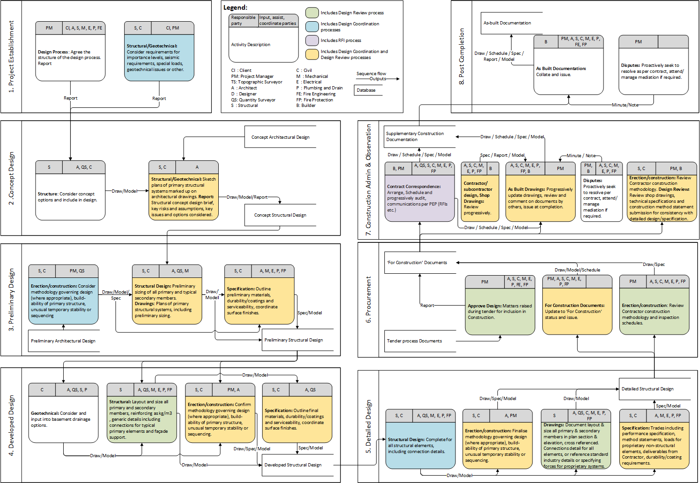
Aggregate of processes: Structural design

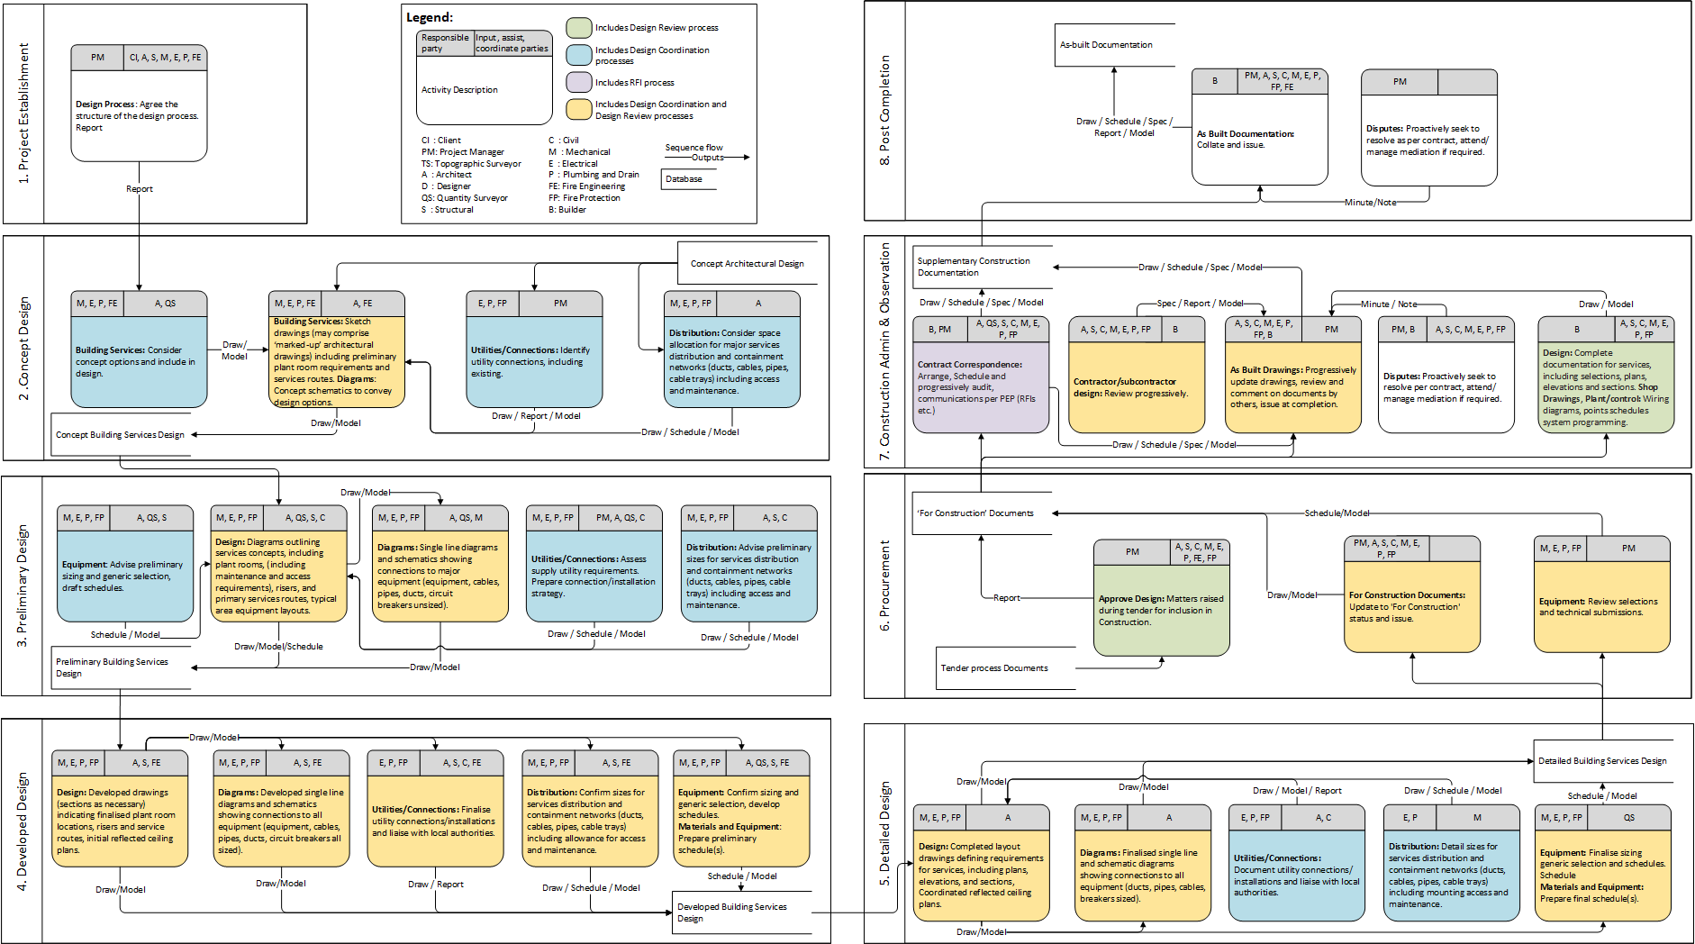
Aggregate of processes: Building services design

Appendix B

Detailed supplemental description for Figure 11, Figure 12 and Figure 13
Smart Contract:

Data Structs:
User: holds username, password hash, email, project role.
Update: Update + UpdateInfoType: holds file hash, revision, description, status, project phase, process aggregate, process, information levels 1 to 5, author, receiver, timestamp.

Blockchain Storage (s):
- s(wallets): mapping (address to bool)
- s(users): mapping(address to User struct)
- s(updates): s(updates) + s(updateInfoTypes):
mapping(ID# to Update struct) + mapping(ID# to UpdateInfoType struct)
- s(excelData): mapping(ID# to 2-D string array)

Modifiers (m):
- m(checkForWallets): Input: w(user). Output: True/False.
Task: Checks for wallet’s existence in s(wallets)

Events (e):
- e(NewUserRegistered): Trigger: f(registerUser). Emits: w(user), username(user), project role(user)
Task: Confirmation of new user registered on the blockchain.
- e(Updates): Trigger: f(newUpdate). Emits: w(user), ID#(update), file description(update)
Task: Confirmation of new update added on the blockchain.

Functions (f):
- f(registerUser): Inputs: fo(Registration_form) – password, password hash. Output: e(NewUserRegistered)
Task: Stores Inputs to s(users)
- f(newUpdate): f(newUpdate) + f(newUpdateInfoType): Inputs: fo(Update_form) – file, file hash, Outputs: e(Updates)
Task: Stores Inputs, d(user), time stamp and file hash to s(updates) and s(updateInfoTypes)
- f(pushExcelData): Inputs: ID#(update), Change log as lists. Outputs: None
Task: Stores Inputs to s(excelData)
- f(getExcelData): Inputs: ID#(update), Outputs: s(excelData)(ID#) as list
Task: Searches s(excelData) for update with ID#

Transaction (Tx.): Transaction added to the blockchain.

Web-application:

Forms (fo):
- fo(Registration_form): Inputs: Wallet Address(w), username, email, project role, password, confirm password
- fo(Excel_update_form): Inputs: Change- log (Excel) file upload, file status, revision, description, project phase, process aggregate, information type (default: “Excel data” prompted) process, and receiver.
- fo(File_verification_form): Inputs: File upload.

Functions (f):
- f(Hash password): Inputs: Password field from fo(Registration_form). Outputs: Hash of password.
Task: Using the “Bcrypt” library, the password is hashed.
- f(Hash file): Inputs: File from fo(Upate_form) or fo(Excel_update_form). Outputs: SHA-256 hash object.
Task: Using the “Hashlib” library: SHA256, the file is hashed.
- f(Add object to SQL DB): Inputs: fo(Registration_form) or fo(Update_form) or fo(Excel_update_form). Output: None
Task: Adds and commits the object data to d(User) or d(Update) as applicable.
- f(Convert change log data to lists): Input: File from fo(Excel_update_form). Output: Change log list.
Task: Extracts change log data from the file and converts it into a list data type object.

Local SQL Database

Data Models (d):
- d(User): Fields: ID, username, email, project role, profile image, wallet address, updates, receivers
- d(Update): Fields: ID, date updated, file hash, transaction hash, file status, file revision, file description, project phase, process aggregate, process, information levels 1 to 5, author and receiver.

