Modelling Spatial Population Exposure and Evacuation Clearance Time for the Auckland Volcanic Field, New Zealand

A.J. Wild, M.S. Bebbington, J.M. Lindsay, D.H. Charlton
Supplementary Material
This file contains details on influence of Auckland Volcanic Field spatial vent location for weighting the evacuation travel time.

Methodology
The presented methodology in the main paper has considered the clearance time as independent from the probability of the next AVF vent location, thereby assuming a uniform distribution of vent occurrence within the AVF (Tomsen et al., 2014). However, there are a number of studies that have explored the spatial intensity for future vent locations in the AVF (Bebbington, 2013, 2015; Bebbington and Cronin, 2011). By considering the likely next vent location, the sensitivity of the clearance times to the vent location can be reviewed. For this study, six different spatial intensity models for assessing the AVF vent locations are applied (Figure 1). Each of these models are translations of the original published model with respect to the presented boundary of the AVF for this study from Runge et al. (2015).

Each of these models are examined with respect to the evacuation travel time (t_{E}) following the same methodology as that present in the main paper to assess how the vent likelihood changes the travel time distributions across the AVF.

Results
As the evacuation travel time (t_{E}) is the only temporal element of the evacuation clearance time that is spatially dependent, only these values are reviewed with respect to the spatial vent model. By assessing the likelihood of a vent in a given location erupting, the distribution of evacuation clearance times and population of evacuees with vehicles can be re-examined (Table 1 and Figure 2). The travel time distributions for each of the spatial vent models are generally stochastically less than those for the uniform vent distribution. While the non-uniform spatial models show a higher likelihood of erupting in the densely populated areas, these areas have sufficient evacuation routes, resulting in a reduction in expected travel time, in at least four of the six spatial models. Clearance times for all the spatial vent models show a secondary peak at the lower end, indicating a greater than uniform potential for a future vent to form in an area which results in minimal travel times. For all the spatial vent models, considering no vent uncertainty, vents occurring in more than 90% of the AVF would result in evacuation travel times of less than 1.5 hours. Consider the distribution of the population without vehicles based on the spatial vent likelihood, we can identify the probable transport support requirements for a future event. All of the different spatial vent models show a greater expected number of people requiring public transport compared to the uniform distribution.

Table 2 and Figure 3 repeat the above exercise, but consider vent uncertainty buffers of 5 and 10 km. In both cases, all the spatial models had a greater 50th and 90th percentile travel time compared to that of the uniform distribution. So with a large buffer, the benefits of more evacuation routes diminishes due to the geography of the isthmus, while the higher expected number to be evacuated remains.
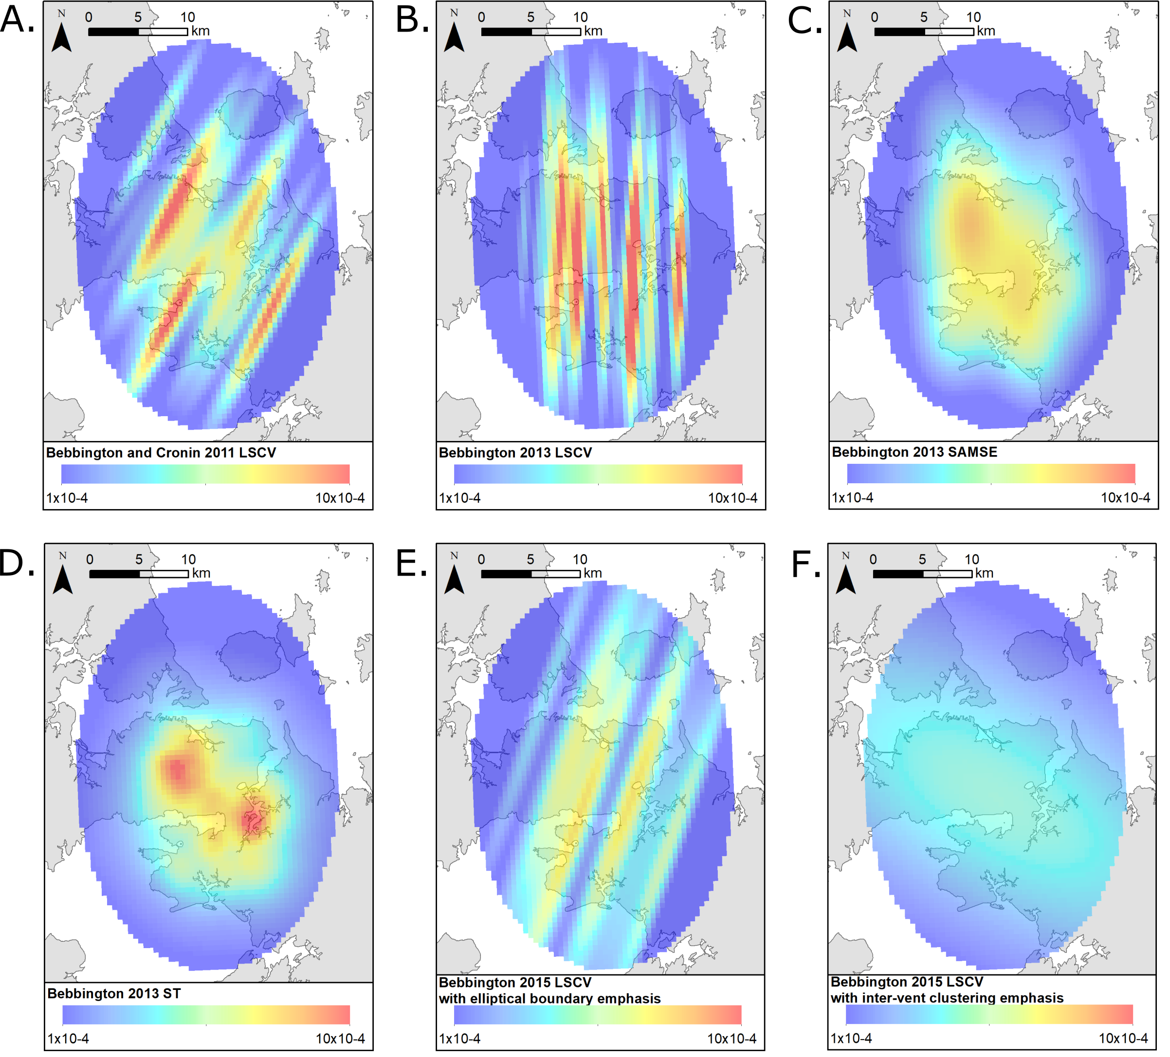
Figure 1 Spatial intensity hazard models for the AVF considered within this study. (A) A kernel density estimate model using least squares cross-validation (LSCV) from (Bebbington and Cronin, 2011). (B) Gaussian anisotropic kernel LSCV from Bebbington (2013). (C) Gaussian anisotropic kernel sum of asymptotic mean squared error (SAMSE) from Bebbington (2013). (D) A spatio-temporal model (Connor and Hill, 1995) for the AVF from Bebbington (2013). (E) An LSCV optima from a bounded Gaussian anisotropic kernel with elliptical boundary emphasis from Bebbington (2015). (F) An alternative LSCV optima from a bounded Gaussian anisotropic kernel with inter-vent clustering emphasis from Bebbington (2015).

Table 1 Evacuation travel times distribution for various AVF spatial vent location models. These times are for clearing the combined evacuation zone (PEZ+SEZ) with vent uncertainty buffer distance set to 0km.
Spatial vent location AVF model | Evacuation travel times (hours – 2 dp)
Spatial vent location AVF model | 10th percentile | 50th percentile | 90th percentile
Bebbington and Cronin 2011 | 0.22 | 0.79 | 1.33
Bebbington 2013 LSCV | 0.22 | 0.76 | 1.18
Bebbington 2013 SAMSE | 0.13 | 0.78 | 1.34
Bebbington 2013 ST | 0.23 | 0.75 | 1.12
Bebbington 2015 Elliptical boundary emphasis | 0.10 | 0.90 | 1.35
Bebbington 2015 Inter-vent clustering emphasis | 0.35 | 0.90 | 1.44
Uniform distribution | 0.10 | 0.83 | 1.42

Table 2 Evacuation travel times distribution for various AVF spatial vent location models. These times are for clearing the combined evacuation zone (PEZ+SEZ) with 5 and 10 km vent uncertainty buffer distance.
Spatial vent location AVF model | Evacuation travel times (hours – 2 dp)
Spatial vent location AVF model | 5 km vent uncertainty |  |  | 10 km vent uncertainty
Spatial vent location AVF model | 10th percentile | 50th percentile | 90th percentile |  | 10th percentile | 50th percentile | 90th percentile
Bebbington & Cronin 2011 LSCV | 0.95 | 1.69 | 2.61 |  | 1.48 | 2.51 | 3.86
Bebbington 2013 LSCV | 0.92 | 1.64 | 2.42 |  | 1.46 | 2.48 | 3.64
Bebbington 2013 SAMSE | 0.85 | 1.63 | 2.53 |  | 1.44 | 2.48 | 3.73
Bebbington 2013 ST | 0.95 | 1.65 | 2.42 |  | 1.48 | 2.49 | 3.64
Bebbington 2015 Elliptical boundary emphasis | 0.76 | 1.64 | 2.42 |  | 1.42 | 2.51 | 3.62
Bebbington 2015 Inter-vent clustering emphasis | 1.07 | 1.73 | 2.42 |  | 1.66 | 2.67 | 3.64
Uniform distribution | 0.82 | 1.61 | 2.32 |  | 1.30 | 2.41 | 3.49

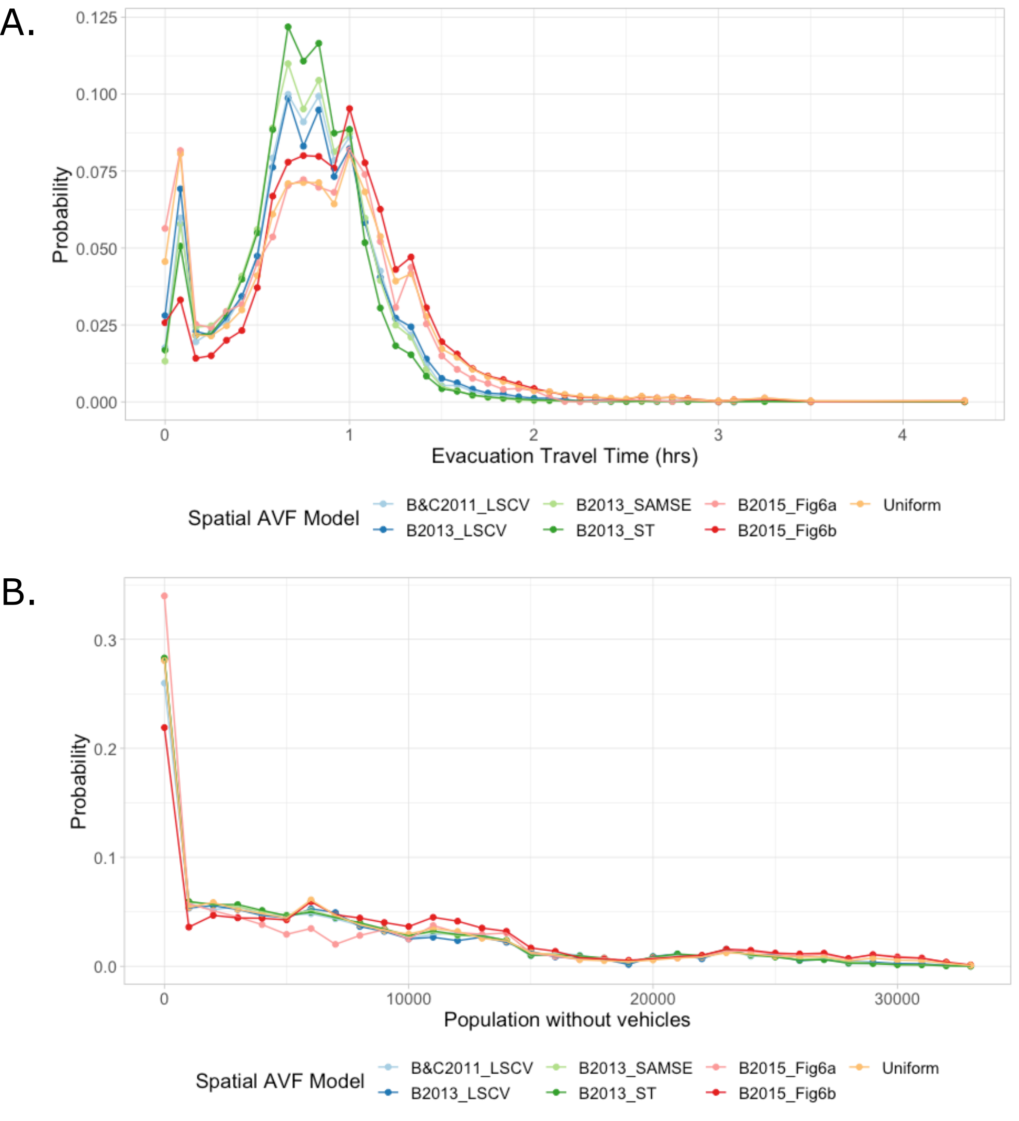Figure 2 Distribution of (A) evacuation travel times and (B) population without vehicles for spatial AVF vent locations models
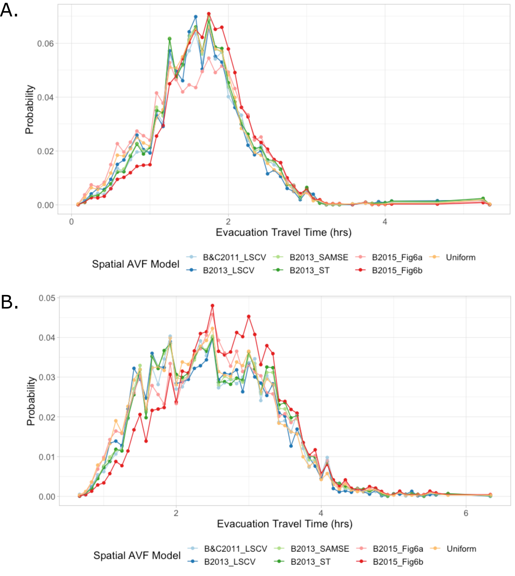Figure 3 Distribution of evacuation travel times for spatial AVF vent locations models with (A) 5 km and (B) 10 km vent uncertainty

References

Bebbington, M.S., 2015. Spatio-volumetric hazard estimation in the Auckland volcanic field. Bulletin of Volcanology 77. https://doi.org/10.1007/s00445-015-0921-3
Bebbington, M.S., 2013. Assessing spatio-temporal eruption forecasts in a monogenetic volcanic field. Journal of Volcanology and Geothermal Research 252, 14–28. https://doi.org/10.1016/j.jvolgeores.2012.11.010
Bebbington, M.S., Cronin, S.J., 2011. Spatio-temporal hazard estimation in the Auckland Volcanic Field, New Zealand, with a new event-order model. Bulletin of Volcanology 73, 55–72. https://doi.org/10.1007/s00445-010-0403-6
Connor, C.B., Hill, B.E., 1995. Three nonhomogeneous Poisson models for the probability of basaltic volcanism: application to the Yucca Mountain region, Nevada. Journal of Geophysical Research: Solid Earth 100, 10107–10125.
Runge, M.G., Bebbington, M.S., Cronin, S.J., Lindsay, J.M., Moufti, M.R., 2015. Sensitivity to volcanic field boundary. Journal of Applied Volcanology 4, 22–22. https://doi.org/10.1186/s13617-015-0040-z
Tomsen, E., Lindsay, J.M., Gahegan, M., Wilson, T.M., Blake, D.M., 2014. Evacuation planning in the Auckland Volcanic Field, New Zealand: a spatio-temporal approach for emergency management and transportation network decisions. Journal of Applied Volcanology 3, 1–22. https://doi.org/10.1186/2191-5040-3-6

