Towards better irrigation management for vineyards based on machine learning algorithms and SHAP analysis: a case study in New Zealand

Authors:
Hsiang-En Wei ¹, Miles Grafton ¹, Michael Bretherton ¹, Matthew Irwin ¹, and Eduardo Sandoval ²
¹ School of Agriculture and Environment, Massey University, Private Bag 11-222,
Palmerston North 4442, New Zealand; h.wei1@massey.ac.nz (H.-E.W.); m.grafton@massey.ac.nz (M.G.); m.r.bretherton@massey.ac.nz (M.B.); m.e.irwin@massey.ac.nz (M.I.)
² AgriFood Digital Lab, School of Food and Advanced Technology, Massey University, Private Bag 11-222, Palmerston North 4442, New Zealand; e.a.sandoval@massey.ac.nz

ABSTRACT
Monitoring and management of grapevine water status (GWS) over the critical period between flowering and veraison plays a significant role in producing grapes of premium quality. GWS monitoring is critical to vineyard management, and so determines which variables are the main drivers of GWS variation. The goal of this study is to provide viticulturists with an approach to simulate the complex relationship between canopy GWS with vegetation, weather, day of the year (DOY), and soil/terrain variables, along with the interpretation of these relationships. A case study done in Martinborough, New Zealand is used for illustration. A UAV was flown over two Pinot Noir vineyards to generate aerial images with 4.3 cm resolution, and the vegetation index, Transformed Chlorophyll Absorption Reflectance Index (TCARI), was computed for every sampled grapevine. Slope and elevation were extracted from a digital elevation model, and apparent electrical conductivity (EC_{a}) was obtained from an EM38 survey. A local weather station provided continuous air temperature, humidity, rainfall, wind speed, and irradiance data, which were computed as variables at weekly and daily intervals. DOY was used to represent temporal trends along the growing season. Hierarchical clustering and three machine learning algorithms (elastic net, random forest regression, support vector regression) were used to regress predictors against stem water potential (Ψstem), measured by a pressure bomb and used as a proxy for GWS. Shapley Additive exPlanations (SHAP) analysis (a statistical tool that weighs the importance of each variable in a model) was used to interpret the relationship between selected predictors and Ψstem. Our results showed that the coefficient of determination (R²) of the best-performed model reached 0.7 when simulated by support vector regression using TCARI, DOY, and elevation as inputs. This study has provided proof of concept of developing regression models that would be beneficial for grapevine irrigation systems via continuous GWS monitoring, while the identification and clarification of the relationship between statistically dominant variables would assist in decision-making to attain optimal grape quality.

1. INTRODUCTION
Studies have demonstrated that grapevine water status (GWS) is a key factor in berry quality, in terms of both vegetative growth and fruit metabolism (Van Leeuwen et al., 2009). During the important phenological stages such as bloom and veraison (Acevedo-Opazo et al., 2013), grapevine water status is ideally under controlled water deficit. This husbandry can benefit berry development by suppressing competition for photosynthetic resources from vegetative growth (Intrigliolo & Castel, 2009), promoting the accumulation of sugar and anthocyanins (Etchebarne et al., 2010), and preventing oxidative damage from reactive oxygen species (Min et al., 2019). The water status of each grapevine varies within a field, leading to variability in vine growth and then berry development. To minimize the variation in grape quality within blocks, it is important to monitor the temporal and spatial variability of GWS, while carrying out corresponding husbandry practices to try and keep water status within an optimal range.
GWS is an integrated response influenced by cultivation practices, weather, and soil/terrain factors. A published study supports the view that cultivar is the main driver of GWS under well-watered conditions, while vegetative expression and soil type becomes more dominant as water deficit increases (Taylor et al., 2010). Weather variables are other important driving factors characterizing the variation of plant water budgets (Irmak & Mutiibwa, 2010). These drivers induce hydraulic and metabolic signals that trigger water consumption by crops, along with a range of physiological responses to water deficit, consequently shaping the spatial and temporal variation of GWS in the field. Several studies have been implemented to simulate and explore the relationship between measured GWS and environmental information composed of vegetative, soil/terrain, day of the year (DOY), and weather variables (Acevedo-Opazo et al., 2008; Acevedo-Opazo et al., 2010; Brillante et al., 2016; Suter et al., 2019; Tang et al., 2022; Taylor et al., 2012).
As GWS represents spatial variability across the field resulting from several factors, identifying the main drivers is essential for vineyard management in terms of GWS optimization. To help describe the relationship between GWS and these variables, machine learning (ML) techniques have recently arisen as an alternative due to their ability to model both linear and nonlinear patterns based on multi-variables (Kuhn & Johnson, 2013). Moreover, when paired with an interpretation tool, such as SHAP, ML models are potentially more powerful as the results of straight ML techniques are usually limited to incomplete interpretations such as feature importance or variable weight (Mangalathu et al., 2020). SHAP has the ability to provide directionality of relationships and can reveal synergistic effects between multiple variables (Lundberg et al., 2020). Therefore, not only can correlative relationships be captured by the ML model, but also causal relationships can be evaluated by SHAP. In this way, GWS manipulation may be possible.
As vineyard management is strongly linked to the hydration state of vines, an understanding of GWS dynamics and the dominant drivers of its changes would be indispensable for viticulture management and to grape quality. The goal of this study is to provide canopy GWS estimation in the production context and provide insights into the relationship between GWS and vegetation, weather, DOY, and soil/terrain variables over the flowering-to-veraison period. The procedures undertaken are (i) modeling changes in GWS based on vegetation, DOY, soil/terrain, and weather variables. The machine learning model with the best predictive performance and logical causal relationships is presented and assessed. (ii) understanding which combination of predictors will be selected in the best performance model of GWS variation, and their contribution and relationship with GWS is evaluated using SHAP analysis.
2. METHODOLOGY
2.1. The Context of the Study Vineyards
The two study vineyards, Wharekauhau (6.6 ha) and Pencarrow (6.7 ha), owned by Palliser Estate, are located at Martinborough in the Greater Wellington Region in New Zealand (NZ), near the Ruamahanga and Huangarua Rivers (Figure 1). Pinot Noir was chosen as the target cultivar in this study, due to its requirement for relatively precise irrigation management. The Pinot Noir vines in both vineyards were planted in 1998-2000 and trained with two-cane vertical shoot positioning. Inter- and intra-row planting space is 2.2 X 1.7 m for Wharekauhau and 2.2 X 1.8 m for Pencarrow. The annual growth cycle of grapevine in NZ comprises budburst, shoot growth, and flowering (September–November), fruit set and veraison (December–February) followed by berry development and harvesting (March–May). From flowering to veraison, termed as the critical period in the following sections, the management of GWS is the most critical determinant in final berry quality.
S-map online ( HYPERLINK "https://smap.landcareresearch.co.nz/" https://smap.landcareresearch.co.nz/), a national soil database developed by Landcare Research, is used to provide a basic soil summary to support the study. There are mainly two types (Glas_8a.2: 60%, Barr_22a.1: 40%) and three types (Barr_22a.1: 50%, Glas_8a.2: 40%, Waka_26a.1: 10%) of soils across the Wharekauhau and Pencarrow vineyards, respectively. Glas_8a.2 and Barr_22a.1 have dominantly silt texture in their topsoil and subsoil, with gravelly subsurface layers from less than 0.45 m to more than 1 m depth. Both types are described as well-drained, with Glas_8a.2 having a moderate soil water holding capacity while Barr_22a having a high capacity. Waka_26a.1 has a silt texture and a clay texture in its topsoil and subsoil, with a gravel content of less than 3%, and a plant rooting depth extending beyond 1 m. It is described as imperfectly drained and highly vulnerable to water logging.
The trials undertaken in this study took place over two growing seasons, 2020/2021 and 2021/2022. The nine measurement dates avoided rainy days and matched the critical period for GWS management. During the study periods the daily mean temperature varied from 10 to 24 ℃, and daily accumulated rainfall ranged between 0 and 39 mm at the vineyards. Due to adequate rainfall, the two vineyards were not irrigated during the study periods.
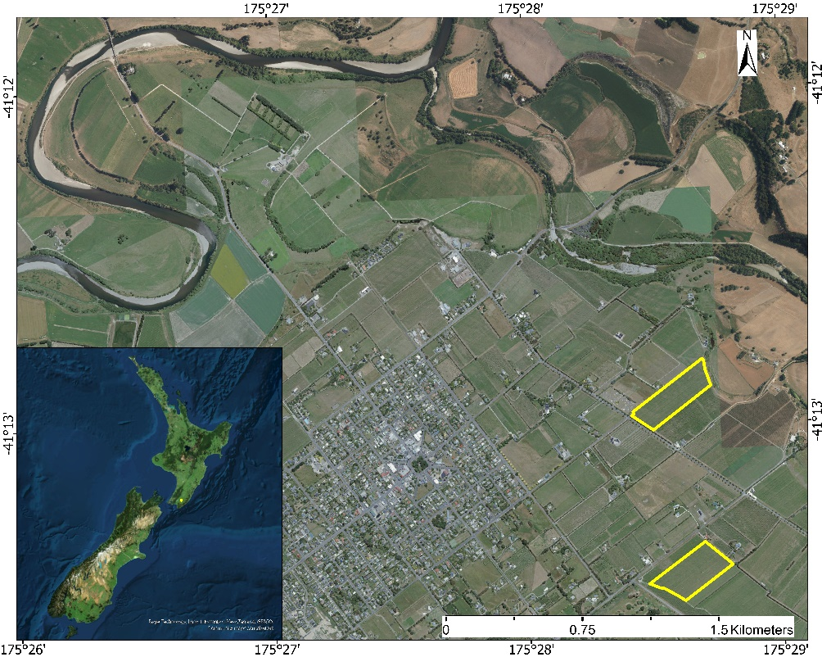
Pencarrow
Wharekauhau
Huangarua River
Ruamahanga River
Figure 1. Location of study vineyards.
2.2. Grapevine Stem Water Potential
Stem water potential (Ψstem) was chosen as a proxy for GWS, and has been expressed as a comprehensive indicator for early water deficit in vines during the day (Patakas et al., 2005). A pressure chamber (model: 610, MPS, Albany, NY, USA) was employed between the hours of 12:30 and 15:30 to assess Ψstem (kPa). Prior to the measurement, two sampled leaves per vine were covered with sealable plastic bags for about 1 h. These two measurements were averaged to represent the grapevine canopy water status. A total of 148 canopies were surveyed over the two growing seasons, and each of their trunk locations was recorded using a global navigation satellite system (GNSS) with real-time kinematic (RTK) correction (model: GPS1200+, Leica Geosystems AG., Heerbrugg, Switzerland).
2.3. Soil Variables
An EM38-MK2 sensor is an electromagnetic induction (EMI)-based sensor (Geonics Ltd., Mississauga, Ontario, Canada). The return reading, apparent electrical conductivity (EC_{a}), is a weighted average based on the depth-related sensitivity of the instrument and the depth-dependent drivers of EC_{a} (McNeill, 1980). Spatial patterns of EC_{a} values have been found to be relatively temporally stable between measurement dates (Heil & Schmidhalter, 2017). The EM38-MK2 was operated in the vertical dipole mode, with the instrument taking integrated EC_{a} measurements at about 1.5 m depth, and towed at the back of an all-terrain vehicle with a Trimble Yuma 2 tablet including a GPS receiver onboard to geo-reference all EC_{a} (mS/m) point data. Values less than 0 mS/m were removed before carrying out dataset interpolation. The geostatistical interpolation method, Empirical Bayesian Kriging (EBK), was used to transform point data onto a continuous surface raster with 1 m resolution in ArcGIS Pro 2.9 (ESRI, Redlands, California, USA).
Elevation (m) and slope (degree) information of the location for each sampled canopy were obtained from the ‘Wellington LiDAR 1m DEM (2013-2014)’ layer provided by Land Information New Zealand data service (https://data.linz.govt.nz/). This digital elevation model in 1 m resolution was generated by aerial LiDAR captured between 2013 and 2014 for the Greater Wellington region. For each grapevine, the mean values of EC_{a}, elevation, and slope within 0.5 m distance of the trunk were computed using ArcGIS Pro.
2.4. Vegetation Variables
Aerial images were obtained between 11:00 and 12:30 under sunny conditions on the same date of Ψstem data measurement to ensure comparability. The reflectance, with a spatial resolution of 0.043 m, was recorded by DJI Phantom 4 multispectral UAV (DJI, Shenzhen, China) in the blue, green, red, red edge, and near-infrared regions. Photogrammetric processing was applied to the aerial data using Pix4Dmapper (Pix4D SA, Lausanne, Switzerland) to generate digital surface models (DSM), digital terrain models (DTM), and reflectance maps. Several ground control points were recorded by GNSS-RTK in each vineyard, with subsequent imagery alignment processing. For each grapevine, only the vegetation component within 0.5 m distance of the trunk was considered for computing vegetation variables since the shoots of adjacent grapevines are often overlapping and intertwined. The acquisition of specific canopy pixels was carried out by overlapping the buffer zones (using recorded trunk location as the center of a circle with a radius of 0.5 m) with the binary raster of canopy height (Figure 2). Subsequently, Transformed Chlorophyll Absorption Reflectance Index (3 * ((Red edge - Red) - 0.2 * (Red edge - Green) *(Red edge/Red))) for each sampled grapevine was calculated based on the average of canopy pixels using ArcGIS Pro. This vegetation index was used for subsequent modeling since it is sensitive to chlorophyll concentration and was reported to be significantly correlated with the Ψstem of grapevines (Baluja et al., 2012; Haboudane et al., 2002).
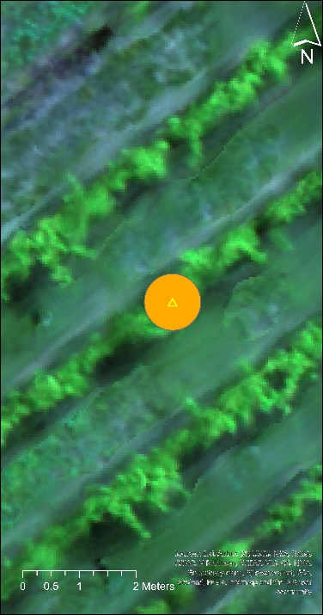 | 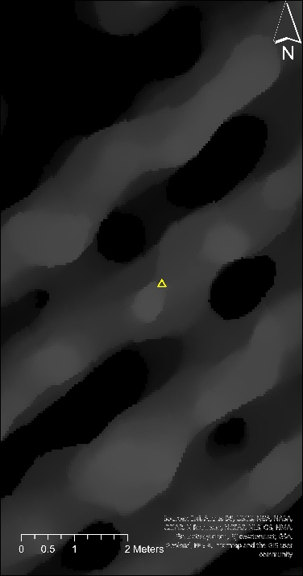 | 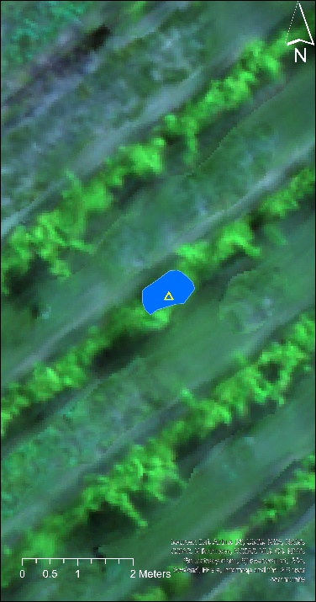
Figure 2. The procedure of obtaining pure pixels for sampled canopies. Left: The subset of an aerial image comprising grapevines and floor vegetation. The buffer zone, the orange circle, was created according to the recorded location, the yellow triangle, of the sampled grapevine. Middle: Binary raster of canopy height was generated by subtracting the digital terrain model from the digital surface model. Right: Pure grapevine pixels, blue region, were acquired by overlapping the buffer zone with binary raster.
2.5. Weather and Temporal Variables
Weather data was recorded by the on-site weather station (175.4741, -41.2247 WGS84) and established by HARVEST.com (http://harvest.com/). The target variables include air temperature (℃), relative humidity (%), rainfall (mm), wind speed (km/h), and irradiance (W/m²). These variables then were used to compute mean temperature, mean relative humidity, total rainfall, mean wind speed, and total irradiance based on weekly and daily intervals before each measurement date. It is assumed that climatic conditions were homogeneous across the two vineyards. Day of the year (DOY) was used to exhibit temporal trends during the critical period.
2.6. Modelling Pipeline
Vegetation, soil/terrain, weather, and DOY variables were used as inputs for regression modeling. Spearman correlation was performed between predictor variables and Ψstem to provide an initial understanding of the relationships between inputs and Ψstem. The closer the correlation was to ±1, the stronger the correlative relationship. The hierarchical clustering for variables was then carried out as an exploratory data analysis (Morgenthaler, 2009), incorporating expert domain knowledge and reducing repetitive information while lowering input dimensionality via identification of clusters among the predictors. The similarity between clusters was based on correlation distance. The approach was implemented using “FeatureAgglomeration” from the sklearn library and “dendrogram” from the scipy library in Python.
According to the clusters generated by hierarchical clustering, combinations of predictor variables were formed by picking (or discarding) one variable from each cluster using “product” from the itertools library in Python. All possible combinations, 2880 in total, were investigated along with three types of machine learning models for performance comparison. The total number of samples (n = 148) were split into training (n = 103) and test (n = 45) sets using a 70/30 ratio. The split was carried out and stratified according to the date of measurement, to ensure that both training and test sets had corresponding percentages of samples for each date. The splitting process was undertaken using “train_test_split” from the sklearn package in Python. All predictor variables were standardized to have mean values equivalent to 0 and a standard deviation of 1.
Elastic net (EN), random forest regression (RFR), and support vector regression (SVR) were applied to estimate Ψstem based on DOY, weather, soil/terrain, and vegetation variables. They were implemented using “ElasticNet”, “RandomForestRegressor”, and “SVR” from the sklearn library in Python. Grid searching on the training set with 10-fold cross-validation, based on the R² value, was used to search for the best combination of hyperparameters. This technique was carried out using “GridSearchCV” from the sklearn library in Python. To compare the performance of regression models and thus choose the optimal model for further analysis, the coefficient of determination (R²) and root mean square error (RMSE) values were computed by applying the trained models with optimized hyperparameters on the test set.
2.9. Shapley Additive exPlanations
The optimal model then underwent Shapley Additive exPlanations (SHAP), based on game theory, to explore the relationships and quantify the contribution (SHAP values) of each predictor variable according to its marginal contribution to the model output (Lundberg & Lee, 2017). In this study, SHAP values based on the training set were computed using KernelExplainer, since this support vector regression performed the best at modeling and was used in SHAP. A summary plot and bar plot for the whole dataset was generated to show important variables and the directionality of their impact. This analysis was implemented via the shap library in Python.
3. RESULTS
3.1 Spearman correlation
The information regarding the correlative strength between variables is provided in Figure 3. The correlation is stronger as the color of the cell changes from red to yellow, and also indicates multicollinearity takes place within the predictor set. The predictor variables that are important in describing the variation in GWS are the day of the year (DOY) and weekly total irradiance (w_IRtotal).
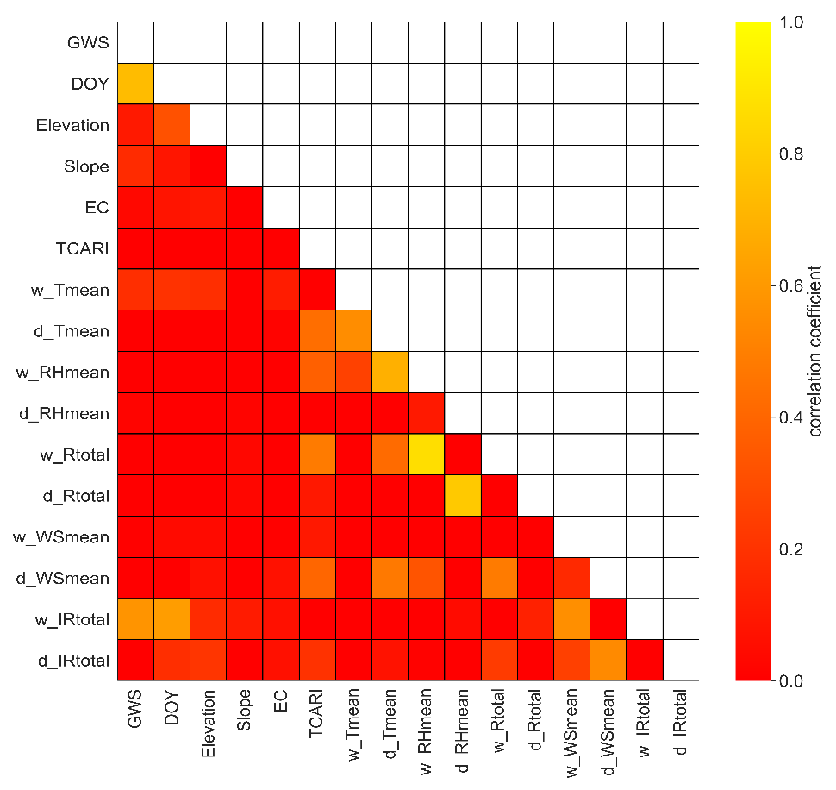
Figure 3. The Spearman correlation heatmap between all variables. The color of the cell indicates the absolute value of the correlation coefficient, where GWS is grapevine water status, TCARI is Transformed Chlorophyll Absorption Reflectance Index, RHmean is mean relative humidity; Rtotal is total rainfall; DOY is the day of the year; IRtotal is total irradiance; WSmean is mean wind speed; Tmean is mean temperature; EC is apparent electrical conductivity. The front letter w or d refers to the temporal scale as weekly or daily interval before the acquisition of stem water potential.
3.2 Hierarchical clustering
Hierarchical clustering, using correlation distance for distinguishing similarity, is employed to cluster the predictors that are statistically redundant to one another. In Figure 4, each leaf of the dendrogram represents one of the 15 predictor variables. The vertical axis indicates how similar the two variables are. The earlier any merging between variables occurs (closer to the bottom of the dendogram), the more correlated those variables are. When variables merge close to the top of the dendrogram, the information they contain is nearly independent of each other. The number of clusters was determined by incorporating domain knowledge. As weather variables are intercorrelated and have an impact on plant physiology leading to changes in spectral features (i.e., VIs), it is reasonable to put them into clusters. However, the relationship between soil/terrain variables and short-term weather effects or vegetation index would be considered weak, so the cut-off line was set to be 0.75, resulting in eight clusters marked with different colors.
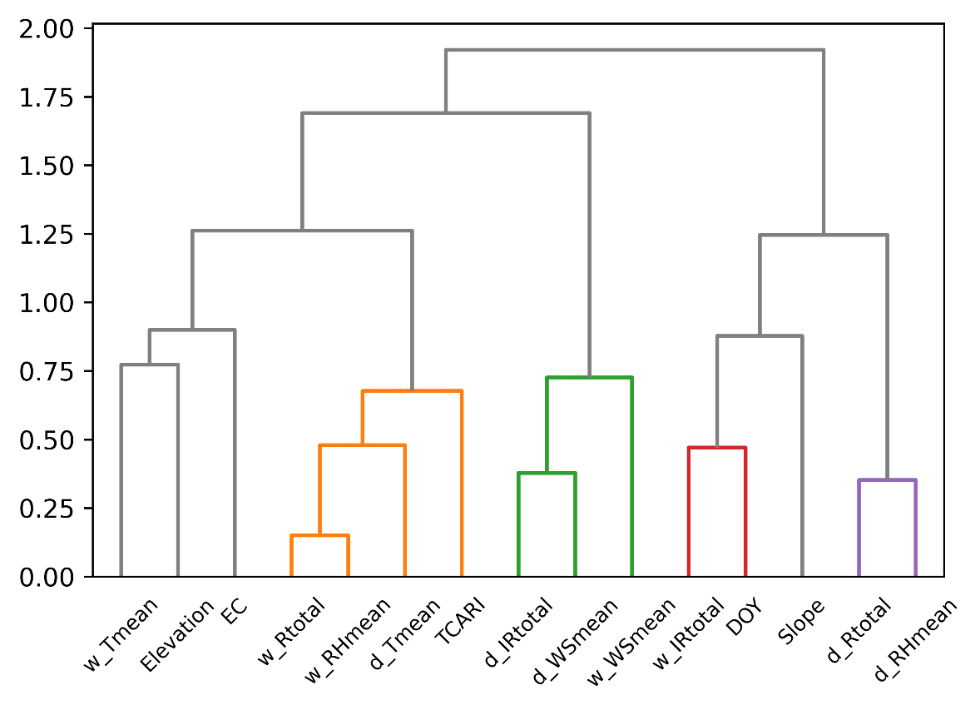
Figure 4. Hierarchical clustering dendrogram of predictor variables.
3.3 Modelling performance
TCARI, day of the year (DOY), soil/terrain, and weather variables were used as inputs to regress against Ψstem using elastic net (EN), random forest regression (RFR), or support vector regression (SVR). The total number of combinations tested was 2880 (8 clusters: 3*2*3*4*5*2*2*2). The regression model with the best performance on the test set in terms of coefficient of determination (R²) and root mean square error (RMSE) was presented with its scatter plot (Figure 5). SVR, a non-linear algorithm, was chosen to be the best descriptor for the relationship between Ψstem and the predictors.
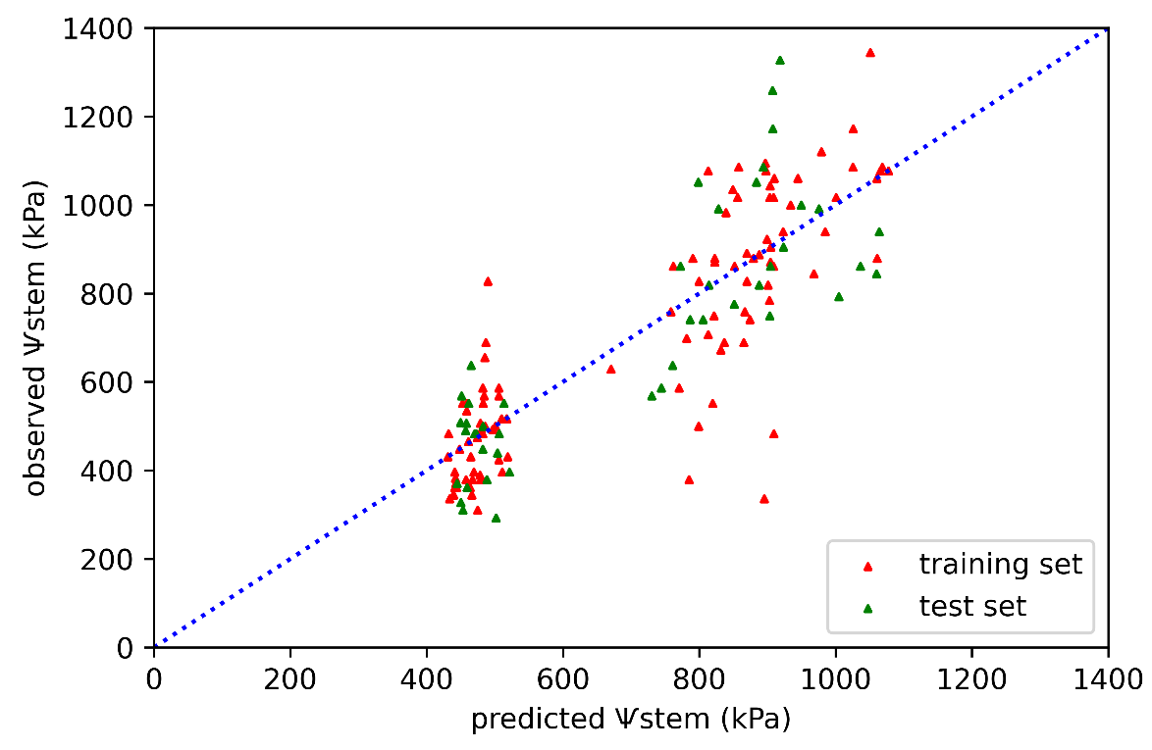
R² = 0.7
RMSE = 146 kPa
Figure 5. Scatter plot between predicted stem water potential and observed water potential for both training set (red triangles) and test set (green triangles) using support vector regression. The coefficient of determination (R²) and root mean square error (RMSE) in the upper left corner indicate the modeling performance on the test set. The blue dotted line is the 1:1 line.
3.4 Shapley Additive exPlanations (SHAP)
To explore the impact of each predictor variable on variation in Ψstem, Shapley Additive exPlanations (SHAP) was employed to support the interpretability of machine learning models. The SHAP values represent how much the contribution the variable makes towards the prediction of models, with positive values increasing Ψstem and negative values decreasing Ψstem prediction. Measured Ψstem is the reading from the pressure bomb, so the higher the value of Ψstem, the lower the water status of the grapevine. The causal effects between Ψstem and predictor variables were assessed using SHAP, with only the models with reasonable relationships being selected and presented. The model in Figure 5 was analyzed and presented in Figure 6 using SHAP analysis. In the summary plot of Figure 6, every dot from each predictor refers to a single observation. A wider spread of dots along the axis of SHAP values indicates that the variable has more influence on the output, thus being of more importance. The color of dots denotes the value of the variable for the observation, where the purple and orange color refers to the high and low variable values, respectively. The summary plot shows how each variable would influence the model prediction. In the bar plot of Figure 6, it give an overview of variable importance for the model. The results show canopies become more dehydrated when DOY increases, Transformed Chlorophyll Absorption Reflectance Index (TCARI) decreases, and where canopies are located on the lower landscape units.
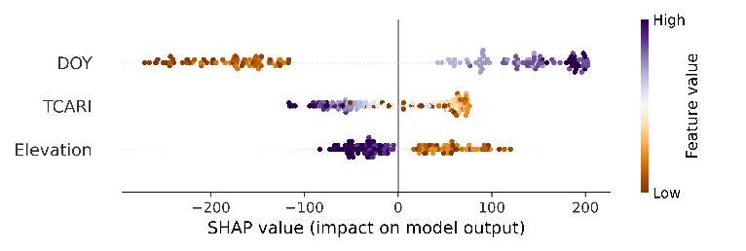 | 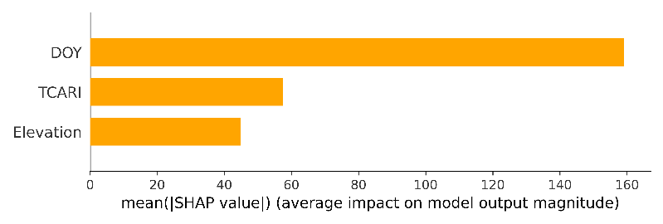
Figure 6. Left: summary plot for regression modeling. Right: bar plot for the predictor variables according to SHAP values calculated. Variables are ranked from top to bottom in descending order of average SHAP value.

4. DISCUSSION

4.1 Preprocessing and Modeling
One of the goals for this study was to identify the causal relationships between predictors and Ψstem, enabling growers to utilize these relationships to modify GWS according to targetted quality standards. Therefore, the models developed in this study were required to have not only predictive capabilities but also logical causality. Initially, all predictor variables were used for regression against Ψstem without clustering preprocessing, with most of the causal relationships being unintuitive. Later, hierarchical clustering was employed to generate groups of highly correlated variables and generate input datasets composed of mutually independent variables, as suggested by Lundberg (2021). These results indicated that the model still exhibited similar prediction results, using fewer predictors, and that all the dominant causal relationships were reasonable and intuitive.
The relationships between Ψstem and soil/terrain, DOY, and weather variables are complex, so that machine learning algorithms, including elastic net (EN), random forest regression (RFR), and support vector regression (SVR), instead of traditional statistics, were utilized to describe these relationships. According to the best-performing model, SVR, the relationship appeared to be non-linear between Ψstem and its predictors. It also appeared that SVR was capable of handling more variables in simulating changes in Ψstem. One explanation for the relatively high performance of SVR is that the dataset may have been limited (n = 148) and more likely to be sensitive to noise, but SVR has been reported to be less sensitive to sampling variation for a small sample size because the selection of support vectors depends on a small subset of observation only (James et al., 2013; Tange et al., 2017). While SVR has been mentioned as needing a higher computational cost (Chen et al., 2020), this was not observed in this study. In contrast, RFR required more computing resources in terms of memory (RAM) and training time in this study. Based on the results of this study, the use of SVR is proposed for remotely monitoring Pinot Noir Ψstem if the regression is based on vegetation, soil/terrain, DOY, and weather variables, but additional ML algorithms need to be investigated to optimize the estimation performance.
4.2 Important Predictor Variables
Following the concept of a soil-plant-atmosphere continuum for water movement in nature (Elfving et al., 1972), various complementary estimators were used to describe the dynamics of GWS, including one vegetation index (TCARI), three soil/terrain variables (elevation, slope, electrical conductivity), one temporal variable (DOY), and ten weather variables (mean temperature, total irradiance, mean relative humidity, mean wind speed, total rainfall at weekly and daily scale). The summary plot in Figure 6 provides some insights into the relationships between Ψstem and the selected predictor variables, including TCARI, the day of the year (DOY), and elevation. The SHAP value for each predictor is the marginal contribution, on average, of that predictor toward the values of final prediction across all observations.
It would appear that a promising estimation of Ψstem can be achieved when using predictors with long-term to short-term effects on GWS. TCARI exhibits chlorophyll variability by capturing it in the green, red, and red edge bands. This expresses a mid-term impact imposed by water deficit, as the chlorophyll content reduces in accordance with the enhancement of dehydration during the growing period. The temporal variable, DOY, is relatively mid to short-term because it reflects the time flow along the growing season. DOY was shown to positively contribute to the dehydration of grapevine (Figures 6). This aligns with grapevine management and weather, as no irrigation was applied during the study period, while heavy rainfall was concentrated around early December, followed by occasional but less intense (< 10 mm) rainfall (Figure 2). In the study of Suter et al. (2019), their best prediction model selected DOY as one of the predictors and explained a great part of the variability in the Ψstem of three cultivars grown in France.
Soil/terrain variables represent long-term effects as they consistently affect GWS over multiple growing seasons (Bellvert et al., 2012). From SHAP summary plots, grapevines appear to be more hydrated when sited on more elevated ground. When evaluating terrain information of observations at both vineyards, Pencarrow, ranging between 44 – 46 m, has an overall higher elevation than Wharekauhau, ranging between 36 – 38 m. The recorded elevation of observations from Wharekauhau is significantly lower than that of observations from Pencarrow (p-value of Mann-Whitney U test is lower than 0.05). One explanation is that the higher landscape terraces, older than 15K years, are likely to have a covering of loess. Loess is a well-sorted quartzo-feldspathic material of silt to clay-sized particles, and it is picked up by wind from nearby aggrading braided riverbeds present during historic global cold cycles. This fine loess will increase the water-holding capacity of the soils developing on these higher and older terraces. Loess deposition will not be present on lower terraces with an age younger than 15K years, where the soils are much more likely to be developing from alluvial deposits from consecutive flooding events over the last 15K years. These deposits have a potentially wider range of textures from silt through to sand and coarse sand. The soils developing from them are likely to be better drained. The soil properties were reported to affect soil water holding capacity, further leading to spatial differences in GWS across the fields (Brillante et al., 2016). Thus, Pencarrow, sited on the higher terrace, may have the ability to hold more water than Wharekauhau due to particle composition, enabling grapevines to be more hydrated.

Funding: This study was funded by a grant from the Massey University Research Fund (MURF) and a grant from the New Zealand Horticulture Trust.

Acknowledgments:
The authors sincerely thank Palliser Estate for providing the vineyards as study fields, and Guy McMaster (chief viticulturist of Palliser Estate) for supplying the pressure bomb during the research period.

REFERENCE

Acevedo-Opazo, C., Tisseyre, B., Guillaume, S., & Ojeda, H. (2008). The potential of high spatial resolution information to define within-vineyard zones related to vine water status. Precision Agriculture, 9(5), 285-302. https://doi.org/10.1007/s11119-008-9073-1

Acevedo-Opazo, C., Tisseyre, B., Taylor, J., Ojeda, H., & Guillaume, S. (2010). A model for the spatial prediction of water status in vines (Vitis vinifera L.) using high resolution ancillary information. Precision Agriculture, 11(4), 358-378.

Acevedo-Opazo, C., Valdés-Gómez, H., Taylor, J., Avalo, A., Verdugo-Vásquez, N., Araya, M., Jara-Rojas, F., & Tisseyre, B. (2013). Assessment of an empirical spatial prediction model of vine water status for irrigation management in a grapevine field. Agricultural Water Management, 124, 58-68.

Baluja, J., Diago, M. P., Balda, P., Zorer, R., Meggio, F., Morales, F., & Tardaguila, J. (2012). Assessment of vineyard water status variability by thermal and multispectral imagery using an unmanned aerial vehicle (UAV). Irrigation Science, 30(6), 511-522. https://doi.org/10.1007/s00271-012-0382-9

Bellvert, J., Marsal, J., Mata, M., & Girona, J. (2012). Identifying irrigation zones across a 7.5-ha ‘Pinot noir’vineyard based on the variability of vine water status and multispectral images. Irrigation Science, 30(6), 499-509.

Brillante, L., Mathieu, O., Lévêque, J., & Bois, B. (2016). Ecophysiological modeling of grapevine water stress in burgundy terroirs by a machine-learning approach. Frontiers in Plant Science, 7, 796.

Chen, H., Huang, J. J., & McBean, E. (2020). Partitioning of daily evapotranspiration using a modified shuttleworth-wallace model, random Forest and support vector regression, for a cabbage farmland. Agricultural Water Management, 228, 105923.

Elfving, D. C., KAUFMANN, M. R., & HALL, A. E. (1972). Interpreting leaf water potential measurements with a model of the soil‐plant‐atmosphere continuum. Physiologia Plantarum, 27(2), 161-168.

Etchebarne, F., Ojeda, H., & Hunter, J. (2010). Leaf: fruit ratio and vine water status effects on Grenache Noir (Vitis vinifera L.) berry composition: water, sugar, organic acids and cations. South African Journal of Enology and Viticulture, 31(2), 106-115.

Haboudane, D., Miller, J. R., Tremblay, N., Zarco-Tejada, P. J., & Dextraze, L. (2002). Integrated narrow-band vegetation indices for prediction of crop chlorophyll content for application to precision agriculture. Remote Sensing of Environment, 81(2-3), 416-426.

Heil, K., & Schmidhalter, U. (2017). The application of EM38: Determination of soil parameters, selection of soil sampling points and use in agriculture and archaeology. Sensors, 17(11), 2540.

Intrigliolo, D. S., & Castel, J. R. (2009). Response of grapevine cv. ‘Tempranillo’ to timing and amount of irrigation: water relations, vine growth, yield and berry and wine composition. Irrigation Science, 28(2), 113-125. https://doi.org/10.1007/s00271-009-0164-1

Irmak, S., & Mutiibwa, D. (2010). On the dynamics of canopy resistance: Generalized linear estimation and relationships with primary micrometeorological variables. Water resources research, 46(8).

James, G., Witten, D., Hastie, T., & Tibshirani, R. (2013). An introduction to statistical learning (Vol. 112). Springer.

Kuhn, M., & Johnson, K. (2013). Applied predictive modeling (Vol. 26). Springer.

Lundberg, S. (2021). Be Careful When Interpreting Predictive Models in Search of Causal Insights. https://towardsdatascience.com/be-careful-when-interpreting-predictive-models-in-search-of-causal-insights-e68626e664b6

Lundberg, S. M., Erion, G., Chen, H., DeGrave, A., Prutkin, J. M., Nair, B., Katz, R., Himmelfarb, J., Bansal, N., & Lee, S.-I. (2020). From local explanations to global understanding with explainable AI for trees. Nature machine intelligence, 2(1), 56-67.

Lundberg, S. M., & Lee, S.-I. (2017). A unified approach to interpreting model predictions. Proceedings of the 31st international conference on neural information processing systems,

Mangalathu, S., Hwang, S.-H., & Jeon, J.-S. (2020). Failure mode and effects analysis of RC members based on machine-learning-based SHapley Additive exPlanations (SHAP) approach. Engineering Structures, 219, 110927.

McNeill, J. (1980). Electromagnetic terrain conductivity measurement at low induction numbers. G. Limited.

Min, Z., Li, R., Chen, L., Zhang, Y., Li, Z., Liu, M., Ju, Y., & Fang, Y. (2019). Alleviation of drought stress in grapevine by foliar-applied strigolactones. Plant Physiology and Biochemistry, 135, 99-110.

Morgenthaler, S. (2009). Exploratory data analysis. Wiley Interdisciplinary Reviews: Computational Statistics, 1(1), 33-44.

Patakas, A., Noitsakis, B., & Chouzouri, A. (2005). Optimization of irrigation water use in grapevines using the relationship between transpiration and plant water status. Agriculture, Ecosystems & Environment, 106(2-3), 253-259.

Suter, B., Triolo, R., Pernet, D., Dai, Z., & Van Leeuwen, C. (2019). Modelling stem water potential by separating the effects of soil water availability and climatic conditions on water status in grapevine (Vitis vinifera L.). Frontiers in Plant Science, 10, 1485.

Tang, Z., Jin, Y., Alsina, M. M., McElrone, A. J., Bambach, N., & Kustas, W. P. (2022). Vine water status mapping with multispectral UAV imagery and machine learning. Irrigation Science, 1-16.

Tange, R. I., Rasmussen, M. A., Taira, E., & Bro, R. (2017). Benchmarking support vector regression against partial least squares regression and artificial neural network: Effect of sample size on model performance. Journal of Near Infrared Spectroscopy, 25(6), 381-390.

Taylor, J. A., Acevedo-Opazo, C., Pellegrino, A., Ojeda, H., & Tisseyre, B. (2012). Can within-season grapevine predawn leaf water potentials be predicted from meteorological data in non-irrigated Mediterranean vineyards? OENO One, 46(3), 221-232.

Taylor, J. A., Acevedo‐Opazo, C., Ojeda, H., & Tisseyre, B. (2010). Identification and significance of sources of spatial variation in grapevine water status. Australian Journal of Grape and Wine Research, 16(1), 218-226.

Van Leeuwen, C., Trégoat, O., Choné, X., Bois, B., Pernet, D., & Gaudillère, J.-P. (2009). Vine water status is a key factor in grape ripening and vintage quality for red Bordeaux wine. How can it be assessed for vineyard management purposes? OENO One, 43(3), 121-134.

