Exploring Performances and their interdependencies in Bridge Construction: A Case Study

Fahimeh Zaeri and James Olabode Bamidele Rotimi² Callum McCorquodale³

ABSTRACT

Analysing construction progress is key to planning and controlling work performance. However the complexity and unique nature of modern construction projects makes it difficult to identify salient stages in projects and interdependencies among them. On one side, there is no common work break down structure with which planners/managers deal with this issue. On the other, the deployment of automated systems produce sub optimal solutions to shorten construction duration and decrease costs.

Incremental launching method is an example of a solution which has been recently employed in many bridge projects. The dilemma that bridge construction projects faces today is that schedulers accomplish the planning of bridge project based on their experiences since construction methods are often new and there is no specific WBS structure yet. The current study creates a framework that includes activities, their dependencies, sequence of performances and their iterations on a case study project in New Zealand. The process studied on the case study project was placement of beams on bridge piers utilizing twin truss gantry launching method. By a process of observation, data associated with the activities, their duration, logic order, and also their dependencies are collected and collated.

The results of the investigation are presented as process models with the intent of showing key steps in simulation modelling. The models developed could eventually assist in scheduling and controlling inherent uncertainties and repetitions in bridge construction projects, consequently improving work performance.

Exploring Performances and their interdependencies in Bridge Construction: A Case Study

Fahimeh Zaeri1 and James Olabode Bamidele Rotimi²
Callum McCorquodale³

ABSTRACT

Analysing construction progress is key to planning and controlling work performance. However the complexity and unique nature of modern construction projects makes it difficult to identify salient stages in projects and interdependencies among them. On one side, there is no common work break down structure with which planners/managers deal with this issue. On the other, the deployment of automated systems produce sub optimal solutions to shorten construction duration and decrease costs.
Incremental launching method is an example of a solution which has been recently employed in many bridge projects. The dilemma that bridge construction projects faces today is that schedulers accomplish the planning of bridge project based on their experiences since construction methods are often new and there is no specific WBS structure yet. The current study creates a framework that includes activities, their dependencies, sequence of performances and their iterations on a case study project in New Zealand. The process studied on the case study project was placement of beams on bridge piers utilizing twin truss gantry launching method. By a process of observation, data associated with the activities, their duration, logic order, and also their dependencies are collected and collated.
The results of the investigation are presented as process models with the intent of showing key steps in simulation modelling. The models developed could eventually assist in scheduling and controlling inherent uncertainties and repetitions in bridge construction projects, consequently improving work performance.

Introduction

Planning is crucial in any activity, and especially in construction projects, performance to expected levels depends on the level of planning that goes into it. Planning provides certainties to beneficial future states and helps also to prevent adverse effects that could occur without planning. The different interdependencies and relationships that could occur in a future project activity would need to be planned in advance of their taking place. Ideally detailed planning activities occur at different levels of an organisation. Those activities have to be decentralised to the level responsibilities for the execution of the work [1-3]. Every operation on projects needs to be progressively divided into smaller, definable, and trackable chunks, when planning [4]. More so in construction projects that can be complex during their execution, advance planning is important [5]. Construction projects comprise many parameters in terms of requirements for technological dependencies and resource capabilities as well as time and costs considerations. Detailed process chain analyses in construction project management are different from stationary industries [6]. Thus an understanding of the execution processes is essential in making a detailed project plan for construction projects.

The characteristics of construction projects makes creating a feasible project schedule that will allow balanced achievement of overall project objectives (time, cost and quality) seem elusive [7]. Especially achieving project objectives using conventional planning tools have become more difficult, and in contemporary literature, is a major concern in the construction project domain [7]. Wu et. al. [5] suggest that this is the main driver for computer based solutions that could improve project scheduling and also speed up the process.

In bridge construction projects (BCP) the planning and analysis function is even more complex because such projects are associated with uncertainties arising from their construction sequence and other associated constraints, resourcing issues and structural adequacies [8]. [9] (as cited in [10]) indicate that factors such as shifting boundary conditions, project time and costs constraints, difficult logistic requirements and the high probability of unexpected incidents happening are common to non-stationary construction processes like bridge works. Bridge works’ planners would therefore need to employ scheduling techniques that could give better control and steer on the use of resources more efficiently.

Computer-based techniques or simulation methods/tools have been effective in the design, planning and analysis of construction projects regardless of complexity or size [11]. However to develop appropriate simulation models, the content of the models need to be determined. This is one of the most difficult aspects in simulation modeling. Hence a proper understanding of the real system to be modelled is crucial. The process to accurately represent a real system (which may or may not currently exist) is referred to as ‘abstraction of a simulation model’. Simulation abstraction is also called ‘conceptual modeling’ and is a simplified representation of any real system. The secret to good conceptual modeling is to get the level of simplification correct, that is, to abstract at the right levels [12]. This infers proper project analysis that helps planners to understand the detailed behaviour of real systems including operations, activities, sub-activities, resources, and their interdependencies. Thus the current study provides an overview of the conceptual model developed for a bridge construction project. It outlines the steps followed in developing the model and provides some understanding of simulation modeling requirements. The next section describes the case study project used to develop the conceptual model. Subsequent sections cover the development of the conceptual model and provide graphical description of the case study project.

Brief description of Case Study project

To build conceptual framework for complex projects, a bridge construction project was selected as a case study. The project is based in New Zealand. The construction of bridges along road ramps on the project is facilitated using self-launching Twin Truss Gantry as the construction method instead of mobile cranes for lifting structural members into place. The study’s objective is to analyse progress during the construction of a section of the ramps so that future work on ramps, at other sections, may be constructed more efficiently. The study presumes that simulation modelling of the work process could help to identify work improvement opportunities, which could improve future work performance.

The work process investigated and reported in this paper, is the erection of super T-beams for road ramps between two abutments (north and south). The work progressed from the south abutment towards the north using 70 ton gantry cranes. The gantry crane works with different span lengths according to the beam design (but in this case span lengths average 31.50m). When a bridge span is completely erected the Launching Gantry (L.G) self-launches to the next pier and the entire process is repeated for the following spans’ T-beam erection. The ramp for which information is collected comprises the construction of seven spans with six intermediate piers. This translates to seven process cycles for the erection of the T-beams. Each process commences with the delivery of the T-beams by trucks, lifting the girders with cranage devices connected to the launching gantry, and finally moving the precast beams into place.

Study Approach/Method

There are several basic steps that have been suggested in literature for the development of simulation models. However the steps used in the current study, in line with suggestions made by [12] and [13], are outlined below:

- Identifying the model inputs
- Identifying work tasks
- Defining resources
- Determining the logic of processing of resources
- Building a model of the process
- Preparing a diagram of the model

The fieldwork undertaken so far, explored the workflows at the operational level for the T-beams along the road ramps using a twin truss gantry. The work progress from delivery of pre cast T-beams to their placement in their final position in a section of the ramp was studied.

In relation to the steps outlined above, steps 1 to 4 have been completed in the fieldwork study. Relevant data was gathered through monitoring of work performance from early 2014 on one of the ramps (Ramp 1). From the data the authors, were able to develop a conceptual model for the bridge construction project. Data collected and notations used in the development of the conceptual frameworks are summarized in Table 1.

In the following sections the steps undertaken to build the conceptual framework are described including work accomplished till date on the case study project.

Conceptual Model Development

In this section the sequence of activities undertaken by the researchers in the development of the conceptual model are described. As suggested by [12] proper modeling requires that as much detail of a work process is recorded as may be possible. This way, the model could be more similar to the real system and more accurate as well.

To create the first working model which is depicted in Figure 1, the authors divided the entire work on the bridge construction project into discernible categories. Hence preliminary works, temporary works, operations and activities are involved in work process; and denoted by P, T, Op. and AC respectively. Simple elements plus decision nodes are used to illustrate the direction of work-flow in the bridge construction project (see Figure 1).

Table 1. Main Data Descriptions and Notations

Data | Descriptions / Notations
Resources | Trailer and Jinker (T), Crane, Gantry crane (G), Super T beam (B), Lifter, Merlo, Tandano crane, Cherry picker, Auxiliary support, Erection beam support, Bogie, Rollers, Master, Slave Winches
Types of beam | (I) Edge beam, (II) Intermediate beam
Preliminary Works | Gantry Plinth (P1), Gantry Assembly (P2)
Temporary Works | Temporary works which are required do be done before commencement of each span and they will stay for the whole span completion (T_{w}): Installation of Runway Beams (T1), Installation of Access Platform (T2).  Temporary works which are required do be done before commencement of each span and they need to be repeated for each beam (T_{WB}).
Main Operations | - Preparation for Delivery of Super T beam (Op.1)  - Delivery(Op.2)  - Placing the Super T beam (Op.3)  - Preparation of Gantry for next round (Op.4)
Activities | - Moving (Ac.2-1) :1-1) Loaded truck move back toward gantry truss (M1), 1-2) truss/Slaves move forward to the top of the truck (M2), 1-3) Truss moving down (M3), 1-4) Unloaded truck move to leave the gantry area/site (M4), 1-5) Truss move down to put the beam on the ground (M5), 1-6) Move the Gantry Truss forward (M6), 1-7) Move the gantry truss forward to centre over first span (M7)  - Lift (Ac.2-2),  - Launch (Ac.2-3): 3-1) Launch Super T beam one span forward (L1), 3-2) Launch Super T forward to the first/next span (L2)  - Temporary placement (Ac.3-T),  - Side-shifting (Ac.3-S)  - Permanent placement (Ac.3-P)
Ancillary Works | - Preparation of beam (included stranding stress bars and temporary walking timber on the top of beam) (An.1)  - Lock master Winch (An.2)  - Lock anchor rope(An.3)  - Unlock Master Winch(An.4)  - Unlock anchor rope(An.5)

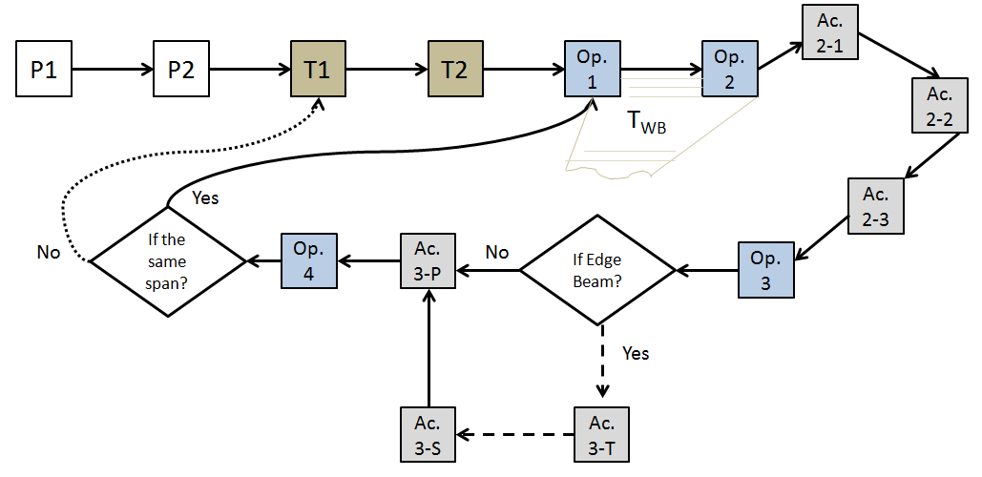

Figure 1. Conceptual model of bridge construction project using launching girder

From Figure 1, it could be observed that the project starts with preliminary works comprising preparatory work on the Gantry Plinth and Gantry Assembly (shown as P1 and P2). This is followed by two temporary work activities denoted by T1 and T2. Consequently, the work section that forms the major focus of the current study is ‘Operation’. Operations begin with Op 1 and works through to Op 4. The completion of Op 2 and its relevant activities lead the process toward performing the placement operation for the bridge girders (T-beams). Depending on the type of beams being placed (intermediate or edge beams), decision would need to be made on the direction of work flow. In this case the first decision concerning the position of the beams would be whether it is an edge or intermediate beam. Finally, when the placement is done and beams are positioned, Op 4 is then undertaken, where its finalisation calls for new decisions. For instance, if the operation continues in the same span, then the next cycle will start from Op 1. However, if the operation is going toward the completion of the next span, then the cycle will begin by accomplishment of T1 on the next pier.

In the second conceptual model (Figure 2) that is developed from the case study project, work performance within operation 2 (Op 2) is illustrated in more detail. Four main categories of work were involved in Op 2 and are clustered as such in Figure 2. Therefore, there was Delivery, Lifting, Moving, and Ancillary works within the Op 2 cycle. At the delivery phase, super T-beams are transported to site from the casting yard by heavy trucks. The trucks maneuver to platforms where the T-beams are lifted up by cranes attached to the gantry truss. This is the lifting phase within the conceptual framework. The third phase involves the movement of the T-beams to be placed in their respective positions along the bridge (road ramp). There are ancillary works that have to occur before final placement of these beams. The ancillary works to be performed will depend on whether the beams are intermediate or edge beams. Such ancillary works include: preparation of the beam, lock master/slave winch etc. as indicated in Table 1. When the beams are fully in position, Op 2 is complete, and work performance shifts to the next operation (Op 3).

In line with [14], the study goes further to identify the different states of resource utilization at the project phases. Halpin and Riggs [15] suggested that the identification of major
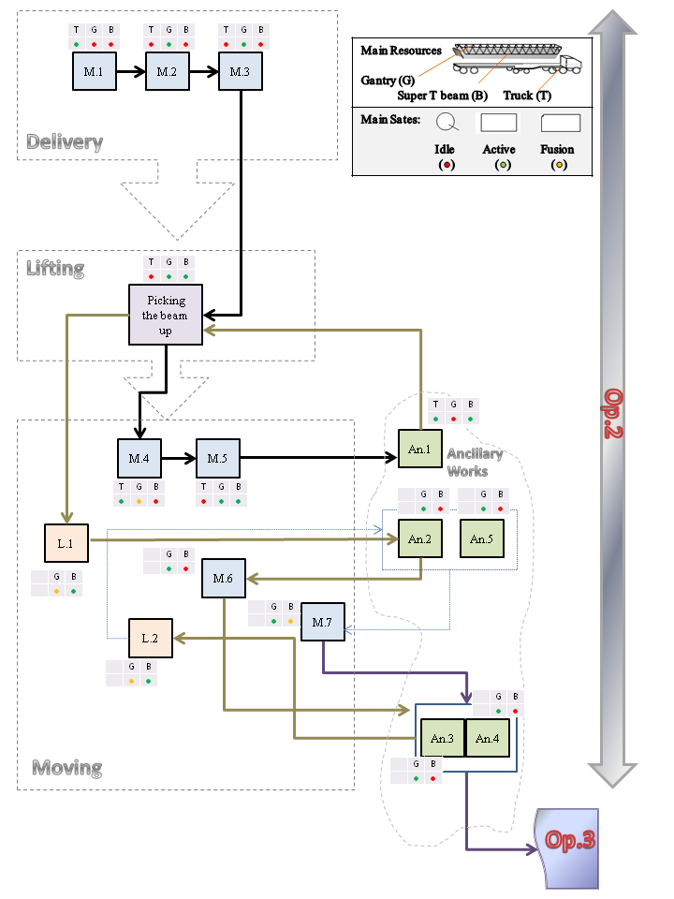

Figure 2. Conceptual model of installation operation of precast T-beams

resources and establishing their various activity states helps to develop the skeletal framework of a construction operation. In this case study project the activity status of three major resources are identified: the twin truss gantry, truck and super T-beams. The activity status of each respective resource is denoted by traffic light symbols: Red - representing an idle state; Green - representing an active state; and Amber for a fusion state. Therefore for each of the activities in the conceptual model, the statuses of the resources being used are indicated. For example, at the lifting phase when a super T-beam is picked up by cranes attached to the truss gantry, the truck is at an idle state and depicted by a Red dot. Whereas at this phase, the truss gantry and the super T-beam are both in active states, hence the two Green dots to show their states in Figure 2.

The developed conceptual model provides a diagrammatic representation of the operations performed in a way that the sequence of work performance, the dependencies among them and their required resources are depicted. With these key operational process determined, the tasks of undertaking time and motion studies on the operations becomes less cumbersome.

Conclusion

The major objective of this paper has been to create a conceptual model for launching beams, using twin truss gantry, on a bridge section of a road construction project. In order to achieve its objective, it was necessary to breakdown the operations involved on the case study project following suggested simulation modeling steps. Analyses of the work operations and processes were to facilitate the eventual modeling of the case study project using simulation software that could improve performance on the project. Simulation modeling is proposed in the study as a complementary planning and scheduling tool that could improve current practice where MS Project software is a preferred planning tool in New Zealand.

The characteristics of the operational system, resources utilized and their activity states are embedded in the conceptual models developed for the case study project. The intent is to provide better understanding of such unstructured projects. This in turn, can provide operational knowledge for the utilization of conceptual frameworks for scheduling dynamic projects. The interdependencies between operational activities are exposed and improvement opportunities identified for future operations. The research outcome contributes to increasing awareness of the capabilities of simulation modeling to improving work performance.

References

1. Barber, P., C. Tomkins, and A. Graves, Decentralised site management—a case study. International Journal of Project Management, 1999. 17(2): p. 113-120.
2. Faniran, O.O., P.E.D. Love, and H. Li, Optimal Allocation of Construction Planning Resources. Journal of Construction Engineering and Management, 1999. 125(5): p. 311-319.
3. Ballard, G. and G. Howell, Shielding Production: Essential Step in Production Control. Journal of Construction Engineering and Management, 1998. 124(1): p. 11-17.
4. Alkass, S. and F. Harris, Development of an Integrated System for Planning Earthwork Operations in Road Construction. Construction Management and Economics, 1991. 9(3): p. 263-289.
5. Wu, I., et al. A pattern-based approach for facilitating schedule generation and cost analysis in bridge construction projects. in Proc. of the 26th CIB-W78 Conference on Managing IT in Construction. 2009.
6. Tam, C., Decision Making and Operations Research Techniques for Construction Management. 2007: City University of HK Press.
7. Srisuwanrat, C., The Sequence Step Algorithm: A simulation-based scheduling algorithm for repetitive projects with probabilistic activity durations. 2009, ProQuest, UMI Dissertations Publishing.
8. Chan, W.-H. and M. Lu. Construction operations simulation under structural adequacy constraints: the Stonecutters Bridge case study. in Simulation Conference (WSC), Proceedings of the 2012 Winter. 2012. IEEE.
9. Hohmann, G., Von der Netzplantechnik zur Simulation-Analyse von Bauprozessen mit Hilfe von Petri-Netzen. 1997.
10. Ailland, K., H.-J. Bargstädt, and S. Hollermann. Construction process simulation in bridge building based on significant day-to-day data. in Proceedings of the Winter Simulation Conference. 2010. Winter Simulation Conference.
11. AbouRizk, S., Role of Simulation in Construction Engineering and Management. Journal of Construction Engineering and Management, 2010. 136(10): p. 1140-1153.
12. Robinson, S. Tutorial: Choosing what to model—Conceptual modeling for simulation. in Simulation Conference (WSC), Proceedings of the 2012 Winter. 2012. IEEE.
13. Al-Ghtani, K., Application of Simulation in Construction Processes (Planning and Modeling of Construction), E.C. King Saud University, Civil Engineering Department, Editor.
14. Akhavian, R. and A.H. Behzadan, Knowledge-Based Simulation Modeling of Construction Fleet Operations Using Multimodal-Process Data Mining. Journal of Construction Engineering and Management, 2013. 139(11).
15. Halpin, D.W. and L.S. Riggs, Planning and Analysis of Construction Operations,. John Wiley and Sons, Inc., New York, N.Y., 1992: p. 381.

¹Doctoral Student, Construction Management Programme, Auckland University of Technology, New Zealand Senior Lecturer, School of Engineering, Construction Management Programme, Auckland University of Technology, New Zealand ³ Site Superintendent (Infrastructure), The Fletcher Construction Company Ltd. New Zealand Zaeri, F, Rotimi, JOB, McCorquodale, C. Exploring performances and their interdependencies in Bridge Construction: A case study, Proceedings of the Istanbul Bridge Conference, 2014.

