Supplementary Material
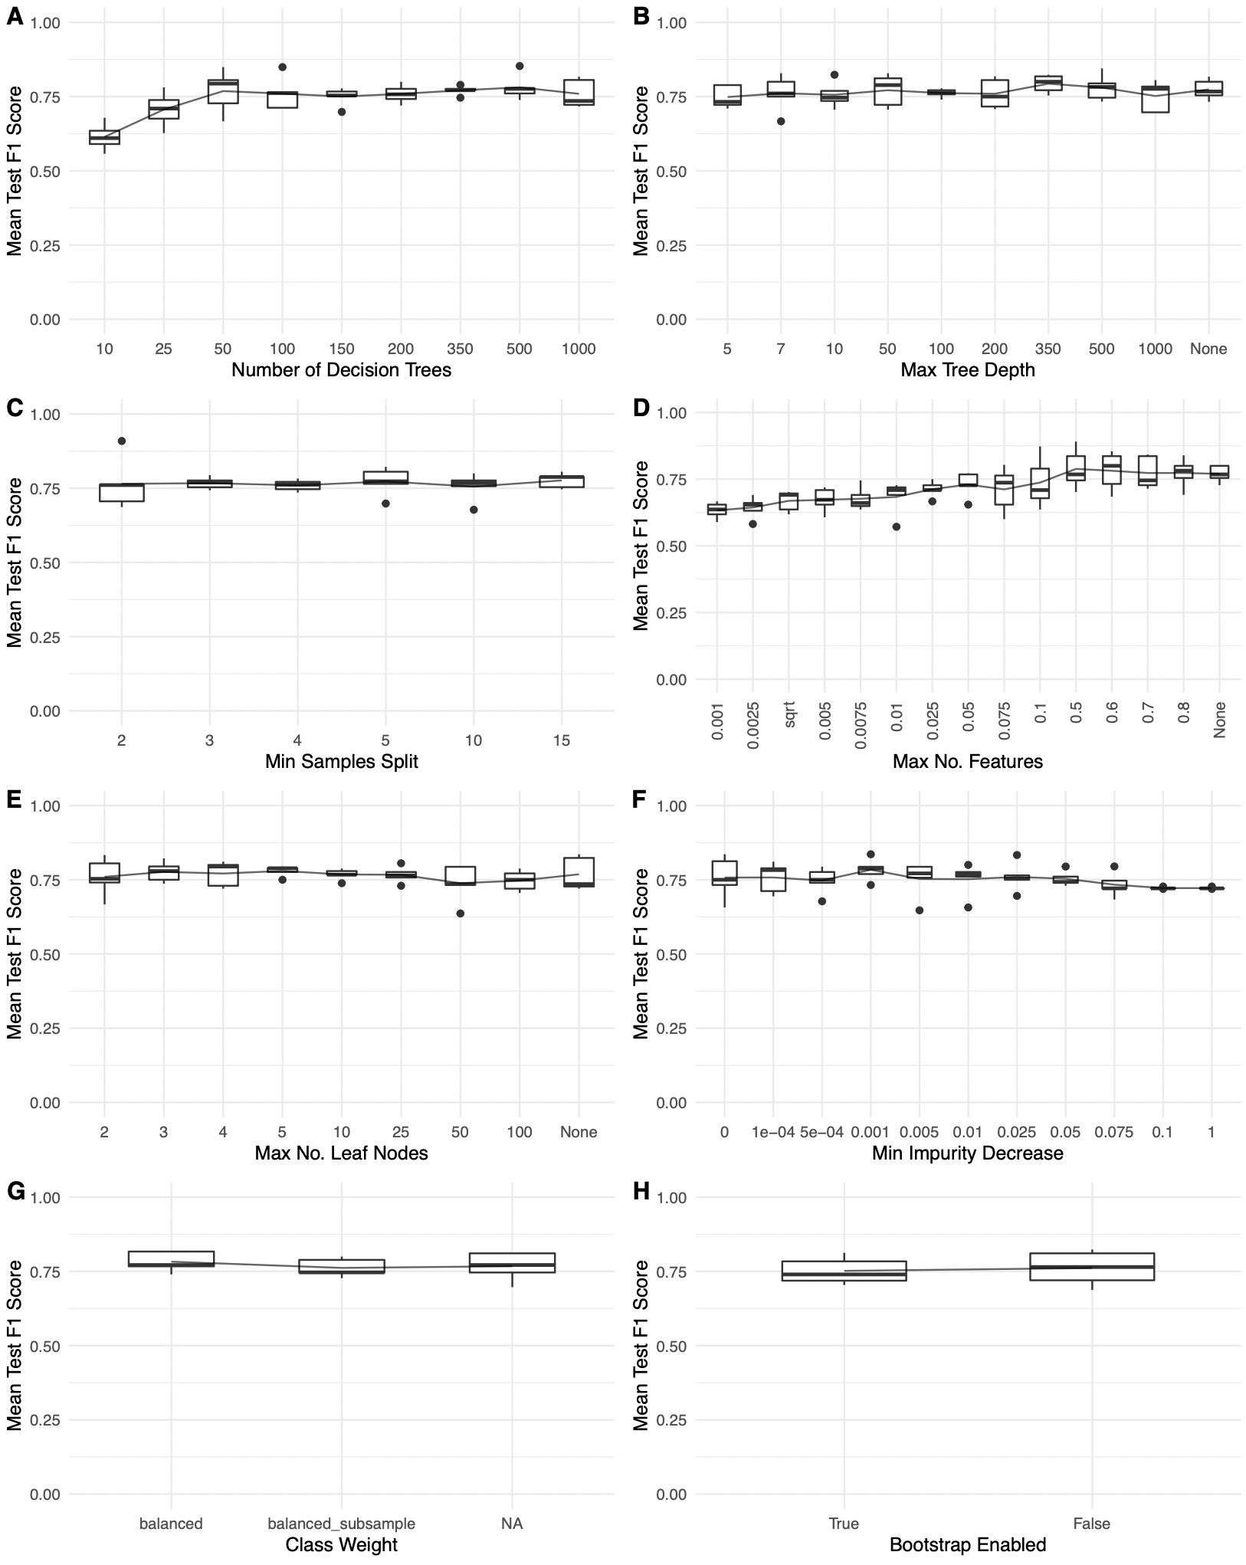
Supplementary Fig. 1 Mean test F1 scores over 8 hyperparameters set to a varying range of intervals, used in building the RF genes-only model for purposes of narrowing down the hyperparameters searched during GridSearchCV to speed up computing time.
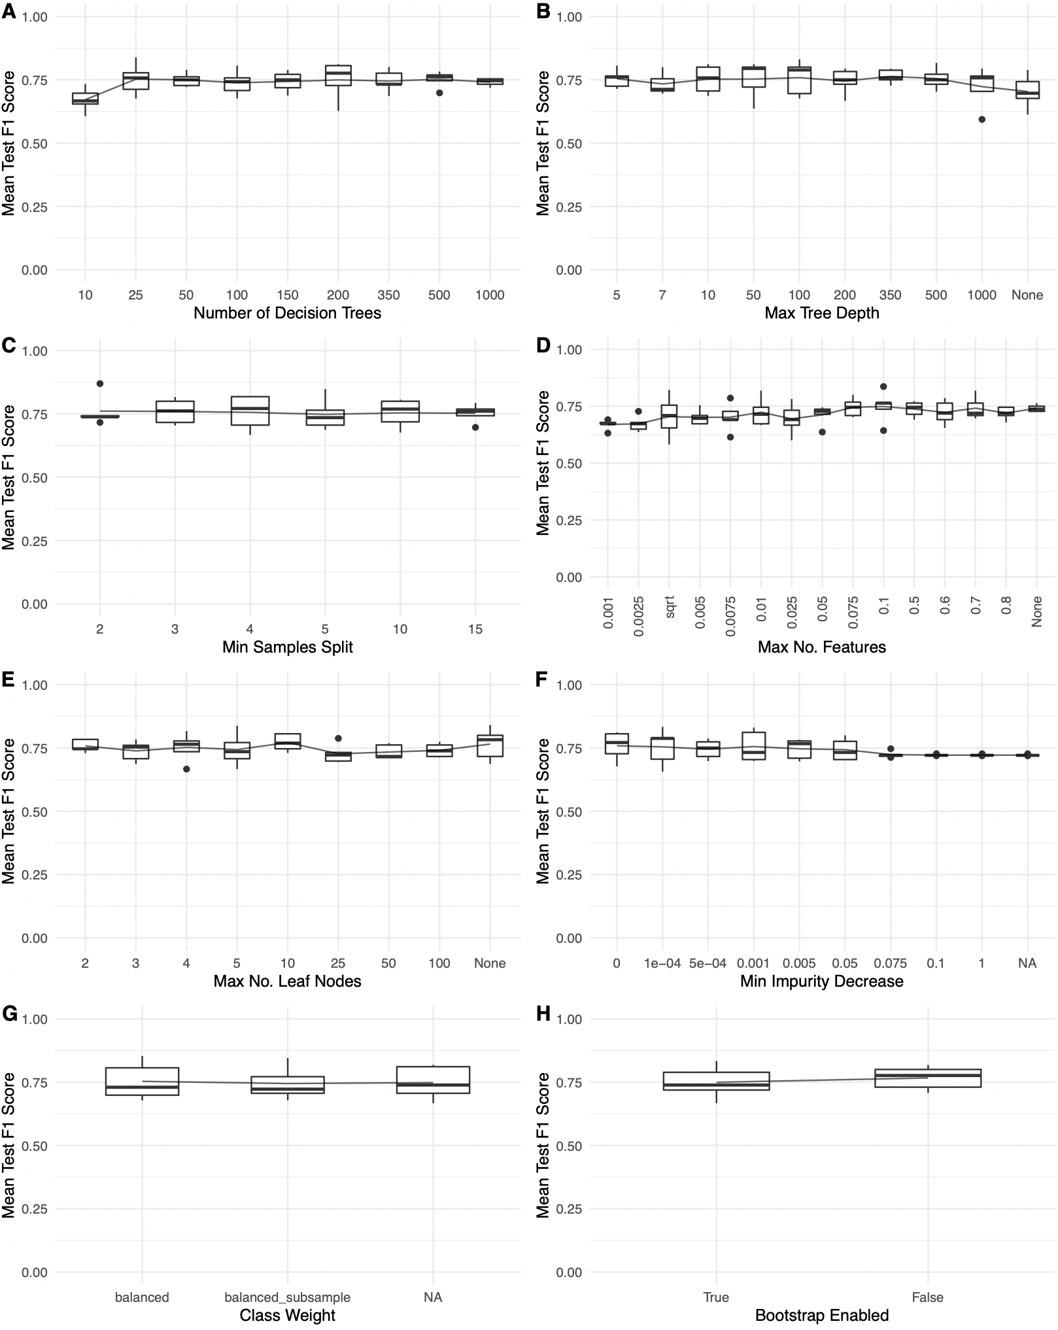
Supplementary Fig. 2 Mean test F1 scores over 8 hyperparameters set to a varying range of intervals, used in building the RF microbial-only model for purposes of narrowing down the hyperparameters searched during GridSearchCV to speed up computing time.
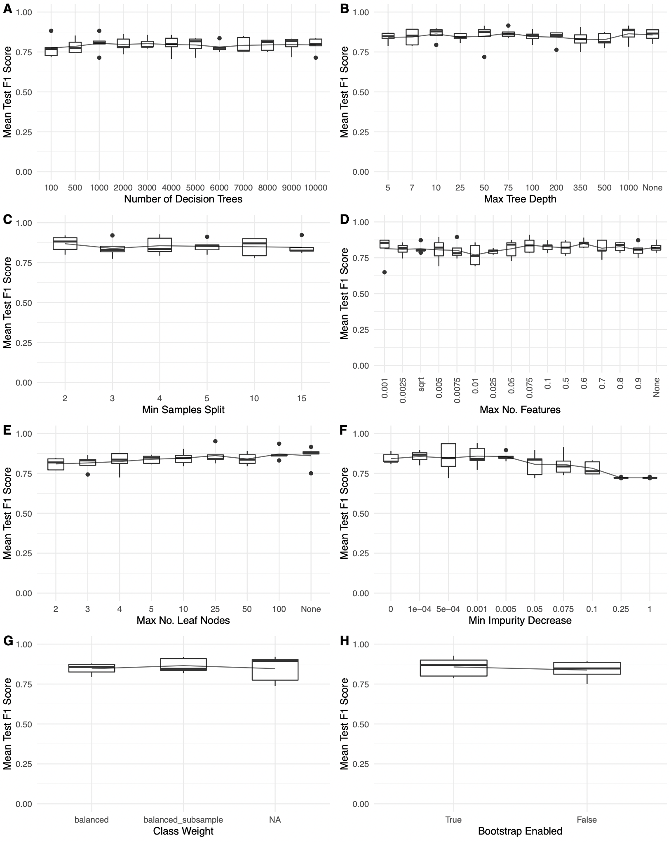
Supplementary Fig. 3 Mean test F1 scores over eight hyperparameters set to a varying range of intervals, used in building the RF genes-and-microbes model for purposes of narrowing down the hyperparameters searched during GridSearchCV to speed up computing time.

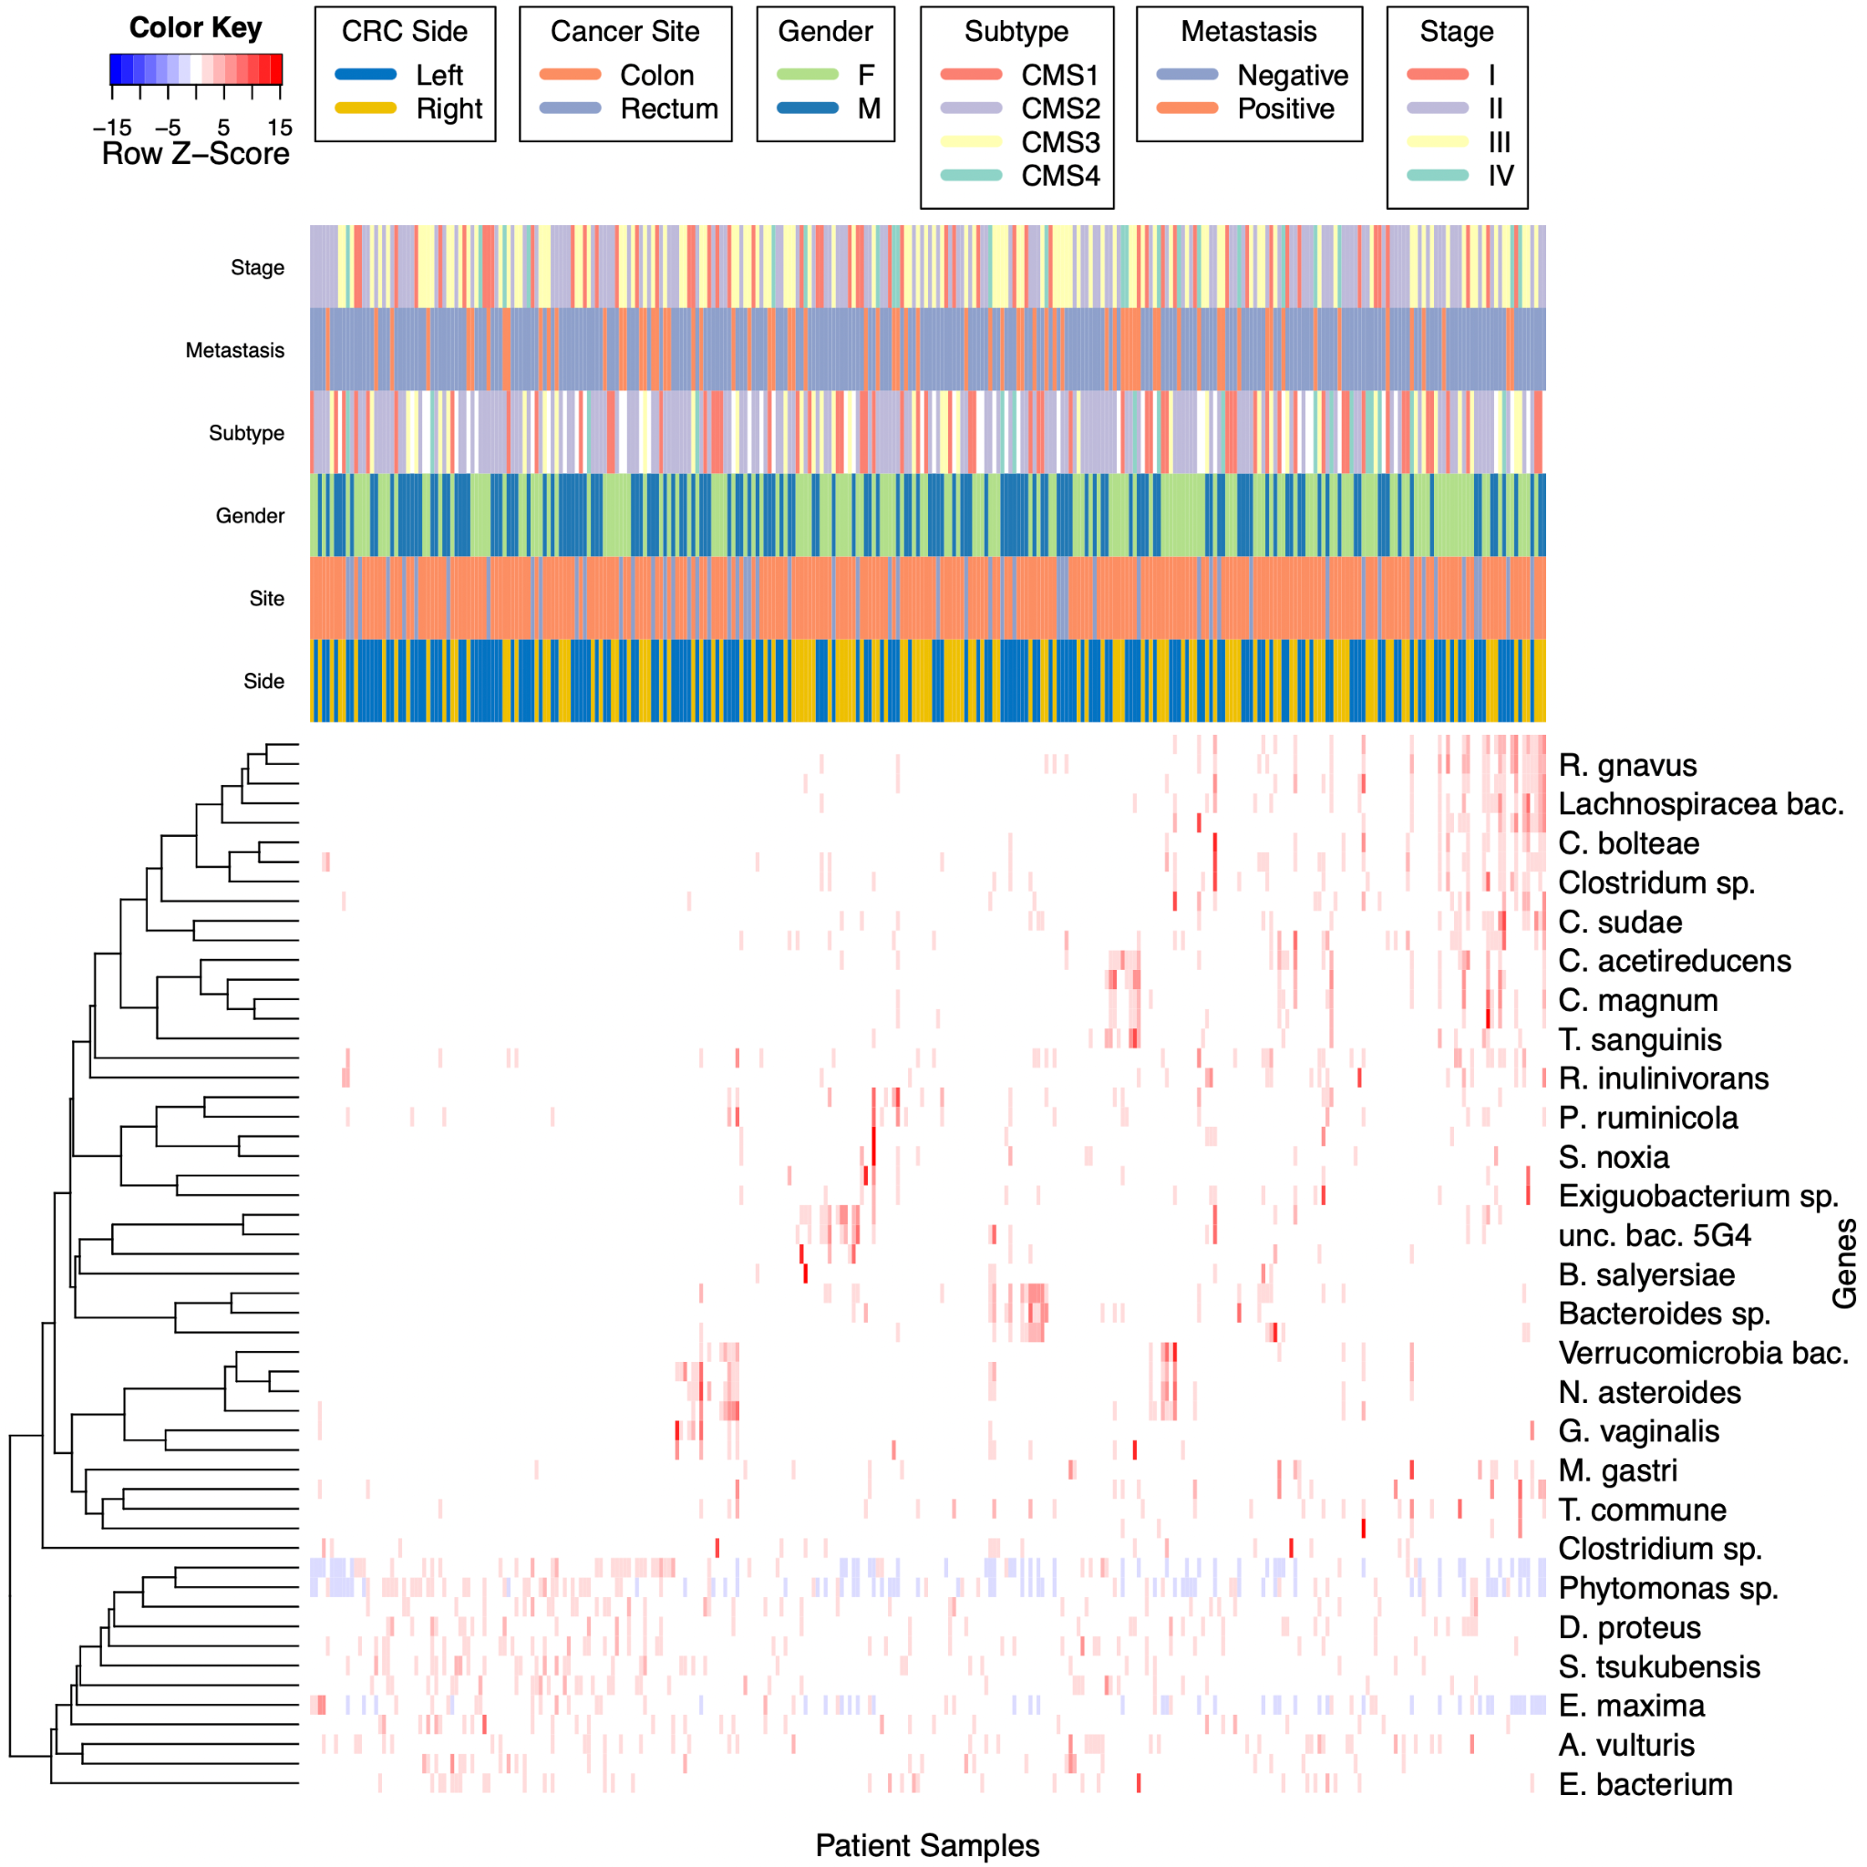

Supplementary Fig. 4 A heatmap of scaled gene expression values of the top-scoring microbial features discovered by the microbes-only RF model and clinical characteristics. Hierarchical clustering of both genes and patients is via Pearson correlation, based on average linkage distance. The colors indicate row-scaled z-scores of TPM RNA-seq gene expression ratios.

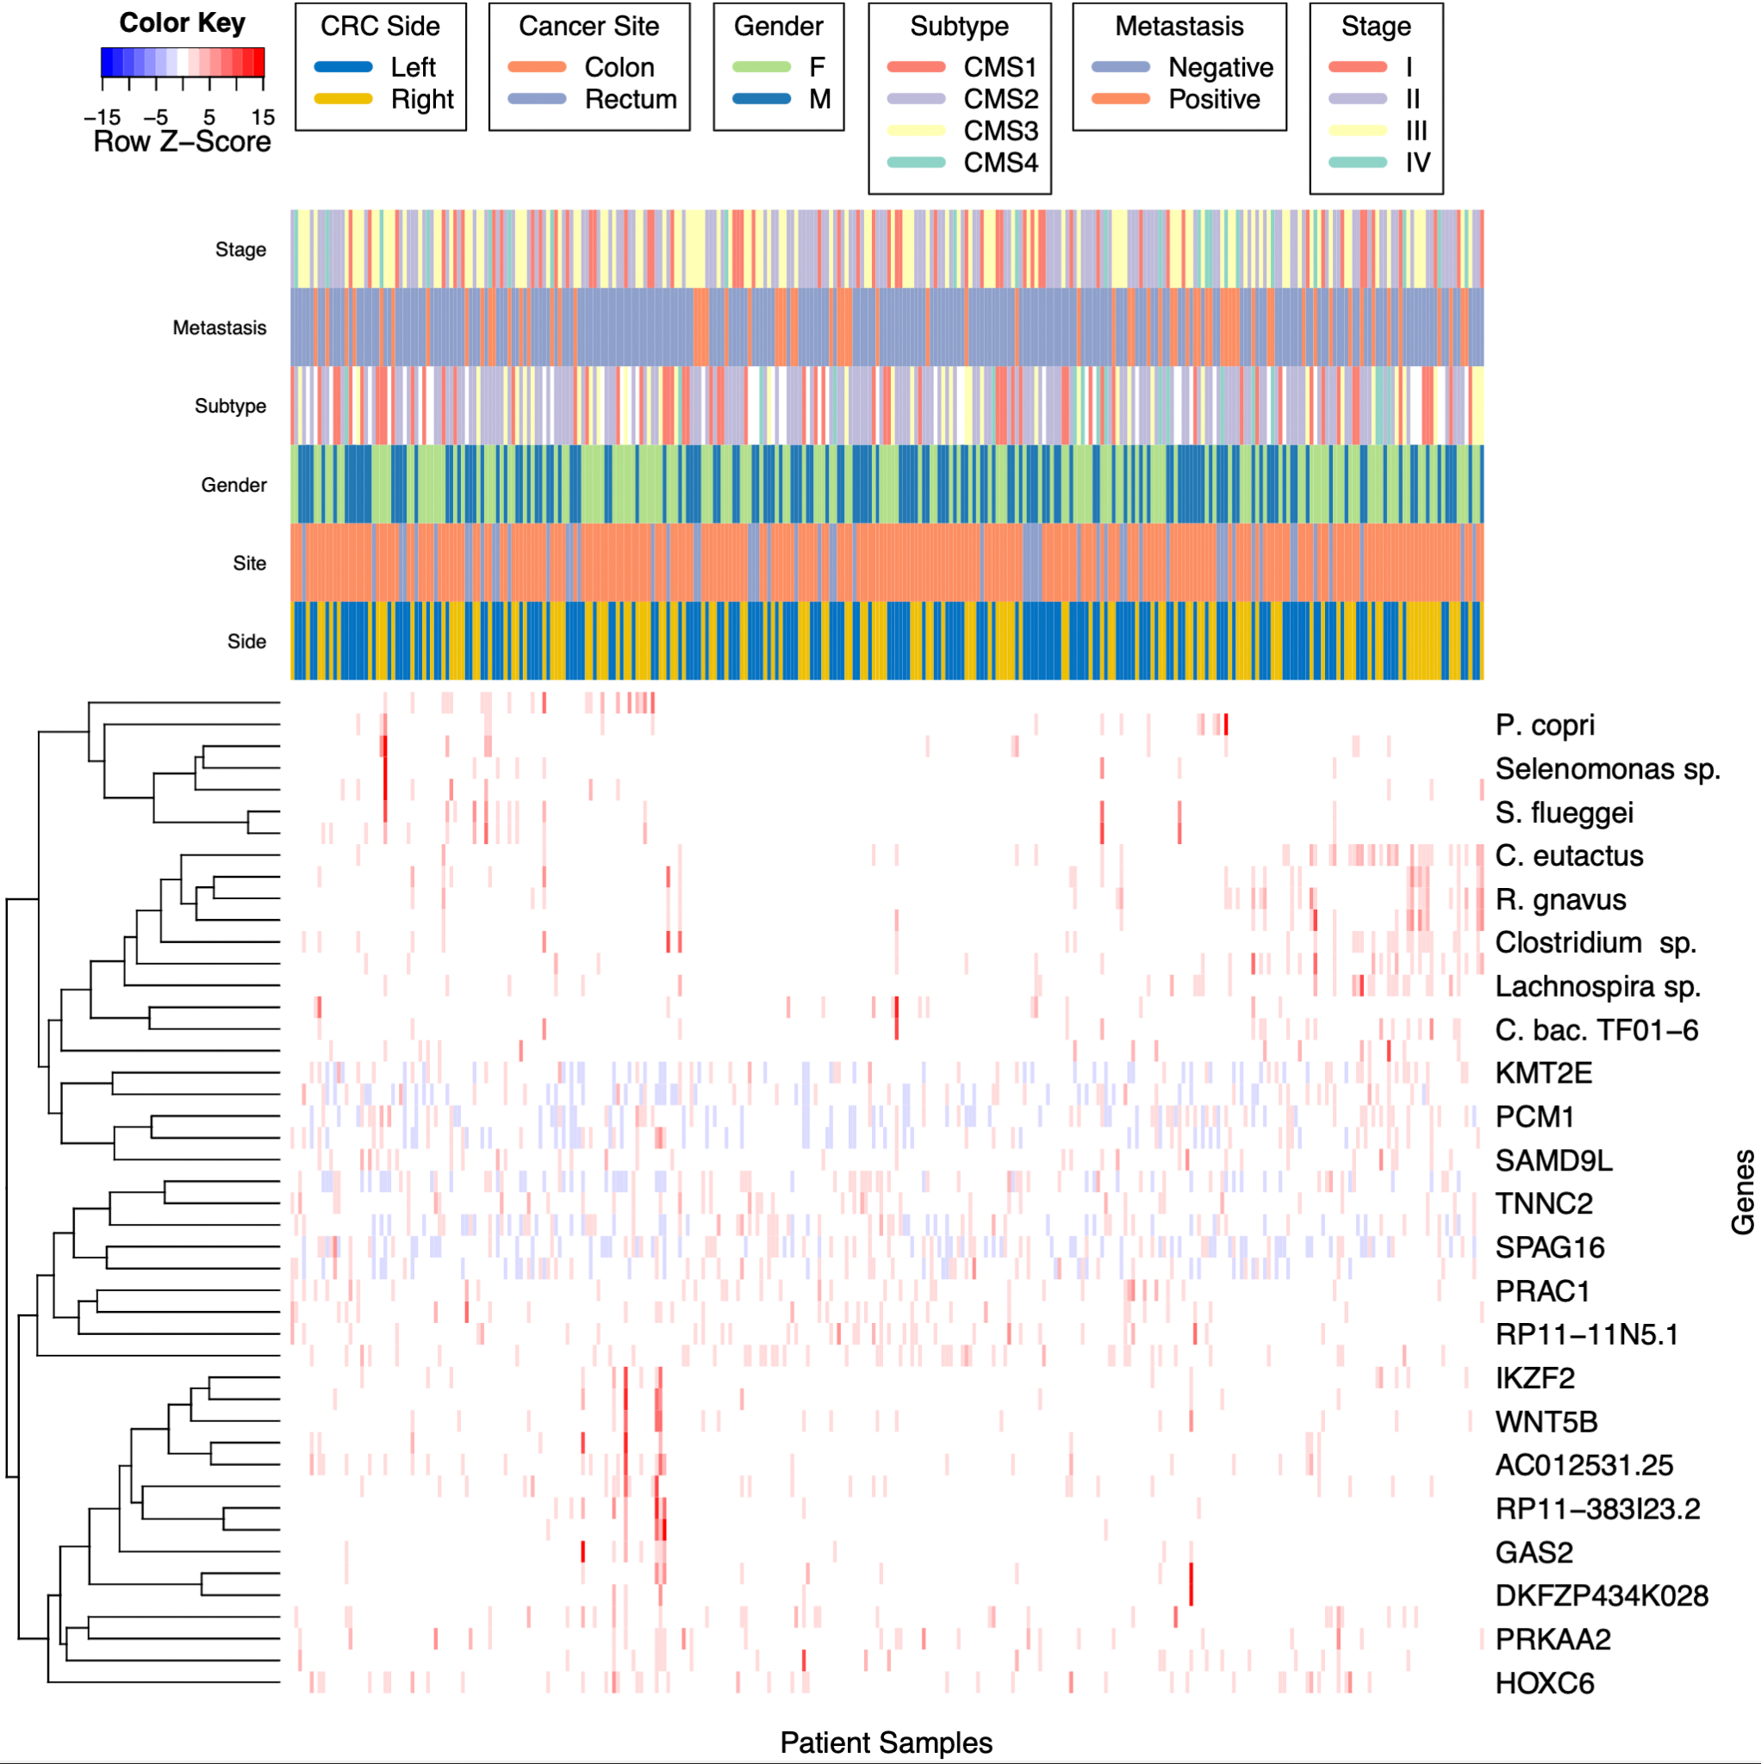Supplementary Fig. 5 A heatmap of scaled genomic and microbial expression values of the top-scoring features discovered by the genes-and-microbes RF model and clinical characteristics. Hierarchical clustering of both genes and patients is via Pearson correlation, based on average linkage distance. The colors indicate row-scaled z-scores of TPM RNA-seq gene expression ratios, as well as CPM normalized RNA-seq human unmapped microbial reads.

Supplementary Table 1. Full version of table 4. Top ranking features with p-values less than 0.05 and their importance scores discovered by our microbes-only model (Left). Side-paired differential expression (fold change) analysis results of CPM values for the same features (Right) Wilcoxon-rank sum test was used to calculate p-values and FDR (Benjamini & Hochberg).

Model Feature Importance Metrics |  |  |  |  | Differential Expression
Rank | Tax ID_Name | Importance Score | Log Importance Score | p-value | Log2 FC | p-value | FDR | Greater Expr. Side
1 | 33038_[Ruminococcus] gnavus | 0.025 | -3.69 | 0 | 2.07E+00 | 1.31E-15 | 3.54E-14 | Right
2 | 76489_Clostridium acetireducens | 0.020 | -3.91 | 0 | 1.88E+00 | 1.69E-13 | 1.52E-12 | Right
3 | 1701326_uncultured bacterium 5G4 | 0.018 | -4.04 | 0 | 1.73E+00 | 6.55E-11 | 2.52E-10 | Right
4 | 397291_Lachnospiraceae bacterium A4 | 0.014 | -4.27 | 0 | 2.30E+00 | 5.29E-16 | 2.85E-14 | Right
5 | 2293240_Ruminococcus sp. TF10-6 | 0.013 | -4.34 | 0 | 2.41E+00 | 2.86E-15 | 5.14E-14 | Right
6 | 239935_Akkermansia muciniphila | 0.011 | -4.51 | 0 | -5.30E-01 | 2.27E-05 | 3.96E-05 | Left
7 | 1531_[Clostridium] clostridioforme | 0.011 | -4.55 | 0 | 1.47E+00 | 1.73E-12 | 1.03E-11 | Right
8 | 936381_Selenomonas sp. CM52 | 0.010 | -4.61 | 0 | 4.03E+00 | 8.68E-11 | 3.13E-10 | Right
9 | 46228_Ruminococcus lactaris | 0.009 | -4.76 | 0 | 1.86E+00 | 2.96E-12 | 1.45E-11 | Right
10 | 43064_Trichococcus pasteurii | 0.007 | -4.97 | 0 | 2.18E+00 | 1.67E-08 | 4.10E-08 | Right
11 | 1262831_Clostridium sp. CAG:678 | 0.007 | -5.01 | 0 | 1.3 | 0.0322 | 0.0464 | Right
12 | 1824_Nocardia asteroides | 0.007 | -5.02 | 0 | -0.19 | 0.00112 | 0.00172 | Left
13 | 208479_[Clostridium] bolteae | 0.007 | -5.03 | 0 | 1.76E+00 | 2.18E-13 | 1.68E-12 | Right
14 | 2026799_Verrucomicrobia bacterium | 0.006 | -5.14 | 0.01 | -0.17 | 2.02E-06 | 3.76E-06 | Left
15 | 1262706_Azospirillum sp. CAG:260 | 0.006 | -5.14 | 0 | 1.15 | 1.86E-09 | 5.57E-09 | Right
16 | 360807_Roseburia inulinivorans | 0.006 | -5.15 | 0 | 1.9 | 1.49E-12 | 1.01E-11 | Right
17 | 83915_Distigma proteus | 0.006 | -5.17 | 0 | 0.29 | 0.109 | 0.137 | Right
18 | 1328_Streptococcus anginosus | 0.006 | -5.19 | 0 | -0.36 | 0.106 | 0.136 | Left
19 | 747377_Clostridium sp. DMHC 10 | 0.006 | -5.20 | 0 | 1.99 | 2.12E-09 | 6.04E-09 | Right
20 | 91626_Mucor ambiguus | 0.006 | -5.20 | 0 | 0.83 | 1.19E-09 | 3.78E-09 | Right
21 | 1741_Thermodesulfobacterium commune | 0.005 | -5.21 | 0 | -0.73 | 0.54 | 0.583 | Left
22 | 88431_Dorea longicatena | 0.005 | -5.23 | 0 | 2.01 | 2.12E-14 | 2.86E-13 | Right
23 | 2702_Gardnerella vaginalis | 0.005 | -5.25 | 0 | -0.49 | 0.624 | 0.661 | Left
24 | 33954_Clostridium magnum | 0.005 | -5.26 | 0 | 2.33 | 2.69E-08 | 6.32E-08 | Right
25 | 291644_Bacteroides salyersiae | 0.005 | -5.27 | 0 | 2.17 | 0.00102 | 0.00161 | Right
26 | 105841_Anaerostipes caccae | 0.005 | -5.27 | 0 | 1.67 | 1.90E-12 | 1.03E-11 | Right
27 | 839_Prevotella ruminicola | 0.005 | -5.27 | 0 | 0.95 | 0.172 | 0.197 | Right
28 | 134013_Phytomonas sp. isolate Hart1 | 0.005 | -5.28 | 0 | -0.29 | 0.0379 | 0.0525 | Left
29 | 1262910_Oscillibacter sp. CAG:155 | 0.005 | -5.29 | 0 | -0.26 | 0.833 | 0.849 | Left
30 | 83656_Streptomyces tsukubensis | 0.005 | -5.31 | 0 | -0.68 | 0.000729 | 0.00119 | Left
31 | 135083_Selenomonas noxia | 0.005 | -5.35 | 0 | 3.44 | 8.73E-06 | 1.57E-05 | Right
32 | 162156_uncultured Bacteroides sp. | 0.005 | -5.35 | 0 | 0.39 | 1.87E-07 | 3.60E-07 | Right
33 | 39486_Dorea formicigenerans | 0.005 | -5.35 | 0 | 1.23 | 4.61E-08 | 9.96E-08 | Right
34 | 872327_Lactobacillus pasteurii | 0.005 | -5.35 | 0 | 1.21 | 1.31E-08 | 3.54E-08 | Right
35 | 1736298_Exiguobacterium sp. Leaf196 | 0.005 | -5.38 | 0 | 2.89 | 3.47E-12 | 1.56E-11 | Right
36 | 310300_Bacteroides pyogenes | 0.004 | -5.41 | 0 | 1.76 | 3.29E-08 | 7.41E-08 | Right
37 | 260710_Olavius algarvensis spirochete endosymbiont | 0.004 | -5.42 | 0 | 1.8 | 1.66E-08 | 4.10E-08 | Right
38 | 1522369_Cyanophora sudae | 0.004 | -5.46 | 0 | 1.61 | 1.19E-13 | 1.28E-12 | Right
39 | 857335_Candidatus Dactylopiibacterium carminicum | 0.004 | -5.46 | 0 | 0.15 | 0.14 | 0.168 | Right
40 | 261299_Intestinibacter bartlettii | 0.004 | -5.48 | 0 | 2 | 2.23E-11 | 9.24E-11 | Right
41 | 564198_Mycolicibacterium bacteremicum | 0.004 | -5.50 | 0 | -0.82 | 0.0132 | 0.0198 | Left
42 | 411484_Clostridium sp. SS2/1 | 0.004 | -5.51 | 0 | 1.99 | 1.44E-10 | 4.87E-10 | Right
43 | 1777_Mycobacterium gastri | 0.004 | -5.57 | 0.01 | 0.17 | 0.418 | 0.471 | Right
44 | 1857645_Actinomyces vulturis | 0.004 | -5.58 | 0.01 | 0.47 | 0.161 | 0.189 | Right
45 | 11768_Feline leukemia virus | 0.004 | -5.58 | 0.01 | -0.49 | 6.37E-05 | 0.000107 | Left
46 | 1736483_Microbacterium sp. Root180 | 0.004 | -5.58 | 0.01 | -0.7 | 0.129 | 0.159 | Left
47 | 1768115_bacterium F082 | 0.004 | -5.58 | 0.01 | 1.44 | 9.65E-08 | 1.93E-07 | Right
48 | 877415_Erysipelotrichaceae bacterium NK3D112 | 0.004 | -5.60 | 0.01 | 0.64 | 0.0327 | 0.0464 | Right
49 | 1632858_Massilibacterium senegalense | 0.004 | -5.61 | 0.01 | -0.09 | 0.444 | 0.489 | Left
50 | 5804_Eimeria maxima | 0.004 | -5.61 | 0.01 | -0.19 | 0.0681 | 0.0919 | Left
51 | 154288_Turicibacter sanguinis | 0.004 | -5.62 | 0.01 | 1.9 | 5.00E-08 | 1.04E-07 | Right
52 | 490622_Trichoderma arundinaceum | 0.004 | -5.63 | 0.01 | -0.04 | 0.791 | 0.821 | Left
53 | 653385_Actinomyces sp. oral taxon 849 | 0.004 | -5.63 | 0.01 | -0.05 | 0.938 | 0.938 | Left
54 | 467085_Candidatus Symbiothrix dinenymphae | 0.004 | -5.65 | 0.01 | -1.95 | 0.0923 | 0.122 | Left

Supplementary Table 2. Full version of table 5. Top ranking features with p-values less than 0.05 and their importance scores discovered by our genes-and-microbes model (Left). Side-paired differential expression (fold change) analysis results of TPM and CPM values for the same features (Right) Wilcoxon-rank sum test was used to calculate p-values and FDR (Benjamini & Hochberg).

Model Feature Importance Metrics |  |  |  |  | Differential Expression
Rank | ENSG ID_Gene/Tax ID_Name | Importance Score | Log Importance Score | p-value | Log2 FC | p-value | FDR | Associated Side
1 | ENSG00000142661_MYOM3 | 0.037 | -3.29 | 0 | -0.62 | 1.36E-08 | 2.71E-08 | Left
2 | ENSG00000198353_HOXC4 | 0.033 | -3.40 | 0 | 1.88 | 2.11E-15 | 3.23E-14 | Right
3 | 33043_Coprococcus eutactus | 0.027 | -3.62 | 0 | 2.08 | 2.00E-14 | 1.54E-13 | Right
4 | ENSG00000159182_PRAC1 | 0.024 | -3.72 | 0 | -2.86 | 5.08E-21 | 2.34E-19 | Left
5 | ENSG00000260597_AC012531.25 | 0.020 | -3.90 | 0 | 1.19 | 4.26E-12 | 2.17E-11 | Right
6 | 33038_[Ruminococcus] gnavus | 0.016 | -4.13 | 0 | 2.07 | 1.31E-15 | 3.02E-14 | Right
7 | ENSG00000184719_RNLS | 0.011 | -4.50 | 0.01 | -0.89 | 2.85E-10 | 9.37E-10 | Left
8 | ENSG00000197757_HOXC6 | 0.011 | -4.54 | 0 | 1.28 | 5.02E-12 | 2.31E-11 | Right
9 | ENSG00000144451_SPAG16 | 0.010 | -4.61 | 0 | -0.64 | 9.00E-09 | 1.97E-08 | Left
10 | 851_Fusobacterium nucleatum | 0.010 | -4.62 | 0 | 1.67 | 2.73E-06 | 3.49E-06 | Right
11 | ENSG00000273374_RP11-383I23.2 | 0.010 | -4.62 | 0 | -1.02 | 2.86E-08 | 5.47E-08 | Left
12 | 446043_uncultured Lachnospira sp. | 0.010 | -4.63 | 0 | 1.46 | 5.97E-09 | 1.37E-08 | Right
13 | 165179_Prevotella copri | 0.009 | -4.66 | 0 | 1.6 | 1.50E-09 | 3.85E-09 | Right
14 | 154288_Turicibacter sanguinis | 0.009 | -4.67 | 0 | 1.9 | 5.00E-08 | 8.51E-08 | Right
15 | 59620_uncultured Clostridium sp. | 0.009 | -4.67 | 0 | 1.09 | 6.86E-12 | 2.87E-11 | Right
16 | ENSG00000101470_TNNC2 | 0.009 | -4.69 | 0 | -1.29 | 3.34E-10 | 1.02E-09 | Left
17 | 936381_Selenomonas sp. CM52 | 0.009 | -4.69 | 0 | 4.03 | 8.68E-11 | 3.07E-10 | Right
18 | ENSG00000162409_PRKAA2 | 0.009 | -4.69 | 0 | -1.2 | 3.90E-10 | 1.12E-09 | Left
19 | ENSG00000124915_DKFZP434K028 | 0.009 | -4.70 | 0 | 0.91 | 1.67E-05 | 1.97E-05 | Right
20 | 712991_Lachnospiraceae bacterium oral taxon 500 | 0.009 | -4.71 | 0 | 2.33 | 9.20E-07 | 1.28E-06 | Right
21 | ENSG00000101076_HNF4A | 0.009 | -4.72 | 0 | -0.48 | 4.73E-08 | 8.37E-08 | Left
22 | ENSG00000177409_SAMD9L | 0.009 | -4.72 | 0 | 1.01 | 7.55E-08 | 1.20E-07 | Right
23 | 2293240_Ruminococcus sp. TF10-6 | 0.009 | -4.72 | 0 | 2.41 | 2.86E-15 | 3.28E-14 | Right
24 | ENSG00000146386_ABRACL | 0.009 | -4.72 | 0 | -0.29 | 1.71E-04 | 0.000192 | Left
25 | 2305245_Clostridiaceae bacterium TF01-6 | 0.009 | -4.74 | 0 | 1.79 | 1.96E-14 | 1.54E-13 | Right
26 | ENSG00000111186_WNT5B | 0.009 | -4.75 | 0 | -0.53 | 2.65E-04 | 0.00029 | Left
27 | ENSG00000188610_FAM72B | 0.009 | -4.75 | 0 | 0.67 | 2.58E-06 | 3.39E-06 | Right
28 | ENSG00000250829_RP11-11N5.1 | 0.009 | -4.75 | 0 | -3.79 | 1.14E-08 | 2.39E-08 | Left
29 | ENSG00000126218_F10 | 0.009 | -4.75 | 0 | -0.55 | 4.46E-10 | 1.21E-09 | Left
30 | 28133_Prevotella nigrescens | 0.009 | -4.75 | 0 | 1.27 | 5.70E-08 | 9.37E-08 | Right
31 | ENSG00000103534_TMC5 | 0.009 | -4.76 | 0 | 0.29 | 7.29E-03 | 0.0078 | Right
32 | 113574_Hyphomicrobium sp. GJ21 | 0.009 | -4.77 | 0 | 2.24 | 2.10E-09 | 5.09E-09 | Right
33 | ENSG00000078674_PCM1 | 0.008 | -4.78 | 0 | 0.39 | 3.38E-08 | 6.22E-08 | Right
34 | 2026799_Verrucomicrobia bacterium | 0.008 | -4.79 | 0 | -0.17 | 2.02E-06 | 2.73E-06 | Left
35 | 105841_Anaerostipes caccae | 0.008 | -4.80 | 0 | 1.67 | 1.90E-12 | 1.09E-11 | Right
36 | 2320113_bacterium 1xD42-87 | 0.008 | -4.80 | 0 | 1.4 | 2.73E-07 | 4.05E-07 | Right
37 | ENSG00000005483_KMT2E | 0.008 | -4.81 | 0 | 0.15 | 2.08E-02 | 0.0213 | Right
38 | ENSG00000197217_ENTPD4 | 0.008 | -4.81 | 0 | 0.3 | 9.00E-07 | 1.28E-06 | Right
39 | ENSG00000030419_IKZF2 | 0.008 | -4.81 | 0 | 0.48 | 1.36E-05 | 1.64E-05 | Right
40 | 135080_Selenomonas flueggei | 0.008 | -4.81 | 0 | 3.21 | 9.96E-13 | 6.54E-12 | Right
41 | ENSG00000166173_LARP6 | 0.008 | -4.84 | 0 | -0.8 | 1.21E-05 | 1.51E-05 | Left
42 | ENSG00000267506_RP11-13K12.1 | 0.008 | -4.85 | 0 | -1.79 | 1.16E-11 | 4.43E-11 | Left
43 | ENSG00000148935_GAS2 | 0.008 | -4.87 | 0 | 0.05 | 2.34E-07 | 3.59E-07 | Right
44 | ENSG00000026559_KCNG1 | 0.008 | -4.87 | 0 | -0.22 | 5.56E-02 | 0.0556 | Left
45 | 1908690_Fimbriiglobus ruber | 0.007 | -4.90 | 0.04 | -0.46 | 2.04E-02 | 0.0213 | Left
46 | ENSG00000144891_AGTR1 | 0.007 | -4.91 | 0.03 | -1.83 | 4.72E-05 | 5.42E-05 | Left

Supplementary Table 3 - Patient Demographics & Cancer Characteristics Stratified by Cancer Side. An alternative version of Table 1, stratified by LCC and RCC patient groups.
Characteristic | LCC Patients | RCC Patients
Patients enrolled - no (%) | 172 (56) | 136 (44)
Median Age - year (range) | 72.7 (28.7, 89.8) | 75.3 (36.9, 91.5)
Sex
Female - no (%) | 79 (26) | 84 (27)
Male - no (%) | 93 (30) | 52 (17)
Metastasis
Positive - no (%) | 44 (14) | 26 (8)
Negative - no (%) | 128 (42) | 110 (36)
Cancer Stage
T1 - no (%) | 34 (11) | 19 (6)
T2 - no (%) | 63 (20.5) | 65 (21)
T3 - no (%) | 63 (20.5) | 42 (14)
T4 - no (%) | 12 (4) | 10 (3)
Nodal Status
Positive - no (%) | 98 (32) | 87 (28)
Negative - no (%) | 74 (24) | 49 (16)

Supplementary Code 1.
Python script for creating the random forest classifier and obtaining the scoring metrics reported in the results for the genes-only classifier. Random forest hyperparameters can also be found within this code, for reproducibility purposes.

A Genes-Only Random Forest Classifier for CRC Anatomical Side.py
#!/usr/bin/env python
# coding: utf-8

#Created by: Tyler Kolisnik
#March 9, 2023

# Description:
#This code is for evaluating and finalizing a random forest model after using grid search cv to find the best parameters
#Includes scoring and validation

# Import required packages and functions
import sklearn
import numpy as np
import pandas as pd
import rpy2.robjects as robjects
import pickle
import seaborn as sns
import matplotlib.pyplot as plt
from scipy import interpolate
from sklearn.ensemble import RandomForestClassifier
from sklearn.model_selection import train_test_split
from sklearn import metrics
from rpy2.robjects import pandas2ri
from sklearn.metrics import confusion_matrix, make_scorer
from sklearn.metrics import classification_report
from sklearn.metrics import precision_recall_curve
from sklearn.metrics import roc_curve
from matplotlib import pyplot

# Increase output plot resolution
plt.rcParams['figure.dpi'] = 300
plt.rcParams['savefig.dpi'] = 300
sns.set(rc={"figure.dpi":300, 'savefig.dpi':300})
sns.set_context('notebook')
sns.set_style("whitegrid")

# Import the training set data (278 samples)
pandas2ri.activate()
readRDS = robjects.r['readRDS']
ml_data=readRDS('/Volumes/FryShareNVME/Preprocessing_Workflow/2022-05-23 preprocessing workflow_SIDE_SPLIT/output_data/2022-03-25-ML-VALUES-discovery-set-side-278samples.rds')
tpmdata=ml_data[0]
tpmdata2=tpmdata.transpose()
targetdata=np.ravel(ml_data[1]).astype(int)
targetlabels=np.ravel(ml_data[2])

# Create the classifier from the best parameter set found in the grid search CV
rforest_finalparamset = RandomForestClassifier(
bootstrap=True,
class_weight=None,
criterion='gini',
max_depth=5,
max_features=0.1,
max_leaf_nodes=4,
min_impurity_decrease=0.0,
min_samples_leaf=1,
min_samples_split=2,
min_weight_fraction_leaf=0.0,
n_estimators=25,
n_jobs=2,
oob_score=True,
random_state=2,
verbose=0,
warm_start=False
)

# Split the dataset into training and testing
#Test Size = 0.25 instructs the model to fit on 75% of the data and test on 25%
#Stratify ensures an even distribution of samples
#Fixing random state allows for reproducibility of results
X_train, X_test, y_train, y_test = train_test_split(tpmdata2, targetdata,
test_size=0.25,random_state=1,
stratify=targetdata,shuffle=True)

# Fit (train) the classifier to our dataset
#alternatively import this from a file if you have already saved the model (.pkl)
#rforest_finalparamset.fit(X_train,y_train)

# Load the model from disk
#filename = '/Volumes/FryShareNVME/2022-03-25-ML-Results-Side/2022-03-26-ML-paramset-analysis/crc-side-random-forest-model.pkl'
filename = '/Volumes/FryShareNVME/2022-03-25-ML-Results-Side/2022-03-27-finalized-paper-data/genes-rf-exploration/crc-side-random-forest-model.pkl'
rforest_finalparamset = pickle.load(open(filename, 'rb'))

# Save the model to disk
#filename = '/Volumes/FryShareNVME/2022-03-25-ML-Results-Side/2022-03-26-ML-paramset-analysis/crc-side-random-forest-model.pkl'
#pickle.dump(rforest_finalparamset, open(filename, 'wb'))

# Make predictions from the training data
rfpredictions=rforest_finalparamset.predict(X_test)
print("Model Accuracy:",metrics.accuracy_score(y_test,rfpredictions))

# Threshold hyperparameter optimization
#The default threshold for a binary variable is 0.5
#Checking the threshold allows for the optimization of the sensitivity and specificity
#and a correction for imbalanced datasets
#If a new threshold is set then you must nolonger use .predict, and must use .predict_proba

# Generate prediction probabilities (necessary for AUROC/AUPRC and thresholds)
yhat = rforest_finalparamset.predict_proba(X_test)
# keep probabilities for the positive outcome only
yhat = yhat[:, 1]
# calculate roc curves
fpr, tpr, thresholds = roc_curve(y_test, yhat)
# calculate the g-mean for each threshold
gmeans = np.sqrt(tpr * (1-fpr))
# locate the index of the largest g-mean
ix = np.argmax(gmeans)
print('Best Threshold=%f, G-Mean=%.3f' % (thresholds[ix], gmeans[ix]))
# plot the roc curve for the model
pyplot.plot([0,1], [0,1], linestyle='--', label='No Skill')
#t=np.linspace(0, 2*np.pi,1000)
pyplot.plot(fpr, tpr, marker='.', label='Logistic')
#pyplot.plot(t, np.interp(t,fpr, tpr), marker='.', label='Cubic Spline')
pyplot.scatter(fpr[ix], tpr[ix], marker='o', color='black', label='Best')
# axis labels
pyplot.xlabel('False Positive Rate')
pyplot.ylabel('True Positive Rate')
pyplot.legend()
# show the plot
pyplot.show()

#With Code Adapted From: https://machinelearningmastery.com/threshold-moving-for-imbalanced-classification/

# See how a threshold adjustment affects the training set
#I ultimately chose to just keep the 0.5 threshold as the scores are close enough
#and it is not of utmost importance in this model to prioritize
#precision(specificity) or recall(sensitivity) over the other

threshold = 0.539077
thresholdpredictions = rforest_finalparamset.predict_proba(X_test)
discpreds2 = thresholdpredictions[:, 1]
test_predictions=rforest_finalparamset.predict(X_test)

preds = [1 if thresholdpredictions[i][1]> threshold else 0 for i in range(len(thresholdpredictions))]

print("0.539077 Threshold:")
pd.DataFrame(classification_report(y_test,preds,output_dict=True)).T

print("0.5 Threshold:")
pd.DataFrame(classification_report(y_test,test_predictions,output_dict=True)).T

# Print Scoring Metrics for Training (Model Discovery) Set
print("Accuracy:",metrics.accuracy_score(y_test,rfpredictions))
print("Out-of-Bag Score:",rforest_finalparamset.oob_score_)
print("F1 Score:",metrics.f1_score(y_test,rfpredictions))
print("ROC AUC Score:",metrics.roc_auc_score(y_test,rfpredictions))
print("Recall Score:",metrics.recall_score(y_test,rfpredictions))
print("Precision Score:",metrics.precision_score(y_test,rfpredictions))
confmat = confusion_matrix(y_test,rfpredictions)
fp = confmat[0][1]
tn = confmat[0][0]
tp = confmat[1][1]
fn = confmat[1][0]
tprate=tp/(tp+fn)
fprate=fp/(fp+tn)

print("False Positives:",fp)
print("False Negatives:",fn)
print("True Positives:",tp)
print("True Negatives:",tn)
print("True Positive Rate:",tprate)
print("False Positive Rate:",fprate)

print(classification_report(y_test,rfpredictions))

# Generate AUROC/AUPRC scores and create functions for plotting curves
val_auprc = sklearn.metrics.average_precision_score(y_test,rfpredictions,pos_label=1)

val_auroc = sklearn.metrics.roc_auc_score(y_test,rfpredictions)
aurocscore="AUROC="+str(round(val_auroc,2))
auprcscore="AUPRC="+str(round(val_auprc,2))
print(auprcscore)
print(aurocscore)
def plot_auroc_curve(y_test,rfpredictions,aurocscore):
data_fpr, data_tpr, data_thresholds = sklearn.metrics.roc_curve(y_test,rfpredictions)
data_fpr_tpr = pd.DataFrame({'fpr':data_fpr, 'tpr':data_tpr})
p = sns.lineplot(data=data_fpr_tpr, x='fpr', y='tpr',ci=None)
p.set(xlabel='False Positive Rate', ylabel='True Positive Rate')
p.plot([0, 1], [0, 1], color='black', ls='--')
p.text(0.2,0.5,aurocscore)

def plot_auprc_curve(y_test,rfpredictions,auprcscore):
data_prcsn, data_rcll, data_thrshlds = sklearn.metrics.precision_recall_curve(y_test,rfpredictions)
data_prcsn_rcll = pd.DataFrame({'prcsn':data_prcsn, 'rcll':data_rcll})
p = sns.lineplot(data=data_prcsn_rcll, x='rcll', y='prcsn',ci=None)
p.set(xlabel='Recall', ylabel='Precision')
p.plot([0, 1], [1, 0], color='black', ls='--')
p.text(0.2,0.5,auprcscore)

# Plot AUROC Curve
plot_auroc_curve(y_test,discpreds2,aurocscore)

# Save to file
plt.savefig("/Volumes/FryShareNVME/2022-03-25-ML-Results-Side/2022-03-27-finalized-paper-data/genes-rf-exploration/plots-for-paper/AUROC-training-set-v2genesonly.pdf")

# Plot AUPRC Curve
plot_auprc_curve(y_test,discpreds2,auprcscore)
plt.show()
# Save to file
plt.savefig("/Volumes/FryShareNVME/2022-03-25-ML-Results-Side/2022-03-27-finalized-paper-data/genes-rf-exploration/plots-for-paper/AUPRC-training-set-v2genesonly.pdf")

# Import independent validation set (30 samples the model has never seen before)
pandas2ri.activate()
readRDS = robjects.r['readRDS']
val_data=readRDS('/Volumes/FryShareNVME/Preprocessing_Workflow/2022-05-23 preprocessing workflow_SIDE_SPLIT/output_data/2022-03-25-ML-VALUES-validation-set-side-30samples.rds')
valdata=val_data[0]
valdata2=valdata.transpose()
valtargetdata=np.ravel(val_data[1]).astype(int)

# Run the model on the validation set
runmodelonvaldata=rforest_finalparamset.predict(valdata2)

# Generate prediction probabilities (necessary for AUROC/AUPRC and thresholds)
val_prob_preds = rforest_finalparamset.predict_proba(valdata2)

# Take only the positive values
val_preds = val_prob_preds[:, 1]

# Print Scoring Metrics for Validation Set
print("Accuracy:",metrics.accuracy_score(runmodelonvaldata, valtargetdata))
print("F1 Score:",metrics.f1_score(runmodelonvaldata, valtargetdata))
print("ROC AUC Score:",metrics.roc_auc_score(runmodelonvaldata, valtargetdata))
print("Recall Score:",metrics.recall_score(runmodelonvaldata, valtargetdata))
print("Precision Score:",metrics.precision_score(runmodelonvaldata, valtargetdata))
confmat = confusion_matrix(runmodelonvaldata,valtargetdata)
fp = confmat[0][1]
tn = confmat[0][0]
tp = confmat[1][1]
fn = confmat[1][0]
tprate=tp/(tp+fn)
fprate=fp/(fp+tn)

print("False Positives:",fp)
print("False Negatives:",fn)
print("True Positives:",tp)
print("True Negatives:",tn)
print("True Positive Rate:",tprate)
print("True Negative Rate:",fprate)

print(classification_report(runmodelonvaldata, valtargetdata))

# Generate validation set AUROC/AUPRC scores
val_auprc = sklearn.metrics.average_precision_score(runmodelonvaldata, valtargetdata,pos_label=1)

val_auroc = sklearn.metrics.roc_auc_score(runmodelonvaldata, valtargetdata)
aurocscore="AUROC="+str(round(val_auroc,2))
auprcscore="AUPRC="+str(round(val_auprc,2))
print(auprcscore)
print(aurocscore)

# Plot AUROC Curve
auroccurve=plot_auroc_curve(valtargetdata,val_preds,aurocscore)

# Save to file
plt.savefig("/Volumes/FryShareNVME/2022-03-25-ML-Results-Side/2022-03-27-finalized-paper-data/genes-rf-exploration/plots-for-paper/AUROC-validation-set-v2-genesonly.pdf")

# Plot AUPRC Curve
plot_auprc_curve(valtargetdata,val_preds,auprcscore)

# Save to file
plt.savefig("/Volumes/FryShareNVME/2022-03-25-ML-Results-Side/2022-03-27-finalized-paper-data/genes-rf-exploration/plots-for-paper/AUPRC-validation-set-v2-genesonly.pdf")

# See how a threshold adjustment affects the validation set (as a post-measure of performance, not for threshold optimization)
#I ultimately chose to just keep the 0.5 threshold as the scores are close enough
#and it is not of utmost importance in this model to prioritize
#precision(specificity) or recall(sensitivity) over the other

threshold = 0.539077 # define threshold here
thresholdpredictions = rforest_finalparamset.predict_proba(valdata2)
valpredictions=rforest_finalparamset.predict(valdata2)

preds = [1 if thresholdpredictions[i][1]> threshold else 0 for i in range(len(thresholdpredictions))]

# Print Classification Report for New Threshold
print("0.539077 Threshold:")
pd.DataFrame(classification_report(valtargetdata,preds,output_dict=True)).T

# Print Classification Report for 0.5 Threshold (Default)
print("0.5 Threshold:")
pd.DataFrame(classification_report(valtargetdata,valpredictions,output_dict=True)).T

# Save the feature importance scores of the random forest model mapped to the features (genes)
ftnames=rforest_finalparamset.feature_names_in_
ftimportances=rforest_finalparamset.feature_importances_
df=pd.DataFrame({ 'feature_names':ftnames,'feature_importances':ftimportances,})
# Save to file
df.to_csv("/Volumes/FryShareNVME/2022-03-25-ML-Results-Side/2022-03-26-ML-paramset-analysis/2022-03-27-crc-rf-final-feature-importance-scores.csv")

Supplementary Code 2.
Python script for creating the random forest classifier and obtaining the scoring metrics reported in the results for the microbial-only classifier. Random forest hyperparameters can also be found within this code, for reproducibility purposes.

A Microbial-Only Random Forest Classifier for CRC Anatomical Side.py
#!/usr/bin/env python
# coding: utf-8

#Created by: Tyler Kolisnik
#March 9, 2023

# Description:
#This code is for evaluating and finalizing a random forest model after using grid search cv to find the best parameters
#Includes scoring and validation

# Import required packages and functions
import sklearn
import numpy as np
import pandas as pd
import rpy2.robjects as robjects
import pickle
import seaborn as sns
import matplotlib.pyplot as plt
from sklearn.ensemble import RandomForestClassifier
from sklearn.model_selection import train_test_split
from sklearn import metrics
from rpy2.robjects import pandas2ri
from sklearn.metrics import confusion_matrix, make_scorer
from sklearn.metrics import classification_report
from sklearn.metrics import roc_curve
from matplotlib import pyplot

# Increase output plot resolution
plt.rcParams['figure.dpi'] = 300
plt.rcParams['savefig.dpi'] = 300
sns.set(rc={"figure.dpi":300, 'savefig.dpi':300})
sns.set_context('notebook')
sns.set_style("whitegrid")

# Import the training set data (278 samples)
pandas2ri.activate()
readRDS = robjects.r['readRDS']
ml_data=readRDS('/Volumes/FryShareNVME/2022-03-25-ML-Results-Side/2022-03-27-finalized-paper-data/microbial-rf-exploration /2022-05-29-microbial-only preprocessing workflow_SIDE/output_data/2022-03-29-CPM-MicrobialONLY-discovery-set-side-278samples.rds')
tpmdata=ml_data[0]
tpmdata2=tpmdata.transpose()
targetdata=np.ravel(ml_data[1]).astype(int)
targetlabels=np.ravel(ml_data[2])

# Create the classifier from the best parameter set found in the grid search CV
rforest_finalparamset = RandomForestClassifier(
bootstrap=True,
class_weight=None,
criterion='gini',
max_depth=5,
max_features=0.1,
max_leaf_nodes=10,
min_impurity_decrease=0.0,
min_samples_leaf=1,
min_samples_split=2,
min_weight_fraction_leaf=0.0,
n_estimators=100,
n_jobs=2,
oob_score=True,
random_state=2,
verbose=0,
warm_start=False
)

# Split the dataset into training and testing
#Test Size = 0.25 instructs the model to fit on 75% of the data and test on 25%
#Stratify ensures an even distribution of samples
#Fixing random state allows for reproducibility of results
X_train, X_test, y_train, y_test = train_test_split(tpmdata2, targetdata,
test_size=0.25,random_state=1,
stratify=targetdata,shuffle=True)

# Fit (train) the classifier to our dataset
#alternatively import this from a file if you have already saved the model (.pkl)
rforest_finalparamset.fit(X_train,y_train)

# Load the model from disk
#filename = '/Volumes/FryShareNVME/2022-03-25-ML-Results-Side/2022-03-26-ML-paramset-analysis/crc-side-random-forest-model.pkl'
#rforest_finalparamset = pickle.load(open(filename, 'rb'))
# Save the model to disk
#filename = '/Volumes/FryShareNVME/2022-03-25-ML-Results-Side/2022-03-26-ML-paramset-analysis/crc-side-random-forest-model.pkl'
#pickle.dump(rforest_finalparamset, open(filename, 'wb'))

# Make predictions from the training data
rfpredictions=rforest_finalparamset.predict(X_test)
print("Model Accuracy:",metrics.accuracy_score(y_test,rfpredictions))

# Threshold hyperparameter optimization
#The default threshold for a binary variable is 0.5
#Checking the threshold allows for the optimization of the sensitivity and specificity
#and a correction for imbalanced datasets
#If a new threshold is set then you must nolonger use .predict, and must use .predict_proba

# Generate prediction probabilities (necessary for AUROC/AUPRC and thresholds)
yhat = rforest_finalparamset.predict_proba(X_test)
# keep probabilities for the positive outcome only
yhat = yhat[:, 1]
# calculate roc curves
fpr, tpr, thresholds = roc_curve(y_test, yhat)
# calculate the g-mean for each threshold
gmeans = np.sqrt(tpr * (1-fpr))
# locate the index of the largest g-mean
ix = np.argmax(gmeans)
print('Best Threshold=%f, G-Mean=%.3f' % (thresholds[ix], gmeans[ix]))
# plot the roc curve for the model
pyplot.plot([0,1], [0,1], linestyle='--', label='No Skill')
pyplot.plot(fpr, tpr, marker='.', label='Logistic')
pyplot.scatter(fpr[ix], tpr[ix], marker='o', color='black', label='Best')
# axis labels
pyplot.xlabel('False Positive Rate')
pyplot.ylabel('True Positive Rate')
pyplot.legend()
# show the plot
pyplot.show()

#With Code Adapted From: https://machinelearningmastery.com/threshold-moving-for-imbalanced-classification/

# See how a threshold adjustment affects the training set
#I ultimately chose to just keep the 0.5 threshold as the scores are close enough
#and it is not of utmost importance in this model to prioritize
#precision(specificity) or recall(sensitivity) over the other

threshold = 0.530549
thresholdpredictions = rforest_finalparamset.predict_proba(X_test)
discpreds2 = thresholdpredictions[:, 1]
test_predictions=rforest_finalparamset.predict(X_test)

preds = [1 if thresholdpredictions[i][1]> threshold else 0 for i in range(len(thresholdpredictions))]

print("0.530549 Threshold:")
pd.DataFrame(classification_report(y_test,preds,output_dict=True)).T

print("0.5 Threshold:")
pd.DataFrame(classification_report(y_test,test_predictions,output_dict=True)).T

# Print Scoring Metrics for Training (Model Discovery) Set
print("Accuracy:",metrics.accuracy_score(y_test,rfpredictions))
print("Out-of-Bag Score:",rforest_finalparamset.oob_score_)
print("F1 Score:",metrics.f1_score(y_test,rfpredictions))
print("ROC AUC Score:",metrics.roc_auc_score(y_test,rfpredictions))
print("Recall Score:",metrics.recall_score(y_test,rfpredictions))
print("Precision Score:",metrics.precision_score(y_test,rfpredictions))
confmat = confusion_matrix(y_test,rfpredictions)
fp = confmat[0][1]
tn = confmat[0][0]
tp = confmat[1][1]
fn = confmat[1][0]
tprate=tp/(tp+fn)
fprate=fp/(fp+tn)

print("False Positives:",fp)
print("False Negatives:",fn)
print("True Positives:",tp)
print("True Negatives:",tn)
print("True Positive Rate:",tprate)
print("True Negative Rate:",fprate)

print(classification_report(y_test,rfpredictions))

# Generate AUROC/AUPRC scores and create functions for plotting curves
val_auprc = sklearn.metrics.average_precision_score(y_test,rfpredictions,pos_label=1)

val_auroc = sklearn.metrics.roc_auc_score(y_test,rfpredictions)
aurocscore="AUROC="+str(round(val_auroc,2))
auprcscore="AUPRC="+str(round(val_auprc,2))
print(auprcscore)
print(aurocscore)
def plot_auroc_curve(y_test,rfpredictions,aurocscore):
data_fpr, data_tpr, data_thresholds = sklearn.metrics.roc_curve(y_test,rfpredictions)
data_fpr_tpr = pd.DataFrame({'fpr':data_fpr, 'tpr':data_tpr})
p = sns.lineplot(data=data_fpr_tpr, x='fpr', y='tpr',ci=None)
p.set(xlabel='False Positive Rate', ylabel='True Positive Rate')
p.plot([0, 1], [0, 1], color='black', ls='--')
p.text(0.2,0.5,aurocscore)

def plot_auprc_curve(y_test,rfpredictions,auprcscore):
data_prcsn, data_rcll, data_thrshlds = sklearn.metrics.precision_recall_curve(y_test,rfpredictions)
data_prcsn_rcll = pd.DataFrame({'prcsn':data_prcsn, 'rcll':data_rcll})
p = sns.lineplot(data=data_prcsn_rcll, x='rcll', y='prcsn',ci=None)
p.set(xlabel='Recall', ylabel='Precision')
p.plot([0, 1], [1, 0], color='black', ls='--')
p.text(0.2,0.5,auprcscore)

# Plot AUROC Curve
plot_auroc_curve(y_test,discpreds2,aurocscore)

# Save to file
plt.savefig("/Volumes/FryShareNVME/2022-03-25-ML-Results-Side/2022-03-27-finalized-paper-data/microbial-rf-exploration /microbialonly-AUROC-training-set.pdf")

# Plot AUPRC Curve
plot_auprc_curve(y_test,discpreds2,auprcscore)

# Save to file
plt.savefig("/Volumes/FryShareNVME/2022-03-25-ML-Results-Side/2022-03-27-finalized-paper-data/microbial-rf-exploration /microbialonly-AUPRC-training-set.pdf")

# Import independent validation set (30 samples the model has never seen before)
pandas2ri.activate()
readRDS = robjects.r['readRDS']
val_data=readRDS('/Volumes/FryShareNVME/2022-03-25-ML-Results-Side/2022-03-27-finalized-paper-data/microbial-rf-exploration /2022-05-29-microbial-only preprocessing workflow_SIDE/output_data/2022-03-29-CPM-MicrobialONLY-validation-set-side-30samples.rds')
valdata=val_data[0]
valdata2=valdata.transpose()
valtargetdata=np.ravel(val_data[1]).astype(int)

# Run the model on the validation set
runmodelonvaldata=rforest_finalparamset.predict(valdata2)

# Generate prediction probabilities (necessary for AUROC/AUPRC and thresholds)
val_prob_preds = rforest_finalparamset.predict_proba(valdata2)

# Take only the positive values
val_preds = val_prob_preds[:, 1]

# Print Scoring Metrics for Validation Set
print("Accuracy:",metrics.accuracy_score(runmodelonvaldata, valtargetdata))
print("F1 Score:",metrics.f1_score(runmodelonvaldata, valtargetdata))
print("ROC AUC Score:",metrics.roc_auc_score(runmodelonvaldata, valtargetdata))
print("Recall Score:",metrics.recall_score(runmodelonvaldata, valtargetdata))
print("Precision Score:",metrics.precision_score(runmodelonvaldata, valtargetdata))
confmat = confusion_matrix(runmodelonvaldata,valtargetdata)
fp = confmat[0][1]
tn = confmat[0][0]
tp = confmat[1][1]
fn = confmat[1][0]
tprate=tp/(tp+fn)
fprate=fp/(fp+tn)

print("False Positives:",fp)
print("False Negatives:",fn)
print("True Positives:",tp)
print("True Negatives:",tn)
print("True Positive Rate:",tprate)
print("True Negative Rate:",fprate)

print(classification_report(runmodelonvaldata, valtargetdata))

# Generate validation set AUROC/AUPRC scores
val_auprc = sklearn.metrics.average_precision_score(runmodelonvaldata, valtargetdata,pos_label=1)

val_auroc = sklearn.metrics.roc_auc_score(runmodelonvaldata, valtargetdata)
aurocscore="AUROC="+str(round(val_auroc,2))
auprcscore="AUPRC="+str(round(val_auprc,2))
print(auprcscore)
print(aurocscore)

# Plot AUROC Curve
auroccurve=plot_auroc_curve(valtargetdata,val_preds,aurocscore)

# Save to file
plt.savefig("/Volumes/FryShareNVME/2022-03-25-ML-Results-Side/2022-03-27-finalized-paper-data/microbial-rf-exploration /microbialonly-AUROC-validation-set.pdf")

# Plot AUPRC Curve
plot_auprc_curve(valtargetdata,val_preds,auprcscore)

# Save to file
plt.savefig("/Volumes/FryShareNVME/2022-03-25-ML-Results-Side/2022-03-27-finalized-paper-data/microbial-rf-exploration /microbialonly-AUPRC-validation-set.pdf")

# See how a threshold adjustment affects the validation set (as a post-measure of performance, not for threshold optimization)
#I ultimately chose to just keep the 0.5 threshold as the scores are close enough
#and it is not of utmost importance in this model to prioritize
#precision(specificity) or recall(sensitivity) over the other

threshold = 0.539077 # define threshold here
thresholdpredictions = rforest_finalparamset.predict_proba(valdata2)
valpredictions=rforest_finalparamset.predict(valdata2)

preds = [1 if thresholdpredictions[i][1]> threshold else 0 for i in range(len(thresholdpredictions))]

# Print Classification Report for New Threshold
print("0.530549 Threshold:")
pd.DataFrame(classification_report(valtargetdata,preds,output_dict=True)).T

# Print Classification Report for 0.5 Threshold (Default)
print("0.5 Threshold:")
pd.DataFrame(classification_report(valtargetdata,valpredictions,output_dict=True)).T

# Save the feature importance scores of the random forest model mapped to the features (genes)
ftnames=rforest_finalparamset.feature_names_in_
ftimportances=rforest_finalparamset.feature_importances_
df=pd.DataFrame({ 'feature_names':ftnames,'feature_importances':ftimportances,})
# Save to file
df.to_csv("/Volumes/FryShareNVME/2022-03-25-ML-Results-Side/2022-03-27-finalized-paper-data/microbial-rf-exploration /2022-04-05-microbialonly-crc-rf-final-feature-importance-scores.csv")

Supplementary Code 3.
Python script for creating the random forest classifier and obtaining the scoring metrics reported in the results for the genes-and-microbes classifier. Random forest hyperparameters can also be found within this code, for reproducibility purposes.

A Genes-And-Microbes Random Forest Classifier for CRC Anatomical Side.py
#!/usr/bin/env python
# coding: utf-8

#Created by: Tyler Kolisnik
#March 9, 2023

# Description:
#This code is for evaluating and finalizing a random forest model after using grid search cv to find the best parameters
#Includes scoring and validation

# Import required packages and functions
import sklearn
import numpy as np
import pandas as pd
import rpy2.robjects as robjects
import pickle
import seaborn as sns
import matplotlib.pyplot as plt
from sklearn.ensemble import RandomForestClassifier
from sklearn.model_selection import train_test_split
from sklearn import metrics
from rpy2.robjects import pandas2ri
from sklearn.metrics import confusion_matrix, make_scorer
from sklearn.metrics import classification_report
from sklearn.metrics import roc_curve
from matplotlib import pyplot

# Increase output plot resolution
plt.rcParams['figure.dpi'] = 300
plt.rcParams['savefig.dpi'] = 300
sns.set(rc={"figure.dpi":300, 'savefig.dpi':300})
sns.set_context('notebook')
sns.set_style("whitegrid")

# Import the training set data (278 samples)
pandas2ri.activate()
readRDS = robjects.r['readRDS']
ml_data=readRDS('/Volumes/FryShareNVME/2022-03-25-ML-Results-Side/2022-03-27-finalized-paper-data/microbial-plusallgenes-exploration/2022-05-29-microbial-plus-all-genes-preprocessing workflow_SIDE/output_data/2022-03-29-CPM-Microbial-PLUS-GENES-discovery-set-side-278samples.rds')
tpmdata=ml_data[0]
tpmdata2=tpmdata.transpose()
targetdata=np.ravel(ml_data[1]).astype(int)
targetlabels=np.ravel(ml_data[2])

# Create the classifier from the best parameter set found in the grid search CV
rforest_finalparamset = RandomForestClassifier(
bootstrap=True,
class_weight=None,
criterion='gini',
max_depth=10,
max_features=0.025,
max_leaf_nodes=4,
min_impurity_decrease=0.0,
min_samples_leaf=1,
min_samples_split=2,
min_weight_fraction_leaf=0.0,
n_estimators=50,
n_jobs=2,
oob_score=True,
random_state=2,
verbose=0,
warm_start=False
)

# Split the dataset into training and testing
#Test Size = 0.25 instructs the model to fit on 75% of the data and test on 25%
#Stratify ensures an even distribution of samples
#Fixing random state allows for reproducibility of results
X_train, X_test, y_train, y_test = train_test_split(tpmdata2, targetdata,
test_size=0.25,random_state=3,
stratify=targetdata,shuffle=True)

# Fit (train) the classifier to our dataset
#alternatively import this from a file if you have already saved the model (.pkl)
rforest_finalparamset.fit(X_train,y_train)

# Load the model from disk
#filename = '/Volumes/FryShareNVME/2022-03-25-ML-Results-Side/2022-03-27-finalized-paper-data/microbial-plusallgenes-exploration/2022-04-03-genesplusbacteria-crc-side-random-forest-model.pkl'
#rforest_finalparamset = pickle.load(open(filename, 'rb'))
#rforest_finalparamset.score(X_test, Y_test)

# Make predictions from the training data
rfpredictions=rforest_finalparamset.predict(X_test)
print("Model Accuracy:",metrics.accuracy_score(y_test,rfpredictions))

# Threshold hyperparameter optimization
#The default threshold for a binary variable is 0.5
#Checking the threshold allows for the optimization of the sensitivity and specificity
#and a correction for imbalanced datasets
#If a new threshold is set then you must nolonger use .predict, and must use .predict_proba

# Generate prediction probabilities (necessary for AUROC/AUPRC and thresholds)
yhat = rforest_finalparamset.predict_proba(X_test)
# keep probabilities for the positive outcome only
yhat = yhat[:, 1]
# calculate roc curves
fpr, tpr, thresholds = roc_curve(y_test, yhat)
# calculate the g-mean for each threshold
gmeans = np.sqrt(tpr * (1-fpr))
# locate the index of the largest g-mean
ix = np.argmax(gmeans)
print('Best Threshold=%f, G-Mean=%.3f' % (thresholds[ix], gmeans[ix]))
# plot the roc curve for the model
pyplot.plot([0,1], [0,1], linestyle='--', label='No Skill')
pyplot.plot(fpr, tpr, marker='.', label='Logistic')
pyplot.scatter(fpr[ix], tpr[ix], marker='o', color='black', label='Best')
# axis labels
pyplot.xlabel('False Positive Rate')
pyplot.ylabel('True Positive Rate')
pyplot.legend()
# show the plot
pyplot.show()

#With Code Adapted From: https://machinelearningmastery.com/threshold-moving-for-imbalanced-classification/

# See how a threshold adjustment affects the training set
#I ultimately chose to just keep the 0.5 threshold as the scores are close enough
#and it is not of utmost importance in this model to prioritize
#precision(specificity) or recall(sensitivity) over the other

threshold = 0.554755
thresholdpredictions = rforest_finalparamset.predict_proba(X_test)
discpreds2 = thresholdpredictions[:, 1]
test_predictions=rforest_finalparamset.predict(X_test)

preds = [1 if thresholdpredictions[i][1]> threshold else 0 for i in range(len(thresholdpredictions))]

print("0.554755 Threshold:")
pd.DataFrame(classification_report(y_test,preds,output_dict=True)).T

print("0.5 Threshold:")
pd.DataFrame(classification_report(y_test,test_predictions,output_dict=True)).T

# Print Scoring Metrics for Training (Model Discovery) Set
print("Accuracy:",metrics.accuracy_score(y_test,rfpredictions))
print("Out-of-Bag Score:",rforest_finalparamset.oob_score_)
print("F1 Score:",metrics.f1_score(y_test,rfpredictions))
print("ROC AUC Score:",metrics.roc_auc_score(y_test,rfpredictions))
print("Recall Score:",metrics.recall_score(y_test,rfpredictions))
print("Precision Score:",metrics.precision_score(y_test,rfpredictions))
confmat = confusion_matrix(y_test,rfpredictions)
fp = confmat[0][1]
tn = confmat[0][0]
tp = confmat[1][1]
fn = confmat[1][0]
tprate=tp/(tp+fn)
fprate=fp/(fp+tn)

print("False Positives:",fp)
print("False Negatives:",fn)
print("True Positives:",tp)
print("True Negatives:",tn)
print("True Positive Rate:",tprate)
print("True Negative Rate:",fprate)

print(classification_report(y_test,rfpredictions))

# Generate AUROC/AUPRC scores and create functions for plotting curves
val_auprc = sklearn.metrics.average_precision_score(y_test,rfpredictions,pos_label=1)

val_auroc = sklearn.metrics.roc_auc_score(y_test,rfpredictions)
aurocscore="AUROC="+str(round(val_auroc,2))
auprcscore="AUPRC="+str(round(val_auprc,2))
print(auprcscore)
print(aurocscore)
def plot_auroc_curve(y_test,rfpredictions,aurocscore):
data_fpr, data_tpr, data_thresholds = sklearn.metrics.roc_curve(y_test,rfpredictions)
data_fpr_tpr = pd.DataFrame({'fpr':data_fpr, 'tpr':data_tpr})
p = sns.lineplot(data=data_fpr_tpr, x='fpr', y='tpr',ci=None)
p.set(xlabel='False Positive Rate', ylabel='True Positive Rate')
p.plot([0, 1], [0, 1], color='black', ls='--')
p.text(0.2,0.5,aurocscore)

def plot_auprc_curve(y_test,rfpredictions,auprcscore):
data_prcsn, data_rcll, data_thrshlds = sklearn.metrics.precision_recall_curve(y_test,rfpredictions)
data_prcsn_rcll = pd.DataFrame({'prcsn':data_prcsn, 'rcll':data_rcll})
p = sns.lineplot(data=data_prcsn_rcll, x='rcll', y='prcsn',ci=None)
p.set(xlabel='Recall', ylabel='Precision')
p.plot([0, 1], [1, 0], color='black', ls='--')
p.text(0.2,0.5,auprcscore)

# Plot AUROC Curve
plot_auroc_curve(y_test,discpreds2,aurocscore)
plot_auroc_curve
# Save to file
plt.savefig("/Volumes/FryShareNVME/2022-03-25-ML-Results-Side/2022-03-27-finalized-paper-data/microbial-plusallgenes-exploration/bacteriaplusgenes-v2-AUROC-training-set.pdf")

# Plot AUPRC Curve
plot_auprc_curve(y_test,discpreds2,auprcscore)

# Save to file
plt.savefig("/Volumes/FryShareNVME/2022-03-25-ML-Results-Side/2022-03-27-finalized-paper-data/microbial-plusallgenes-exploration/bacteriaplusgenes-v2-AUPRC-training-set.pdf")

# Import independent validation set (30 samples the model has never seen before)
pandas2ri.activate()
readRDS = robjects.r['readRDS']
val_data=readRDS('/Volumes/FryShareNVME/2022-03-25-ML-Results-Side/2022-03-27-finalized-paper-data/microbial-plusallgenes-exploration/2022-05-29-microbial-plus-all-genes-preprocessing workflow_SIDE/output_data/2022-03-29-CPM-Microbial-PLUS-GENES-validation-set-side-30samples.rds')
valdata=val_data[0]
valdata2=valdata.transpose()
valtargetdata=np.ravel(val_data[1]).astype(int)

# Run the model on the validation set
runmodelonvaldata=rforest_finalparamset.predict(valdata2)

# Generate prediction probabilities (necessary for AUROC/AUPRC and thresholds)
val_prob_preds = rforest_finalparamset.predict_proba(valdata2)

# Take only the positive values
val_preds = val_prob_preds[:, 1]

# Print Scoring Metrics for Validation Set
print("Accuracy:",metrics.accuracy_score(runmodelonvaldata, valtargetdata))
print("F1 Score:",metrics.f1_score(runmodelonvaldata, valtargetdata))
print("ROC AUC Score:",metrics.roc_auc_score(runmodelonvaldata, valtargetdata))
print("Recall Score:",metrics.recall_score(runmodelonvaldata, valtargetdata))
print("Precision Score:",metrics.precision_score(runmodelonvaldata, valtargetdata))
confmat = confusion_matrix(runmodelonvaldata,valtargetdata)
fp = confmat[0][1]
tn = confmat[0][0]
tp = confmat[1][1]
fn = confmat[1][0]
tprate=tp/(tp+fn)
fprate=fp/(fp+tn)

print("False Positives:",fp)
print("False Negatives:",fn)
print("True Positives:",tp)
print("True Negatives:",tn)
print("True Positive Rate:",tprate)
print("True Negative Rate:",fprate)

print(classification_report(runmodelonvaldata, valtargetdata))

# Generate validation set AUROC/AUPRC scores
val_auprc = sklearn.metrics.average_precision_score(runmodelonvaldata, valtargetdata,pos_label=1)

val_auroc = sklearn.metrics.roc_auc_score(runmodelonvaldata, valtargetdata)
aurocscore="AUROC="+str(round(val_auroc,2))
auprcscore="AUPRC="+str(round(val_auprc,2))
print(auprcscore)
print(aurocscore)

# Plot AUROC Curve
auroccurve=plot_auroc_curve(valtargetdata,val_preds,aurocscore)
auroccurve
# Save to file
plt.savefig("/Volumes/FryShareNVME/2022-03-25-ML-Results-Side/2022-03-27-finalized-paper-data/microbial-plusallgenes-exploration/bacteriaplusgenes-v2-AUROC-validation-set.pdf")

# Plot AUPRC Curve
plot_auprc_curve(valtargetdata,val_preds,auprcscore)

# Save to file
plt.savefig("/Volumes/FryShareNVME/2022-03-25-ML-Results-Side/2022-03-27-finalized-paper-data/microbial-plusallgenes-exploration/bacteriaplusgenes-v2-AUPRC-validation-set.pdf")

# See how a threshold adjustment affects the validation set (as a post-measure of performance, not for threshold optimization)
#I ultimately chose to just keep the 0.5 threshold as the scores are close enough
#and it is not of utmost importance in this model to prioritize
#precision(specificity) or recall(sensitivity) over the other

threshold = 0.554755 # define threshold here
thresholdpredictions = rforest_finalparamset.predict_proba(valdata2)
valpredictions=rforest_finalparamset.predict(valdata2)

preds = [1 if thresholdpredictions[i][1]> threshold else 0 for i in range(len(thresholdpredictions))]

# Print Classification Report for New Threshold
print("0.570738 Threshold:")
pd.DataFrame(classification_report(valtargetdata,preds,output_dict=True)).T

# Print Classification Report for 0.5 Threshold (Default)
print("0.5 Threshold:")
pd.DataFrame(classification_report(valtargetdata,valpredictions,output_dict=True)).T

# Save the feature importance scores of the random forest model mapped to the features (genes)
ftnames=rforest_finalparamset.feature_names_in_
ftimportances=rforest_finalparamset.feature_importances_
df=pd.DataFrame({ 'feature_names':ftnames,'feature_importances':ftimportances,})
# Save to file
df.to_csv("/Volumes/FryShareNVME/2022-03-25-ML-Results-Side/2022-03-27-finalized-paper-data/microbial-plusallgenes-exploration/2022-04-05-bacteriaplusgenes-v2-crc-rf-final-feature-importance-scores.csv")

# Save the model to disk
filename = '/Volumes/FryShareNVME/2022-03-25-ML-Results-Side/2022-03-27-finalized-paper-data/microbial-plusallgenes-exploration/2022-04-03-microbialplusallgenes-v2-crc-side-random-forest-model.pkl'
pickle.dump(rforest_finalparamset, open(filename, 'wb'))

