Life-giving, caring leadership: He Totara

Helena Baker and Jenny Poskitt

Introduction
Leadership literature often focuses on the role of the principal as an individual, and effects of their work on student learning, but there is growing recognition of the relational work of leaders (Hilstad & Moller, 2013). An appreciation for the inter-connectedness of people, things physical, spiritual, social and intellectual, not only transforms principals, their teachers and student community, but also is also the essence of hautūtanga, culturally appropriate and healthy leadership. The authors symbolise this inter-connection through their shared bicultural schooling as children, and subsequent intertwined professional educational experience. This article shares the transformational experiences of a principal towards a more life-giving, culturally responsive leadership style.
A life-giving experience - He Totara
The principal reflects: As a child I lived in Ashhurst with my family and Totara Reserve became a motu rakau (stand of trees) where my whānau spent time. It was here that my mother shared her deep respect for te wao nui a tane and passed on tikanga intrinsic to the ngahere (forest). Mum also told magical stories (many of which were her own), that demonstrated how our whānau, hapu and iwi revered the ngahere for its beauty, spiritual essence and bountifulness.
I have a clear memory of being on a whānau outing at Totara Reserve and telling mum about a totara tree that I had just seen on one of the tracks in the reserve. The tree looked as if it had a wedge cut out of it many years ago and I was saddened by the scar this had left. Mum asked me to take her to this tree. As we came closer to the totara, I pointed it out, just ahead of us. Mum gently quietened me and silently bowed her head. She then walked up to the tree and said a little karakia and gave it a big hug. She turned to me and invited me to do the same. I hugged the tree, feeling a bit silly, but was pleased that it was just Mum and me. She then guided my hand back to the scar and got me to touch around the whole area. I remember noticing that the bark was growing in to cover the area. The tree was healing itself…
I still feel amazed by this natural phenomenon and have visited this tree many times over the years. It is also no wonder that the totara tree is the metaphor to underpin my story of leadership and the shift in perspective that occurred when we strengthened our relational approaches to leadership at Te Kura o Tākaro.

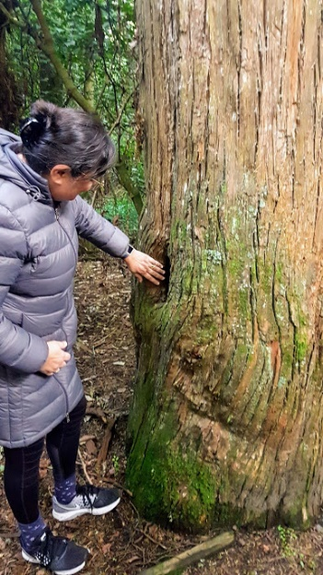
Caring leadership
The story of the ‘Rākau Rangatira’ encapsulates notions of a caring web of interrelationships and connectedness between things physical, spiritual and social. The interaction between the Totara, mother and child taught attentiveness to the suffering of an ‘other’ – through the awareness of, and concern for the tree – a lesson was learned about the power of the ethic of care to heal. At its core, school leadership is a social relationship, in which the enhancement of kaiako (teacher), ākonga (student) and whānau (family) well-being and academic success are uppermost in the responsibilities of the tumuaki (principal). Relational leadership means attending to them as persons with spiritual, intellectual, physical, and emotional capacities to be nurtured (Glazer, 2019), or more pertinent to New Zealand is Durie’s (2001) Te Whare Tapa Whā model of taha tinana, taha wairua, taha whānau taha hinengaro – an integrated model that recognises the foundation of wairua (spiritual) health and inter-connected effects of spiritual, family and mental health for personal and collective wellbeing.
Through the caring actions and interactive manner of the tumuaki, kaiako and ākonga learn the extent to which they are valued, respected, and safe to be themselves and take risks, so that deep learning and higher achievement might occur. In caring school cultures, kaiako and ākonga have a deeper sense of belonging, with higher levels of emotional, social and academic support – key elements for improving well-being and academic outcomes (Louis, Murphy & Smylie, 2016). Indeed, Louis et al. (2016, p.344) argue that, “Principals who care for teachers support the development of a culture that focuses, at least implicitly, on equity” since teachers who are supported, are more likely to develop positive caring teacher-student relationships which are critical for learning (Hattie, 2009), and life-long success (Birch & Ladd, 1997).
But what does caring mean? According to Louis et al. (2016), caring for others is expressed through empathetic awareness and meeting of other’s needs; being genuine and authentic; prioritising requirements of the cared person (often ahead of one’s own); responsive to the situation (based on principles rather than being rule bound); and a sense of mutuality (realizing the inter-dependence of success – each of us is responsible for other’s success). Care is best developed in situations of trust where others can be depended on to honour their commitments, over time rather than one-off special events, and in environments of belonging-acceptance, or community (Louis et al., 2016).
“Leader caring provides a special kind of support for teachers who work in settings [with students experiencing higher levels of poverty] that are commonly associated with demoralization and burnout” (Louis et al., 2016, p.337). Teachers (kaiako) low in self-efficacy and energy struggle to care for their students (ākonga) because kaiako capacity to build and sustain nurturing relationships with ākonga and whānau is dependent on their levels of resilience; while kaiako with tumuaki who care about their well-being (Noddings, 2005) are more likely to thrive. Al-Ghabban (2018) argues that creating space together for kaiako to reflect and discuss (e.g. difficult situations they have experienced with ākonga), helps kaiako understand their own feelings, and to share strategies or resources. From these experiences, kaiako develop greater awareness and language for compassion. In short, compassion is sensitivity to the suffering of self and others, being touched by it, and being motivated to alleviate suffering (Al-Ghabban, 2018). Taking action by creating time to be alongside the other, to listen, express empathy and to support them through validation and sharing of strategies, are means of alleviating the suffering of others, and in so doing, build their capacity for compassion.
As Fullan (2001) argued, principals catalyse cultural change – they are pivotal in creating and enhancing caring, compassionate school communities. A collective approach to leadership (Nicholson & Kurucz, 2017), enables tumuaki to engage with staff to develop an ‘ethic of care’ that can permeate all relationships, in order that all members of the community can flourish. To flourish, requires recognition and confirmation of the respective strengths and talents that members possess – “bringing out the best in others” (Nicholson & Kurucz, 2017, p. 38). Recognising ‘the best in others’ comes from a relationship of knowing them, attributing best possible motives to mistakes they may make, and drawing attention to ‘their best selves’ so they may reflect on actions and benefit from respectful discussions.
So how does this educational theory about caring, compassionate leadership, and the metaphor of the Totara, relate to real leadership in New Zealand?

Stuck in crisis, a tree battered and exposed…

Leading a Decile One school involves dealing with a range of crises including: gang and/or family violence, traumatic effects of students who are tired and hungry, diagnosed and undiagnosed mental and physical health issues, care and protection issues and Oranga Tamariki, bomb threats, lockdowns, student abduction, student behavioural issues that require police intervention, irate and violent parents and natural disasters. Addictive patterns of leadership can be initially rewarding - solving urgent issues - and working from a moral imperative that impacts vulnerable and marginalised tamariki. However, those rewards come at the expense of establishing systems for normal activities.
The leadership team at Te Kura o Tākaro, were adept in a crisis. They looked out for each other, worked together and found ways to navigate through each crisis. In the long term, this addictive pattern of leadership was not sustainable and had a devasting impact on the well-being of the tumuaki. At the end of 2016, she was diagnosed with breast cancer and spent ten months of 2017 in treatment and absolute exhaustion. The tumuaki had become the scarred totara tree.
How could the tumuaki, the totara, that stood out above the canopy; the tree that leaned into the elements that buffered it; the tree that was headstrong and protected others, fixed things, was of service to all, find it difficult to take care of itself? A tree that even when cut down could still be fashioned into a raakau (weapon) to continue to fight at any cost. As with the Totara, a change was needed, to allow healing and growth. The change came with support from an external facilitator and the realization that it was the school relationships, not the tumuaki, that was the Totara, a “Rakau Rangatira”.

The Rakau Rangatira, caring relational leadership Model for Te Kura o Tākaro
A Raukau Rangatira metaphor was developed and adapted from Scott’s (2002) Tree Model for leadership. The entire tree: the roots, the trunk, branches and leaves formed the basis of the relational model of leadership that transformed the school.

Nga Aka (The Roots)
The roots are the foundation that hold the people in place. They are deep and feed growing relational needs to: being appreciative, remaining connected to place and people, working constantly on commitments to each other, being authentic and respectful in communications. These roots became well established and formed the basis of the localised Marautanga (school curriculum).

Te Tinana (The Trunk)
The trunk represents the leadership team – the main supportive structure that holds the school together –and provides the pathway for the wai rakau (sap) to travel to all parts of the tree for survival of the Rakau Rangatira. In strengthening the tinana, the leadership team established and maintained clear communication systems, connected to kura values. This model provides guidance on how to approach ‘crisis’ and ‘business as usual’ school management. Such support takes strength and commitment, which is possible due to the heartwood of the Rakau Rangatira that is renowned for its strength and durability.

Nga Kaupeka (The Branches)
The branches extend out from the tinana (trunk). Each branch is separate, and reaches upwards to enable the branch and the leaves to find spaces in which to grow. The branches are also holons, that is, they are parts of the tree system that are complete in themselves. They represent the school teams and allocated areas of responsibility; each with their own identity, yet connected to the larger system.

Nga Rau (The Leaves)
The leaves on the branches represent the team members. It is the tinana (leadership team) who ensure that leaves grow strong and cope with the ever-changing environment and surroundings. Each member’s separate strengths come from the solid home base of the tinana. In times of support, the tinana coordinates and maintains relational values, which provide clear pathways for the life-giving wai rakau to flow.

Te Taiao (Adaptations to the environment)
As the Rakau Rangatira grows it is continually shaped by Tawhirimatea (weather) and its surroundings. Kura live in, and are shaped by, a climate of prevailing winds, rain and sunshine. Rather than resist the elements, which could uproot or break the rakau, continual adaptation as leaders is vital.
The Rakau Rangatira metaphor has provided a breath of life (te manawa ora) for Te Kura o Tākaro to develop a strong identity, and clear values for all relationships and decision-making in the school - a truly bicultural way of being, and doing, and sustainable leadership.
Conclusion
The purpose of sharing this metaphor of the Totara, is threefold. One purpose is to share the importance of caring leadership – for the benefit of all people in the school community, including the tumuaki! The second purpose is to share a Tikanga Māori approach to authentic leadership and demonstrate the power of metaphors and narratives - the appropriateness of remembering (a childhood memory that powerfully informed leadership), the value of connected relationships - socially, spiritually, physically and intellectually (with kaiako, ākonga and whānau; with the Totara that represents the physical and spiritual worlds). Interestingly, the authors also share multiple connectedness through their bicultural childhood educational experiences and professional lives. Finally, caring, relational leadership is essential for sustainability of leaders in schools (kura), but even more importantly, for the next generation of leaders (kaiārahi), kaiako, ākonga and whānau, and the well-being of Aotearoa New Zealand.
E mama
Ka puawai mai te mahara, ko te ngaakau aroha tona hua.
(In the remembering, love returns)
References
Al-Ghabban, A. (2018). A compassion framework: the role of compassion in schools in promoting well-being and supporting the social and emotional development of children and young people. Pastoral Care in Education, 36(3), 176-188. DOI: 10.1080/02643944.2018.1479221.
Durie, M. (2001) Mauri ora: The Dynamics of Māori health. Oxford: Oxford University Press.
Fullan, M. (2001). Leading in a culture of change. San Francisco: Jossey-Bass.
Glazer, R. (2019). Elevate: Push beyond your limits and unlock success in yourself and others. Simple5mins: Illinois.
Hattie, J. (2009). Visible learning: A synthesis of over 800 meta-analyses relating to achievement. New York, NY: Routledge.
Hilstad, K., & Moller, J. (2013). Leadership as relational work: Risks and opportunities. International Journal of Leadership in Education, 16(3), 245-262. DOI: 10.1080/13603124.2012.761353.
Louis, K., Murphy, J., & Smylie, M. (2016). Caring leadership in schools: Findings from exploratory analyses. Educational Administration Quarterly, 52(2), 310-348.
Nicholson, J., & Kurucz, E. (2017). Relational leadership for sustainability: Building an ethical framework from the moral theory of ‘ethics of care’. Journal of Business Ethics, 156, 25-43. DOI: 10.1007/sl0551-017-3593-4.
Noddings, N. (2005). The challenge to care in schools: An alternative approach to education (2nd Ed). New York, NY: Teachers College Press.
Scott, S. (2002). Fierce Conversations. Achieving success at work & in life, one conversation at a time. New York, NY: New American Library.

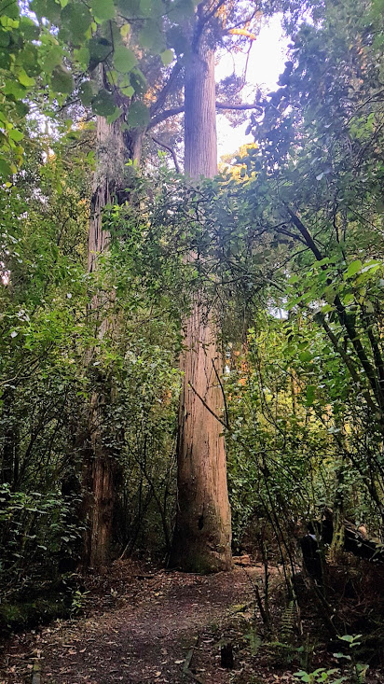

.Acknowledgements and thanks to Senior Leaders Team, Marilyn, Stacey and Josie, Dr Phil Ramsey Massey University And Rene Aish Te Aroha Noa.

Helena Baker (Tumuaki, Te Kura o Tākaro) and Jenny Poskitt (Associate Professor, Te Kura o Te Mātauranga, Te Kunenga ki Purehuroa)

Re reo Māori story published about a Rimu tree.

