Supplementary figures
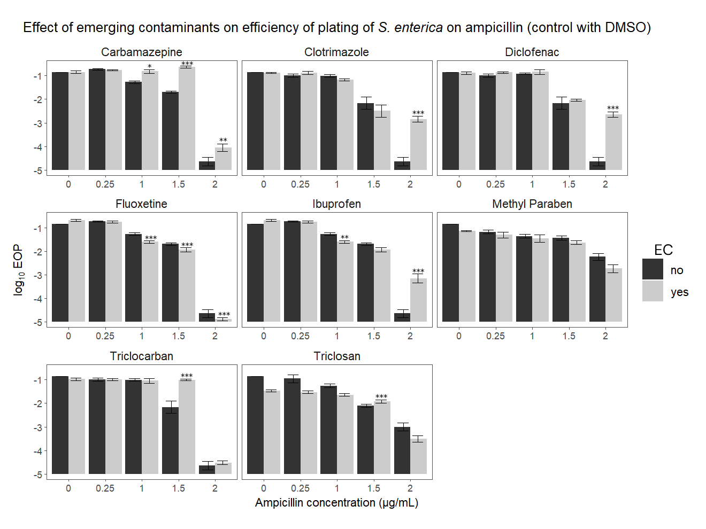
Supplementary figure 1: efficiency of plating of S. enterica on increasing concentration of ampicillin, with and without emerging contaminates. The control (no EC) for this series included 0.25% DMSO, for all but the triclosan series, which included 0.01% DMSO.
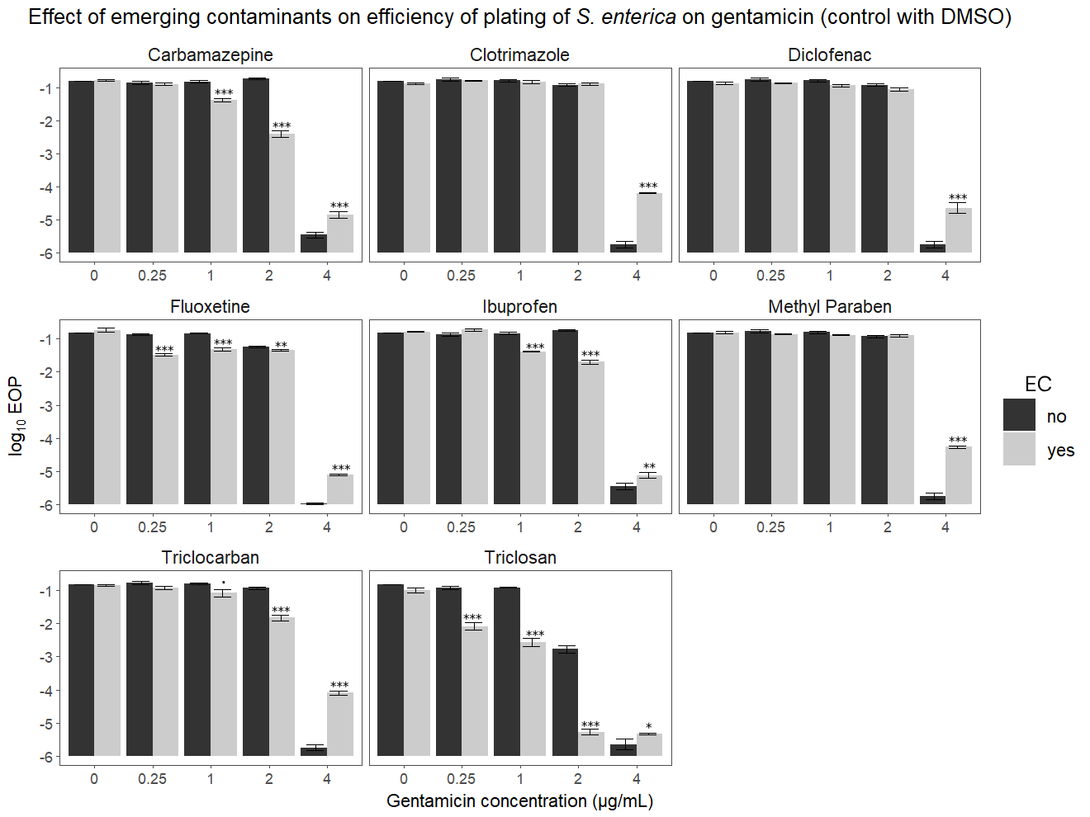
Supplementary figure 2: efficiency of plating of S. enterica on increasing concentration of gentamicin, with and without emerging contaminates. The control (no EC) for this series included 0.25% DMSO, for all but the triclosan series, which included 0.01% DMSO.
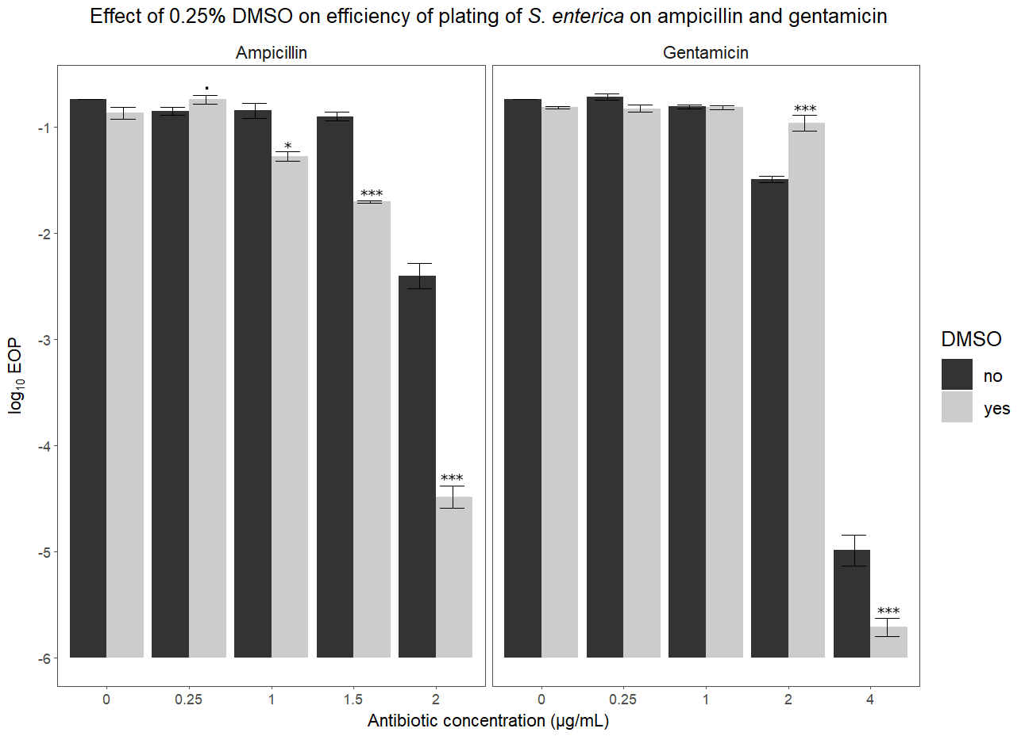
Supplementary Figure 3: efficiency of plating of S. enterica on increasing concentrations of ampicillin and gentamicin, with and without DMSO (0.25%).
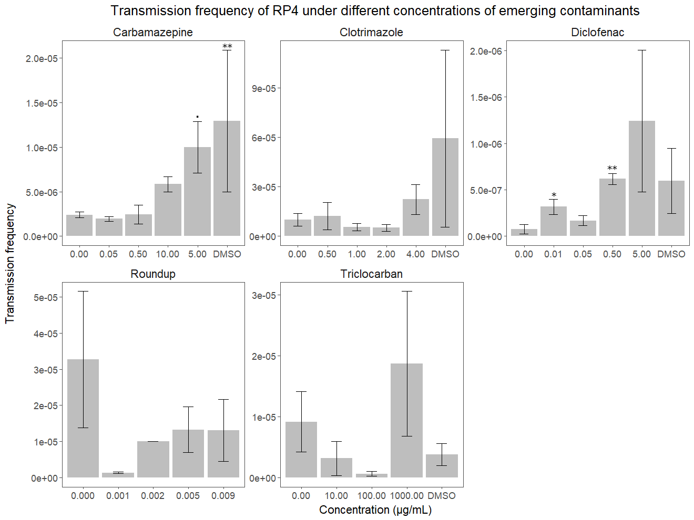
Supplementary figure 4: transmission frequency of RP4 between S. enterica and E. coli exposed to different concentrations of five ECs. Transmission frequency is reported in transconjugants per limiting parent.

