Table S1: Molasses phytohormone profile
Phytohormone | Concentration (ng/g FW) | Applied to plants (nM)
12-Oxo-phytodienoic acid (OPDA) | 997.028 | 0.682
Abscisic acid (ABA) | 1191.744 | 0.902
Brassinolide | 0 | 0
Cinnamic acid (CA) | 2417.868 | 3.264
Gibberellin A3 (GA3) | 0 | 0
Gibberellin A4 (GA4) | 0 | 0
Indole-3-acetic acid (IAA) | 647.716 | 0.739
Indole-3-butyric acid (IBA) | 0 | 0
Indole-3-carboxylic acid (ICA) | 10.648 | 0.013
Jasmonic acid (JA) | 188.192 | 0.179
Jasmonic acid-isoleucine (JA-Ile) | 19.438 | 0.012
Methyl-indole-3-acetic acid (Methyl-IAA) | 6.057 | 0.007
Methyl-jasmonic acid (Methyl-JA) | 0 | 0
Salicylic acid (SA) | 7362.209 | 10.661
Zeatin | 210.470 | 0.192
Phytohormone profiling was performed as per Suwanchaikasem, P., Idnurm, A., Selby-Pham, J., Walker, R., Boughton, B.A., 2022. Root-TRAPR: a modular plant growth device to visualize root development and monitor growth parameters, as applied to an elicitor response of Cannabis sativa. Plant Methods 18, 1-20.

Table S2: Yield and nutritional measures
Measure | N | Control |  | Molasses |  | P-value
Measure | N | Mean | SD | Mean | SD | P-value
Seed weight (g/ seed) | 4 | 0.0146 | 0.0019 | 0.0131 | 0.0016 | 0.256
Seed yield (g/ plant) | 12 | 4.79 | 2.49 | 5.36 | 3.80 | 0.669
Oil (mg/ 10 mg seed) | 4 | 3.66 | 0.18 | 3.53 | 0.36 | 0.529
Protein (mg/ g seed) | 4 | 27.24 | 4.42 | 26.47 | 3.10 | 0.783

Phytohormone
Table S3: Leaf phytohormone results
Measure | N | Control |  | Molasses |  | P-value
Measure | N | Mean | SD | Mean | SD | P-value
12-Oxo-phytodienoic acid (OPDA) | 4 | 4281 | 1817 | 3512 | 268 | 0.434
Abscisic acid (ABA) | 4 | 449 | 117 | 396 | 75 | 0.479
Brassinolide | 4 | 0 | 0 | 0 | 0 | -
Cinnamic acid (CA) | 4 | 0 | 0 | 0 | 0 | -
Gibberellin A3 (GA3) | 4 | 0 | 0 | 0 | 0 | -
Gibberellin A4 (GA4) | 4 | 0 | 0 | 0 | 0 | -
Indole-3-acetic acid (IAA) | 4 | 10.49 | 0.83 | 10.15 | 0.55 | 0.522
Indole-3-butyric acid (IBA) | 4 | 0 | 0 | 0 | 0 | -
Indole-3-carboxylic acid (ICA) | 4 | 1.22 | 2.44 | 2.36 | 1.59 | 0.466
Jasmonic acid (JA) | 4 | 5.93 | 2.38 | 6.27 | 1.73 | 0.821
Jasmonic acid-isoleucine (JA-Ile) | 4 | 6.12 | 5.11 | 5.86 | 1.73 | 0.928
Methyl-indole-3-acetic acid (Methyl-IAA) | 4 | 0 | 0 | 0 | 0 | -
Methyl-jasmonic acid (Methyl-JA) | 4 | 12.9 | 10 | 7.6 | 8.7 | 0.459
Salicylic acid (SA) | 4 | 109 | 18 | 92 | 31 | 0.383
Zeatin | 4 | 8.40 | 3.14 | 7.97 | 2.94 | 0.85
Mean and SD data presented as ng / g FW
Table S4: Sugar leaf phytohormone results
Measure | N | Control |  | Molasses |  | P-value
Measure | N | Mean | SD | Mean | SD | P-value
12-Oxo-phytodienoic acid (OPDA) | 4 | 12612 | 9995 | 9390 | 2066 | 0.551
Abscisic acid (ABA) | 4 | 1111 | 355 | 868 | 295 | 0.334
Brassinolide | 4 | 0 | 0 | 0 | 0 | -
Cinnamic acid (CA) | 4 | 83 | 165 | 33 | 66 | 0.597
Gibberellin A3 (GA3) | 4 | 0 | 0 | 0 | 0 | -
Gibberellin A4 (GA4) | 4 | 0 | 0 | 0 | 0 | -
Indole-3-acetic acid (IAA) | 4 | 0 | 0 | 0 | 0 | -
Indole-3-butyric acid (IBA) | 4 | 0 | 0 | 0 | 0 | -
Indole-3-carboxylic acid (ICA) | 4 | 12.66 | 2.90 | 10.79 | 4.15 | 0.489
Jasmonic acid (JA) | 4 | 32.52 | 11.66 | 26.16 | 6.38 | 0.375
Jasmonic acid-isoleucine (JA-Ile) | 4 | 27.7 | 11.1 | 36.4 | 19.6 | 0.468
Methyl-indole-3-acetic acid (Methyl-IAA) | 4 | 0 | 0 | 0 | 0 | -
Methyl-jasmonic acid (Methyl-JA) | 4 | 5.23 | 1.82 | 5.71 | 3.06 | 0.795
Salicylic acid (SA) | 4 | 625 | 196 | 433 | 63 | 0.111
Zeatin | 4 | 23.38 | 8.59 | 21.24 | 8.66 | 0.738
Mean and SD data presented as ng / g FW

Table S5: Seed phytohormone results
Measure | N | Control |  | Molasses |  | P-value
Measure | N | Mean | SD | Mean | SD | P-value
12-Oxo-phytodienoic acid (OPDA) | 4 | 268 | 68 | 257 | 38 | 0.776
Abscisic acid (ABA) | 4 | 118 | 23 | 184 | 97 | 0.238
Brassinolide | 4 | 0 | 0 | 0 | 0 | -
Cinnamic acid (CA) | 4 | 263 | 116 | 563 | 322 | 0.13
Gibberellin A3 (GA3) | 4 | 0 | 0 | 0 | 0 | -
Gibberellin A4 (GA4) | 4 | 13.39 | 1.03 | 15.15 | 2.88 | 0.294
Indole-3-acetic acid (IAA) | 4 | 59.35 | 18.71 | 108.95 | 76.84 | 0.256
Indole-3-butyric acid (IBA) | 4 | 0 | 0 | 0 | 0 | -
Indole-3-carboxylic acid (ICA) | 4 | 544 | 80 | 815 | 283 | 0.115
Jasmonic acid (JA) | 4 | 3.25 | 1.31 | 3.54 | 1.25 | 0.759
Jasmonic acid-isoleucine (JA-Ile) | 4 | 19.5 | 9.9 | 13.9 | 1.6 | 0.307
Methyl-indole-3-acetic acid (Methyl-IAA) | 4 | 0.70 | 0.37 | 1.57 | 1.42 | 0.279
Methyl-jasmonic acid (Methyl-JA) | 4 | 0 | 0 | 0 | 0 | -
Salicylic acid (SA) | 4 | 2793 | 226 | 3428 | 1645 | 0.473
Zeatin | 4 | 4.15 | 1.02 | 6.71 | 3.00 | 0.157
Mean and SD data presented as ng / g FW

Table S6: Root phytohormone results
Measure | N | Control |  | Molasses |  | P-value
Measure | N | Mean | SD | Mean | SD | P-value
12-Oxo-phytodienoic acid (OPDA) | 4 | 1430 | 437 | 1001 | 278 | 0.149
Abscisic acid (ABA) | 4 | 22.97 | 2.57 | 13.02 | 3.18 | 0.003
Brassinolide | 4 | 0 | 0 | 0 | 0 | -
Cinnamic acid (CA) | 4 | 0 | 0 | 3.33 | 6.66 | 0.196
Gibberellin A3 (GA3) | 4 | 0 | 0 | 0 | 0 | -
Gibberellin A4 (GA4) | 4 | 10.89 | 1.57 | 9.72 | 1.61 | 0.339
Indole-3-acetic acid (IAA) | 4 | 32.42 | 4.58 | 46.62 | 2.36 | 0.002
Indole-3-butyric acid (IBA) | 4 | 0 | 0 | 0 | 0 | -
Indole-3-carboxylic acid (ICA) | 4 | 0.798 | 1.597 | 6.638 | 1.159 | 0.001
Jasmonic acid (JA) | 4 | 0.96 | 0.46 | 1.15 | 0.56 | 0.615
Jasmonic acid-isoleucine (JA-Ile) | 4 | 0 | 0 | 0 | 0 | -
Methyl-indole-3-acetic acid (Methyl-IAA) | 4 | 5.37 | 1.33 | 19.60 | 4.89 | 0.001
Methyl-jasmonic acid (Methyl-JA) | 4 | 0 | 0 | 0 | 0 | -
Salicylic acid (SA) | 4 | 94.1 | 15.3 | 430.2 | 160.3 | 0.006
Zeatin | 4 | 0 | 0 | 0 | 0 | -
Mean and SD data presented as ng / g FW

Bioassay
Table S7: Hydrogen peroxide (µmol H₂O₂/ g FW).
Measure | N | Control |  | Molasses |  | P-value
Measure | N | Mean | SD | Mean | SD | P-value
Root | 4 | 0 | 0 | 0 | 0 | -
Leaf | 4 | 8.65 | 0.89 | 11.31 | 6.07 | 0.420
Sugar leaf | 4 | 9.16 | 3.04 | 9.10 | 5.43 | 0.985
Seed | 4 | 9.39 | 11.26 | 4.30 | 7.13 | 0.474

Table S8: Peroxidase activity (ΔAbs₄₇₀ · min⁻¹ / mg total protein).
Measure | N | Control |  | Molasses |  | P-value
Measure | N | Mean | SD | Mean | SD | P-value
Root | 4 | 338 | 18 | 323 | 38 | 0.488
Leaf | 4 | 0 | 0 | 0 | 0 | -
Sugar leaf | 4 | 0 | 0 | 0.025 | 0.050 | 0.196
Seed | 4 | 0.0100 | 0.0201 | 0.0427 | 0.0195 | 0.058

Table S9: Chitinase activity (µmol GlcNAc released /g total protein).
Measure | N | Control |  | Molasses |  | P-value
Measure | N | Mean | SD | Mean | SD | P-value
Root | 4 | 521 | 149 | 510 | 22 | 0.887
Leaf | 4 | 171 | 44 | 194 | 62 | 0.570
Sugar leaf | 4 | 662 | 81 | 621 | 76 | 0.486
Seed | 4 | 163 | 33 | 183 | 27 | 0.409

Metabolites
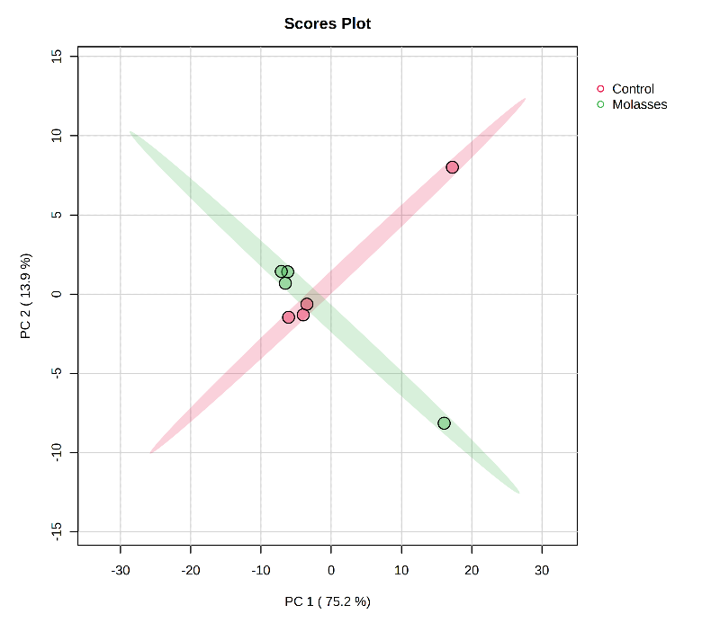 | 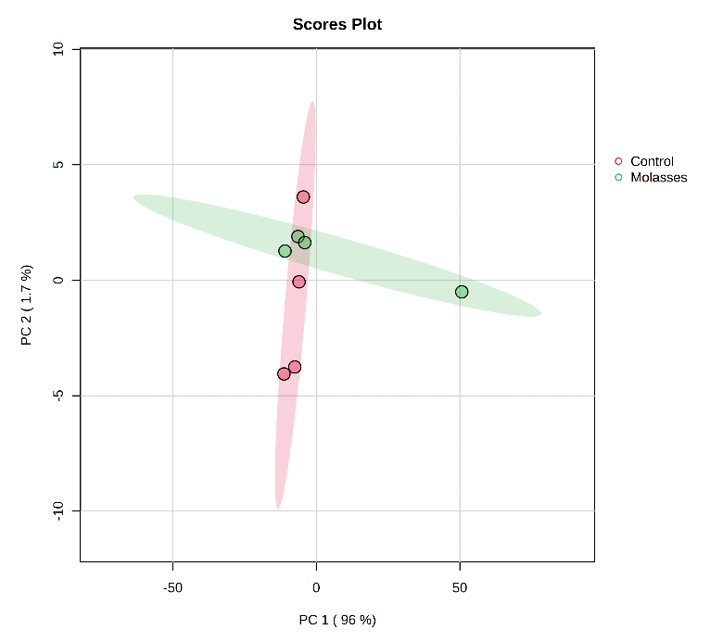
(A) | (B)
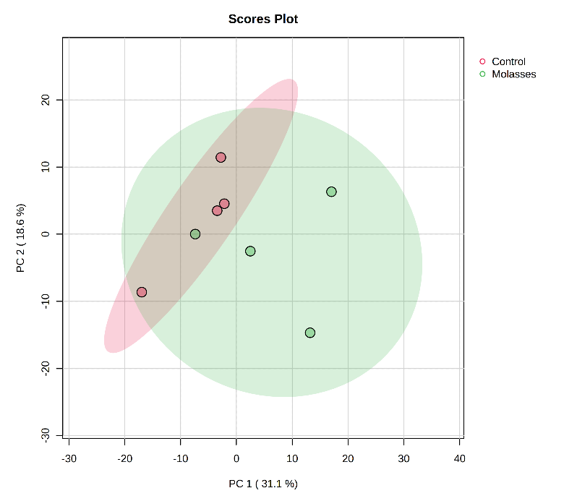 | 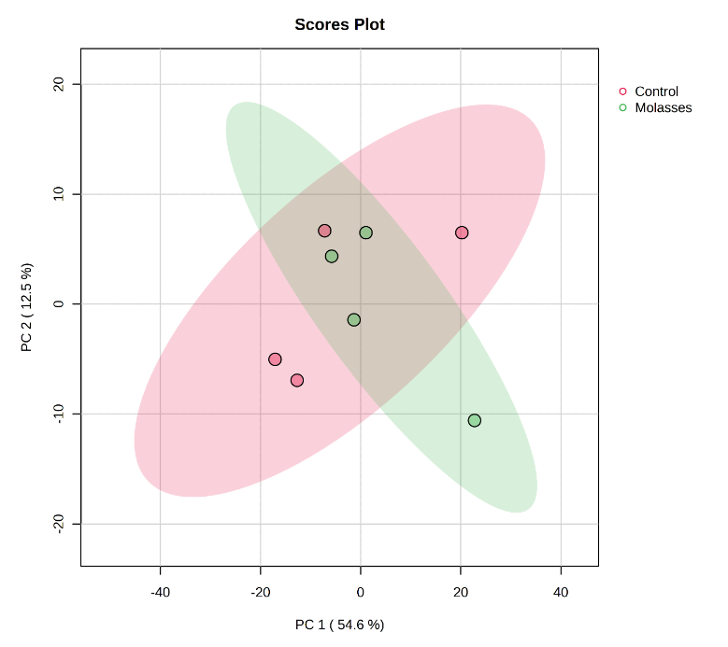
(C) | (D)
Figure S1: Principal component analyses of (A) root, (B) leaf, and (C) sugar leaf metabolite profiles, and (D) seed polar metabolite profile. Shaded regions represent 95% confidence.

Table S10: Significant and marginally significant changes to individual root metabolites
Metabolite | Fold-changeª | P-value
1-(3-Acetyl-2,4,6-trihydroxyphenyl)-1,5-anhydrohexitol | 8.15 | 0.077
Genistein | 3.14 | 0.094
Methyl (17beta)-3,6-dimethoxyestra-1,3,5(10),6,8-pentaene-17-carboxylate | 0.68 | 0.068
ª - Compared to untreated control

Table S11: Significant and marginally significant changes to individual sugar leaf metabolites
Metabolite | Synonymª | Fold-change^{b} | P-value
(1S,3R,4R,5R)-1,3,4-trihydroxy-5-{[(2E)-3-(4-hydroxy-3-methoxyphenyl)prop-2-enoyl]oxy}cyclohexane-1-carboxylic acid | 3-O-feruloyl-D-quinic acid | 0.65 | 0.028
(3R,5E,7E,23R,25R)-3,25-Dihydroxy-23,26-epoxy-9,10-secocholesta-5,7,10-trien-26-one |  | 0.51 | 0.003
1-Hydroxy-3,5,6-trimethoxy-10-methyl-9(10H)-acridinone |  | 0.74 | 0.024
2-[4-(Hydroxymethyl)cyclohexyl]-2-propanyl hexopyranoside |  | 0.67 | 0.042
3-[3-(beta-D-Glucopyranosyloxy)-2-methoxyphenyl]propanoic acid |  | 0.54 | 0.050
3-Hydroxy-3-methylglutaric acid | Meglutol | 0.43 | 0.069
4-(2-Carboxyethyl)-2-methoxyphenyl beta-D-glucopyranosiduronic acid | Dihydroferulic acid 4-glucuronide | 0.79 | 0.039
5,6-Dihydroxy-2,6-bis(3-methyl-2-buten-1-yl)-4-(4-methylpentanoyl)-4-cyclohexene-1,3-dione | Prehumulone | 0.69 | 0.032
6-Oxoestriol |  | 0.66 | 0.009
Caffeic acid 3-glucoside |  | 0.75 | 0.051
Cannabigerolic acid (CBG) |  | 0.67 | 0.033
D-Xylulosonic acid |  | 0.62 | 0.037
L-Glutamic acid |  | 0.51 | 0.090
Marinobufagenin |  | 0.73 | 0.055
N-feruloylglycine |  | 0.64 | 0.026
Pyrogallol-2-O-glucuronide |  | 0.68 | 0.045
Salicylic acid |  | 0.63 | 0.062
trans-p-Sinapoyl-Î²-D-glucopyranoside | 1-Sinapoyl-D-glucose | 0.77 | 0.028
Xanthosine |  | 0.71 | 0.010
a - Synonym from chemspider (chemspider.com), b - Compared to untreated control

Table S12: Seed PNP metabolite profiles
Metabolite | Synonymª | Fold-change^{b} | p-value
1-Hydroxy-3,5,6-trimethoxy-10-methyl-9(10H)-acridinone | Citpressine II | 0.73 | 0.033
3,8,9-trihydroxy-10-propyl-3,4,5,8,9,10-hexahydro-2H-oxecin-2-one | Herbarumin II | 1.49 | 0.083
3-[(1-Carboxyvinyl)oxy]-4-hydroxybenzoic acid | Dehydrochorismic acid | 3.67 | 0.072
4-(2-Carboxyethyl)-2-methoxyphenyl beta-D-glucopyranosiduronic acid | Dihydroferulic acid 4-glucuronide | 1.60 | 0.080
6-Hydroxy-3,4a,5-trimethyl-2-oxo-2,4,4a,5,6,7,8,8a,9,9a-decahydronaphtho[2,3-b]furan-4-yl (2Z)-2-methyl-2-butenoate | 3b-Hydroxy-6b-angeloyloxy-7(11)-eremophilen-12,8b-olide | 1.38 | 0.094
Azelaic acid |  | 1.94 | 0.078
Cannabidiolic acid (CBDA) |  | 1.35 | 0.096
Haplodimerine |  | 0.71 | 0.061
Methyl 4,5,7,11-tetrahydroxy-2-methyl-2',10-dioxospiro[9-oxatricyclo[6.3.1.0^{1,5}]dodecane-6,3'-oxetane]-7-carboxylate | Veranisatin C | 1.77 | 0.068
Tricoumaroyl spermidine |  | 1.45 | 0.097
Uridine |  | 1.42 | 0.021
Wighteone |  | 1.37 | 0.032
a - Synonym from chemspider (chemspider.com), b - Compared to untreated control
Table S13: Seed polar metabolite profiles
Metabolite | Fold changeª | p-value
(E)-2-methyl-4-(7H-purin-6-ylamino)but-2-en-1-ol | 1.54 | 0.282
1-Methyl-14-oxapentacyclo[11.6.1.0²,¹¹.0⁴,⁹.0¹⁶,²⁰]icosa-2,4(9),10,13(20),15-pentaene-5,8,12-trione 1 | 1.28 | 0.672
1-Methyl-14-oxapentacyclo[11.6.1.0²,¹¹.0⁴,⁹.0¹⁶,²⁰]icosa-2,4(9),10,13(20),15-pentaene-5,8,12-trione 2 | 0.99 | 0.986
3-Demethyl cannabisin G | 1.37 | 0.101
Cannabisin B | 7.42 | <0.001
Cannabisin C | 1.57 | 0.028
Cannabisin D | 0.69 | 0.566
Cannabisin E | 1.34 | 0.307
Cannabisin H | 6.67 | 0.001
Cannabisin M | 0.76 | 0.402
Corylin | 1.36 | 0.623
Erythrinin A | 1.31 | 0.672
Ferulic acid | 1.24 | 0.362
Grossamide K | 1.06 | 0.759
Isocannabisin N | 1.08 | 0.815
L-Phenylalanine | 2.06 | 0.277
L-Tryptophan | 1.18 | 0.565
N-(1-Deoxy-1-fructosyl)phenylalanine | 0.59 | 0.593
N-feruloyltyramine | 1.49 | 0.067
N-transcaffeoyltyramine | 8.32 | <0.001
N-transcaffeoyltyramine isomer | 0.74 | 0.677
N-trans-coumaroyltyramine | 16.05 | <0.001
a - Compared to untreated control

Table S14: LogP values for polar metabolites presented in Table 4.
Metabolite | Valueª
Cannabisin B | 4.2
Cannabisin C | 4.6
Cannabisin H | 2.3
N-feruloyltyramine | 2.1
N-transcaffeoyltyramine | 2.4
N-trans-coumaroyltyramine | 2.7
a - sourced from PubChem (pubchem.ncbi.nlm.nih.gov), computed by XLogP3 3.0 (PubChem release 2021.05.07)

TEAC modelling
Table S15: Dataset and sources utilised for TEAC modelling.
Compound | TEAC (mM)ª | Source^{b}
1,2-disinapoyl gentiobiose | 1.6700 | Plumb et al. (1997)
1,5-Dihydroxyanthraquinone | 0.0760 | Cai et al. (2006)
1-sinapoyl-2-feruloyl gentiobiose (2-Feruloyl-1-sinapoylgentiobiose) | 1.7900 | Plumb et al. (1997)
2,6-Dihydroxyanthraquinone | 0.0720 | Cai et al. (2006)
5-Methoxyfuranocoumarin | 0.0030 | Cai et al. (2006)
Acetylskikonin | 0.1070 | Cai et al. (2006)
Aesculetin | 2.3975 | Thuong et al. (2010), Cai et al. (2006)
Aesculin | 0.3800 | Thuong et al. (2010)
Alizarin | 1.0700 | Cai et al. (2006)
Alizarin-2-glucoside | 0.1050 | Cai et al. (2006)
Aloe-emodin | 0.0770 | Cai et al. (2006)
Anthraquinone | 0.0090 | Cai et al. (2006)
Apigenidin | 2.3500 | Rice-Evans et al. (1995)
Apigenin | 0.7680 | Rice-Evans et al. (1995), Cai et al. (2006)
Apigetrin (Apigenin-7-glucoside) | 0.0830 | Cai et al. (2006)
Arctigenin | 0.1040 | Cai et al. (2006)
Ascorbic Acid | 0.9950 | Miller and Rice-Evans (1997), Rice-Evans et al. (1995)
Astragalin (Kaempferol-3-glucoside) | 0.1380 | Cai et al. (2006)
Baicalein | 2.5600 | Cai et al. (2006)
Baicalin (Baicalein-7-glucuronide) | 1.5500 | Cai et al. (2006)
Benzoic acid | 0.0050 | Cai et al. (2006)
Bisdemethoxycurcumin | 1.1800 | Cai et al. (2006)
Butein | 2.4200 | Cai et al. (2006)
Caffeic Acid | 1.3475 | Plumb et al. (1997), Thuong et al. (2010), Raudonis et al. (2012), Cai et al. (2006)
Catechin | 2.2760 | Rice-Evans et al. (1995), Thuong et al. (2010), Raudonis et al. (2012), Cai et al. (2006), Rice-Evans (1995)
Chalcone | 0.0010 | Cai et al. (2006)
Chinese gallotannin (gallotannins) | 11.6300 | Cai et al. (2006)
Chlorogenic acid | 1.0733 | Miller and Rice-Evans (1997), Raudonis et al. (2012), Cai et al. (2006)
Chrysazine | 0.0680 | Cai et al. (2006)
Chrysin | 0.7555 | Rice-Evans et al. (1995), Cai et al. (2006)
Chrysophanol | 0.0690 | Cai et al. (2006)
Corilagin (monomeric ellagitannin) | 7.7600 | Cai et al. (2006)
Coumarin | 0.0010 | Cai et al. (2006)
Curcumin | 2.2400 | Cai et al. (2006)
Cyanidin | 4.2000 | Rice-Evans et al. (1995)
Cyanidin-3-glucoside | 2.4700 | Miller and Rice-Evans (1997)
Cyanidin-3-rutinoside | 3.2500 | Miller and Rice-Evans (1997)
Daidzein | 0.1010 | Cai et al. (2006)
Daidzin (Daidzein-7-glucoside) | 0.0720 | Cai et al. (2006)
Daphnetin | 2.1500 | Thuong et al. (2010)
Delphinidin-3-glucoside | 2.4700 | Miller and Rice-Evans (1997)
Delphinidin-3-rutinoside | 3.2500 | Miller and Rice-Evans (1997)
Demethoxycurcumin | 1.6300 | Cai et al. (2006)
Emodin | 0.0950 | Cai et al. (2006)
Epicatechin | 2.2480 | Rice-Evans (1995), Miller and Rice-Evans (1997), Raudonis et al. (2012), Rice-Evans et al. (1995), Cai et al. (2006)
Epicatechin gallate | 5.1100 | Rice-Evans (1995), Cai et al. (2006)
Epigallocatechin | 3.7650 | Rice-Evans (1995), Cai et al. (2006)
Epigallocatechin gallate | 4.0667 | Rice-Evans (1995), Raudonis et al. (2012), Cai et al. (2006)
Esculetin-6-glucoside | 0.1640 | Cai et al. (2006)
Ferulic Acid | 1.9233 | Plumb et al. (1997), Cai et al. (2006), Thuong et al. (2010)
Flavanone | 0.0000 | Cai et al. (2006)
Flavone | 0.0030 | Cai et al. (2006)
Flavonol | 0.7070 | Cai et al. (2006)
Fraxetin | 0.8500 | Thuong et al. (2010)
Fraxin | 0.4100 | Thuong et al. (2010)
Galangin | 1.1200 | Cai et al. (2006)
Gallic acid | 3.1800 | Miller and Rice-Evans (1997), Cai et al. (2006), Rice-Evans (1995)
Genistein | 0.5615 | Rice-Evans et al. (1995), Cai et al. (2006)
Genistin | 0.4335 | Rice-Evans et al. (1995), Cai et al. (2006)
Glutathione | 0.9000 | Rice-Evans et al. (1995)
Glycitein | 0.0970 | Cai et al. (2006)
Hesperetin | 0.4030 | Cai et al. (2006)
Hesperidin | 0.5920 | Miller and Rice-Evans (1997), Cai et al. (2006)
Hyperoside | 0.7100 | Raudonis et al. (2012)
Isoferulic acid | 1.5300 | Cai et al. (2006)
Isoflavone | 0.0050 | Cai et al. (2006)
Isoquercitrin | 0.5300 | Raudonis et al. (2012)
Juglone | 0.1050 | Cai et al. (2006)
Kaempferol | 1.4267 | Plumb et al. (1997), Cai et al. (2006), Rice-Evans et al. (1995)
Luteolin | 2.1800 | Cai et al. (2006)
Luteolin-7-glucoside | 1.4700 | Cai et al. (2006)
Magnolol (neolignans) | 0.2090 | Cai et al. (2006)
Malvidin | 2.0600 | Rice-Evans et al. (1995)
Matairesinol | 0.2530 | Cai et al. (2006)
m-Coumaric acid | 0.8200 | Cai et al. (2006)
m-Hydroxybenoic acid | 0.0250 | Cai et al. (2006)
Morin | 2.6800 | Cai et al. (2006)
Myricetin | 2.2050 | Rice-Evans et al. (1995), Cai et al. (2006)
Naringenin | 0.8735 | Rice-Evans et al. (1995), Cai et al. (2006)
Naringin | 0.3660 | Rice-Evans et al. (1995), Cai et al. (2006), Miller and Rice-Evans (1997)
o-Coumaric acid | 0.9300 | Cai et al. (2006)
o-Hydroxybenzoic acid (Salicylic acid) | 0.0370 | Cai et al. (2006)
p-Coumaric acid | 1.9600 | Cai et al. (2006)
Peonidin | 2.2200 | Rice-Evans et al. (1995)
Phloretin | 1.7900 | Cai et al. (2006)
Phloridzin | 2.3800 | Miller and Rice-Evans (1997)
p-Hydroxybenoic acid | 0.0280 | Cai et al. (2006)
Physcion | 0.0680 | Cai et al. (2006)
Piceatannol | 2.5300 | Cai et al. (2006)
Piceatannol-3'-glucoside | 1.6200 | Cai et al. (2006)
Procyanidin B-1 (dimer) | 6.1400 | Cai et al. (2006)
Procyanidin C-1 (trimer) | 8.2900 | Cai et al. (2006)
Protocatechuic acid | 1.1500 | Cai et al. (2006)
Pseudopurpurin | 1.6200 | Cai et al. (2006)
Purpurin | 1.9300 | Cai et al. (2006)
Quercetin | 3.6250 | Plumb et al. (1997), Raudonis et al. (2012), Cai et al. (2006), Rice-Evans et al. (1995)
Quercetin 3-0-sophoroside | 1.4500 | Plumb et al. (1997)
Quercetin-3-glucoside | 2.3900 | Cai et al. (2006)
Quercetin-3-glucoside-7-rhamnoside | 1.5600 | Cai et al. (2006)
Quercitrin | 1.2450 | Raudonis et al. (2012), Cai et al. (2006)
Quinizarin | 0.5480 | Cai et al. (2006)
Resveratrol | 2.1400 | Cai et al. (2006)
Resveratrol-3-glucoside | 1.3500 | Cai et al. (2006)
Resveratrol-4'-glucoside | 0.5580 | Cai et al. (2006)
Rhein | 0.0760 | Cai et al. (2006)
Ruberythric acid | 0.0730 | Cai et al. (2006)
Rutin | 1.6567 | Rice-Evans et al. (1995), Raudonis et al. (2012), Cai et al. (2006)
Sappanchalcone | 1.9300 | Cai et al. (2006)
Scopoletin | 0.9765 | Cai et al. (2006), Thuong et al. (2010)
Secoisolariciresinol | 0.3080 | Cai et al. (2006)
Sinapic Acid | 1.8400 | Plumb et al. (1997)
Stilbene | 0.0020 | Cai et al. (2006)
Syringic acid | 1.3900 | Cai et al. (2006)
Taxifolin | 1.9000 | Rice-Evans et al. (1995)
trans-Cinnamic acid | 0.0070 | Cai et al. (2006)
Umbelliferone | 0.5300 | Thuong et al. (2010)
Vanillic acid | 0.0920 | Cai et al. (2006)
α-tocopherol | 0.9700 | Rice-Evans et al. (1995)
a – as determined by ABTS, b – where multiple sources are present the average was used.

Table S16: Coefficients for terms used within regression equation for prediction of TEAC.
Term | Coefficient | p-value
Constant | 0.2437732206715580 | 0.159
VC | 0.1567749546929250 | 0.009
nHBD1 | 0.3958544559329020 | <0.001
nAliOH | -0.7025585968834280 | <0.001
RCOR | -0.8316374012684330 | 0.004
nHBD1² | 0.0426081076688713 | 0.001
RCOR² | 0.2428039482179180 | 0.109
nHBD1³ | -0.0016072010385511 | <0.001

Table S17: TEAC predictions for significant and marginally significant PNP metabolites
Metabolite | p-value | TEAC_{Predicted}
3b-Hydroxy-6b-angeloyloxy-7(11)-eremophilen-12,8b-olide | 0.094 | 0.61
Azelaic acid | 0.078 | 0.24
Cannabidiolic acid (CBDA) | 0.096 | 1.82
Citpressine II | 0.033 | 0.09
Dehydrochorismic acid | 0.072 | 0.99
Dihydroferulic acid 4-glucuronide | 0.080 | 0.00
Haplodimerine | 0.061 | 0.68
Herbarumin II | 0.083 | 0.00
Tricoumaroyl spermidine | 0.097 | 4.03
Uridine | 0.021 | 0.30
Veranisatin C | 0.068 | 0.00
Wighteone | 0.032 | 1.50

Table S18: Literature reported antioxidant capacities for P metabolites.
Metabolite | Method of reported antioxidant capacity | Reference
Cannabisin B | DPPH | Chen et al. (2012)
Cannabisin B | Oxygen radical absorbance capacity (ORAC) | Mélanie Bourjot et al. (2016)
Cannabisin C | ABTS (as % inhibition) | Yan et al. (2015)
N-Feruloyltyramine | DPPH | Zhang et al. (2016)
N-Transcaffeoyltyramine | DPPH | Chen et al. (2012)
N-Transcaffeoyltyramine | ORAC | Mélanie Bourjot et al. (2016)
N-Transcaffeoyltyramine | ABTS (as % inhibition) | Yan et al. (2015)
N-Trans-coumaroyltyramine | DPPH | Zhang et al. (2016) and  Brice Landry et al. (2022)

Fatty acid
Table S19: Hemp seed fatty acid profiles
Fatty acid methyl esters (FAMEs) | N | Control |  | Molasses |  | P-value
Fatty acid methyl esters (FAMEs) | N | Mean | SD | Mean | SD | P-value
C10:0 Methyl caprate | 4 | 3.90 | 0.44 | 3.23 | 0.53 | 0.114
C11:0 Methyl undecanoate | 4 | 0.225 | 0.057 | 0.308 | 0.232 | 0.511
C12:0 Methyl laurate | 4 | 0.025 | 0.032 | 0.008 | 0.017 | 0.390
C14:0 Methyl myristate | 4 | 0.35 | 0.03 | 0.45 | 0.28 | 0.504
C15:0 Methyl pentadecanoate | 4 | 0 | 0 | 0.00833 | 0.01667 | 0.196
C16:0 Methyl palmitate | 4 | 11.45 | 0.22 | 9.54 | 1.97 | 0.102
C16:1n7 Methyl palmitoleate | 4 | 0.317 | 0.019 | 0.242 | 0.050 | 0.031
C17:0 Methyl heptadecanoate | 4 | 0.142 | 0.032 | 0.125 | 0.050 | 0.595
C17:1n7 Methyl cis-10-Heptadecenoate | 4 | 0.0917 | 0.0167 | 0.0750 | 0.050 | 0.550
C18:0 Methyl stearate | 4 | 3.83 | 0.26 | 3.82 | 0.48 | 0.977
C18:1n9c Methyl oleate | 4 | 12.4 | 1.2 | 11.6 | 1.5 | 0.451
C18:1n7 Vaccenic acid | 4 | 1.99 | 0.05 | 1.78 | 0.22 | 0.108
C18:2n6c Methyl linolelaidate (LA, ω6) | 4 | 42.0 | 0.8 | 39.9 | 1.8 | 0.073
C18:3n6 Methyl γ-linolenate (GLA, ω6) | 4 | 1.10 | 0.15 | 0.92 | 0.06 | 0.067
C18:3n3 Methyl linolenate (ALA, ω3) | 4 | 16.5 | 2.1 | 15.5 | 2.2 | 0.542
C20:0 Methyl arachidate | 4 | 0.625 | 0.032 | 0.63 | 0.07 | 1.000
C20:1n9 Methyl cis-11-eicosenoate | 4 | 0.317 | 0.019 | 0.342 | 0.032 | 0.228
C22:0 Methyl behenate | 4 | 0.242 | 0.050 | 0.233 | 0.047 | 0.816
C23:0 Methyl tricosanoate | 4 | 0 | 0 | 0.050 | 0.058 | 0.091
C24:0 Methyl lignocerate | 4 | 0.0167 | 0.0333 | 0.375 | 0.551 | 0.242
The following were not detected in any sample: C4:0 Methyl butyrate, C6:0 Methyl hexanoate, C8:0 Methyl octanoate, C13:0 Methyl tridecanoate, C14:1n5 Methyl myristoleate, C15:1n5 Methyl cis-10-pentadecenoate, C18:1n9t Elaidic acid methyl ester, C20:2 cis-11,14-Eicosadienoic acid methyl ester, C20:3n6 cis-8,11,14-Eicosatrienoic acid methyl ester, C21:0 Methyl heneicosanoate, C20:3n3 cis-11,14,17-Eicosatrienoic acid methyl ester, C20:4 Methyl arachidonate (ARA, ω6), C20:5 Methyl eicosapentaenoate (EPA, ω3), C22:1 Methyl erucate, C22:2 cis-13,16-Docosadienoic acid methyl ester, C22:6 Methyl docosahexaenoate (DHA, ω3), C24:1 Methyl nervonate.

Table S20: Changes to fatty acid category and ratio
Measure | N | Control |  | Molasses |  | P-value
Measure | N | Mean | SD | Mean | SD | P-value
Total saturated FA | 4 | 20.80 | 0.87 | 18.81 | 3.10 | 0.263
Total unsaturated FA | 4 | 74.67 | 0.83 | 70.33 | 5.37 | 0.162
Total ω-6 FA | 4 | 43.07 | 0.72 | 40.78 | 1.80 | 0.057
Total ω-3 FA | 4 | 16.48 | 2.13 | 15.49 | 2.21 | 0.542
ω-6: ω-3 FA | 4 | 2.65 | 0.39 | 2.66 | 0.29 | 0.960

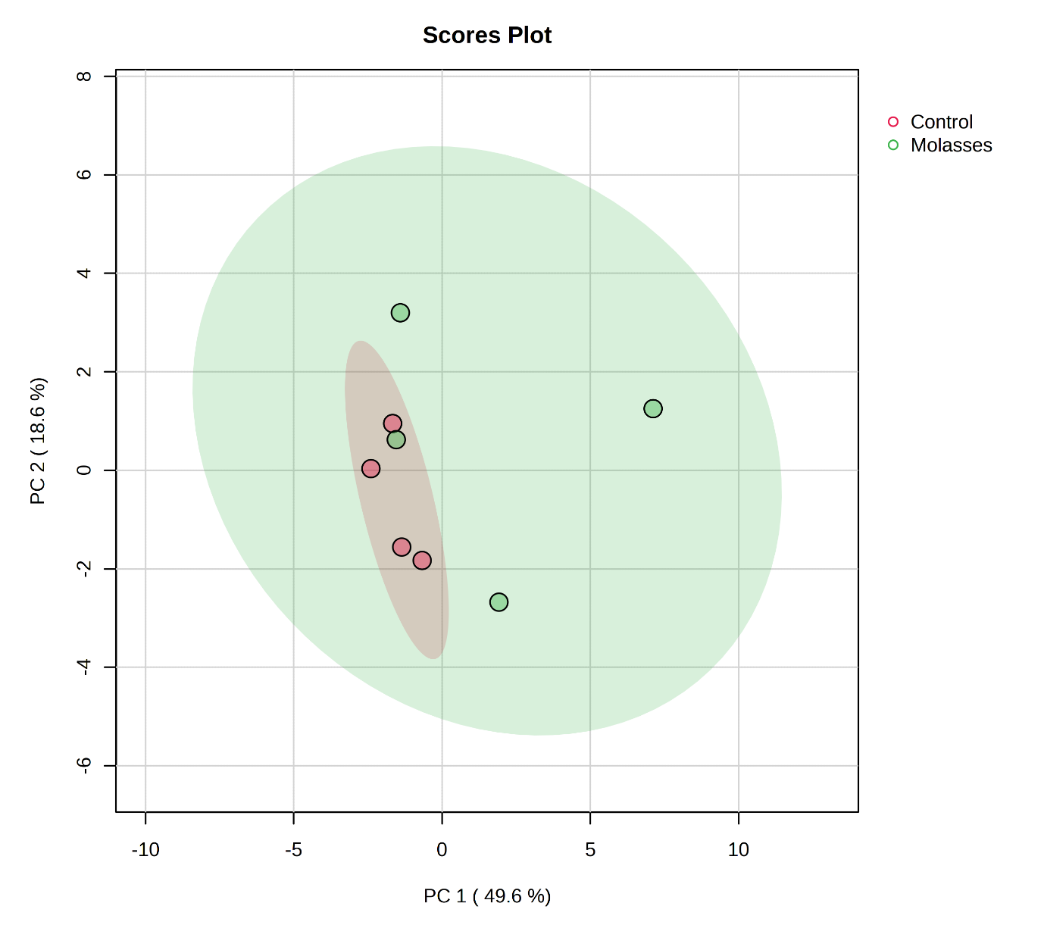
Figure S3. PCA of seed fatty acid profile.

Antioxidant

Table S21: Antioxidant measures
Measure | Control |  |  |  | Molasses |  |  |  | P-value
Measure | N | Mean | SD | SEM | N | Mean | SD | SEM | P-value
TPC (mg GAE/100g) | 12 | 185 | 67 | 19 | 12 | 170 | 52 | 15 | 0.531
DPPH (mg TE /g) | 6 | 1747 | 975 | 398 | 6 | 1340 | 130 | 53 | 0.334
ABTS (mg TE /g) | 5 | 17237 | 30362 | 13578 | 5 | 66147 | 6906 | 3089 | 0.008
Cell-based antioxidant | 12 | 0.79 | 0.14 | 0.04 | 11 | 0.75 | 0.11 | 0.03 | 0.367
Cell-based prooxidant | 12 | 1.24 | 0.23 | 0.07 | 11 | 1.24 | 0.25 | 0.07 | 0.943
Cytotoxicity | 12 | 100.5 | 7.1 | 2.1 | 11 | 94.6 | 3.8 | 1.1 | 0.019

References:
Brice Landry, K., Tariq, S., Malik, A., Sufyan, M., Ashfaq, U. A., Ijaz, B., & Shahid, A. A. (2022). Berberis lyceum and Fumaria indica: in vitro cytotoxicity, antioxidant activity, and in silico screening of their selected phytochemicals as novel hepatitis C virus nonstructural protein 5A inhibitors. Journal of Biomolecular Structure and Dynamics, 40(17), 7829-7851.
Cai, Y.-Z., Sun, M., Xing, J., Luo, Q., & Corke, H. (2006). Structure–radical scavenging activity relationships of phenolic compounds from traditional Chinese medicinal plants. Life sciences, 78(25), 2872-2888. https://www.sciencedirect.com/science/article/pii/S0024320505011860?via%3Dihub
Chen, T., He, J., Zhang, J., Li, X., Zhang, H., Hao, J., & Li, L. (2012). The isolation and identification of two compounds with predominant radical scavenging activity in hempseed (seed of Cannabis sativa L.). Food Chemistry, 134(2), 1030-1037.
Mélanie Bourjot, Andy Zedet, Belinda Demange, Marc Pudlo, & Girard-Thernier, C. (2016). In Vitro Mammalian Arginase Inhibitory and Antioxidant Effects of Amide Derivatives Isolated from the Hempseed Cakes (Cannabis sativa). Planta Med Int Open, 3, e64–e67.
Miller, N. J., & Rice-Evans, C. A. (1997). The relative contributions of ascorbic acid and phenolic antioxidants to the total antioxidant activity of orange and apple fruit juices and blackcurrant drink. Food Chemistry, 60(3), 331-337. https://doi.org/https://doi.org/10.1016/S0308-8146(96)00339-1
Plumb, G. W., Price, K. R., Modes, M. J., & Williamson, G. (1997). Antioxidant properties of the major polyphenolic compounds in broccoli. Free radical research, 27(4), 429-435. https://www.tandfonline.com/doi/abs/10.3109/10715769709065782
Raudonis, R., Raudone, L., Jakstas, V., & Janulis, V. (2012). Comparative evaluation of post-column free radical scavenging and ferric reducing antioxidant power assays for screening of antioxidants in strawberries. Journal of Chromatography A, 1233, 8-15. https://doi.org/10.1016/j.chroma.2012.02.019
Rice-Evans, C. A. (1995). Plant polyphenols: free radical scavengers or chain-breaking antioxidants? Biochemical Society Symposia,
Rice-Evans, C. A., Miller, N. J., Bolwell, P. G., Bramley, P. M., & Pridham, J. B. (1995). The Relative Antioxidant Activities of Plant-Derived Polyphenolic Flavonoids. Free radical research, 22(4), 375-383. https://doi.org/10.3109/10715769509145649
Thuong, P. T., Hung, T. M., Ngoc, T. M., Ha do, T., Min, B. S., Kwack, S. J., Kang, T. S., Choi, J. S., & Bae, K. (2010). Antioxidant activities of coumarins from Korean medicinal plants and their structure-activity relationships. Phytotherapy Research, 24(1), 101-106. https://doi.org/10.1002/ptr.2890
Yan, X., Tang, J., dos Santos Passos, C., Nurisso, A., Simões-Pires, C. A., Ji, M., Lou, H., & Fan, P. (2015). Characterization of lignanamides from hemp (Cannabis sativa L.) seed and their antioxidant and acetylcholinesterase inhibitory activities. Journal of agricultural and food chemistry, 63(49), 10611-10619.
Zhang, L., Tu, Z.-c., Yuan, T., Wang, H., Xie, X., & Fu, Z.-f. (2016). Antioxidants and α-glucosidase inhibitors from Ipomoea batatas leaves identified by bioassay-guided approach and structure-activity relationships. Food Chemistry, 208, 61-67.

