Affective polarization and wellbeing: Investigating potential intrapersonal harm from affective polarization

Abstract
Affective polarization—antipathy towards members of one’s political outgroup—may pose challenges to social cohesion and personal well-being. Prior studies have suggested that one’s affective polarization may cause intrapersonal harm as well as interpersonal harm. It has been associated with reduced social support, increased stress, and worse physical health. This pre-registered study investigated the intrapersonal harm of affective polarization using a six-wave longitudinal survey (N = 470). Affective polarization, social support, perceived stress, and self-rated health were measured fortnightly for three months preceding the 2024 U.S. presidential election. Random Intercept Cross-Lagged Panel Models were employed to investigate the within-person effects of affective polarization on these indicators of wellbeing. Contrary to hypotheses, none of the hypothesised cross-lagged effects were significant, suggesting that changes in affective polarization did not predict changes in social support, stress, or health. However, cross-sectional analyses did reflect past findings, showing that higher levels of affective polarization were associated with lower social support, greater stress, and worse health. We additionally found evidence for perceived stress causing moderate increases in affective polarization. Stable differences by political orientation were also observed in our sample, with liberals reporting higher affective polarization and stress, lower social support, and worse health. Despite the lack of significant effects, potentially due to limitations such as sample size and measurement constraints, our findings underscore the importance of further investigations with appropriate robust designs to clarify the relationship between affective polarization and well-being. These results challenge the assumption that affective polarization directly drives declines in well-being.
Keywords: affective polarization, stress, social support, health, political polarization,

A wealth of research has shown that, in recent decades, affective polarization—antipathy and aversion to one’s political outgroup—has been increasing between members of political-ideological groups in the United States, and in other countries around the world (Boxell et al., 2022; Finkel et al., 2020; Iyengar et al., 2012; Kekkonen & Ylä-Anttila, 2021; Orriols & León, 2020). People appear to increasingly dislike members of their ideological-political outgroups, being increasingly reluctant to associate or have family ties with them (Huber & Malhotra, 2017; Iyengar et al., 2012), appraising them more negatively (Carmines & Nassar, 2022), and expressing and displaying prejudice towards them (Gift & Gift, 2015; Iyengar & Westwood, 2015; Westwood et al., 2018).
Affective polarization has been shown to influence a range of phenomena and increase behaviours that are counterproductive in pluralistic societies that rely on a certain level of goodwill and cooperation between ideological groups. Experiments have shown that it politicises and undermines ideals of political belief formation (Druckman et al., 2013, 2021) and increases belief in in-group-congruent misinformation (Jenke, 2023). Longitudinal studies suggest that it negatively impacts support for democratic norms (Kingzette et al., 2021), and it likewise harms social trust (Lee, 2022; Torcal & Thomson, 2023). Additionally, expressed prejudice based on political orientation can exceed prejudices based on race, religion, and gender (Carmines & Nassar, 2022) and multiple studies using behavioural experiments such as selection tasks and trust games have verified this (Iyengar & Westwood, 2015; Lelkes & Westwood, 2017; Westwood et al., 2018). Other experiments have shown that this animosity also affects economic decisions and willingness to cooperate with others (Engelhardt & Utych, 2020; McConnell et al., 2018), and can drive discrimination in employee selection (Gift & Gift, 2015), dating preferences (Huber & Malhotra, 2017; Nicholson et al., 2016), and even roommate selection (Shafranek, 2021).
While these findings highlight how affective polarization damages the socio-political environment and promotes prejudice toward others, some research suggests it also harms the polarised individual—negatively affecting their interpersonal relationships, stress levels, and even physical health. The present study investigated this potential for intrapersonal harm using a longitudinal survey measuring the impact of affective polarisation on social support, stress, and health.
Affective Polarization, Social Support, Stress, and Health
Social support is the perception that one is a part of a social network of individuals who can provide love, care, support, and mutual assistance (Willis, 1991). It can come from relatives, romantic partners, co-workers, mentors, or other social-community ties (Taylor, 2012). Social support can help lower anxiety and depression and consistently reduces psychological distress during crises such as terror attacks or serious medical diagnoses. Social support powerfully predicts health and longevity outcomes, rivalling the influence of well-established risk factors such as smoking, blood pressure, obesity, and physical activity. For a review of this research, see Taylor (2012).
Affective polarization is usually studied through the lenses of social identity theory and intergroup threat theory (Tajfel & Turner, 1986; Stephan et al., 2009; Renstrom et al., 2021). Social identity theory suggests that strong ingroup identification inherently creates preferences for ingroup members and avoidance of outgroups, especially in the presence of so-called “aggravating conditions” like contentious election periods (Brown, 2000). This aversion to the outgroup drives selective association and a desire for homophily. Indeed, political affective polarization is characterised by an aversion toward—and a desire for social distance from political outgroup members (McMurtrie et al., 2024; Iyengar et al., 2012). Highly polarised individuals show particularly strong preferences for homophily in their social networks, friendships, romantic relationships, work relationships, and family ties (Arora et al., 2022; Huber & Malhotra, 2017; Iyengar et al., 2012; McPherson et al., 2001), which suggests that affective polarization may constrain one’s ability to form and maintain supportive social networks, and there is some evidence for this. For example, during times of heightened polarization people are less likely to travel to visit family for holidays, and if they do, are more likely to cut visits short (Chen & Rohla, 2018; Lee, 2021). For those who live in a politically dissimilar area, affective polarization and the desire for homophily may make it more difficult to find romantic partners (Huber & Malhotra, 2017; Iyengar et al., 2018; Nicholson et al., 2016), harder to find jobs (Gift & Gift, 2015), and is associated with lower social support (Chopik & Motyl, 2016; Panagopoulos et al., 2022). Polarization also undermines social trust, a vital component of social network formation (Lee, 2022). Political moderates find cues of strong partisanship off-putting, suggesting that polarized individuals likely drive politically disinterested others away (Klar et al., 2018), and people do indeed report losing meaningful relationships to politics (Smith et al., 2019).
Collectively, these findings suggest a theoretical mechanism whereby affective polarization undermine individuals’ ability to build and maintain robust social support networks and creates a self-reinforcing cycle of social network constriction—polarized individuals may both actively avoid outgroup members and inadvertently repel potential network partners, undermining their access to diverse sources of social support. However, empirically, it is still unclear whether this is truly the case and whether it translates into in lower social support among polarized partisans. Many of the studies reviewed above either do not measure affective polarization, instead merely tracking behaviours during times of heightened polarization such as during elections (Chen & Rohla, 2018; Lee, 2021), or they investigated whether affective polarization and partisanship drives people to discriminate against others (Huber & Malhotra, 2017; Nicholson et al., 2016; Shafranek, 2021) with no indication of whether this translates into a loss of social support for those who are affectively polarized.
Affective polarization may also exert a direct negative effect on partisans’ mental wellbeing. Social identity theory posits that when individuals identify strongly with a group—especially when that group forms a core part of their self-concept—they become more sensitive to the presence and actions of outgroups. In competitive or ideologically charged contexts, this often leads to automatic dislike of outgroup members and the perception of outgroups as symbolically or literally threatening (Stephan et al., 2009). Such environments are hypothesized to be psychologically stressful, activating chronic vigilance for threat, anxiety about group status, and general emotional strain (Major & Schmader, 2017; Stephan et al., 2009). Consistent with this view, individuals highly engaged in politics or socio-political discourse often report impaired wellbeing, including elevated stress, sleep disruption, and even suicidal thoughts (Smith, 2022). Affective polarization has also been linked to poorer mental health outcomes such as depression and anxiety (Fraser et al., 2022; Nayak et al., 2021; Panagopoulos et al., 2022), and stronger outgroup antipathy predicts worse mental health (Smith et al., 2019). Moreover, affective polarization and outgroup hostility are frequently accompanied by anxiety and anger—emotions that contribute to stress (Fraser et al., 2022; Hackett et al., 2018). Finally, longitudinal evidence shows that stress and anxiety increased during the 2016 U.S. election period (Hagan et al., 2020; Roche & Jacobson, 2019).
Thus, intergroup threat theory and the studies reviewed above, support the idea that affective polarization increases stress. However, as with social support, the extant evidence comes from either cross-sectional studies, or from longitudinal studies which do not directly measure affective polarization but simply track indicators of stress during an election period. It may be that the stress induced during an election period is due to other factors, such as anxiety produced by a potential status loss in an election defeat or is due to the ambient tension accompanying the election period. The current research does not allow an inference to be made as to whether being affectively polarized definitively increases one’s stress.
Theoretical models of political stress propose that affective polarization also exerts a negative effect on health. The effect is proposed to occur both indirectly, by changing citizens’ health behaviours and receptivity to public health messaging from ingroup and outgroup authorities, and directly, by acting as a socio-political stressor which exerts the well-known detrimental effect of stress on health (Braveman et al., 2011; Nelson, 2022; Slavich, 2016). Affective polarization has its basis in cognitions of social identity threat and negative emotional reactions to outgroup members, which—like other negative emotional states—has been theorised to be produce physiological stress responses, including heightened cardiovascular reactivity, elevated cortisol levels, and increased allostatic load (Major & Schmader, 2017; Slavich, 2017).
The evidence supporting the relationship between affective polarization and health varies in quality and in whether it focuses on the direct or indirect effect of affective polarization on health. For example, a study by Van Bavel et al. (2024) empirically showed that polarization affected belief formation, receptivity to public health messaging, and health behaviours during the covid-19 pandemic which had an effect on health outcomes. They also claimed that “Polarization can also directly affect an individual’s health by increasing stress and feelings of isolation” (p. 3087). Supporting this idea, Nelson (2022) found that participants’ level of affective polarization was significantly negatively associated with a measure of self-reported health that has been shown to be a valid indicator of actual health status, and thus they asserted that affective polarization is “like drinking poison” (p. 1). However, they used cross-sectional designs which are not suitable for establishing causality. Likewise, Fraser et al. (2022) found that those who feel more politically distant from the average voter in their state reported more days of both poor mental and physical health—again a cross-sectional finding. In the same vein, Mefford et al. (2020) showed an increase in acute cardiovascular disease hospitalizations after the 2016 US presidential election, and Rosman et al. (2021) found that patients in North Carolina who were wearing cardiac monitoring devices during the election period were more likely to experience arrhythmias than at other times. However, in these studies individuals’ affective polarization was not measured, the markers of health were simply tracked during a time of purported heightened polarization.
Thus, these studies provide only indirect theoretical support for the effect of affective polarization on health. It is not possible, based on these studies, to ascertain whether affective polarization exerts an intrapersonal negative effect on health. It is unclear in studies such as these whether it is other politics-related stress (such as a potential election loss), the polarization of those in one’s social environment, or one’s own level of affective polarization which is related to the decline in health outcomes.
The Present Study
While the findings from prior research support a theoretical argument for how affective polarization could exert a negative impact on social, mental, and physical wellbeing, such effects have not been investigated using analyses that are suitable for investigating causality. Thus, the claim that affective polarization exerts an inward harm and that “resentment is like drinking poison” (Nelson, 2022, p. 508) has not yet been supported. We perform the first investigation of the intrapersonal harms of affective polarization using designs and analyses suitable for investigating causal effects.
The present six-wave longitudinal study, which ran for three months preceding the 2024 US presidential election, investigated the effect of affective polarization on social support, stress, and health, using single-indicator random intercept cross lagged panel models (RI-CLPM’s: Mulder & Hamaker, 2021). The RI-CLPM is well-suited for investigating causality because it establishes temporal precedence in estimating effects, which cannot be inferred from standard cross-sectional designs.
As in standard cross lagged panel models, the RI-CLPM models the autoregressive effects over time, and thus controls for the carry-over effects of variables with themselves. The inclusion of the random intercepts allows the RI-CLPM to partial out stable between-person differences and model the within-person relationships between variables more accurately, whereas the traditional cross lagged panel model confuses interindividual associations for intraindividual processes (Hamaker et al., 2015). The results of between-person analyses often do not reflect the actual relationships between variables within individuals when there are both stable trait and state level components to the variance (Hamaker, 2023). Because of this, we can assume that the cross-lagged coefficients from an RI-CLPM more accurately reflect causal relationships (Lucas, 2023), though we still cannot make strong causal claims—rather, relying on a weaker claim akin to Granger causality (Bressler & Seth, 2011; Hamaker et al., 2015). The RI-CLPM is one method of analysis which can better address questions of causality from non-experimental data.
We hypothesised that affective polarization would have a significant (p < .05) negative cross-lagged effect on social support (H1), a significant positive cross-lagged effect on perceived stress (H2), and a significant negative cross-lagged effect on health (H3).
Methods
The present study received low-risk ethics approval by the first author’s institution (application ID: 4000027301), and the research was conducted in accordance with the principles outlined in the Declaration of Helsinki (WMA, 2024). The analyses and measures reported here were part of a larger research project, which included a fourth research hypothesis (H4) as seen in the pre-registration. Due to constraints of publication word limits and the fact that the fourth hypothesis does not directly relate to the first 3 hypotheses of this paper and its focus on wellbeing, the analysis of the fourth hypothesis is to be reported in a separate research paper.
Sample Size Determination
The primary criterion for determining sample size was the financial constraint of the project. We aimed for a sample of 500 participants at each wave. We did however perform an a priori power analysis. We used the R package powRICLPM (Mulder, 2023; See accompanying website-app: https://jeroendmulder.github.io/powRICLPM/index.html) to perform a power analysis for a single indicator RI-CLPM over 6 survey waves. The power analysis shows that with a sample size of around 500 participants, we would have a statistical power of 70% to detect standardised cross-lagged effects of 0.15, and over 80% to detect cross lagged effects of 0.2. Given our financial constraints, we found this to be an acceptable level of power for this initial study.
A fuller description of the sample size determination process, as well as the R code for the power analysis can be seen in the pre-registration: https://osf.io/83sgc/?view_only=eaa9fbc0af614f8cb63a2b6036dfa88b
Participants and Procedure
Participants were recruited from Prolific and were required to have listed US in their nationality and to have self-described as either Liberal or Conservative on their profile. We used quota sampling to recruit an equal number of each to ensure the sample was more politically representative of the general American population. We conducted our study over a three-month pre-election period from August to October 2024. This period provided us with an opportunity to collect data at a time when the relevant constructs were likely in a state of flux, as variation in the constructs over time is a requirement for modelling change and causal effects. It also allowed us to investigate trends in these constructs seen in past election periods.
At the first wave, T1, we recruited an initial sample of 552 participants. Exclusions were applied either at the study-level such that no data from excluded participants was used, or at the wave-level such that only data from a particular wave was excluded. Our exclusion rules can be seen in the pre-registration (https://osf.io/83sgc/?view_only=eaa9fbc0af614f8cb63a2b6036dfa88b), and a detailed account of all exclusions can be seen in the Data Preparation file found in the OSF repository for this project (https://osf.io/d8sbw/?view_only=e3aa8c392ee44680ba494479ee39ea96). After applying the exclusion criteria at the wave and study level we had a final sample of 470 participants (M_{age} = 44.4, SD_{age} = 14.1, 56% female, 43% Male, 1 % Non-binary, and an even 50% liberal/conservative).
At the beginning of each survey, participants were asked to place themselves on a political orientation scale (liberal, slightly liberal, slightly conservative, conservative). An embedded tag was created in the survey, such that those who indicated they were liberal received a tag of “Target = Conservative”, and “Group = Liberal”, and vice versa. These were then inserted into the relevant items in the affective polarization scale, allowing the items to be tailored such that each participant was seeing the appropriate ingroup and outgroup labels in the items.
Measures
The following measures were presented in random order in each survey, and the items within these measures were also presented in random order. Scores for affective polarization, perceived stress, and social support were calculated as average scores on each scale. We reported Omega total (ꞷ_{t}) reliability ranges over the course of the study. Omega total is analogous to Cronbach’s alpha but loosens the assumptions necessary for the accurate assessment of reliability using Cronbach’s alpha and has been shown to outperform it when these assumptions are violated (Dunn et al., 2014; Flora, 2020; McNeish, 2018).
This study was part of a larger survey project, so a small number of other measures were also administered in the survey but are not described here, though the project as a whole is described in the pre-registration.
Affective Polarization
Affective polarization was measured using the affective polarization scale (APS; McMurtrie et al., 2024). This scale (ꞷ_{t} = 0.96–0.98 across waves) was composed of 15 items measuring Social Distance (I try to avoid socialising with [outgroup]), Aversion ([outgroup] are immoral), and Incivility (I like to make [outgroup] angry). Responses were collected on a 7-point Likert scale (strongly disagree to strongly agree, with a neutral midpoint, neither agree nor disagree).
Social Support
Social support was measured using the 24-item Social Provisions Scale (SPS; Jones & Perlman, 1987). The scale (ꞷ_{t} = 0.96–0.97) contained items measuring social support in the form of practical help, informational support, emotional support, social integration, esteem support, and providing support. Items such as “There are people I can depend on to help me if I really need it” and “If something went wrong, no one would come to my assistance”, are measured on a 4-point scale (strongly disagree, disagree, agree, strongly agree). Items 2, 3, 6, 9, 10, 14, 15, 18, 19, 21, 22, and 24 were reverse coded.
Stress
Perceived stress was measured using the Perceived Stress Scale-10 (PSS-10; Cohen & Williamson, 1988). This scale (ꞷ_{t} = 0.92–0.95) contains 10 items, with responses on a 5-point scale (Never to Often). It is a commonly used measure of perceived stress (Lee, 2012). It contains items such as “In the last two weeks, how often have you been upset because of something that happened unexpectedly?” And “In the last two weeks, how often have you felt that you were unable to control the important things in your life?”. Items 4, 5, 7, 8 were reverse coded.
Health
Health status was measured using a single item: “Would you say that in general your health is currently poor, fair, good, very good, or excellent?”. This item has been used widely in many different countries and languages and has been shown to be a valid indicator of general health and a good predictor of mortality (Jylhä, 2009; Sturgis et al., 2001). This measure is ideal for the purposes of our study, as we have no hypotheses concerning what aspect of health is affected by affective polarization and are not attempting to predict or measure specific health disorders. The short, single item of general self-rated health is comprehensive and non-specific, capturing a general sense of one’s current health status.
Statistical Analyses
We used single-indicator RICLPMs to investigate our hypotheses. As outlined in our pre-registration, we planned to run multiple-indicator models, if possible, but were to switch to single indicator models if the multiple-indicator models encountered errors and failures, which they did. All multiple-indicator models encountered errors such as perpetual rendering, failure to converge on a solution, and/or matrices which were not positive definite. Thus, we ran single-indicator models using the average scores at each time point, as laid out in our pre-registration. These RICLPMs followed the protocol of Mulder & Hamaker (2021), in which random intercepts were created as a latent variable of the repeated measures with factor loadings fixed to 1, and within person components at each time point were the individuals’ score at that time point. The structural relations between these constructs were then laid out according to the standard RI-CLPM method as described by Mulder and Hamaker (2021). The model is visualised in figure 1.
Figure 1
The RI-CLPM model-structure used in the present study, depicting the cross-lagged relationship between constructs Stress and Affective polarization over 6 waves. S_{i1} represents the participants’ stress score at time T1, and so on to S_{i5} at time T5. BS_{i} represents the participants’ random intercept, which captures their time-invariant deviation from the grand means, or the stable trait-like component. The within components (W) at each time represent the differences between participants' observed score and their expected score based on their random intercept and the grand means.
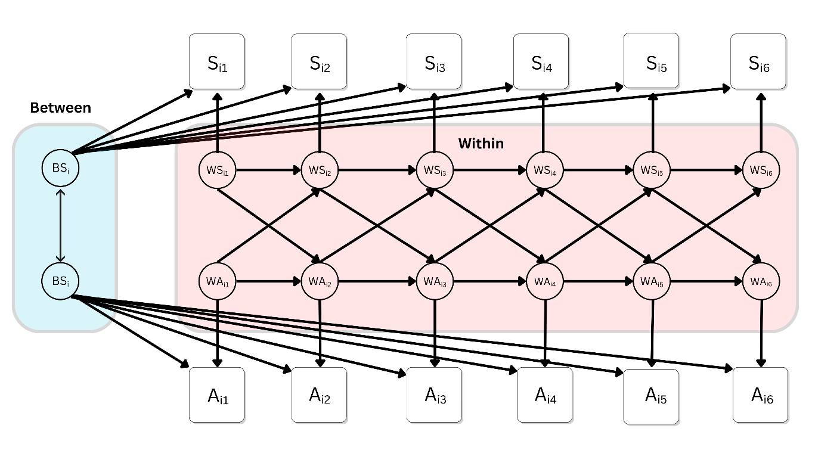
For all models, we constrained the autoregressive and cross-lagged coefficients to be constant over time. These assumptions were applied to the model for ease of interpretability, and are not themselves subject to testing, though our pre-registered model-fit criteria would indicate whether the model constraints and identification can be deemed appropriate. The full results of all unconstrained models can be seen in the results output in the OSF. Analyses were performed in R, version 4.3.2 (R Core team, 2023). We used robust full information maximum likelihood (MLR) estimation in the R package lavaan.
Results
The full data cleaning, exclusions, and merging process from our 6 surveys can be seen in the Data Preparation file in our OSF. The final data set used in this study, as well as full analysis code and output can also be found there: https://osf.io/d8sbw/?view_only=e3aa8c392ee44680ba494479ee39ea96.
Descriptive statistics, including means, standard deviations, and intraclass coefficients (ICCs) for all variables in the study can be seen in table 1. There is no clear overall trend in our constructs over the course of our study in the lead up to the presidential election, and sample statistics for our constructs are surprisingly stable over time. Average affective polarization was below the neutral midpoint, 4, in our sample across all waves. Average perceived stress, which asks participants to report frequency of experienced symptoms, was between a response of 2 “almost never” and 3 “sometimes”. The social support scale had no neutral midpoint, and average responses were consistently between “agree” and “strongly agree”. The average health response in our sample was slightly above 3 which indicates a response of “good” health.
Table 1
Descriptive statistics for all measures in the present study across the 6 survey waves (T1-T6)
 | T1  M (SD) | T2  M (SD) | T3  M (SD) | T4  M (SD) | T5  M (SD) | T6  M (SD) | ICC
Affective Polarization | 3.5 (1.4) | 3.4 (1.5) | 3.6 (1.5) | 3.5 (1.5) | 3.5 (1.5) | 3.6 (1.5) | 0.86
Social Support | 3.2 (0.5) | 3.3 (0.5) | 3.3 (0.6) | 3.3 (0.6) | 3.3 (0.5) | 3.3 (0.6) | 0.84
Perceived Stress | 2.5 (0.8) | 2.4 (0.8) | 2.4 (0.8) | 2.4 (0.9) | 2.4 (0.9) | 2.4 (0.9) | 0.78
Health | 3.3 (0.9) | 3.3 (0.9) | 3.3 (0.9) | 3.2 (0.9) | 3.2 (0.9) | 3.2 (0.9) | 0.88

Likewise, when observing trends by political orientation during our study, there is no discernible effect of the encroaching election (Figure 2). However, there are stable average differences between liberals and conservatives. In our sample, Liberals were consistently higher in affective polarization (d = 0.17–0.27; Panel A) and perceived stress (d = 0.13–0.28; Panel C), were lower in social support (d = 0.18–0.31; Panel B) and had worse self-rated health (d = 0.27–0.36; Panel D).
Figure 2
Trends in affective polarization, social support, perceived stress, and self-rated health among liberals (n = 237) and conservatives (n = 233), measured bi-weekly over the course of three months preceding the 2024 US presidential election. Scales do not begin at zero to allow for error bar visibility. Affective polarization values can range from 1-7, social support from 1-4, and perceived stress and health from 1-5. Error bars indicate 95% CI’s
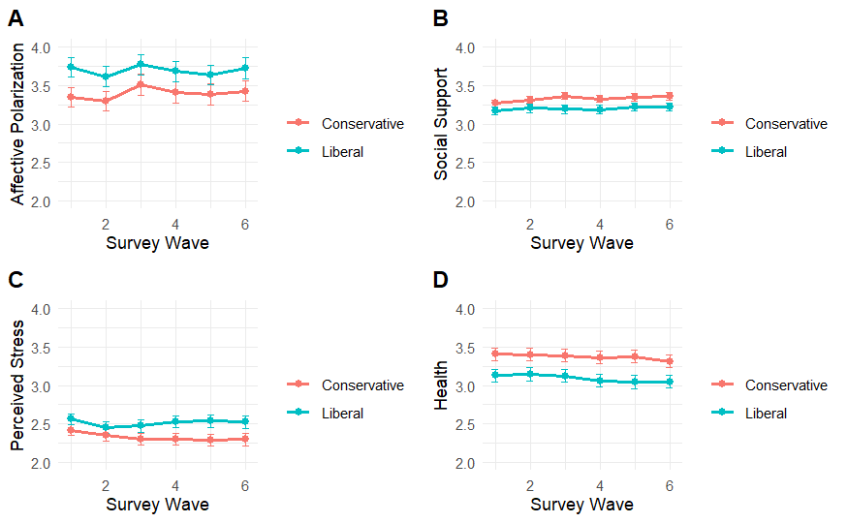
Pre-registered Analyses
All three of our single indicator RI-CLPMs with constrained autoregressive and cross lagged effects showed good fit according to our pre-registered criteria (Table 2). Likewise, the chi-square difference tests for these models and their unconstrained versions were non-significant, indicating that imposing the constraints did not result in a significantly worse fit (Table 2).

Table 2
Fit statistics for the RI-CLPM models assessing hypotheses H1-H3
Fit statistic (pre-registered fit criteria) | H1 | H2 | H3
RMSEA (< .06) | 0.05 | 0.04 | 0.05
SRMR (< .08) | 0.04 | 0.04 | 0.03
CFI (> .95) | 0.99 | 0.99 | 0.99
TLI (> .90) | 0.99 | 0.99 | 0.99
X² | 93.67, p = .01 | 95.32, p = .008 | 87.43, p = .03
∆X² (28) | 35.02, p = .17 | 34.66, p = .18 | 32.86, p = .24
Note: ∆X² (28) indicates the results of a chi-square difference test with 28 degrees of freedom, between the constrained and an unconstrained models.
H1: Affective Polarization and Social Support
Our first hypothesis, H1, was not supported (Figure 3). There was no significant cross-lagged effect of affective polarization of social support (β = 0.01, p = .34, 95% CI [-0.02, 0.04]). Nor was there evidence of a significant effect of social support on affective polarization (β = 0.01, p = .96, 95% CI [-0.24, 0.26]). There was a significant autoregressive effect for social support over time (β = 0.18, p = .001, 95% CI [0.07, 0.28]), but this was not the case for affective polarization (β = 0.07, p = .28, 95% CI [-0.06, 0.20]). However, a significant negative correlation between the random intercepts (r = -.13, p < .001, 95% CI [-0.20, -0.06]) was found, which is akin to a cross sectional correlation. This suggests that, at least in the course of our study, there was no evidence of affective polarization negatively impacting social support. However, those who tend to report higher levels of affective polarization do tend to also report lower levels of social support.

Figure 3
A simplified diagram of the RI-CLPM assessing relationships between affective polarization (AP) and social support (SPS), showing the within person dynamics over time, and the stable between person correlation
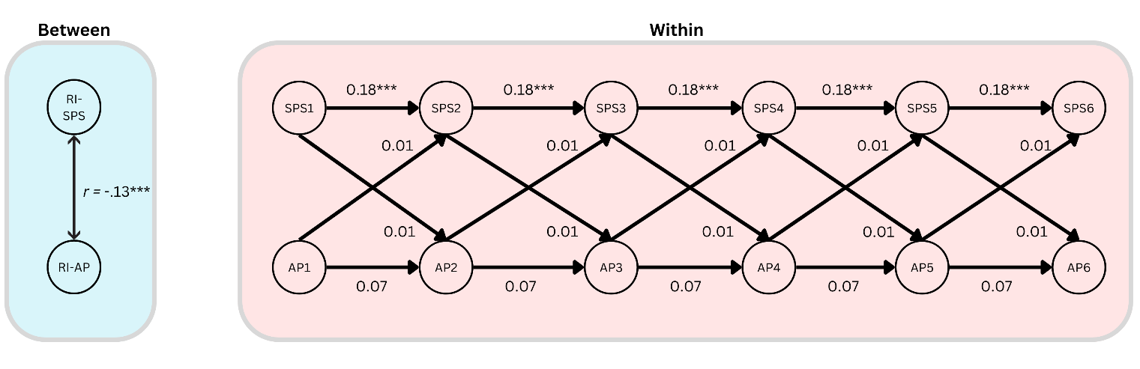
Note: *** = p < .001
H2: Affective Polarization and Perceived Stress
Our second hypothesis, H2, was also not supported (Figure 4). There was no significant positive cross lagged effect of affective polarization on perceived stress (β = 0.01, p = .74, 95%CI [-0.05, 0.07]). There was, however, a small and just significant positive cross-lagged effect of perceived stress on affective polarization (β = 0.11, p = .04, 95%CI [0.05, 0.21]), perhaps indicating a medium-sized (β_{standardised} = 0.08) causal effect runs in the opposite direction. There was a significant autoregressive effect of perceived stress over time (β = 0.25, p < .001, 95% CI [0.13, 0.36]), but this was not so for affective polarization (β = 0.07, p = .36, 95% CI [-0.07, 0.20]). There was also a significant between-person correlation of the random intercepts (r = .23, p = < .001, 95% CI [0.13, 0.33]). The results therefore indicate that those who report higher levels of affective polarization also tend to report higher levels of perceived stress, and that increases in perceived stress are associated with moderate increases in affective polarization over time.

Figure 4
A simplified diagram of the RI-CLPM assessing relationships between affective polarization (AP) and perceived stress (PSS), showing the within person dynamics over time, and the stable between person correlation
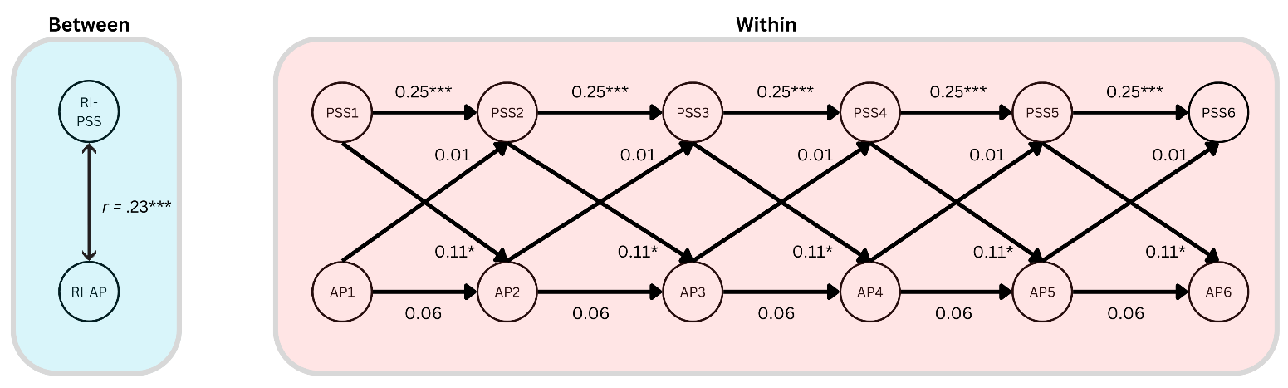
Note: *** = p < .001, * = p < .05
H3: Affective Polarization and Health
Our third hypothesis, H3, was also not supported (figure 5). There was no significant cross lagged effect of affective polarization on health (β = 0.02, p = .32, 95% CI [-0.02, 0.06]). There was also no significant cross lagged effect of health on affective polarization (β = 0.01, p = .85, 95% CI [-0.11, 0.13]). There was a just significant autoregressive effect of health over time (β = 0.12, p = 0.04, 95% CI [0.01, 0.23]), this was not so for affective polarization (β = 0.07, p = .27, 95% CI [-0.06, 0.20]). There was also a significant negative between-person correlation of the random intercepts (r = -.18, p = .002, 95% CI [-0.29, -0.07]). This indicates that those who tend to report higher affective polarization also tend to report worse health.

Figure 5
A simplified diagram of the RI-CLPM assessing relationships between affective polarization (AP) and self-reported health (H), showing the within person dynamics over time, and the stable between person correlation
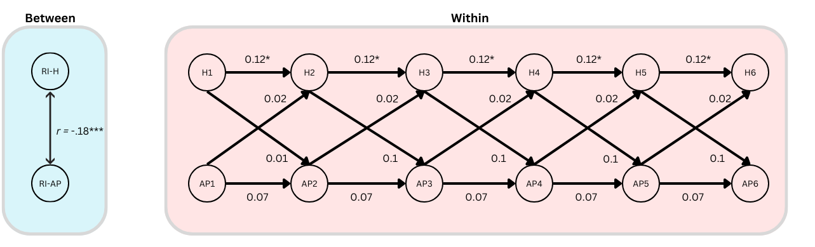
Note: *** = p < .001, * = p < .05

Discussion
The goal of this study was to investigate potential intrapersonal harms of affective polarization. Specifically, we investigated whether affective polarization negatively impacts one’s social relationships and social support (Chen & Rohla, 2018; Lee, 2021; Smith et al., 2019), whether affective polarization causes psychological stress (Fraser, et al., 2022; Smith, 2022; Smith et al., 2019), and whether experiencing affective polarization is “like drinking poison” (Nelson, 2022, p. 01). Our study measured relevant constructs fortnightly over a contentious three-month pre-election period, leading up to the 2024 US presidential election, at a time reasonably expected to be characterised by heightened emotions relating to politics.
Contrary to our hypotheses, none of our analyses found evidence suggesting that affective polarization is causally related to the social, mental, and physical harms often ascribed to it. Fluctuations in affective polarization did not predict changes in social support, stress, or self-rated health over time. However, the cross-sectional correlations between our constructs showed the expected relationships based on past observational studies. Higher affective polarization was significantly negatively associated with social support and self-rated health, and significantly positively associated with perceived stress. Therefore, people who, on average, report higher affective polarization tend to also report higher stress, lower social support, and worse health. These associations were small to moderate according to the updated effect size guidelines for the social sciences (Gignac & Szodorai, 2016). We did, however, find tentative evidence that perceived stress is causally related to increased affective polarization.
Not only did we not find sufficient evidence to suggest that one’s own level of affective polarization causes one harm, we also did not see any evidence in trends which would suggest that the election and its attendant ambient polarization had an effect on the constructs of interest. Based on the literature reviewed in this study, one would expect to see a clear increase in affective polarization and stress leading up to the election, and a decrease in social support and health. None of these changes were observed, although there was a stable difference in these constructs by political orientation.
There are multiple potential explanations for our results. When one’s hypotheses are falsified, it is ambiguous whether it is the main “target” hypothesis which has been falsified, or any one of the many auxiliary assumptions (Stanford, 2023). It may simply be that affective polarization does not exert the harmful effects suggested by prior observational research, and that our research correctly identified this fact.
Alternatively, it may be that the effects we aimed to quantify exert themselves on a different timescale and that the length of our time lags were incorrect, causing the effects to be lost in noise. However, according to Dormann & Griffin (2015) longitudinal studies in the social sciences typically use time lags that are far too long, and that “shortitudinal” studies with shorter time lags such as ours are more appropriate. The question of whether our time lags were optimal or not remains open.
Implications
The present study may have provided evidence that affective polarization is being overly pathologized by researchers spuriously extrapolating to causal conclusions based on cross-sectional associations. These findings represent a significant contribution to the literature on affective polarization and its putative consequences. While the cross-sectional associations between affective polarization and wellbeing, highlighted in past research, were replicated here, the RI-CLPM showed that these may be caused by other confounding variables, as changes in affective polarization did not reflect changes in our wellbeing indicators. This may indicate that the intrapersonal harms associated with affective polarization are exaggerated and adds to a growing literature which questions other harms frequently ascribed to affective polarization (Brookman et al., 2022).
Affective polarization’s effects are increasingly ambiguous in many areas and there may even be benefits to affective polarization. From a social identity and intergroup threat theory perspective, affective polarization may reflect a strengthened ingroup identification, which may have benefits in that it can enhance self-esteem, provide existential and epistemic security, and foster solidarity among group members (Stephan et al., 2009). Thus, while affective polarization may be somewhat socially alienating and stressful in some ways, which may impact health, it may also fulfil other important psychological needs by offering stability, identity, and meaning in opposition to perceived outgroup threats. Indeed, some studies have asserted that affective polarization may have other positive outcomes, such as driving political and civic engagement (Iyengar & Krupenkin, 2018) which others have claimed may even improve wellbeing (Nelson, 2022; Wray-Lake et al., 2019). Additionally, some political theorists assert that a certain level of affective polarization, as part of political agonism, may be good for democracy and should not necessarily be discouraged (Mouffe, 2000). Thus, uncritically pathologizing affective polarization may have unexpected negative consequences, and affective polarization may be a more complex phenomena than previously thought.
Despite our inability to test the potentially heterogeneous causal relationships among liberals and conservatives, we did replicate here the finding that liberals tend to report being slightly more affectively polarized than conservatives. This may have been due to an anticipated electoral victory for conservatives, though similar findings, largely driven by an asymmetry in desire for social distance among liberals, have also been seen at other times and during other election periods (Casey et al., 2023; Cox, 2021; McMurtrie, 2024; Mitchel et al., 2014; Ridge, et al., 2025). However, the differences seen in our results were small, and questions around the presence of asymmetries in political prejudice, polarization, and related constructs such as authoritarianism remain open and contested (Brandt & Crawford, 2020; Ditto et al., 2019; Gidron et al., 2023).
Limitations
A significant limitation to the present study was the potential lack of statistical power to estimate effects. Our power analysis found that a sample of 500 participants would give 70% power to detect cross-lagged effects of 0.15, or over 80% to detect effect sizes of 0.2. In the context of RI-CLPMs these are considered relatively large effect sizes (Orth et al., 2022). Because of exclusions and dropouts, we ended up with a final sample of 470 participants. As per our pre-registration we had hoped to increase that statistical power for H1 and H2 through the use of multiple indicators which facilitates the estimation of measurement error (Mulder, 2023), however the complexity of the models made them unfeasible. Additionally, beyond the issue of power, our inability to use multiple indicators to model measurement error could have introduced uncertainty into our estimates of causal effects. Therefore, it is possible that the true effects went undetected in our models.
The generalizability of our findings is also limited by the specific research context, both in regard to research timing and cultural context. While the US presents a compelling case for studying affective polarization due to its strong two-party system, its high level of ideological and social sorting, and its extensive partisan media ecosystems, this does mean that our findings may not generalize to other cultures or other political contexts, such as multiparty political systems (Knudsen, 2021; Wagner, 2021). Likewise, while we ran our study in the pre-election period due the well-established fact that election periods are associated with greater affective polarization (Hernandez et al., 2021), the proximity of the data collection period to the election may have meant that changes in affective polarization stabilized at the maximum among those participants who are prone to polarization. This may be why our constructs showed a surprising stability over time, and our analysis method designed to track associated changes in the constructs found no significant results.
Future Directions
Future studies should aim to replicate the present investigation with a much larger sample size, and/or by increasing the number of survey periods in the study which increases power by reducing measurement error in the random intercepts, and thus allows for greater sensitivity in estimating within person effects (Orth et al., 2022).
Future studies could also perform a multiple groups analysis in left- and right-wing participants separately. An a priori data simulation and comprehensive model testing should also be performed to ensure multiple indicator RI-CLPMs could be run. This would allow researchers to model measurement error and test measurement invariance, which may improve measurement validity and increase statistical power.
Lastly, in the present study, we opted to use complex non-experimental longitudinal analyses which are capable of tentatively making causal claims. This was because, in our view, the pre-election period presented a data collection context in which affective polarization was predicted to be in a state of flux. However, our constructs were relatively stable over the course of our study, so future studies could investigate these findings further by extending the data collection period to continue after an election in order to potentially capture greater variation. This would result in a design closer to an interrupted time series design, which may better allow researchers to quantify the effect of changes in affective polarization on the outcome variables, as affective polarization has shown to peak immediately after an election before declining quickly (Hernandez et al., 2021). Likewise, experimental designs could be used to investigate these effects with a higher degree of internal validity. However, in the context of affective polarization research these usually rely on vignette experiments (Huddy & Yair, 2021) or manipulations using trust games (Brookman et al., 2022), both of which are subject to some controversy and questions of validity (Collett & Childs, 2011; Hughes & Huby, 2004; Koppel et al., 2022).

References
Arora, S. D., Singh, G. P., Chakraborty, A., & Maity, M. (2022). Polarization and social media: A systematic review and research agenda. Technological Forecasting and Social Change, 183, 121942. https://doi.org/10.1016/j.techfore.2022.121942
Boxell, L., Gentzkow, M., & Shapiro, J. M. (2022). Cross-country trends in affective polarization. The Review of Economics and Statistics, 1–60. https://doi.org/10.1162/rest_a_01160
Brandt, M. J., & Crawford, J. T. (2020). Worldview conflict and prejudice. In B. Gawronski (Ed.), Advances in Experimental Social Psychology (Vol. 61, pp. 1–66). Elsevier. https://doi.org/10.1016/bs.aesp.2019.09.002
Braveman, P., Egerter, S., & Williams, D. R. (2011). The social determinants of health: Coming of age. Annual Review of Public Health, 32(1), 381–398. https://doi.org/10.1146/annurev-publhealth-031210-101218
Bressler, S. L., & Seth, A. K. (2011). Wiener–Granger Causality: A well established methodology. NeuroImage, 58(2), 323–329. https://doi.org/10.1016/j.neuroimage.2010.02.059
Broockman, D. E., Kalla, J. L., & Westwood, S. J. (2022). Does Affective Polarization Undermine Democratic Norms or Accountability? Maybe Not. American Journal of Political Science, ajps.12719. https://doi.org/10.1111/ajps.12719
Brown, R. (2000). Social identity theory: Past achievements, current problems and future challenges. European Journal of Social Psychology, 30(6), 745–778. https://doi.org/10.1002/1099-0992(200011/12)30:6<745::AID-EJSP24>3.0.CO;2-O
Campos, N., & Federico, C. (2024). A New Measure of Affective Polarization. OSF Preprints. https://doi.org/10.31219/osf.io/xg3b7
Carmines, E., & Nassar, R. (2022). Comparing stereotypes across racial and partisan lines: A study in affective polarisation. Journal of Elections, Public Opinion and Parties, 32(3), 727–738. https://doi.org/10.1080/17457289.2021.1942015
Casey, J. P., Vanman, E. J., & Barlow, F. K. (2023). Empathic Conservatives and Moralizing Liberals: Political Intergroup Empathy Varies by Political Ideology and Is Explained by Moral Judgment. Personality and Social Psychology Bulletin, 01461672231198001. https://doi.org/10.1177/01461672231198001
Chen, M. K., & Rohla, R. (2018). The effect of partisanship and political advertising on close family ties. Science, 360(6392), 1020–1024. https://doi.org/10.1126/science.aaq1433
Chopik, W. J., & Motyl, M. (2016). Ideological fit enhances interpersonal orientations. Social Psychological and Personality Science, 7(8), 759–768. https://doi.org/10.1177/1948550616658096
Cohen, S., & Williamson, G. (1988). Perceived stress in a probability sample of the United States. In S. Spacapan & S. Oskamp (Eds.), The social psychology of health (pp. 31–67). Sage Publications.
Collett, J. L., & Childs, E. (2011). Minding the gap: Meaning, affect, and the potential shortcomings of vignettes. Social Science Research, 40(2), 513–522. https://doi.org/10.1016/j.ssresearch.2010.08.008
Cox, D. A. (2021). The state of American friendship: Change, challenges, and loss. Survey Center on American Life. https://www.americansurveycenter.org/research/the-state-of-american-friendship-change-challenges-and-loss/
Ditto, P. H., Liu, B. S., Clark, C. J., Wojcik, S. P., Chen, E. E., Grady, R. H., Celniker, J. B., & Zinger, J. F. (2019). At Least Bias Is Bipartisan: A Meta-Analytic Comparison of Partisan Bias in Liberals and Conservatives. Perspectives on Psychological Science, 14(2), 273–291. https://doi.org/10.1177/1745691617746796
Dormann, C., & Griffin, M. A. (2015). Optimal time lags in panel studies. Psychological Methods, 20(4), 489–505. https://doi.org/10.1037/met0000041
Druckman, J. N., Klar, S., Krupnikov, Y., Levendusky, M., & Ryan, J. B. (2021). How affective polarization shapes Americans’ political beliefs: A study of response to the covid-19 pandemic. Journal of Experimental Political Science, 8(3), 223–234. https://doi.org/10.1017/XPS.2020.28
Druckman, J. N., Peterson, E., & Slothuus, R. (2013). How elite partisan polarization affects public opinion formation. American Political Science Review, 107(1), 57–79. https://doi.org/10.1017/S0003055412000500
Dunn, T. J., Baguley, T., & Brunsden, V. (2014). From alpha to omega: A practical solution to the pervasive problem of internal consistency estimation. British Journal of Psychology, 105(3), 399–412. https://doi.org/10.1111/bjop.12046
Engelhardt, A. M., & Utych, S. M. (2020). Grand old (tailgate) party? Partisan discrimination in apolitical settings. Political Behavior, 42(3), 769–789. https://doi.org/10.1007/s11109-018-09519-4
Finkel, E. J., Bail, C. A., Cikara, M., Ditto, P. H., Iyengar, S., Klar, S., Mason, L., McGrath, M. C., Nyhan, B., Rand, D. G., Skitka, L. J., Tucker, J. A., Van Bavel, J. J., Wang, C. S., & Druckman, J. N. (2020). Political sectarianism in America. Science, 370(6516), 533–536. https://doi.org/10.1126/science.abe1715
Flora, D. B. (2020). Your coefficient alpha is probably wrong, but which coefficient omega is right? A tutorial on using r to obtain better reliability estimates. Advances in Methods and Practices in Psychological Science, 3(4), 484–501. https://doi.org/10.1177/2515245920951747
Fraser, T., Aldrich, D. P., Panagopoulos, C., Hummel, D., & Kim, D. (2022). The harmful effects of partisan polarization on health. PNAS Nexus, 1(1), pgac011. https://doi.org/10.1093/pnasnexus/pgac011
Geisen, E. (2022, April 8). Improve data quality by using a commitment request instead of attention checks. Qualtrics Market Research. https://www.qualtrics.com/blog/attention-checks-and-data-quality/
Gidron, N., Adams, J., & Horne, W. (2023). Who Dislikes Whom? Affective Polarization between Pairs of Parties in Western Democracies. British Journal of Political Science, 53(3), 997–1015. https://doi.org/10.1017/S0007123422000394
Gidron, N., Sheffer, L., & Mor, G. (2022). Validating the feeling thermometer as a measure of partisan affect in multi-party systems. Electoral Studies, 80, 102542. https://doi.org/10.1016/j.electstud.2022.102542
Gift, K., & Gift, T. (2015). Does politics influence hiring? Evidence from a randomized experiment. Political Behavior, 37(3), 653–675. https://doi.org/10.1007/s11109-014-9286-0
Gignac, G. E., & Szodorai, E. T. (2016). Effect size guidelines for individual differences researchers. Personality and Individual Differences, 102, 74–78. https://doi.org/10.1016/j.paid.2016.06.069
Hackett, J. D., Gaffney, A. M., & Data, L. (2018). Intergroup anxiety and political loss: The buffering effects of believing in the open marketplace of ideas and openness to diverse political discussions. Journal of Applied Social Psychology, 48(3), 150–164. https://doi.org/10.1111/jasp.12500
Hagan, M. J., Sladek, M. R., Luecken, L. J., & Doane, L. D. (2020). Event-related clinical distress in college students: Responses to the 2016 U.S. Presidential election. Journal of American College Health, 68(1), 21–25. https://doi.org/10.1080/07448481.2018.1515763
Hamaker, E. L. (2023). The curious case of the cross-sectional correlation. Multivariate Behavioral Research, 1–12. https://doi.org/10.1080/00273171.2022.2155930
Hamaker, E. L., Kuiper, R. M., & Grasman, R. P. P. P. (2015). A critique of the cross-lagged panel model. Psychological Methods, 20(1), 102–116. https://doi.org/10.1037/a0038889
Hughes, R., & Huby, M. (2004). The construction and interpretation of vignettes in social research. Social Work & Social Sciences Review, 11(1), 36–51.
Hernández, E., Anduiza, E., & Rico, G. (2021). Affective polarization and the salience of elections. Electoral Studies, 69, 102203. https://doi.org/10.1016/j.electstud.2020.102203
Huber, G. A., & Malhotra, N. (2017). Political homophily in social relationships: Evidence from online dating behavior. The Journal of Politics, 79(1), 269–283. https://doi.org/10.1086/687533
Huddy, L., & Yair, O. (2021). Reducing Affective Polarization: Warm Group Relations or Policy Compromise? Political Psychology, 42(2), 291–309. https://doi.org/10.1111/pops.12699
Iyengar, S., & Krupenkin, M. (2018). The strengthening of partisan affect: Strengthening of partisan affect. Political Psychology, 39, 201–218. https://doi.org/10.1111/pops.12487
Iyengar, S., & Westwood, S. J. (2015). Fear and loathing across party lines: New evidence on group polarization: fear and loathing across party lines. American Journal of Political Science, 59(3), 690–707. https://doi.org/10.1111/ajps.12152
Iyengar, S., Konitzer, T., & Tedin, K. (2018). The home as a political fortress: Family agreement in an era of polarization. The Journal of Politics, 80(4), 1326–1338. https://doi.org/10.1086/698929
Iyengar, S., Sood, G., & Lelkes, Y. (2012). Affect, not ideology. Public Opinion Quarterly, 76(3), 405–431. https://doi.org/10.1093/poq/nfs038
Jenke, L. (2023). Affective polarization and misinformation belief. Political Behavior, 46, 825-884. https://doi.org/10.1007/s11109-022-09851-w
Jylhä, M. (2009). What is self-rated health and why does it predict mortality? Towards a unified conceptual model. Social Science & Medicine, 69(3), 307–316. https://doi.org/10.1016/j.socscimed.2009.05.013
Kekkonen, A., & Ylä-Anttila, T. (2021). Affective blocs: Understanding affective polarization in multiparty systems. Electoral Studies, 72, 102367. https://doi.org/10.1016/j.electstud.2021.102367
Kingzette, J., Druckman, J. N., Klar, S., Krupnikov, Y., Levendusky, M., & Ryan, J. B. (2021). How affective polarization undermines support for democratic norms. Public Opinion Quarterly, 85(2), 663–677. https://doi.org/10.1093/poq/nfab029
Klar, S., Krupnikov, Y., & Ryan, J. B. (2018). Affective polarization or partisan disdain? Public Opinion Quarterly, 82(2), 379–390. https://doi.org/10.1093/poq/nfy014
Knudsen, E. (2021). Affective Polarization in Multiparty Systems? Comparing Affective Polarization Towards Voters and Parties in Norway and the United States. Scandinavian Political Studies, 44(1), 34–44. https://doi.org/10.1111/1467-9477.12186
Landry, A., Finkel, E., Hoyle, R. H., Druckman, J., & Van Bavel, J. J. (2024). Partisan Antipathy and the Erosion of Democratic Norms [Preprint]. PsyArXiv. https://doi.org/10.31234/osf.io/ahgy6
Lee, A. H.Y. (2022). Social trust in polarized times: how perceptions of political polarization affect americans’ trust in each other. Political Behavior, 44(3), 1533–1554. https://doi.org/10.1007/s11109-022-09787-1
Lee, B. (2021). Close relationships in close elections. Social Forces, 100(1), 400–425. https://doi.org/10.1093/sf/soaa101
Lee, E.-H. (2012). Review of the psychometric evidence of the perceived stress scale. Asian Nursing Research, 6(4), 121–127. https://doi.org/10.1016/j.anr.2012.08.004
Lelkes, Y., & Westwood, S. J. (2017). The limits of partisan prejudice. The Journal of Politics, 79(2), 485–501. https://doi.org/10.1086/688223
Lucas, R. E. (2023). Why the cross-lagged panel model is almost never the right choice. Advances in Methods and Practices in Psychological Science, 6(1), 1–22. https://doi.org/10.1177/25152459231158378
Major, B., & Schmader, T. (2017). Stigma, Social Identity Threat, and Health (B. Major, J. F. Dovidio, & B. G. Link, Eds.; Vol. 1). Oxford University Press. https://doi.org/10.1093/oxfordhb/9780190243470.013.3
McConnell, C., Margalit, Y., Malhotra, N., & Levendusky, M. (2018). The economic consequences of partisanship in a polarized era. American Journal of Political Science, 62(1), 5–18. https://doi.org/10.1111/ajps.12330
McMurtrie, B. (2024). Differences in affective polarization, need for closure, intellectual humility, identity strength, and authoritarianism among Liberals and Conservatives: A secondary data analysis of McMurtrie (2024). https://doi.org/10.31234/osf.io/msn4z
McMurtrie, B., Philipp, M., Hebden, R., & Williams, M. (2024). Development and validation of the affective polarization scale. International Review of Social Psychology, 37(1), 11. https://doi.org/10.5334/irsp.926
McNeish, D. (2018). Thanks coefficient alpha, we’ll take it from here. Psychological Methods, 23(3), 412–433. https://doi.org/10.1037/met0000144
McPherson, M., Smith-Lovin, L., & Cook, J. M. (2001). Birds of a feather: homophily in social networks. Annual Review of Sociology, 27(1), 415–444. https://doi.org/10.1146/annurev.soc.27.1.415
Mefford, M. T., Mittleman, M. A., Li, B. H., Qian, L. X., Reynolds, K., Zhou, H., Harrison, T. N., Geller, A. C., Sidney, S., Sloan, R. P., Mostofsky, E., & Williams, D. R. (2020). Sociopolitical stress and acute cardiovascular disease hospitalizations around the 2016 presidential election. Proceedings of the National Academy of Sciences, 117(43), 27054–27058. https://doi.org/10.1073/pnas.2012096117
Mitchell, A., Gottfried, J., Kiley, J., & Matsa, K. E. (2014). Political polarization & media habits. Pew Research Center. https://www.pewresearch.org/journalism/2014/10/21/political-polarization-media-habits/
Mouffe, C. (2000). Deliberative democracy or agonistic pluralism. Institute for Advanced Studies, 72. 1-17.
Mulder, J. D. (2023). Power analysis for the random intercept cross-lagged panel model using the powRICLPM r-package. Structural Equation Modelling: A Multidisciplinary Journal, 30(4), 645–658. https://doi.org/10.1080/10705511.2022.2122467
Mulder, J. D., & Hamaker, E. L. (2021). Three extensions of the random intercept cross-lagged panel model. Structural Equation Modelling: A Multidisciplinary Journal, 28(4), 638–648. https://doi.org/10.1080/10705511.2020.1784738
Nayak, S. S., Fraser, T., Panagopoulos, C., Aldrich, D. P., & Kim, D. (2021). Is divisive politics making Americans sick? Associations of perceived partisan polarization with physical and mental health outcomes among adults in the United States. Social Science & Medicine, 284, 113976. https://doi.org/10.1016/j.socscimed.2021.113976
Nelson, M. H. (2022). Resentment is like drinking poison? The heterogeneous health effects of affective polarization. Journal of Health and Social Behavior, 63(4), 508–524. https://doi.org/10.1177/00221465221075311
Nicholson, S. P., Coe, C. M., Emory, J., & Song, A. V. (2016). The politics of beauty: the effects of partisan bias on physical attractiveness. Political Behavior, 38(4), 883–898. https://doi.org/10.1007/s11109-016-9339-7
Orriols, L., & León, S. (2020). Looking for affective polarisation in Spain: Psoe and Podemos from conflict to coalition. South European Society and Politics, 25(3–4), 351–379. https://doi.org/10.1080/13608746.2021.1911440
Orth, U., Meier, L. L., Bühler, J. L., Dapp, L. C., Krauss, S., Messerli, D., & Robins, R. W. (2022). Effect size guidelines for cross-lagged effects. Psychological Methods. https://doi.org/10.1037/met0000499
Panagopoulos, C., Fraser, T., Aldrich, D. P., Kim, D., & Hummel, D. (2022). Bridging the divide: Does social capital moderate the impact of polarization on health? Political Research Quarterly, 75(3), 875–891. https://doi.org/10.1177/10659129211034561
R Core team. (2023). R: A language and environment for statistical computing [Computer software].
Renström, E. A., Bäck, H., & Carroll, R. (2021). Intergroup threat and affective polarization in a multi-party system. Journal of Social and Political Psychology, 9(2), 553–576. https://doi.org/10.5964/jspp.7539
Roche, M. J., & Jacobson, N. C. (2019). Elections have consequences for student mental health: an accidental daily diary study. Psychological Reports, 122(2), 451–464. https://doi.org/10.1177/0033294118767365
Rosman, L., Salmoirago‐Blotcher, E., Mahmood, R., Yang, H., Li, Q., Mazzella, A. J., Lawrence Klein, J., Bumgarner, J., & Gehi, A. (2021). Arrhythmia risk during the 2016 us presidential election: The cost of stressful politics. Journal of the American Heart Association, 10(11), e020559. https://doi.org/10.1161/JAHA.120.020559
Shafranek, R. M. (2021). Political considerations in nonpolitical decisions: A conjoint analysis of roommate choice. Political Behavior, 43(1), 271–300. https://doi.org/10.1007/s11109-019-09554-9
Slavich, G. M. (2016). Life stress and health: A review of conceptual issues and recent findings. Teaching of Psychology, 43(4), 346–355. https://doi.org/10.1177/0098628316662768
Smith, Hibbing, M. V., & Hibbing, J. R. (2019). Friends, relatives, sanity, and health: The costs of politics. PLOS ONE, 14(9), e0221870. https://doi.org/10.1371/journal.pone.0221870
Smith. (2022). Politics is making us sick: The negative impact of political engagement on public health during the Trump administration. PLOS ONE, 17(1), e0262022. https://doi.org/10.1371/journal.pone.0262022
Stephan, W. G., Ybarra, O., & Morrison, K. R. (2009). Intergroup threat theory. In T. Nelson (Ed.), Handbook of prejudice. Mahwah, NJ, USA: Lawrence Erlbaum
Sturgis, P., Thomas, R., Purdon, S., Bridgwood, A., & Dodd, T. (2001). Comparative Review and Assessment of Key Health State Measures of the General Population. Department of Health.
Tajfel, H., & Turner, J. C. (1979). An integrative theory of intergroup conflict. In W. G. Austin & S. Worchel (Eds.), The social psychology of intergroup relations (pp. 33-37). Monterey, CA, USA: Brooks/Cole.
Taylor, S. E. (2012). Social support: A review. In H. S. Friedman (Ed.), The Oxford Handbook of Health Psychology (1st ed., pp. 190–214). Oxford University Press. https://doi.org/10.1093/oxfordhb/9780195342819.013.0009
Torcal, M., & Thomson, Z. A. (2023). Social trust and affective polarization in Spain (2014–19). Electoral Studies, 81, 102582. https://doi.org/10.1016/j.electstud.2023.102582
Wagner, M. (2021). Affective polarization in multiparty systems. Electoral Studies, 69, 102199. https://doi.org/10.1016/j.electstud.2020.102199
Westwood, S. J., Iyengar, S., Walgrave, S., Leonisio, R., Miller, L., & Strijbis, O. (2018). The tie that divides: Cross-national evidence of the primacy of partyism: the tie that divides. European Journal of Political Research, 57(2), 333–354. https://doi.org/10.1111/1475-6765.12228
World Medical Association. (2024). WMA Declaration of Helsinki – Ethical principles for medical research involving human participants. https://www.wma.net/policies-post/wma-declaration-of-helsinki/

