Learning in and from primary schools: Teaching Aotearoa New Zealand’s histories at Years 1 to 6

Genaro Oliveira

Matt Kennedy

Abstract

This article shares insights from a survey of primary school teachers across the Manawatū-Whanganui region about history teaching at Years 1 to 6. By focusing on the voices of primary teachers, the article aims to fill a gap in public debates about the new Aotearoa New Zealand’s histories curriculum so far outweighed by the viewpoints of policy-makers, journalists, university historians and secondary school representatives. Teachers’ answers suggest that despite differences of approach, focus and depth, local primary schools have already been teaching Aotearoa New Zealand’s histories long before the 2019 government announcement, and through creative and critical approaches.

Introduction

Students and teachers involved in senior history classes across the country have become familiar with the NCEA expression “a historical event of significance to New Zealanders.” As made clear in the standards’ explanatory notes (NZQA, 2019), to be considered significant, a historical event must meet a basic criteria. It must have been perceived as important to the people who witnessed it; had deep and widespread effects over the lives of people in the past; and also have some enduring consequences upon the present. With its far-reaching consequences over the learning of future students and the practices of teachers, the announcement that Aotearoa New Zealand’s histories will be compulsory in all schools by 2022 will likely be remembered as a significant event in the country’s history.
This article focuses on how the upcoming curriculum will impact the primary school sector. Particularly, it shares insights from a survey of primary school teachers across the Manawatū-Whanganui region about their current teaching practices and views on history teaching at Years 1 to 6. The fact that primary schools will have to teach NZ history discreetly and prescriptively for the first time should have prompted major news headlines and deep conversations following the announcement. However, so far, the voices of policy-makers, journalists, university historians and secondary school representatives have prevailed.
By focusing on primary teachers’ views and experiences teaching history, this article aims to address this gap. Answers from the 10 local schools suggest that: 1) despite the differences of approach, focus and depth, primary schools have already been teaching NZ histories long before the announcement; 2) Despite prior experience teaching history, most teachers still lack confidence teaching NZ histories and welcome Professional Learning & Development (PLD); 3) Beyond content, primary teachers have already employed a range of innovative pedagogical strategies to approach social sciences learning in general, and history in particular.

Curriculum and History Teaching in New Zealand

Curriculum reforms in Aotearoa New Zealand have been accompanied by heated public debates dating back as far as when the theme of evolution was introduced in the 1928 revised syllabus (McGeorge, 1992). Specifically regarding social sciences and history, major curricular changes included the 1950s creation of social studies as an integrated subject that built on several social sciences, which resulted in past and recent discontent among teachers of traditional disciplines such as history (Taylor, 2008); the publication of The New Zealand Curriculum Framework (1993) and social sciences learning area drafts (1994-1997) that exposed deep political and epistemological differences between the groups involved in the writing process (Mutch et al., 2008); the launching of the current non-prescriptive, outcomes and competency-based New Zealand Curriculum – NZC (Ministry of Education, 2007), a document both celebrated for its forward-focused and student-centred aims and criticised for the potential of ‘downgrading’ and ‘dislodging’ of subject knowledge (Priestley & Sinnema, 2014; Wood & Sheehan, 2012); and the ongoing curriculum review, which began with the 2019 announcement that Aotearoa New Zealand’s histories would be compulsory and was followed by the release of the draft curriculum in February 2021.
Similar to other countries, curriculum reforms in New Zealand have been informed by political, economic and ideological consensus, negotiations and conflicts (Hunter, 2006; Roberts, 2018). Albeit less contentious than social sciences curricular changes in the recent past (Openshaw, 2000), public reactions to the announcement and the recently released draft history curriculum also expressed concerns. These ranged from the draft curriculum omissions (Sheehan, 2021; Royal Society of New Zealand, 2021) to doubts about the feasibility of implementing a new curriculum in a short timeframe; from adding stress to already overstretched school workloads to lack of teacher preparation (Harawira, 2021).
However, it is noteworthy that actors from all political sides mostly agreed on the need of a new national history curriculum to help students understand the past and how it has shaped the country. In its public submission to parliament over the new curriculum, the major opposition party noted the ideological ‘identity politics’ underpinning the writing. However, apart from pointing to the draft’s narrowness and the boredom that might result from this, the basic recommendations were that the draft’s main ideas should be depoliticised, made more complex and expanded (Goldsmith, 2021). Multipartisan commitment to biculturalism also helps to explain the relatively untroubled acceptance of the new curriculum’s statement that “Māori history is the foundational and continuous history of Aotearoa New Zealand” (Ministry of Education, 2021, p. 3). Again, rather than disputing this historical premise, the opposition basically pointed to the risks of not doing “justice to our rich and multi-layered history in this country” and “rendering our history as a simple division between oppressors and victims” (Goldsmith, 2021). Regardless of ongoing debates and differing viewpoints regarding its details, the new curriculum symbolises a paradigm shift. This is especially true when viewing it in the longue durée of the British-exclusive history content initially prescribed in the country’s first national curriculum following the Education Act in 1877 (Manning, 2018).
In addition to capturing teachers’ views on current curriculum changes, our study wanted to explore their experiences teaching history at primary levels. After all, the nature of curriculum is at once philosophical and political (Stewart et al., 2017) but also practical as it involves all learning not just through planning and use of resources but also relationships and interactions (Tenorio, 2004). Teachers’ prior experiences delivering historical content is particularly relevant considering the new curriculum’s potential to go beyond the current NZC’s focus on conceptual understanding and skills (Taylor & Sheehan, 2011) by giving teachers clearer guidelines on how to address historical knowledge and contexts in the classroom. After all, as the initial part of the social sciences curriculum refresh, the new history curriculum seems to offer some light into the perceived lack of specific aims and a core knowledge base (Aitken, 2005) that has characterised the junior social sciences learning area so far.
Additionally, our study also explores how primary teachers have been using social studies as an opportunity to promote disciplinary learning, notably by developing students’ historical thinking concepts and methods. Similar to the implementation of social studies at junior secondary levels (Taylor & Sheehan, 2011), it is fair to assume that many primary teachers may also lack understanding of historical concepts and methodologies to implement the new curriculum. Promoting ‘historical thinking’– that is, the emphasis on learning historical skills rather than just traditional factual memorisation of content - has become a popular pedagogical approach across the Anglophone world (Thorp & Persson, 2020). Teaching disciplinary processes and concepts (how historians ‘do history’) beyond factual information has been probably more self-evident to senior history teachers (Sheehan, 2013), who have become used to designing their history programs lessons in fine tune with the expectations of NCEA. However, at least in theory, from Year 1 to 13, teachers’ planning is aligned to the outcomes-based structure of the NZC in which substantive knowledge (dates, names and facts) is not an end in itself but a way to contextualise and develop concept-based learning and disciplinary skills. In other words, from primary to senior years, history learning is carried out in alignment with the social sciences’ four Conceptual Strands and Achievement Objectives, which until now had not prescribed any historical content except for key conceptual understandings and disciplinary concepts and processes to be addressed.
In addition to historical thinking, our study explored teachers’ familiarity with two history-friendly pedagogical frameworks: Te Takanga o te Wā (Tamua, 2014). and the Effective Pedagogy in Social Sciences: Tikanga ā Iwi: BES report (Aitken & Sinnema, 2008). The Ministry of Education (MoE) has promoted BES findings via printed copies distributed to schools and tertiary teacher education providers. Both anecdotal evidence from classrooms and research (Taylor, 2013) suggest that many social sciences teachers have relied on the BES for ideas and examples of planning/teaching (engaging with research) and also for Teaching as Inquiry (engaging in research). The BES is also showcased on MoE websites as a reference for ‘effective pedagogy’ across the social sciences in general, therefore, covering history teaching as well.
Different from the BES, which builds on examples from all school sectors and the social sciences learning area as a whole, Te Takanga o te Wā is unique in three ways: 1) it is a history-specific pedagogical resource; 2) it was specifically designed for primary Years 1-8; 3) it focuses on the teaching of Māori histories. As discussed later in the findings, evidence suggests that this resource was not popular among teachers in this study up to the moment in which the survey was conducted. However, the publication of Te Takanga o te Wā signals a shift in primary teaching though Māori-centred lenses (Yukich, 2021). Familiarity and use of this resource is likely to increase rapidly as teachers prepare to implement the new curriculum next year, also due to the MoE’s efforts to make it more visible now as a key resource on the social sciences online and Māori history webpages.

Survey Methodology

10 schools in Palmerston North, Horowhenua and Marton were selected based on personal and university networks, but also to ensure a representative sample that included low to high decile, urban and rural, public and private institutions. After agreeing to collaborate with the research, school principals sent invitations of an online Qualtrics survey to their school staff. 102 teachers took part in the survey. Participation was voluntary. All participants were informed prior to starting the survey that all data collected would be reported anonymously, that the project had been evaluated by peer review and judged to be low risk, and that decisions whether or not to participate would not affect their relationship with their schools. A 38-item survey informed by relevant literature on curriculum and history pedagogy was devised based on a mixture of open-ended, multiple-choice, and Likert-scales questions. Answers from open-ended sections underwent thematic analysis in which responses were identified, examined and recorded in order to report patterns and omissions within the data.
The survey was also an opportunity to investigate teachers’ familiarity and practical use of one international history education approach and two locally-developed resources. While there are many historical thinking pedagogical frameworks, the survey used Seixas and Morton’s (2013) as this Canadian model has become influential among social sciences circles in general, and history teaching in New Zealand in particular (Wood & Sheehan, 2021). The Canadian model’s focus on developing understanding of procedural concepts (eg. significance, perspective, evidence, cause and consequence, and continuity and change) is relevant for teachers as it is also aligned with the language used in the back-end of the NZC. As the main goal was to shed light into primary teachers use of history thinking – not their ability to identify any specific framework or theoretical reference – the survey paraphrased Seixas and Morton’s ideas without directly citing its authors as a reference. The only concept in the survey that was not part of the Canadian framework, ‘contestability’, was borrowed from the recently developed Australian curriculum (Henderson, 2011). The idea was to probe whether teaching trends across the Tasman had impacted New Zealand shores.
In addition to historical thinking, and again to explore teachers’ familiarity with the ideas - not source identification - of other history-friendly pedagogical resources, the survey also paraphrased the twelve principles of effective pedagogy from the BES summary- Effective pedagogy in social sciences/tikanga ā iwi. The second resource used in the survey, Te Takanga o te Wā, has a detailed framework based on five interwoven themes (Whakapapa, Tūrangawaewae, Mana motuhake, Kaitiakitanga, Whanaungatanga), which provide teachers and students ways to connect themselves to Māori histories. The survey paraphrased the history-specific suggested pedagogies that it lays out to approach Māori histories.
The survey instrument for primary teachers was divided into six sections: history content, teaching confidence, history pedagogy, history resources, assessing history and biographical/professional information. This article reports and discusses findings from the three initial sections.

Survey Findings

History Content

The first part of the survey focused on the history content teachers had planned and delivered at primary school. The first question was open-ended, “what history topics have you taught at school?”, and encouraged teachers to think of history in the broadest possible terms: “as all human experiences in and about the past - both Western and non-Western, local and global, ancient and recent, academic and found in pop culture, mass media, fiction”. There were no prompts or restrictions. This allowed teachers total freedom to share teaching experiences in the wording of their choice, and as with as much detail as needed.
Findings from this opening question corroborate at least two well known facts based on anecdotal evidence and personal experiences of many who have worked with/in the primary sector: a) teaching history content is widespread and varied across primary schools; b) a significant share of this content is related to Aotearoa NZ’s histories.
A total of 373 historical topics were spontaneously mentioned by teachers in the open-ended initial question. Noticeably, all respondents said they had taught some history at primary school level. But, as surveyed teachers noted, quantity does not mean quality or depth. A few reported only “very little”, “not a lot” or “only brief mentions about [history]” in their lessons. However, the sheer number of topics teachers mentioned is not only meaningful in itself, but also reveals how the primary teachers in this study are engaged in a diversity of historical content spanning across multiple eras, geographies and cultures. In terms of chronological scope, topics ranged from Palaeolithic histories to recent history events, covering virtually every century in between. With the exception of South America, history topics from all other continents were also mentioned, including Antarctica. An unexpectedly encouraging result was that 63.3% (236 of 373) of the identified topics directly addressed Aotearoa New Zealand’s histories (see Image 1). This high percentage of national/local history topics mentioned by primary teachers in this study is even more impressive considering that the next two most popular historical topics taught by respondents (history of technology/science and multicultural histories, respectively) were tied at with just 6.4%. Completing the top spots of common content taught at primary lessons were art historical topics (4%), Greco-Roman history (2.9%) and WWI/WWII (2.7%).

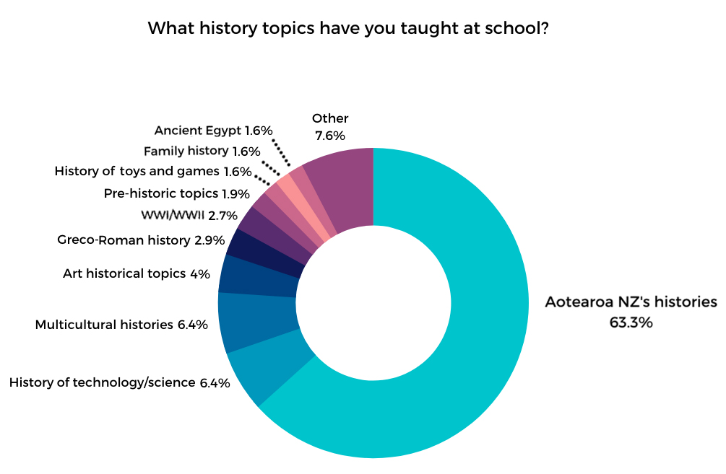

Within the Aotearoa New Zealand histories, there were significant imbalances among the 236 topics mentioned by teachers in the survey. Not surprisingly, teaching related to the Treaty of Waitangi (ToW) (27.1%) was the top ranked topic. A combination of wide ranging topics related to Māori histories made the second spot (19.1%). Third on the list, completing the triad of big topics being taught, was ANZAC/Gallipoli (16.1%). Thereafter the fourth most popular were topics relating to local/regional histories (12.3%), and those relating to the respective school’s history came fifth (8.9%). Completing the list were colonial/settler histories (5.5%); topics related to New Zealand disasters (5.1%), famous New Zealanders (3.4%) and New Zealand’s ‘difficult histories’ (2.1%).

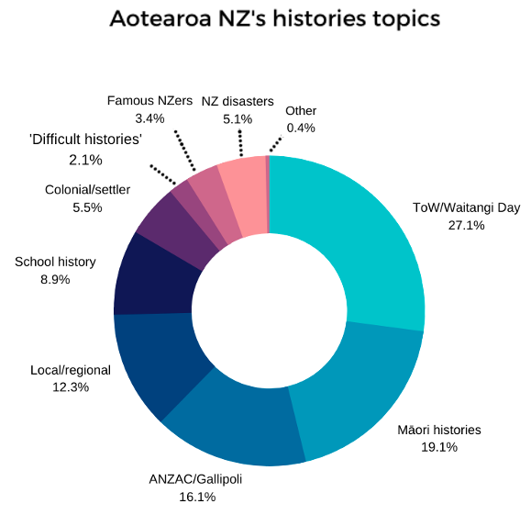

There were notable variations under the category ‘Māori histories’. Among the 45 topics mentioned by teachers, 14 covered Māori myths and legends, 6 focused on pre-colonial migration to Aotearoa, while the vast majority of the remaining ones touched on Māori cultures and traditions (language, art, crafts, tikanga and games). These answers suggest that most primary teachers in this study have opted to approach Māori histories through mythical/spiritual stories, distant realms and cultural topics rather than addressing modern and contemporary histories. Primary teachers’ decision to avoid more recent and sensitive historical events, many of which reverberate on today’s political and economic struggles, might be pragmatic. Teachers are busy people who have to walk a fine line between engaging hundreds of young learners whilst maintaining regular and diplomatic contact with their parents. Teaching mythical/legendary accounts located in cosmogonic times means bypassing difficult histories that relate to ongoing societal issues. But teachers’ choices might also have sector-specific pedagogical motivations as well. Myths and legends provide multiple pathways to spark children’s imagination, providing engaging storytelling that connect to other learning areas such as English and the Arts. Also, teachers planning is often based on available, usable resources. Most school libraries have richly illustrated books on this topic, and teachers are just a few clicks away from finding appealing online animations such as that of Papatūānuku and Ranginui’s separation (KIWA Digital, 2017) or Māui slowing the Sun (Darkhizzle, 2009).
Nonetheless, regardless of actual motivations, the fact that many primary teachers have been teaching Māori myths and legends provides schools with many pathways to build on their prior experiences and provide Professional Learning & Development (PLD), upskilling and guidance on the new curriculum. Myths and legends can be entry point to pūrākau as a method of decolonising histories through Māori lenses (Lee, 2009) \. Focus on pre-colonial Māori era can also be a tactical way to go beyond linear progressive Eurocentric notions of time towards a more multi-layered understanding of history as whakapapa (Warne, 2020).
Back to the self-declared experience teachers in this study have with the ‘big 3’ topics, it is reassuring that the teaching of ToW, Gallipoli and ‘Māori histories’ is widespread across these primary schools. However, it is also a reminder of the need of topic diversification and fresh approaches that prevent student boredom. ‘Treaty fatigue’ has unfortunately become a well-known term in educational circles as well. No one wants to add more topics to the list. Like anything compulsory, the new curriculum has the potential to act as a Trojan horse, transporting the menace of demotivation. As discussed later in the article, given that creative pedagogies are a priority for primary teachers, and that the primary sector is leading in educational trends such as curriculum integration and Innovative Learning Environments (ILEs) (Carvalho et al., 2020), this sector seems equipped with classroom-tested initiatives that could inspire the intermediate and secondary sectors, even the tertiary one.
For the schools involved in this study, an auspicious finding for the implementation of the new history curriculum is that their primary teachers have already been taking local history seriously. Topics related to local/regional history stood in 4th place, mentioned by 12.3% of respondents. If these are added to the 8.9% of answers addressing the topic of ‘school history’ – which is by definition as ‘local’ as any education can get for students – then the category of local/regional histories would increase to a significant 21.1%, hopping to 2nd place in the list of most widespread topics taught by local teachers at Manawatū primary schools. As detailed in the discussion of pedagogy, local history topics seem a logical departing point for primary school children who need concrete, next-door examples in order to extrapolate to abstract ones far away in space and time (Cooper, 2012).
To conclude this section on history content taught at primary schools involved in this study, it is important to mention teachers’ initiatives together with local Māori. To the question ‘have you created history learning experiences in partnership with local iwi/hapū?’, 45.12% of teachers answered ‘yes’ versus 54.88% who have not. Less than 50% of teachers could be interpreted as a relative low number in most education contexts. However, given that co-planning and co-teaching in open-plan ILEs classrooms has become an increasing trend across primary schools (Carvalho et al. 2020), the numbers in the survey suggest a good probability that primary classrooms would have at least one teacher with experience developing content together with or under guidance of local Māori.
When asked to provide details about their partnership with local iwi/hapū, the overwhelming majority of teachers mentioned visits either to Te Hotu Manawa O Rangitāne O Manawatū Marae, Te Rangimarie Marae and Te Marae o Hine/The Square facilitated by local iwi. Teachers highlighted the partnerships as opportunities to “to learn about history, Māori tradition and arts”, for developing the Te Reo Māori, as well as a way for bringing “experts from the community in to assist with writing a school haka and taking students for kapa haka”. Some respondents highlighted that their schools have local kaumatua (elders), and other whānau (family) members who guide the school about iwi and hapū protocols in general, and support in teaching students local and NZ history.

Teaching Confidence

While the finding that 83.3% of teachers reported that they have taught New Zealand history is promising, an overwhelming majority of teachers also expressed a lack of confidence in this area. 2.44% of respondents thought they were highly confident to teach ‘Aotearoa NZ’s histories in general’ . While the number of teachers who feel ‘very confident’ (10.98%) or ‘moderately confident’ (52.44%) to teach NZ histories in general is encouraging, the combined amount of those who expressed slight or no confidence at all (34,15%) raises concerns. When numbers are broken down according to the specific historical themes, an encouraging total of 78.32% teachers indicated either extreme, high or moderate confidence in delivering lessons related to the Te Tiriti/ ToW. But overall the findings indicate a gloomier landscape of teachers’ self-declared confidence in teaching the remaining historical themes. Put simply, while a good share of teachers opted for the middle of the scale, declaring themselves at least ‘moderately confident’ to teach all themes, the combination of the percentages on the extreme side of the scales inevitably highlighted lack of confidence. The numbers speak for themselves. For example, only 13.25% of teachers feel extremely or very confident to teach the theme ‘The arrival of Māori to Aotearoa New Zealand’ versus 42.17% who feel slightly or not confident at all. Asymmetry between elevated levels of confidence versus low or none were also found in all other themes:

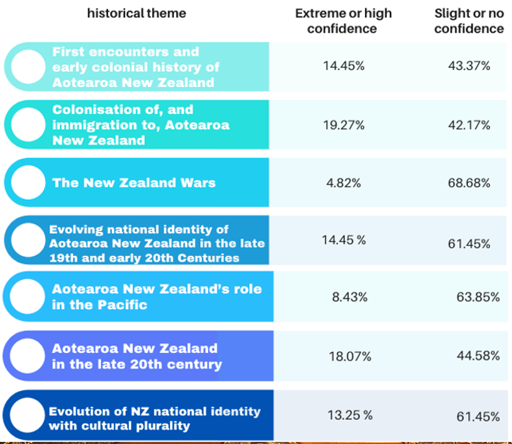

The survey asked teachers how comfortable they were with their ability to teach ‘difficult histories’, for example, related to the New Zealand Wars and the impact of colonisation on Māori and Pacific peoples. A few teachers were pessimistic, stating that they “do not feel comfortable teaching my junior students about NZ land wars” and are “unsure how difficult histories will be taught to five and six year olds or even older children within the primary school”. However, the combined percentage of those who felt extremely or somewhat comfortable (50.6%) to address ‘difficult histories’ in primary classrooms was considerably higher than that of those who feel somewhat or extremely uncomfortable (18.07%). These numbers suggest that teachers’ self-declared levels of confidence to teach a topic do not equate their levels of comfort and/or willingness to teach this same topic. Teachers’ relative low levels of confidence to teach NZ history while remaining mostly untroubled by the prospect of teaching ‘difficult histories’ might seem a contradiction. But it attests to teachers modus operandi and sound pedagogical grounding. Given the generalist and dynamic nature of primary teaching, many primary teachers have become used to describing themselves as adaptive professionals, who constantly make curricular and pedagogical changes to meet students’ needs and in response to changes outside the school (Anthony et al. 2015). The findings point to the fact that despite not confident yet with the new history content, teachers seem to possess the repertoire of pedagogical tools to remain comfortable with the prospect of teaching any topic, including ‘difficult’ ones.
On this, when asked the open-ended question about what was required to teach ‘difficult histories’, teachers indicated willingness to overcome lack of confidence through proper training and reliable resources “for us to learn before we teach”. Many answers emphasised the role of schools and the government in providing support through a “consistent plan”, a “very 'prescribed' structured curriculum”, “clear guidance” and “step by step in detailed guides”. In addition on structure and clarity, the need for PLDs stood out in teachers responses. They asked for “Lots of PLD in this area” and “support from consultants/facilitators to grow both teacher knowledge and pedagogical skills for teaching history” and also mentors who could be “available for direct consultation”.
However, while many respondents underscored the need for “effective Professional Development (by) trusted experts” concerns were raised about how these could lack understanding of the specificities and needs of primary school settings. A teacher suggested that “If an historian is going to write the curriculum they need to teach a topic for a term in a low decile Year 4 or 5 class”. This provocative joke was echoed in more serious tones by several other teachers who mentioned how learning resources should be “age-appropriate”; “written in child speak” attuned to “developmental appropriateness of topics” and “suited to 'todays' children teachers”. Worries that top-down decisions would not be “practical, simple and digestible” to students was a recurrent topic in the answers. To avoid this, teachers frequently mentioned “resources written in child speak” and “kids friendly” formats. Suggestions were made to create “story-like resources” that can “ enable children to transport themselves back in time” and also that are created “in a way children understand”.
In addition to training and resources tailored to the needs of the primary school community, many teachers expressed their concerns about historical bias when teaching ‘difficult history’ topics. They emphasised the need to have access to “unbiased children's stories and videos” and “accurate and concise information”, so they could “deliver the lesson in an unbiased, unemotional way”. Emphasis was also given to equity, so the curriculum was “approved by representatives of all involved. So that ALL teachers across NZ are giving ALL students the same messages regardless of individual beliefs” and that “everybody having the same resource(s)”. It is possible that teachers’ fear of biased knowledge and inequitable decision-making might be an aftereffect of the well-known ‘history wars’ that took place in other post-colonial Anglophone countries, notably the Australian context that led to a compromise with the creation of their own compulsory national history curriculum (Parker & Donnelly, 2014). Teachers urge for structured and non-biased teaching is also likely a symptom of the so-called ‘post-truth’ days, in which historical knowledge has been pulverised by new media narratives and the rise of global populism often based on the reinterpretation of national pasts (Gudonis & Jones, 2020)
Expectedly, in order to prepare to teach ‘difficult histories’ in 2022, many respondents mentioned the need to have access both to digital resources - such as “YouTube videos”; “Interactive resources that engage learners” and “digital resources including short films, interactive places, workbooks”- but also to the physical collections and experiences provided by local libraries and museums. Related to the previously mentioned concerns that intellectuals might be unequipped to create age appropriate and kids-friendly resources, respondents also emphasised the need of “lots of mixed media resources” and “not just paper readings!” so treasured by academics.

History Pedagogy

Teachers were asked how best to create meaningful and engaging history learning experiences. In open-ended responses, they expressed a preference for social constructivist pedagogies and teaching strategies that: a) encourage agency and student voice while minimising direct instruction; b) are based on an inquiry approach; c) present opportunities for conversation and group debate; d) promote hands-on learning; e) link to children’s’ personal identities, backgrounds, and everyday experiences
The most commonly identified strategies involved bringing history “to life” through learning opportunities outside the classroom, historical images, role play, stories of individuals and their experiences, and connections to the learner’s whānau (family). In effect, teachers believe that making sense of Aotearoa New Zealand’s histories should begin with supporting each child’s understanding of their own personal history as a member of Aotearoa New Zealand. Teachers also placed emphasis on children exploring history impartially and from multiple perspectives in order to develop historical thinking skills and make meaning of New Zealand history for themselves with increasing sophistication.
Passionate delivery was mentioned by teachers as a key to successful learning of New Zealand history in primary schools. Yet many teachers feel that their existing content knowledge is not sufficient to support the confidence and passion that is required. Indeed teachers call for timely, specialised advice, guidance, and coaching to be provided so that they can meet the potential demands of the new aspects of the curriculum and the needs of their learners.
The survey also provided evidence of how local primary teachers are also promoting ‘historical thinking’ among their cohorts. Once again, many teachers in this study located themselves in the middle of the scale, declaring neither agreement nor disagreement that their schools had enabled students to carry out the seven historical thinking skills paraphrased in the survey. However, the combined percentages of those who ‘strongly or somewhat’ agreed rather than disagreed was overwhelming. For example, 44.15% of teachers agreed that their learning programs had enabled students to ‘decide what is significant in history’ versus a mere 11.68% who disagreed. Similar proportions were also found when teachers were asked whether their lessons had enabled students to: Use sources as evidence (57.14% versus 6.49%); Identify continuity and change (50.65% versus 7.80 %); Analyse cause and consequence (57.14% versus 6.49; Understand different perspectives about a historical event (62.34% versus 10.38); Make ethical judgements about the historical actions of individuals or groups (44.15% versus 15.58%). The only category in which the ‘disagree’ side of the scale prevailed was about whether teaching had enabled students to ‘Understand contestability (how historians differ and debate about history interpretations). Results in this section point to two realities. First, even if teachers are not self-aware or able to directly identify historical thinking approaches or cite their leading authors, they have nonetheless been teaching history-specific disciplinary skills to their students. Second, this has much to do with the fact that many historical processes and concepts are embedded in the Achievement Objectives (AOs) of the NZC targeted at Years 1 to 8, not just for junior secondary (Years 9-10) and senior students (Years 11-13). The fact that the concept of ‘contestability’ does not make the pages of the NZC, or any other MoE curricular resources at this stage, likely explains why this was the only historical concept in which the combined responses of teachers who disagreed (29.87%) prevailed over those who ‘agreed’ (27.28%). It also suggests little influence resulting from the relatively recent Australian history curriculum implementation.
Because BES findings stem from everyday classroom practices, it was expected that most teachers would tend to ‘agree’ with the paraphrased BES statements regardless whether they had read the original report or not. Indeed, different than previous survey questions, few teachers remained in the ‘neutral’ middle of the scale. But the difference between those that ‘strongly or somewhat agreed’ in comparison to those that ‘slightly or did not agree at all’ was even higher than anticipated. For example, an overwhelming 74.03% of teachers agreed that history teaching in their school “draws on content relevant to students’ lives and cultural backgrounds” versus a mere 5.2% who disagreed. Similar proportions appeared in every other paraphrased BES findings:

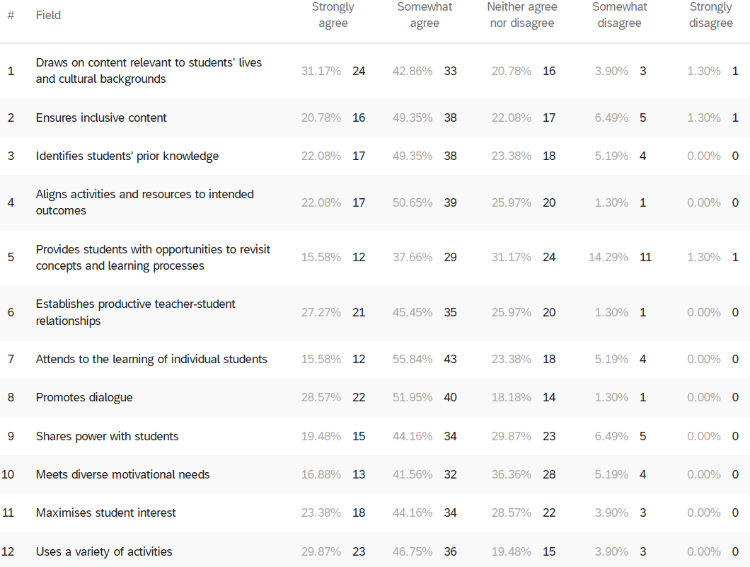

Again, teachers’ overall ‘agreement’ with the paraphrased BES statements does not equate with awareness and/or direct usage of the BES report itself. This is irrelevant to the interpretation of survey findings on pedagogy. As mentioned, the BES is perceived as unique as it aims not to provide top-down scholarly-made recipes to teachers. Rather, it is premised on sharing and maximising the impact of common successful practices that many teachers have been using already. In this sense, the BES findings are better seen as a summary of practices and ideas that spring from everyday classrooms. Because of this intrinsic link to classrooms, it is likely that many of the paraphrased BES statements were read as straightforward and self-evident by teachers who responded the survey. Again, the main point is not where or how surveyed teachers reached this nearly consensual agreement that their practices reflect BES findings. What matters in the interpretation of the data is that teachers practices seem to be grounded on BES findings. And as BES findings should provide examples and principles of “what works, how and why it works" for diverse learners of the social sciences - history included – this would indicate a solid pedagogical foundation for the implementation of the new curriculum.
In addition to the BES, the survey paraphrased another NZ-created resource, Te Takanga o te Wā (Tamua, 2015), with the same aim of inquiring into teachers pedagogical preparation to implement the new curriculum. The data suggests that, regardless of direct or conscious use of the resource, most of Te Takanga of Te Wā’s suggested pedagogies already rank high among teachers’ practices. The percentages ahead refer to teachers that ‘strongly or mostly agreed’ versus those that ‘somewhat or strongly disagreed’ that they used the following pedagogies when teaching history:

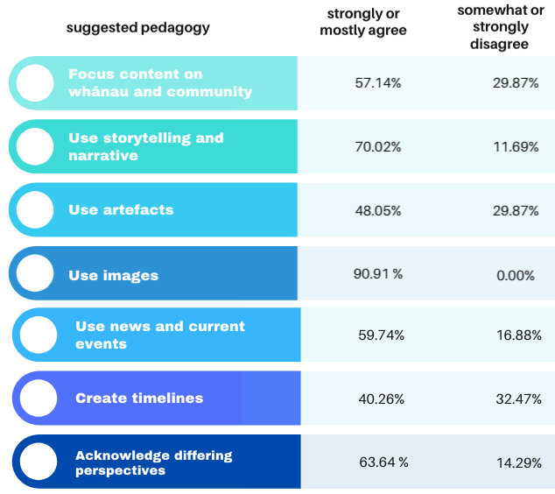

However, there are two interrelated pedagogies from Te Takanga o te Wā’s framework that seem to be areas of development for teachers: Draw on expertise from the community, in which percentages reached a technical tie (38.96% versus 37.66%) and Take history teaching outside the classroom (32.47% versus 55.84%). A third suggested pedagogy that ranked low was Take part in social action, (22.07% versus 58.44%), which adds further evidence to previous research indicating this is an aspect of teaching social sciences learning area that remains confusing to many teachers (Wood, 2013).
Finally, the firm and dynamic pedagogical foundations that inform primary teachers was further evidenced when the survey asked them to evaluate the frequency with which they employed a range of teaching strategies to teach history topics. Primary settings have embraced socio-constructivist and culturally-responsive practices. Principles of collaboration and inclusion have been embedded both in schools architecture/furniture and in lesson planning. Accordingly, teachers ranked Inquiry-based learning (68.83%), group work (53.24%), digital classroom (44.16%), Class conversations/debate (44.15%) and Differentiated Learning (42.87%) as the top-ranked approaches they employ ‘always or most of the time”. This is in stark contrast with what are perceived as traditional pedagogies of ‘direct instruction/lecture’ (6.49%), individual work (9.09%). Other pedagogies that ranked high were Problem-based learning (36.36%) and game-based learning (27.28%). Importantly, however, the employment of ‘historical inquiry’ as a teaching approach was ‘never’ or only ‘sometimes’ used by the majority of respondents (57.14%). This suggests an area of development for the primary schools, one which can particularly benefit from university and secondary school experience modelling historical research.

Conclusion and implications

The completion of this article coincided with a visit to one of our local schools. It was a crowded Friday morning. Students and staff gathered in a packed hall to celebrate weeks of learning achievements in front of proud parents and tīpuna (grandparents). At some point, all eyes tuned to a presentation of a series of activities related to ANZAC/Gallipoli. Images showed students frantically sprinting up and across the school field as if charging against Ottoman territory. Inside classrooms, students crawled under strings hung low across walls simulating ‘barbed wires’ through no-man’s-land. As a reward for their heroic actions, students had to eat one Weet-Bix biscuit each, no milk allowed. It was hard-to-swallow lesson about soldiers’ rations during the war, in those days fought both against enemies and malnutrition.
But there was another lesson at play in the hall that day: the slide show was a recap of primary schools’ expertise in turning abstract and sensitive knowledge into tangible and engaging student-centred experiences. In particular, it translated into images a reality that has been well-known for members of the sector, and which the survey only corroborated: critical and creative teaching of Aotearoa NZ’s histories has been flourishing across primary schools, and long before the announcement of the new curriculum.
Discussions so far about the new curriculum have tended to focus on ‘what’ questions, especially ‘what’ historical content should be included versus ‘what’ is still missing. Public debates about the ‘how’ to teach (pedagogies and approaches to) Aotearoa NZ’s histories are virtually non-existent. This is an area that primary teachers, with their expertise in making the NZC come to life as accessible, dynamic and imaginative learning, could contribute to the current national kōrero (conversations) on teaching history. So far, though, there has been an implicit top-down approach to implementing the history curriculum based on an unspoken assumption that government policy will rely on university erudition, then on secondary schools’ history experts, which will then inform primary schools ‘generalists’.
By adding the experiences of primary schools, this article highlights the contribution that this sector can make to the debate of designing and delivering Aotearoa NZ’s histories. The successful implementation of the new curriculum depends as much on sound content and skills knowledge as on innovative pedagogies that will breathe life into the new curriculum. Fostering more collaboration that builds on the experiences and strengths from all educational sectors is important.
Primary educators will no doubt benefit from the prolific production of academic historians and the repertoire built by history departments at secondary schools. As noted in the discussion of survey findings, this is particularly significant in order to help primary teachers – most of whom have no history training: a) raise teaching confidence related to the seven broad historical themes suggested prior to the release of the draft curriculum; b) go beyond the ‘big three’ topics (ToW, Gallipoli and ‘Māori histories’) by incorporating less popular - often difficult and more recent - history topics into their planning; c) adapt historiographical collections and works into age-appropriate and primary-friendly resources; d) connect existing learning activities based on local/school histories to national and international contexts; e) access quality digital material, especially films and videos aligned with the new curriculum and suitable to younger audiences; f) develop young students’ historical skills and model history inquiry, especially by learning how ‘to do history’ through bicultural lenses that reflect mana ōrite mō te mātauranga Māori (Western and Indigenous knowledges parity)
In turn, with their accumulated mahi (work) on curriculum integration, ILEs, inquiry-led, student-centred models and iwi partnerships, as well as with years of experience teaching Aotearoa NZ’s histories as documented in this article, primary teachers have much to teach to students and society alike.

Acknowledgements

The authors would like to acknowledge the help of local principals and teachers who welcomed us to their schools, and generously devoted their time and expertise to complete the survey.

References:

Aitken, G. (2005). The purpose and substance of social studies: Citizenship education possibilities. In P. Benson & R. Openshaw (Eds.), Towards effective social studies (pp. 85-112). Palmerston North: Kanuka Grove Press.

Aitken, G. & Sinnema, C. (2008). Effective pedagogy in social sciences/Tikanga-a-iwi: Best evidence synthesis iteration (BES). Ministry of Education. https://www.educationcounts.govt.nz/publications/series/2515/35263

Anthony, G., Hunter, J., & Hunter, R. (2015). Prospective teachers’ development of adaptive expertise. Teaching and Teacher Education, 49, 108–117.

Bruggink, M., Goei, S.L. & Koot, H.M. (2016). Teachers’ capacities to meet students’ additional support needs in mainstream primary education. Teachers and Teaching, 22:4,

Carvalho, L., Nicholson, T., Yeoman, P., & Thibaut, P. (2020). Space matters: Framing the New
Zealand learning landscape. Learning Environments Research.

Cooper, H. (2012). History 5-11. A guide for teachers. Routledge.

Darkhizzle (2009, May 22). How Maui slowed the Sun - By Peter Gossage [Video]. YouTube. https://www.youtube.com/watch?v=jbM3PwcGi0g

Goldsmith, P. (2021, June 1) National submits on New Zealand history curriculum https://www.national.org.nz/national-submits-on-new-zealand-history-curriculum

Gudonis, M., & Jones, B. (2020). History in a Post-Truth World Theory and Praxis. Routledge.

Harawira, T. (2021, February 3) Aotearoa history to be taught in all schools from 2022. Te Ao Māori News. https://www.teaomaori.news/aotearoa-history-be-taught-all-schools-2022

Henderson, D. (2011). History in the Australian curriculum F-10: Providing answers without asking questions. Curriculum Perspectives. 31(3) 57-63.

Hunter, P. (2006). Framing a social sciences learning area in the New Zealand curriculum draft for consultation 2006. Teachers and Curriculum: Kaiako me te Marautanga, 9, 19–27.

KIWA Digital (2017, July 5). The Māori Gods - Book One: The Beginning of the Universe [Video]. YouTube. https://www.youtube.com/watch?v=AnOWHeJNbZM

Lee, J. (2009). Decolonising Māori narratives: Pūrākau as method. MAI Review 2(3):1–12.

Manning, R. (2018). The New Zealand (School Curriculum) ‘History Wars’: The New Zealand Land Wars Petition and the Status of Māori Histories in New Zealand Schools (1877–2016). The Australian Journal of Indigenous Education, 47(2), 120-130

McGeorge, C. (1992). Evolution and the New Zealand primary school curriculum, 1900–1950. History of Education, 21, 205–218.

Ministry of Education (2007) .The New Zealand Curriculum. http://nzcurriculum.tki.org.nz/

Ministry of Education (2021). Aotearoa New Zealand’s histories in our national curriculum. Draft for consultation.
https://nzcurriculum.tki.org.nz/content/download/169209/1249015/file/CO2716_MOE_Aotearoa_NZ_Histories_A3_FINAL-020.pdf

Ministry of Education. (2021, September). Curriculum and assessment changes. https://www.education.govt.nz/our-work/changes-in-education/curriculum-and-assessment-changes/

Mutch, C., Hunter, P., Milligan, A., Openshaw, R., & Siteine, A. (2008). Understanding
the social sciences as a learning area. A position paper prepared for the Ministry of
Education. Wellington, NZ: Ministry of Education.

NZQA (2019). 91001 Achievement standard 2019. https://www.nzqa.govt.nz/nqfdocs/ncea-resource/achievements/2019/as91001.pdf

Parker, R., & Donnelly, D. (2014). Changing conceptions of historical thinking in History education: an Australian case study. Revista Tempo e Argumento, 6:11, 113‐136.. http://dx.doi.org/10.5965/2175180306112014113

Priestley, M., & Sinnema, C. (2014). Downgraded curriculum? An analysis of knowledge in new curricula in Scotland and New Zealand. The Curriculum Journal, 25(1), 50–75

Roberts, P. (1998). The politics of curriculum reform in New Zealand. Curriculum Studies, 6:1, 29-46,

Royal Society of New Zealand (2021). Aotearoa New Zealand’s Histories A response to
draft curriculum. https://www.royalsociety.org.nz/assets/Aotearoa-New-Zealand-histories-response-to-draft-curriculum-May-2021-digital.pdf

Seixas, P., & Morton, T. (2013). The big six historical thinking concepts. Nelson Education.

Sheehan, M. (2021, May 28). New curriculum: Thinking critically about the past. Newsroom. https://www.newsroom.co.nz/ideasroom/new-curriculum-thinking-critically-about-the-past

Sheehan, M. (2013). “Better to do than receive”: Learning to think historically
through internally assessed course work. Teaching and Learning Research Initiative (TLRI),
http://www.tlri.org.nz/sites/default/files/projects/Sheehan_Summary%20web%20ready%20%28v6%29.pdf

Stenson, M. (1990). History in New Zealand schools. New Zealand Journal of History, 24, (2), 168–182

Stewart, G., Trinick, T., & Dale, H. (2017). Te Marautanga o Aotearoa: History of a national Māori curriculum. Curriculum Matters, 13, 8–20

Tamua, M. (2014). Te takanga o te wā—Māori history in Aotearoa New Zealand: Teaching guidelines for years 1–4. Ministry of Education. http://maorihistory.tki.org.nz/en/programme-design/te-takanga-o-te-wa-maori-history-guidelines-year-1-8/

Taylor, R. (2008). Teachers’ conflicting responses to change: An evaluation of the implementation of senior social studies for the NCEA, 2002-2006. Unpublished doctoral dissertation, Massey University, Palmerston North

Taylor, R., & Sheehan, M. (2011). The Place of History in The New Zealand Curriculum. New Zealand Journal of Teachers’ Work, 8(2), 156–167.

Tenorio, R. (2004). Curriculum is everything that happens: an interview with Rita Tenorio. In Burant, T., Christensen, L., Dawson Salas, K., Walters, S. (Eds.). (2010). The new teacher book: Finding purpose, balance, and hope during our first years in the classroom. Milwaukee, WI: Rethinking Schools.

Thorp, R., Persson, A. (2020). On historical thinking and the history educational challenge. Educational Philosophy and Theory, 52:8, 891-901.

Warne, K. (2020, August 15). A whakapapa approach to history. E-Tangata. https://e-tangata.co.nz/history/a-whakapapa-approach-to-history/

Wood, B. (2013). What Is a Social Inquiry? Crafting Questions that Lead to Deeper Knowledge about Society and Citizenship Participation. Review of SET: Research Information for Teachers 2013 (3): 20–28.

Wood, B. & Sheehan, M. (2012). Dislodging knowledge? The New Zealand curriculum in the 21stcentury. Pacific-Asian Education, 24(1), 17–30

Wood, B. & Sheehan, M. (2021). Transformative disciplinary learning in history and social studies: Lessons from a high autonomy curriculum in New Zealand. The Curriculum Journal, 32, 495– 509

Yukich, R. (2021). Feeling Responsible Towards Aotearoa New Zealand’s Past: Emotion at Work in the Stance of Five Pākehā History Teachers. New Zealand Journal of Education Studies.

The authors

Dr Genaro Oliveira is a lecturer in education at the Institute of Education, Massey University, Te Kunenga ki Pūrehuroa.
g.oliveira@massey.ac.nz

Matt Kennedy is the principal at West End School, Te Kura O Urumutu. principal@westend.school.nz

National Certificate of Educational Achievement (NCEA) is Aotearoa New Zealand’s qualification for senior secondary school students.
The region is located in the lower half of the Te Ika-a-Māui (North Island) of Aotearoa New Zealand. The main cities are Palmerston North and Whanganui.
This is a five-year programme (2021-2025) aimed at refreshing the New Zealand Curriculum (English-medium schools) and Te Marautanga o Aotearoa (Māori-medium schools).
Beyond Social Sciences, The Ministry of Education Much has also hinted that the Aotearoa New Zealand’s histories curriculum might serve as a template for the curriculum changes of the other Learning Areas being refreshed in the next five years (Ministry of Education, 2021) https://www.education.govt.nz/our-work/changes-in-education/curriculum-and-assessment-changes/
Social studies refers to the integrated and compulsory subject taught in schools, from Years 1 to 10, as part the Social Sciences Learning Area of the New Zealand Curriculum (NZC).
According to the Ministry of Education, deciles in NZ are a measure of the socioeconomic status of schools’ students, “where decile 1 schools are the 10% of schools with the highest proportion of students from low socio-economic communities, whereas decile 10 schools are the 10% of schools with the lowest proportion of these students”. https://www.education.govt.nz/school/funding-and-financials/resourcing/operational-funding/school-decile-ratings/
For the analysis, these were grouped into 40 topic categories.
While survey answers are not explicit, it is very likely that teachers who mentioned just ‘WWI’ also taught the Gallipoli campaign.
Te Tiriti o Waitangi (The Treaty of Waitangi), signed in 1840, was a formal agreement made between the British Crown and Māori rangatira (chiefs). It is considered Aotearoa New Zealand’s founding document. While it aimed at fostering unity, conflicting interpretations of the Treaty and breaches of it have resulted in military, land and political conflicts.
Māori creation stories state that Ranginui (the sky father )and Papatūānuku (the earth mother) were initially joined together. But their children eventually plotted to separate them, allowing light to enter into the world.
Pūrākau are Māori traditional narratives that can “range from stories about the creation of the world, people and the natural environment to historical events and particular incidents” (Lee, 2009).
Māori tribe/sub-tribes
Conducted prior to the release of the draft curriculum, the survey investigated knowledge about the 7 broad historical themes initially suggested by the government prior to the release of the draft curriculum. https://www.beehive.govt.nz/release/nz-history-be-taught-all-schools
This is certainly related to the widespread popularity of this topic in schools mentioned above.
The high percentages might also have to do with fact that the language of Te Takanga o te Wā resembles other effective pedagogies seen in the BES and in the MoE TKI resources.

