Supplementary Table 1. Plot characteristics in the coffee-pine agroforestry within UB Forest

Indicators | Parameters | Pruned Coffee | Unpruned Coffee
Soil | Soil available P (mg P/kg soil) | 1.58¹ _{(*very low)}
Soil | Cation exchange capacity (cmol_{c}/kg soil) | 39.03¹ _{(*high)}
Soil | Soil pH | 5.44¹ _{(*acidic)}
Soil | Base saturation (%) | 46.61¹ _{(*medium)}
Soil | Soil bulk density (g/cm³) | 0.65² _{(*low)}
Soil | Soil texture class | Silty loam³
Soil | Soil organic C (g/100 g) | 7.83⁴ _{(*very high)} | 6.88⁴ _{(*very high)}
Coffee Tree | Coffee height (m) | <1.5 | 2–3
Coffee Tree | Fresh weight coffee production (kg/ha) | 194.79 | 183.32
Coffee Tree | Dry weight coffee production (kg/ha) | 61.55 | 53.64
Microclimate | Average daily soil temperature (⁰C)⁴ | 20.87 | 21.98
Microclimate | Average daily air temperature (⁰C)⁴ | 22.61 | 22.35
Microclimate | Δ Average soil temperature (⁰C)⁴ | 3.5 | 3.5
Microclimate | Δ Average air temperature (⁰C)⁴ | 9.5 | 6
Microclimate | Canopy cover (%)⁴ | 64.68 | 69.40
Note: soil characteristics were measured at 0-20 cm soil depth.
*Classification based on Indonesian Soil Research Institute (2009), ¹Putri et al. (2019), ²Azizah et al. (2023), ³Kurniawan et al. (2019),⁴Nugroho et al. (2023)

Supplementary Table 2. Fertilizer types and application per coffee plant for each coffee canopy management factor (T1 and T2)
Fertilizer type | Fertilizer dose | Fertilizer applied per plant (g) |  |  |  | Amount of nitrogen applied per plant (g)
Fertilizer type | Fertilizer dose | Poultry manure | Urea | SP-36 | KCl | Amount of nitrogen applied per plant (g)
Inorganic | Low | - | 140 | 70 | 130 | 64.40
 | Medium | - | 480 | 870 | 460 | 220.80
 | High | - | 750 | 1,380 | 840 | 345.00
Mixed | Low | 2,165 | 70 | 35 | 65 | 64.46
 | Medium | 5,365 | 240 | 435 | 230 | 190.34
 | High | 8,530 | 375 | 690 | 420 | 299.60
Organic | Low | 4,330 | - | - | - | 64.52
 | Medium | 10,730 | - | - | - | 159.88
 | High | 17,060 | - | - | - | 254.19

Supplementary Table 3. The effect of coffee canopy and fertilizer management in coffee agroforestry systems on soil available N at 0-20 cm and 20-40 cm depth of soil
Parameters | Pruning Management | Fertilizer Management
Parameters | Pruning Management | Organic Fertilizer (O) |  |  |  | Inorganic Fertilizer (I) |  |  |  | Mixed Fertilizer (M)
Parameters | Pruning Management | Low | Medium | High |  | Low | Medium | High |  | Low | Medium | High
Total N  (g/kg) | 0-20 cm soil depth
Total N  (g/kg) | Pruned Coffee (T1) | 5.87±0.1ab | 5.35±0.1e | 6.14±0.11a |  | 5.53±0.07cde | 5.41±0.12e | 5.47±0.08de |  | 5.73±0.16bcd | 5.79±0.07bc | 5.26±0.03ef
Total N  (g/kg) | Unpruned Coffee (T2) | 5.2±0.02ef | 5.01±0.15fg | 5.25±0.14ef |  | 4.21±0.06i | 4.81±0.04gh | 4.67±0.18h |  | 4.5±0.04hi | 4.65±0.05h | 4.5±0.04hi
Total N  (g/kg) | 20-40 cm soil depth
Total N  (g/kg) | Pruned Coffee (T1) | 5.49±0.02a | 5.55±0.14a | 4.96±0.04bcd |  | 5.37±0.14ab | 4.77±0.11de | 4.9±0.1cd |  | 4.94±0.16bcd | 5.03±0.12bcd | 5.25±0.23abc
Total N  (g/kg) | Unpruned Coffee (T2) | 3.12±0.07j | 3.88±0.11gh | 3.4±0.06ij |  | 4±0.09fgh | 3.34±0.21ij | 4.42±0.01ef |  | 4.18±0.14fg | 3.87±0.1gh | 3.68±0.3hi
Ammonium  (mg/kg) | 0-20 cm soil depth
Ammonium  (mg/kg) | Pruned Coffee (T1) | 3.04±0.54ghi | 4.76±0.29def | 2.46±0.02hij |  | 3.16±0.51gh | 1.7±0.13j | 2.44±0.05hij |  | 1.98±0.42ij | 1.72±0.45j | 2.17±0.32hij
Ammonium  (mg/kg) | Unpruned Coffee (T2) | 6.12±0.04bc | 4.42±0.24ef | 4.03±0.04fg |  | 5.67±0.04cd | 5.31±0.51cde | 5.04±0.12def |  | 7.86±0.12a | 7.77±0.15a | 6.71±0.13b
Ammonium  (mg/kg) | 20-40 cm soil depth
Ammonium  (mg/kg) | Pruned Coffee (T1) | 1.78±0.28f | 2.69±0.08abc | 2.36±0.06bcdef |  | 1.9±0.3ef | 1.83±0.17f | 1.83±0.09f |  | 2.84±0.17ab | 2.7±0.08abc | 2.46±0.11bcde
Ammonium  (mg/kg) | Unpruned Coffee (T2) | 3.2±0.14a | 2.75±0.14ab | 3.13±0.34a |  | 2.13±0.26cdef | 2.8±0.31ab | 3.23±0.07a |  | 2.01±0.11def | 2.52±0.01bcd | 2.05±0.22def
Nitrate  (mg/kg) | 0-20 cm soil depth
Nitrate  (mg/kg) | Pruned Coffee (T1) | 7.48±1.36 | 9.6±1.41 | 10.6±4.63 |  | 10.8±3.58 | 5.32±0.53 | 5.75±3.53 |  | 12.94±1.13 | 21.54±1.68 | 15.14±1.12
Nitrate  (mg/kg) | Unpruned Coffee (T2) | 6.78±2.79 | 17.36±1.86 | 24.48±3.12 |  | 12.83±2.9 | 11.37±3.99 | 10.61±3.44 |  | 10.26±3.69 | 19.83±1.5 | 16.8±3.54
Nitrate  (mg/kg) | 20-40 cm soil depth
Nitrate  (mg/kg) | Pruned Coffee (T1) | 11.35±1.47ef | 14.18±2.26def | 19.49±1.56bcd |  | 11.65±1.55ef | 11.36±1.53ef | 10.7±0.91f |  | 11.75±0.43ef | 17.59±1.43bcd | 8.56±1.1f
Nitrate  (mg/kg) | Unpruned Coffee (T2) | 17.84±1.28bcd | 16.87±0.29cde | 22.59±2.12abc |  | 16.82±0.48cde | 21.01±4.01abc | 10.03±1.76f |  | 25.3±3.58a | 21.79±1.18abc | 22.93±2.74ab
Net N-NH₄⁺ (mg/kg) | 0-20 cm soil depth
Net N-NH₄⁺ (mg/kg) | Pruned Coffee (T1) | -7.59±0.42gh | -6.25±0.22f | -8.04±0.02ghi |  | -7.49±0.4g | -8.63±0.1i | -8.06±0.04ghi |  | -8.41±0.33hi | -8.61±0.35i | -8.27±0.25ghi
Net N-NH₄⁺ (mg/kg) | Unpruned Coffee (T2) | -4.6±0.03bc | -5.92±0.18ef | -6.22±0.03f |  | -4.95±0.03cd | -5.23±0.4cde | -5.44±0.09def |  | -3.25±0.09a | -3.32±0.12a | -4.14±0.1b
Net N-NH₄⁺ (mg/kg) | 20-40 cm soil depth
Net N-NH₄⁺ (mg/kg) | Pruned Coffee (T1) | -7.02±0.21cde | -6.31±0.06a | -6.57±0.04abc |  | -6.93±0.23bcd | -6.98±0.13cde | -6.99±0.07cde |  | -6.2±0.13a | -6.31±0.06a | -6.49±0.09ab
Net N-NH₄⁺ (mg/kg) | Unpruned Coffee (T2) | -6.9±0.11bcd | -7.25±0.11de | -6.96±0.26cd |  | -7.73±0.2f | -7.22±0.24de | -6.88±0.06bcd |  | -7.83±0.08f | -7.43±0.01ef | -7.79±0.17f
Note: average ± s.e.d (standard error of different mean); Average followed by different lowercase letters indicate significant differences among combination between coffee canopy and fertilization both types and doses (Analysis of Variance with Tukey HSD test at P ≤ 0.05)

Parameters | Pruning Management | Fertilizer Management
Parameters | Pruning Management | Organic Fertilizer (O) |  |  |  |  |  | Inorganic Fertilizer (I) |  |  |  |  |  | Mixed Fertilizer (M)
Parameters | Pruning Management | Low | Medium | High |  |  | Low |  | Medium | High |  |  | D1 |  | D2 | D3
Net N-NO₃⁻ (mg/kg) | 0-20 cm soil depth
Net N-NO₃⁻ (mg/kg) | Pruned Coffee (T1) | -4.27±0.58 | -2.94±0.37 | -2.72±1.21 |  |  | -2.67±0.94 |  | -4.51±0.40 | -4.14±0.75 |  |  | -2.19±0.30 |  | -0.25±0.44 | -1.69±0.29
Net N-NO₃⁻ (mg/kg) | Unpruned Coffee (T2) | -1.17±0.68 | 3.88±1.69 | 3.21±0.81 |  |  | 0.58±0.76 |  | 0.25±1.04 | 0.07±0.90 |  |  | 0.00±0.96 |  | 2.16±0.39 | 1.47±0.92
Net N-NO₃⁻ (mg/kg) | 20-40 cm soil depth
Net N-NO₃⁻ (mg/kg) | Pruned Coffee (T1) | -1.63±0.97 | 0.58±0.67 | 1.16±4.47 |  |  | -0.45±0.41 |  | -1.70±0.98 | -1.26±0.74 |  |  | -0.42±0.11 |  | 1.37±0.61 | -0.79±0.46
Net N-NO₃⁻ (mg/kg) | Unpruned Coffee (T2) | 1.41±1.11 | 3.74±0.73 | 4.64±0.51 |  |  | 2.31±0.85 |  | 3.62±1.03 | 1.13±0.46 |  |  | 3.16±1.91 |  | 4.27±0.35 | 4.03±0.93
Microbial Biomass N  (mg/kg) | 0-20 cm soil depth
Microbial Biomass N  (mg/kg) | Pruned Coffee (T1) | 89.72±2.49a | 84.01±0.78ab | 84.4±1.55ab |  |  | 60.27±3.23bcd |  | 79.19±2.46abc | 82.8±2.61ab |  |  | 56.74±4.89cd |  | 76.14±11.8abc | 57.3±4.9bcd
Microbial Biomass N  (mg/kg) | Unpruned Coffee (T2) | 58.17±4.15bcd | 60.92±12.07bcd | 77.47±12.03abc |  |  | 47.63±3de |  | 37.93±5.18ef | 40.45±0.29ef |  |  | 31.96±0.51f |  | 45.09±2.67de | 39.3±1.41ef
Microbial Biomass N  (mg/kg) | 20-40 cm soil depth
Microbial Biomass N  (mg/kg) | Pruned Coffee (T1) | 11.15±2.11ef | 20.01±1.94bcd | 18.57±1.14cde |  |  | 19.61±3.83bcde |  | 13.94±0.9def | 13.85±0.91def |  |  | 6.31±1.24f |  | 7.57±1f | 19.2±9.3bcde
Microbial Biomass N  (mg/kg) | Unpruned Coffee (T2) | 35.53±1.97a | 37±1.14a | 35.01±1.23a |  |  | 25.16±0.91bc |  | 27.36±1.42b | 26.32±0.59bc |  |  | 7.57±0.75f |  | 19.51±1.16bcde | 14.0±1.5def
Fresh weight of coffee bean per tree (g/tree) | Pruned Coffee (T1) | 9.91±2.71e | 100.8±20.2abc | 59.24±13.3cde |  |  | 39.5±31.9cde |  | 45.9±4.9cde | 104.4±12.8abc |  |  | 137.9±40.6ab |  | 84.4±11.1abcd | 90.8±17.7abc
Fresh weight of coffee bean per tree (g/tree) | Unpruned Coffee (T2) | 47.5±20.4cde | 104.9±20.9abc | 15.81±1.94de |  |  | 79.0±29.9abcde |  | 70.7±20.1bcde | 52.9±32.8cde |  |  | 43.2±5.4cde |  | 147.9±14.8a | 98.0±29.7abc
Dry weight of coffee bean per tree (g/tree) | Pruned Coffee (T1) | 3.25±1.15e | 29.83±7.09bc | 19.63±4.52cde |  |  | 11.7±9.4cde |  | 12.55±1.74cde | 31.27±2.6bc |  |  | 51.3±15.7a |  | 27.5±2.5bcd | 27.9±4.7bcd
Dry weight of coffee bean per tree (g/tree) | Unpruned Coffee (T2) | 3.25±1.15e | 26.12±5.21bcd | 7.71±3.66de |  |  | 22.18±8.43bcde |  | 23.4±10.7bcde | 15.09±8.0cde |  |  | 13.7±2.6cde |  | 41.3±2.75ab | 29.79±8.01bc
Note: average ± s.e.d (standard error of different mean); Average followed by different lowercase letters indicate significant differences among combination between coffee canopy and fertilization both types and doses (Analysis of Variance with Duncan multiple range test at P ≤ 0.05)

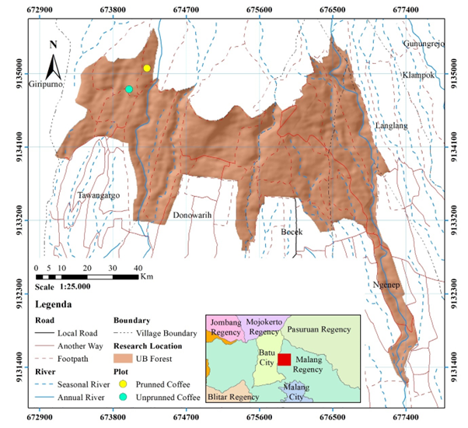
Supplementary Fig 1. Location of coffee plantation within Universitas Brawijaya experimental site (Nugroho et al. 2023)
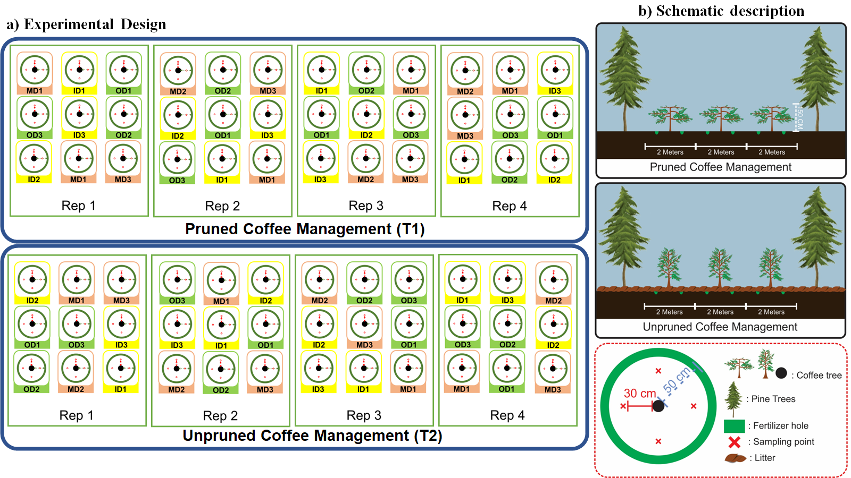
Supplementary Fig. 2. Experimental design and sampling plot at the UB agroforestry research station (a) and Schematic describing the canopy coffee management approach (pruned and unpruned coffee) applied at the UB agroforestry research station (Nugroho et al. 2023). The large tree (Fig. 2b) is pine, whereas the short tree (Fig. 2b) is coffee. The code listed represents a combination of fertilizer type (i.e., organic fertilizer (O), inorganic fertilizer (I), and a mixture of 50% organic fertilizer and 50% inorganic fertilizer (M)) and fertilizer dose (i.e., low dose (D1), medium dose (D2), and high dose (D3)).

