Table S1 Alpha diversity index at different physiological stages
Index | Non-pregnancy | Gestation period | Lactation period | P value
ACE | 1195.578±24.69 | 1209.296± 23.12 | 1190.485±14.36 | 0.379
Chao1 | 1202.094±24.20 | 1217.096±20.03 | 1197.415±18.81 | 0.340
Simpson | 0.989±0.00 | 0.988±0.00 | 0.988±0.01 | 0.993
Shannon | 8.183±0.26 | 8.045±0.33 | 8.165±0.37 | 0.769
Note: Peer data shoulders marked with different lowercase letters indicate significant differences (P < 0.05), the same letters or no letters indicate non-significant differences (P > 0.05).

Table S2 Comparison of differences in rumen flora phylum levels at different physiological stages (%)
Parameter | Non-pregnancy | Gestation period | Lactation period | P value
Chloroflexi | - | 0.01 | 0.02 | ＜0.001
Fibrobacteres | - | 0.04 | 0.16 | 0.008
Lentisphaerae | - | 0.01 | 0.01 | 0.029
Spirochaetes | - | 0.47 | 1.03 | 0.040
Bacteroidetes | - | 50.30 | 45.70 | 0.113
Atribacteria | 0.02 | - | 0.04 | 0.007
Fibrobacteres | 0.07 | - | 0.16 | 0.040

Table S3 Comparison of differences in rumen flora genus levels at different reproductive stages (%)
Parameter | Non-pregnancy | Gestation period | Lactation period | P value
Prevotella_1 | - | 31.50 | 19.80 | 0.002
Moryella | - | 0.26 | 0.42 | 0.008
Lachnoclostridium | - | 0.00 | 0.02 | 0.009
Fibrobacter | - | 0.04 | 0.16 | 0.010
Treponema_2 | - | 0.40 | 0.90 | 0.041
Ruminococcus_2 | 2.49 | 5.94 | - | 0.043
uncultured_bacterium_f_Lachnospiraceae | 3.37 | 4.44 | - | 0.036
[Eubacterium]_ruminantium_group | 0.77 | - | 1.21 | 0.005
Moryella | 0.27 | - | 0.42 | 0.037
Fibrobacter | 0.07 | - | 0.16 | 0.043
Helicobacter | 0.06 | - | 0.03 | ＜0.001
Erysipelotrichaceae_UCG-009 | 0.15 | - | 0.05 | 0.015

Figure S1. Analysis of the rumen microbiota diversity. (A) Distribution of OTU; (B) dilution curve; (C) PCoA. NP: Non-pregnancy, Gp: Pregnancy, LP: Lactation.

Figure S2. Up-down-regulated differential microbiota metabolites in the top 10 differential multiples
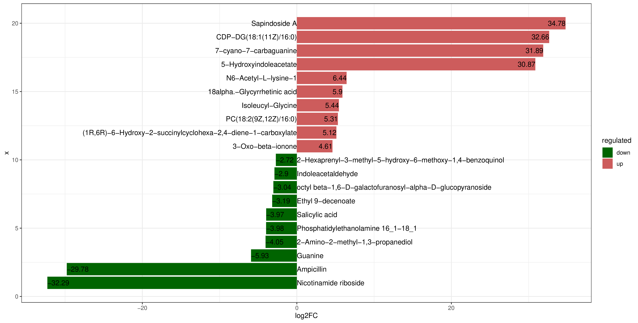
NP-GP
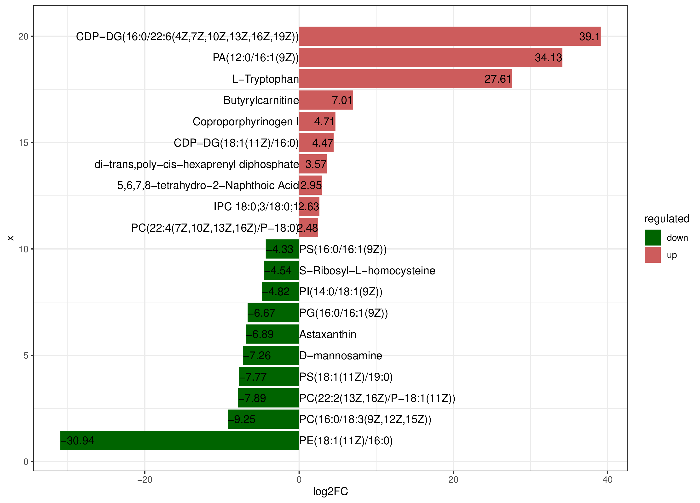
GP-LP
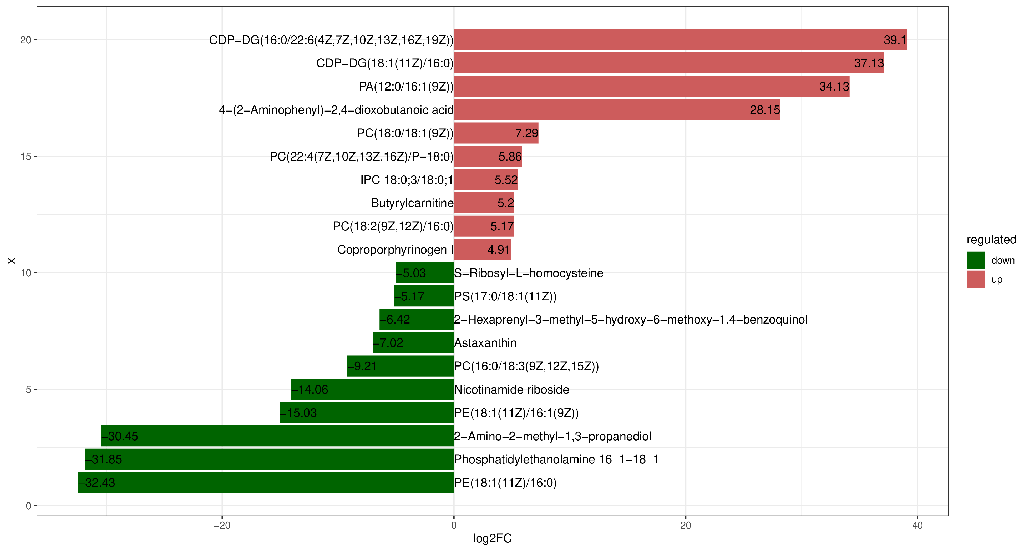
NP-LP

Figure S3. Cluster analysis of microbial metabolites
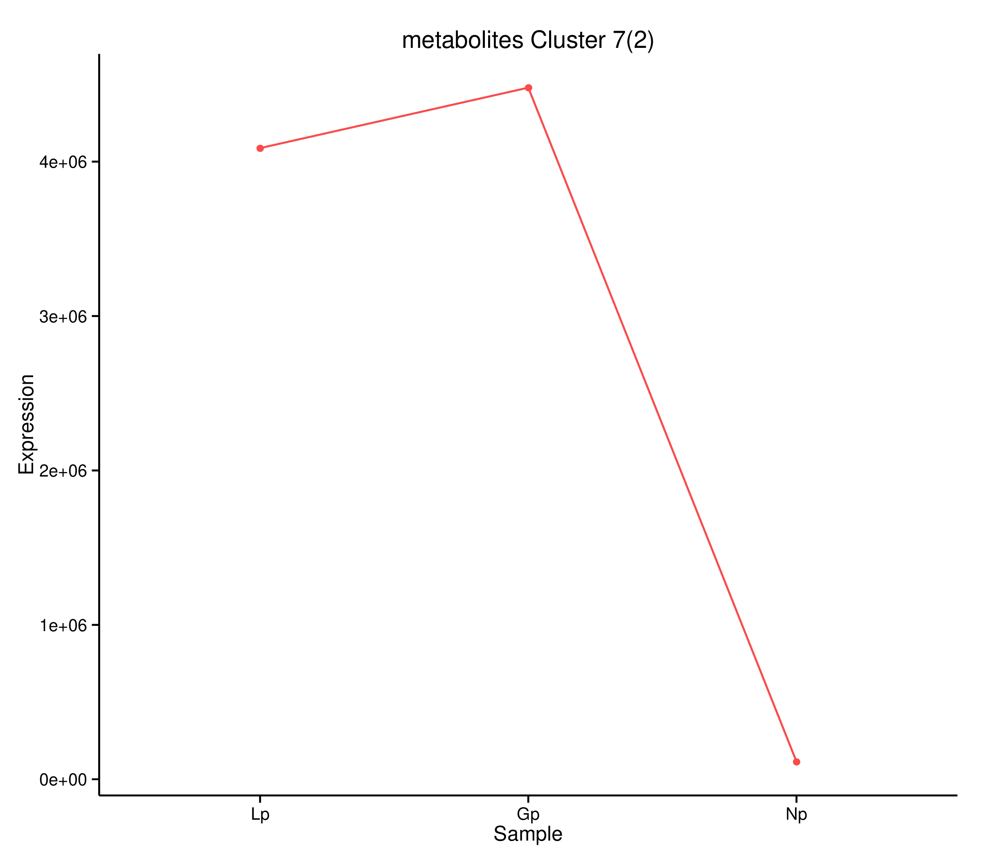 PC(18:2(9Z,12Z)/16:0)
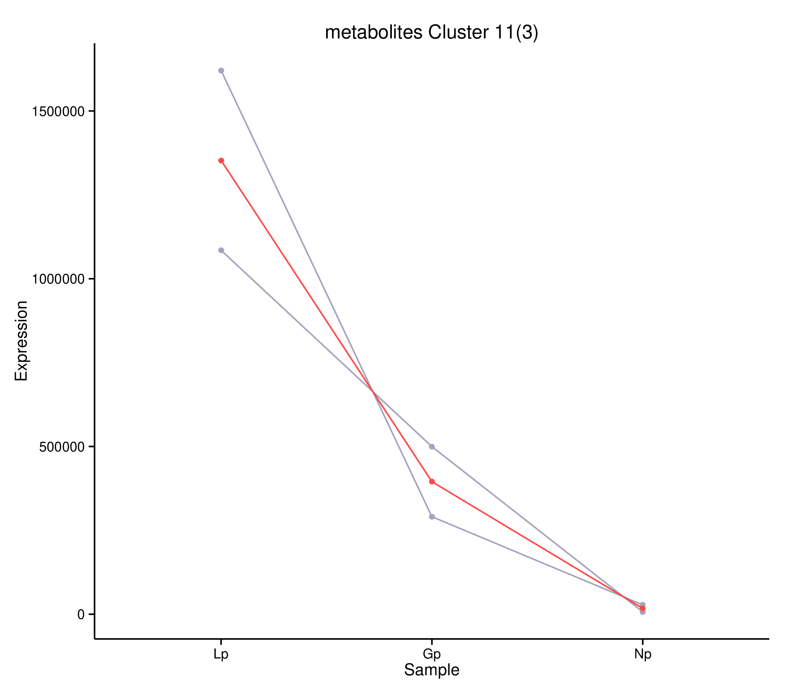
PC(18:0/18:1(9Z))、PC(22:4(7Z,10Z,13Z,16Z)/P-18:0)

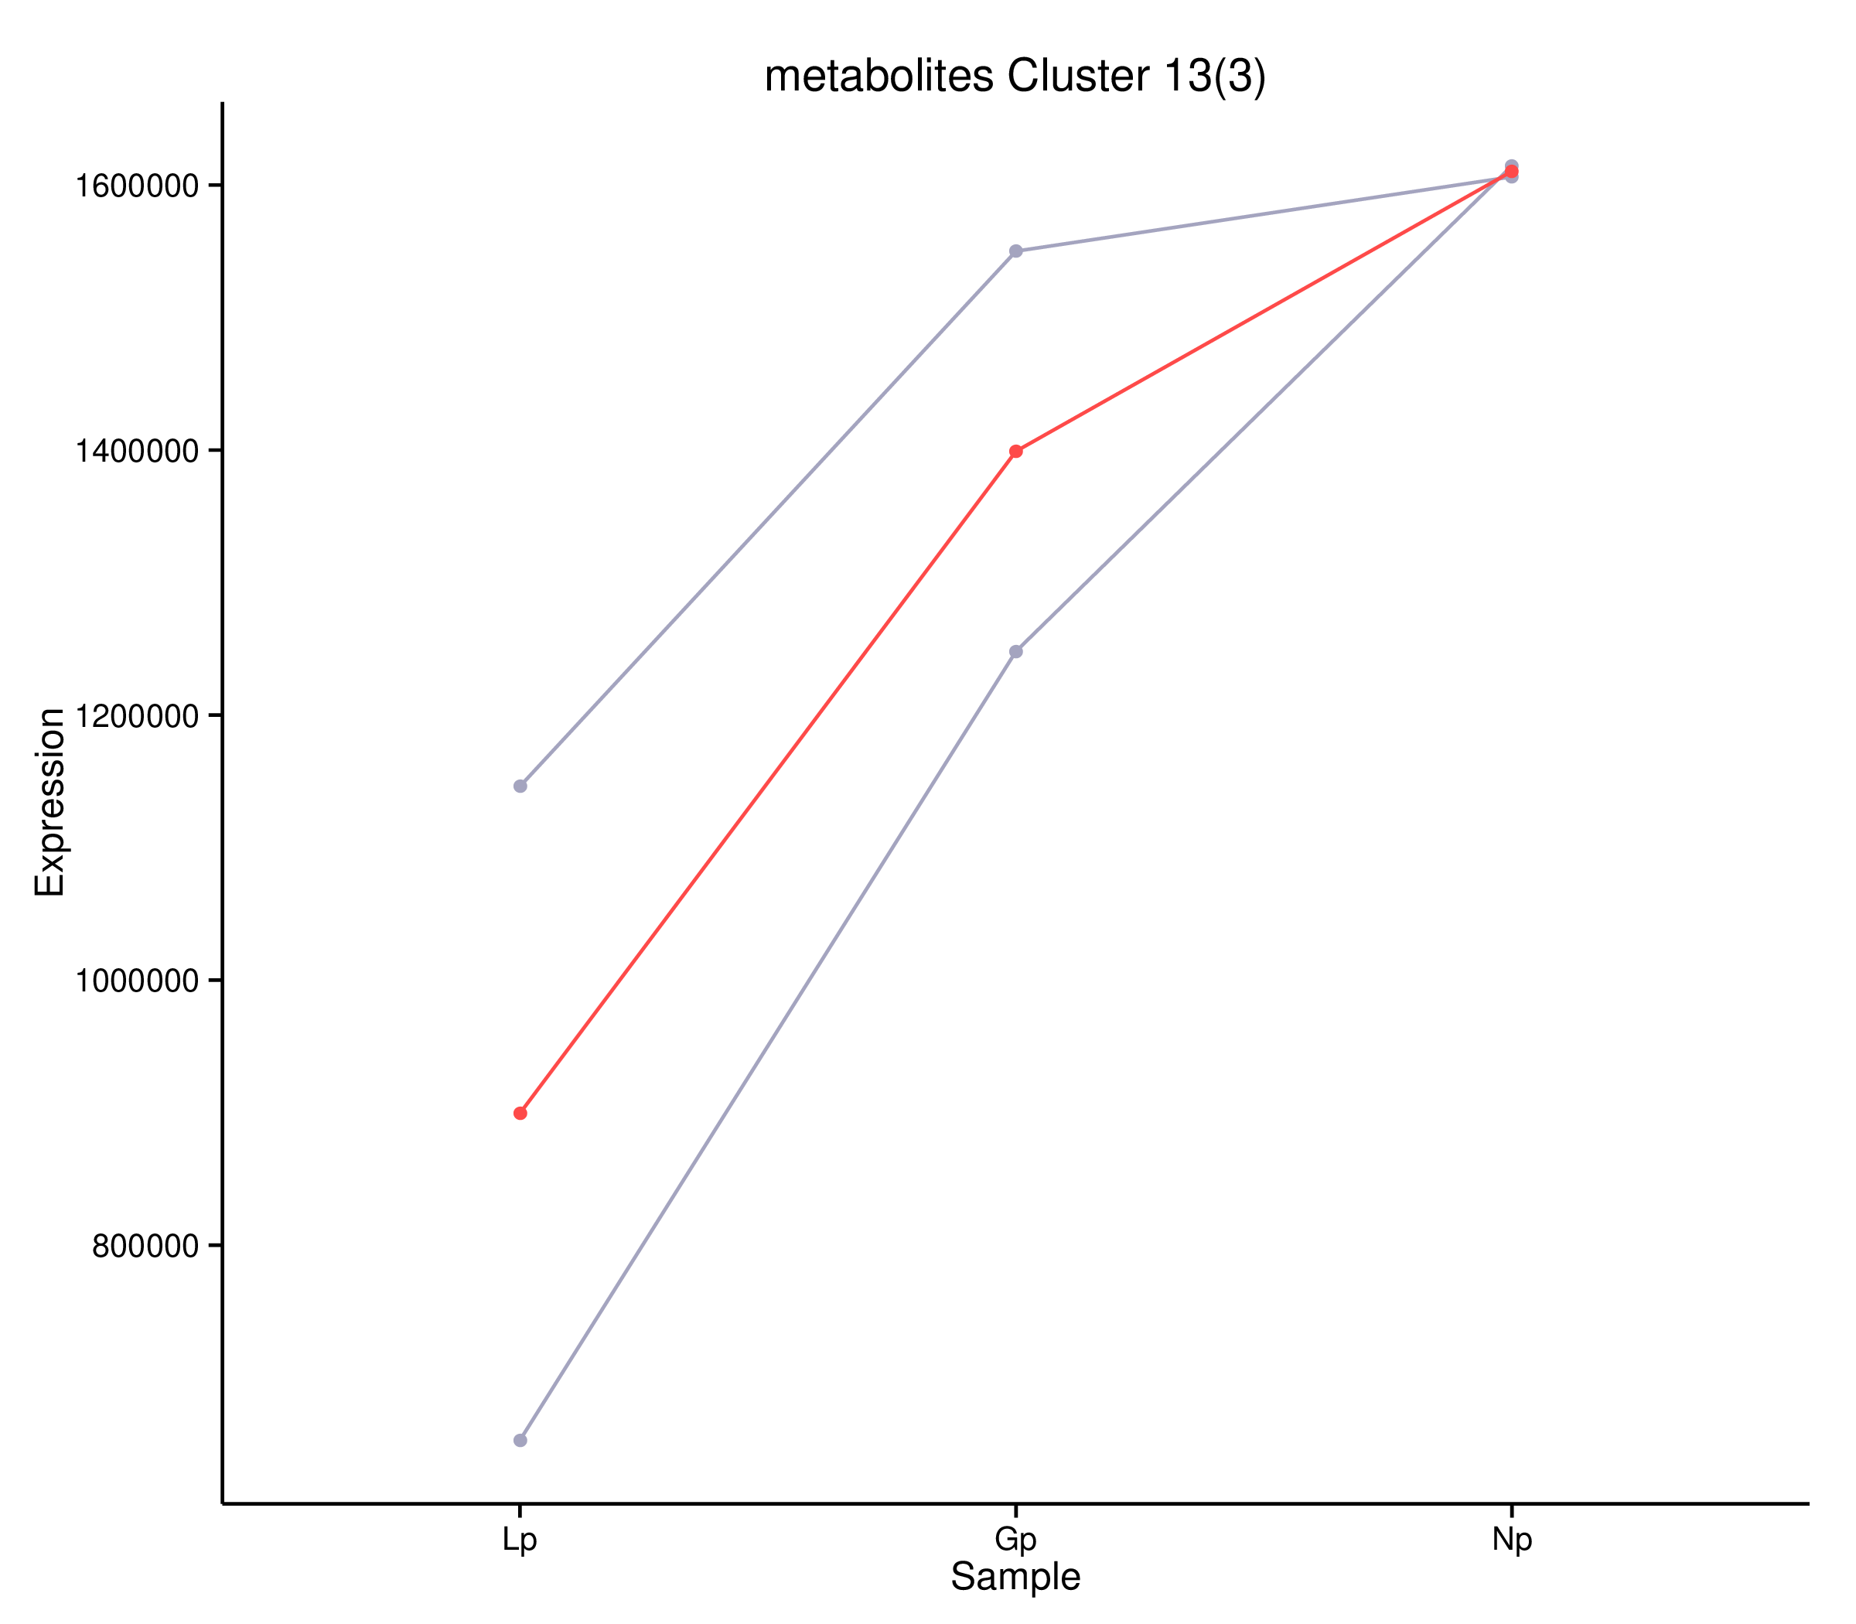
1-Stearoyl-2-hydroxy-sn-glycero-3-phosphocholine、β-Cryptoxanthin

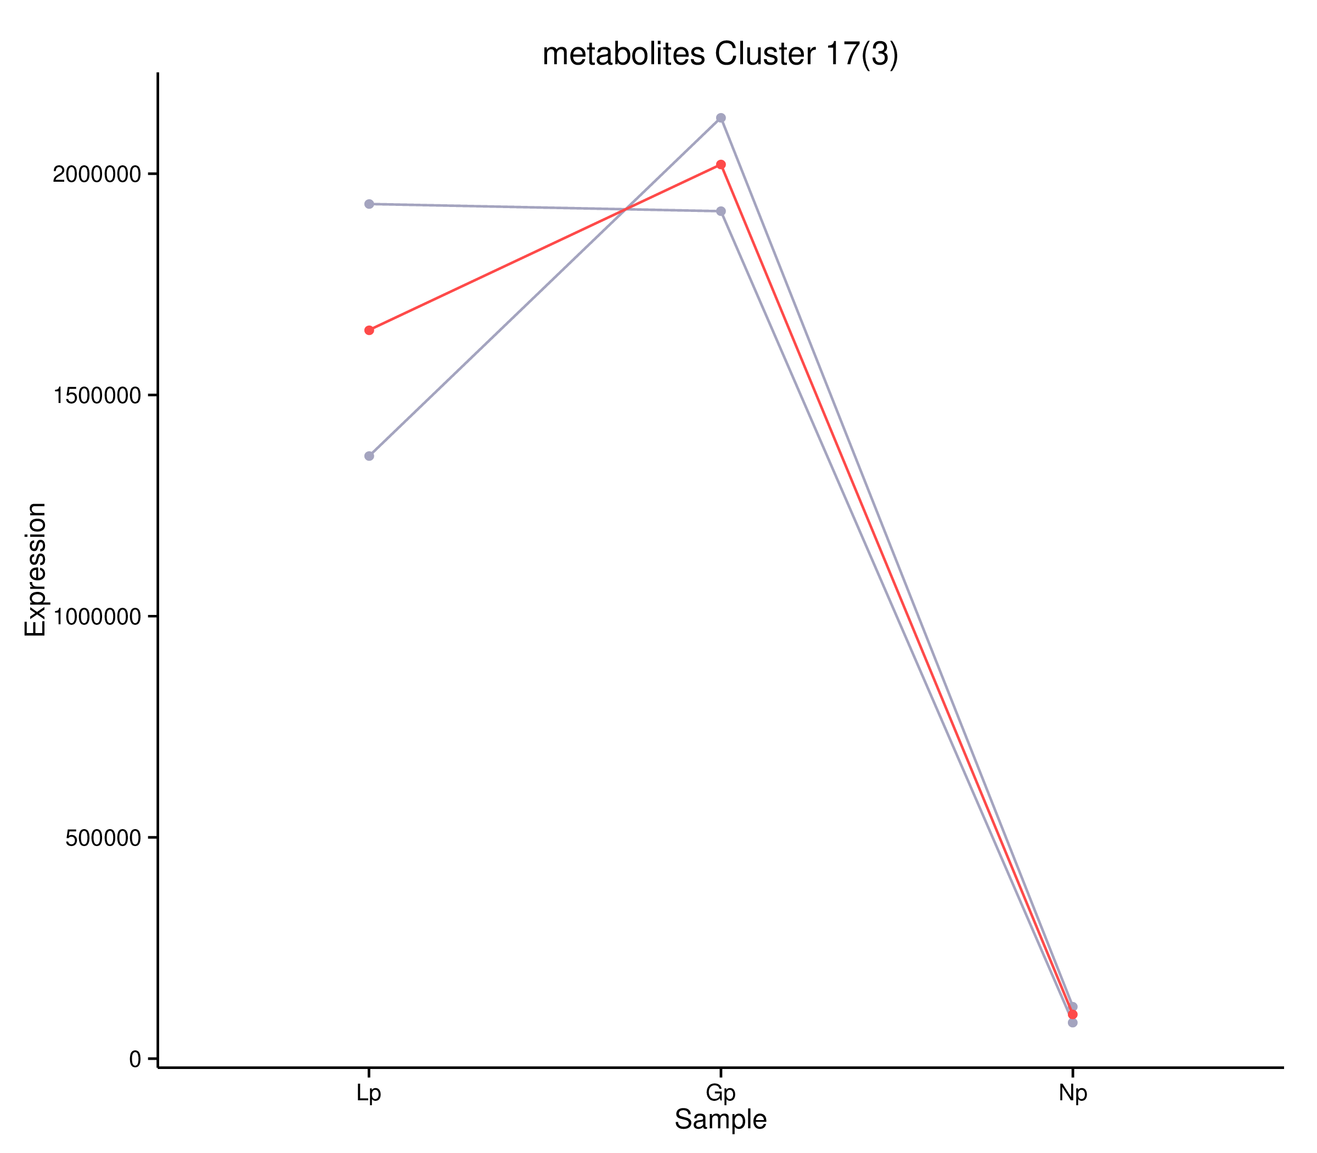
PE(18:1(11Z)/19:0)、PC(16:0/18:0)

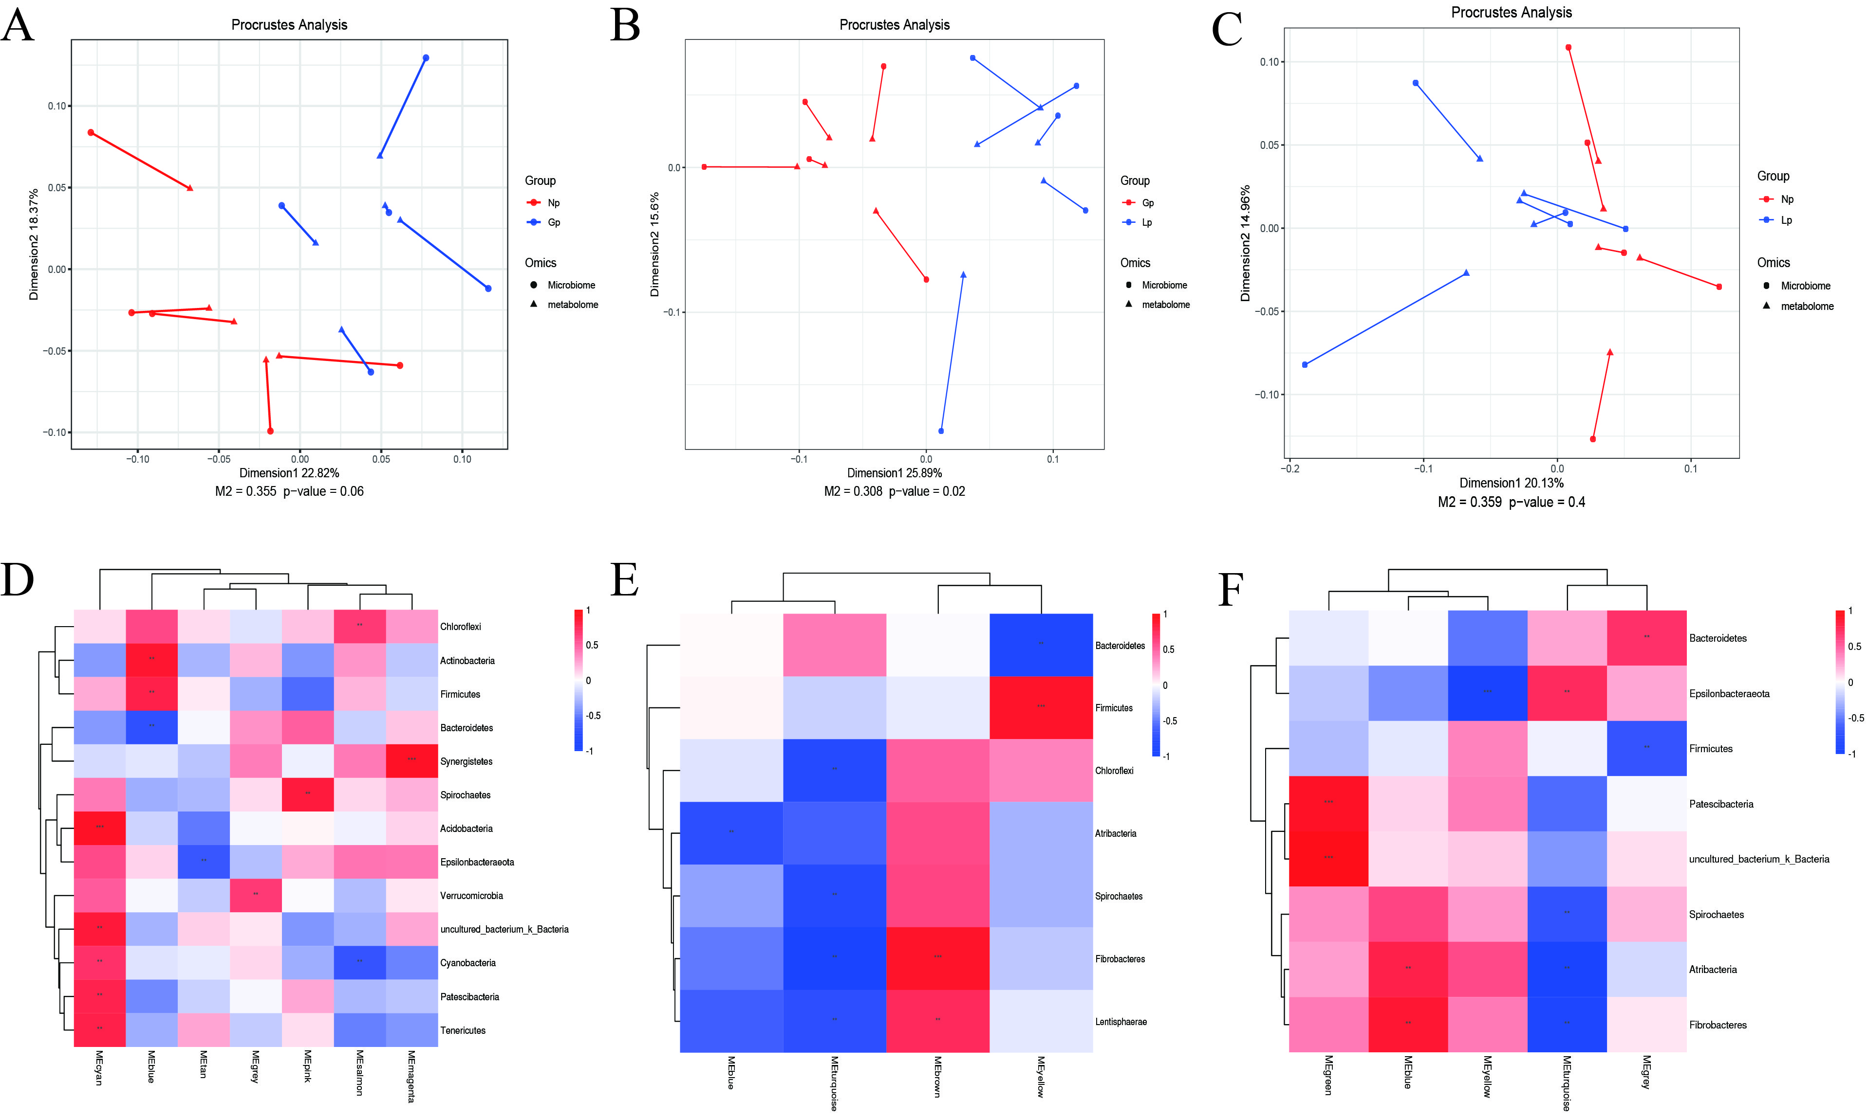
Figure S4. Combined analysis of the rumen microbiome and metabolites. A-C: Microbial-metabolite Procrustes analysis; D-F: Microbial-metabolite correlation heatmap. Note: A, D: NP-GP; B, E: GP-LP; C, F: NP-LP. *, ** and *** indicate P < 0.05, P < 0.01 and P < 0.001, respectively. NP: Non-pregnancy, Gp: Pregnancy, LP: Lactation.

Figure S5. Heat map of correlation between differential metabolites and genus level microbiota
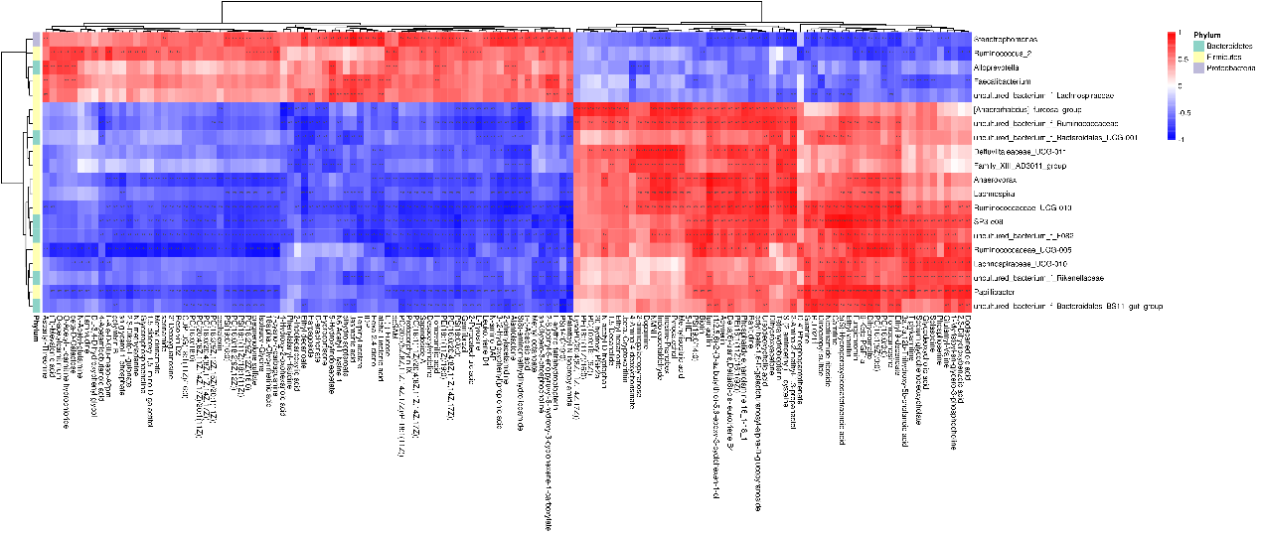
NP-GP
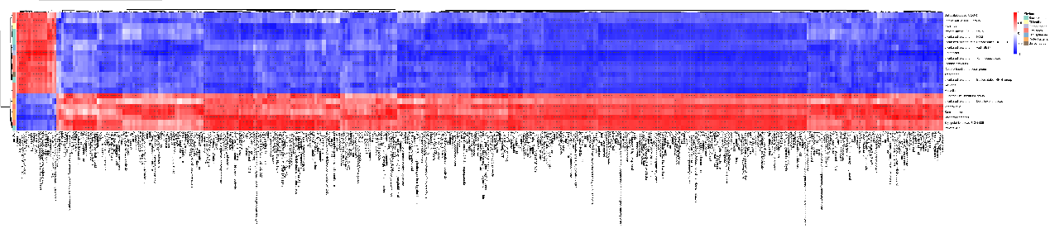
GP-LP
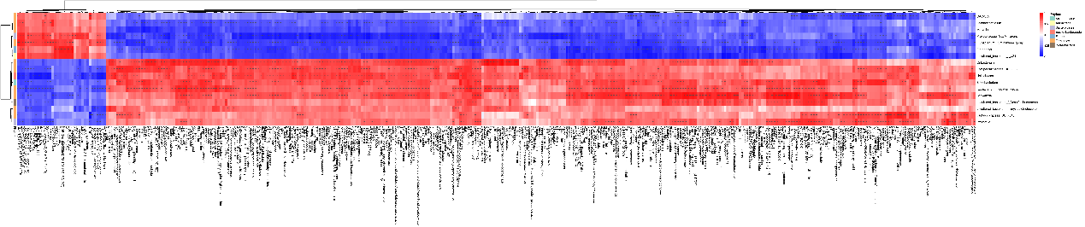
NP-LP

Figure S6. up-down-regulated differential blood metabolites in the top 10 differential multiples
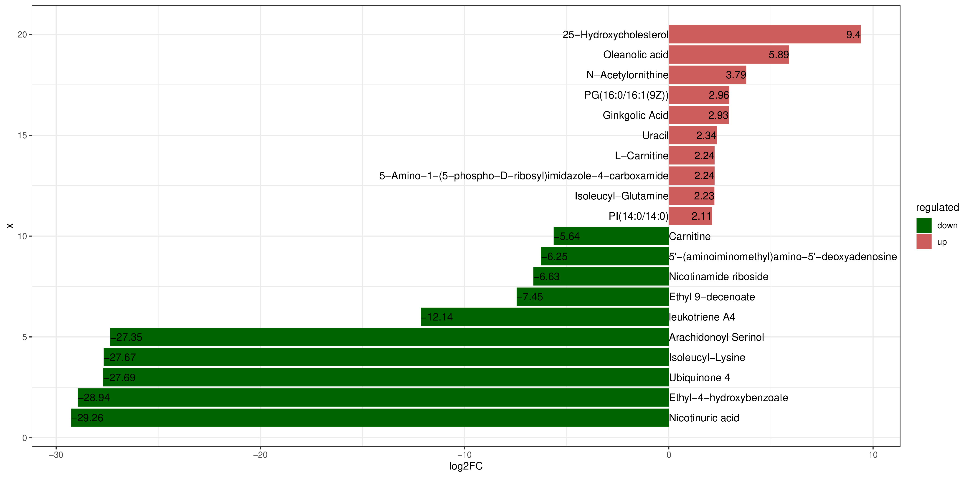
NP-GP
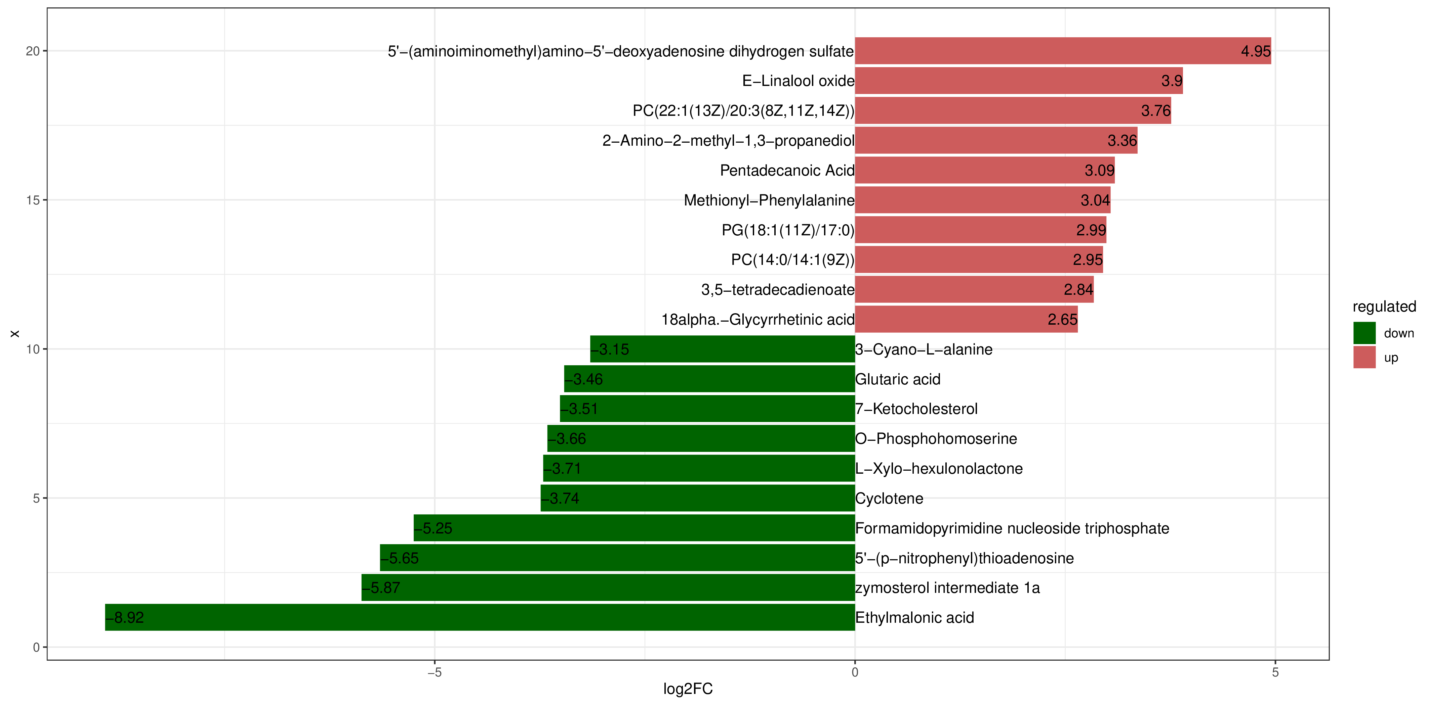
GP-LP
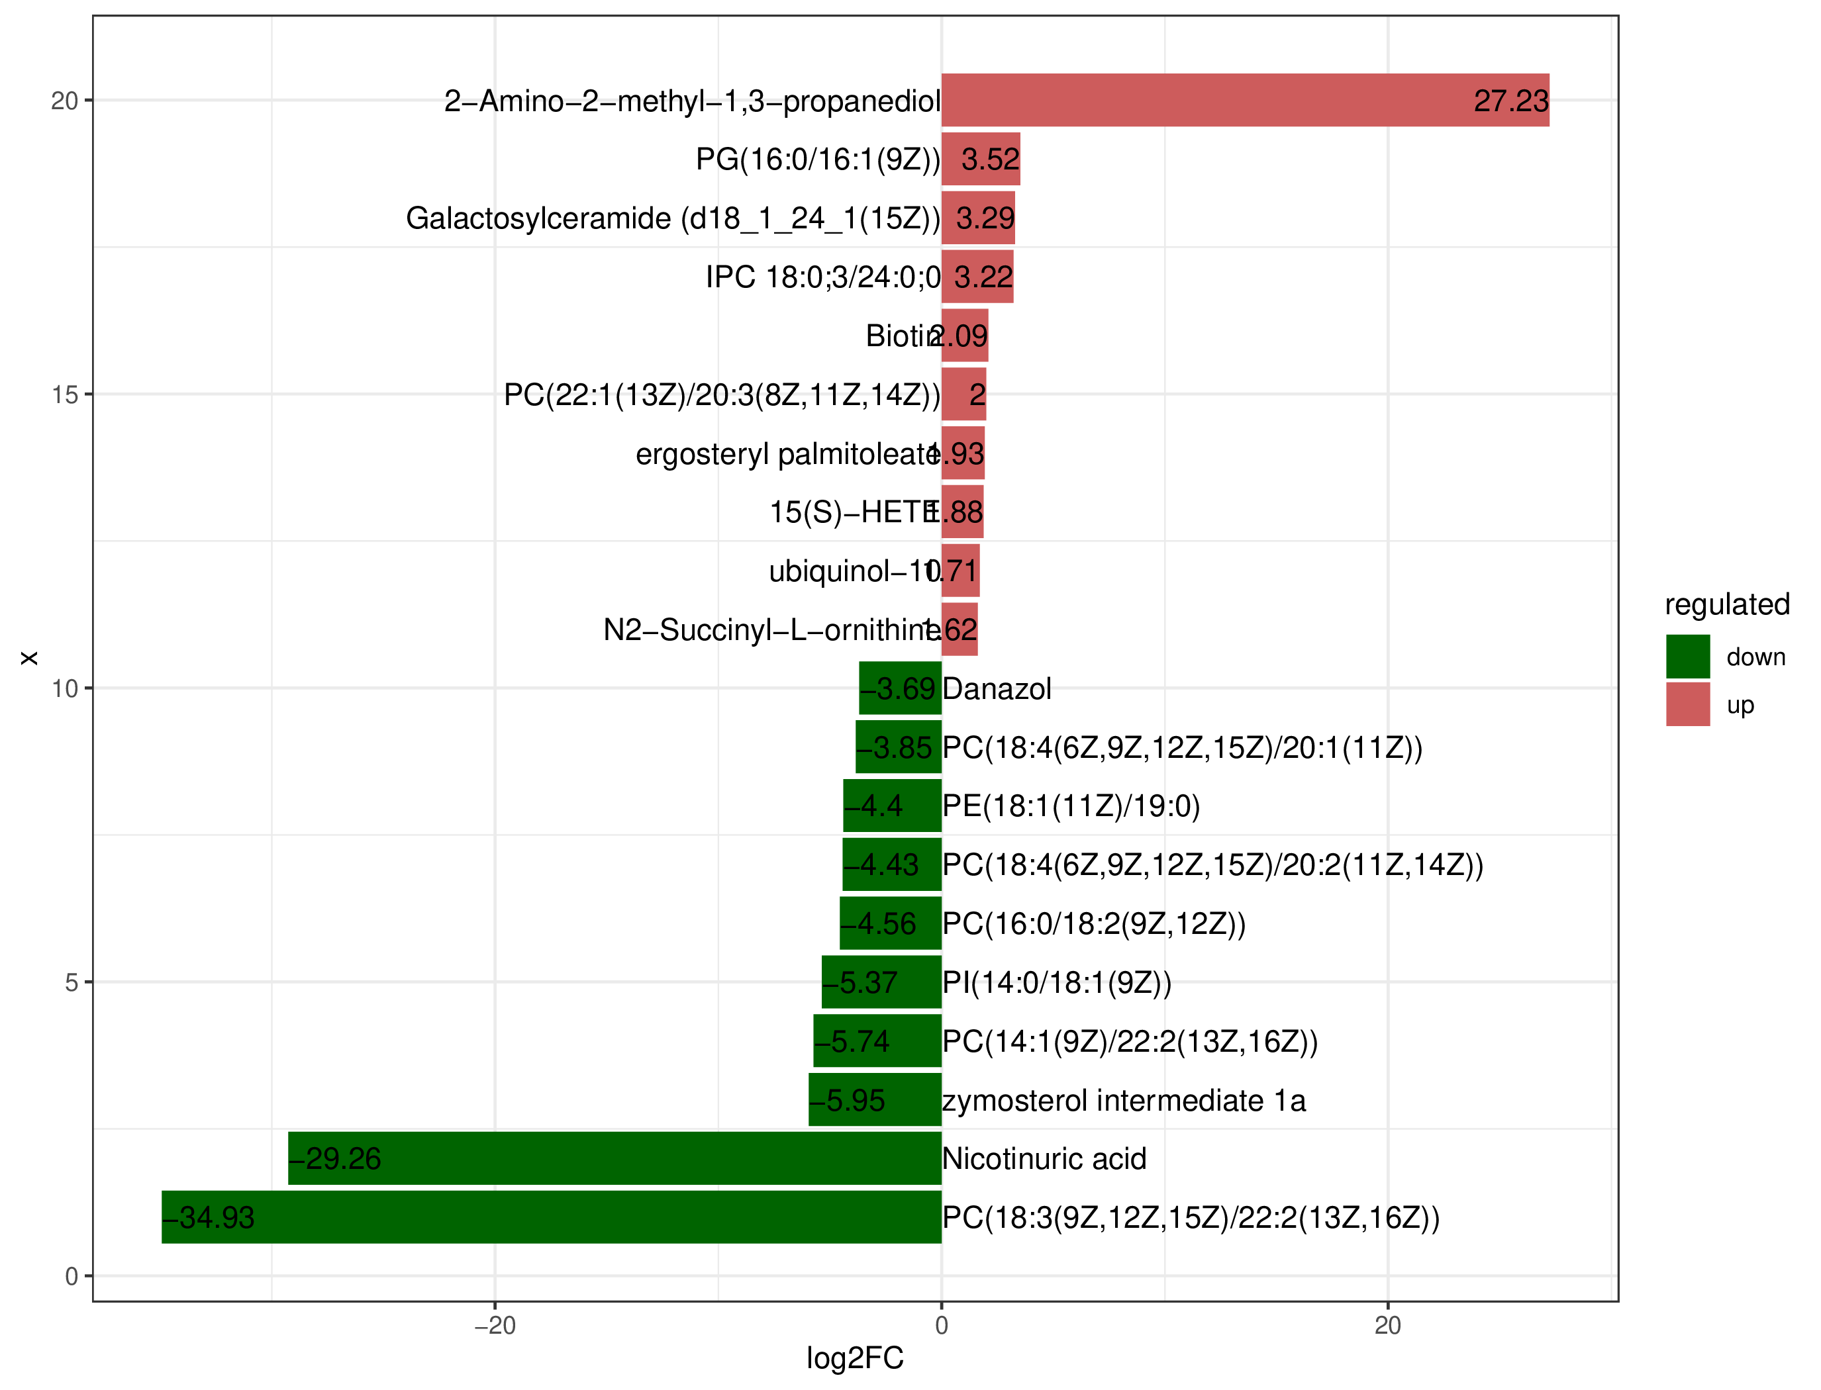
NP-LP

Figure S7. Cluster of metabolites of blood differences
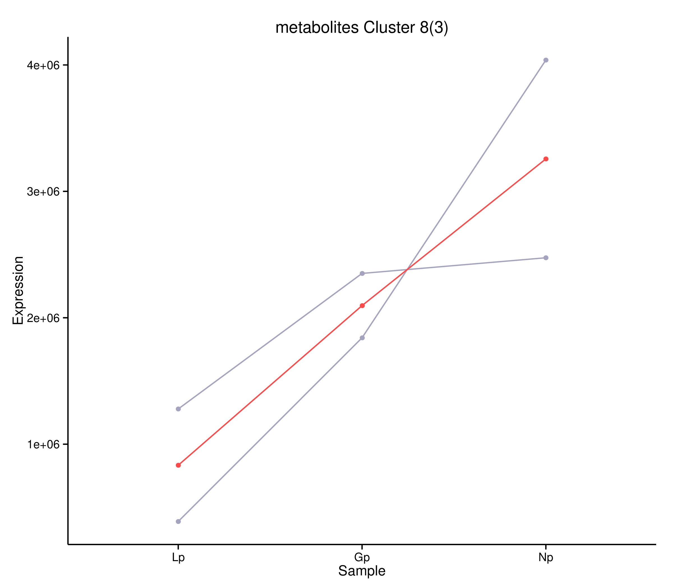
PC(18:2(9Z,12Z)/16:0)、 PC(22:4(7Z,10Z,13Z,16Z)/P-18:0)
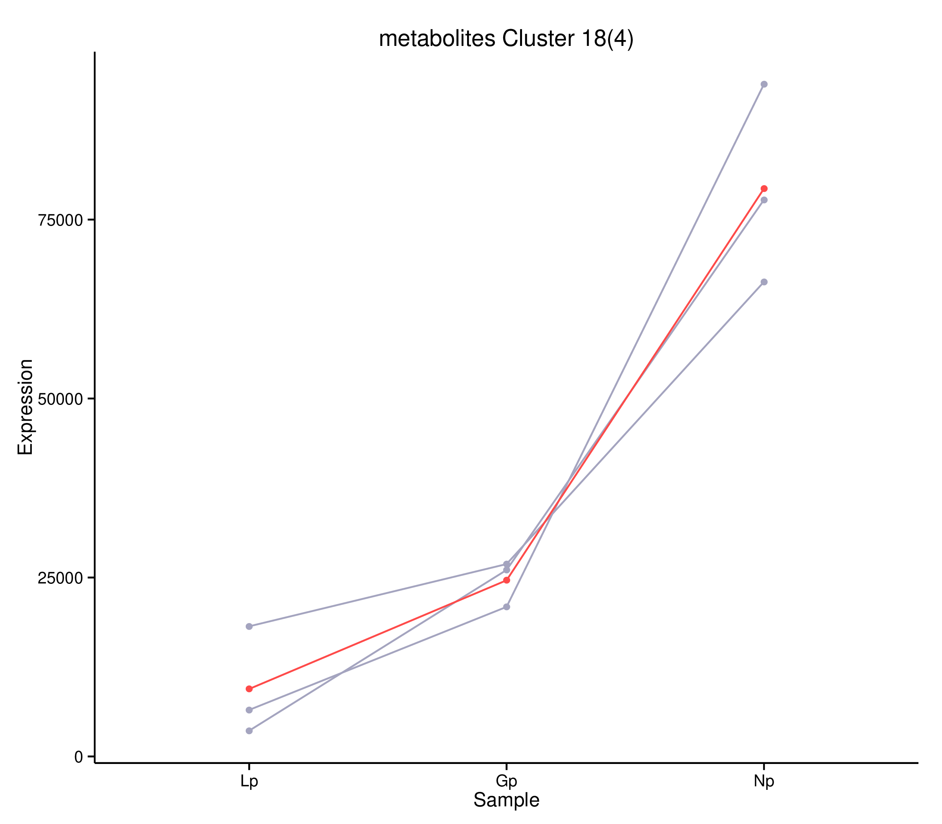
PC(18:4(6Z,9Z,12Z,15Z)/20:1(11Z))、PC(18:4(6Z,9Z,12Z,15Z)、20:2(11Z,14Z))
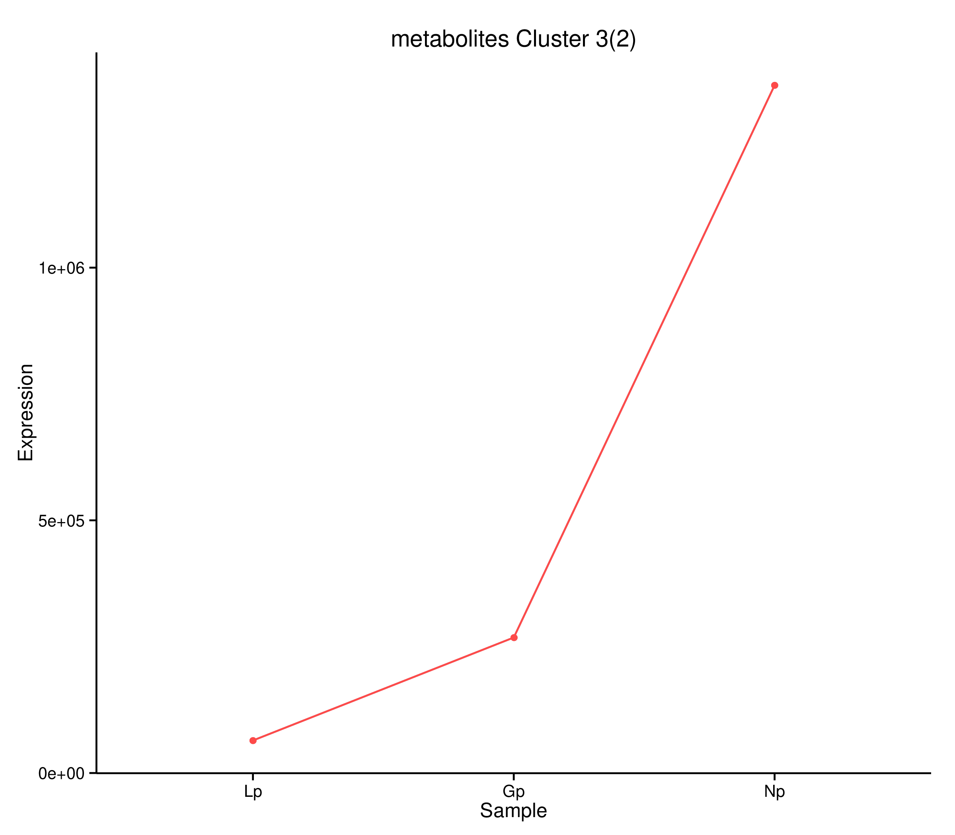 PE (18:1(11Z)/19:0)

