Supplementary materials
1. Overall networks
1.1 Network centrality
Strength centrality, closeness centrality, and betweenness centrality are presented in Figure S1. All three centrality indices showed similar patterns in that trust in governing bodies (GBody) and trust in community (Comm) had relatively high centrality. The centrality index for trust in security institutions (Scrt) showed some variability, where it had the highest closeness centrality, moderately high strength centrality, but low in between centrality. As betweenness centrality assesses “the number of times a specific node lies between two other nodes on their shortest connecting edge” (Epskamp, Borsboom, & Fried, 2018, p. 339), this may suggest trust in security institutions is not as central in connecting two random trust types as trust in governing bodies, which is the alternative order political institution.
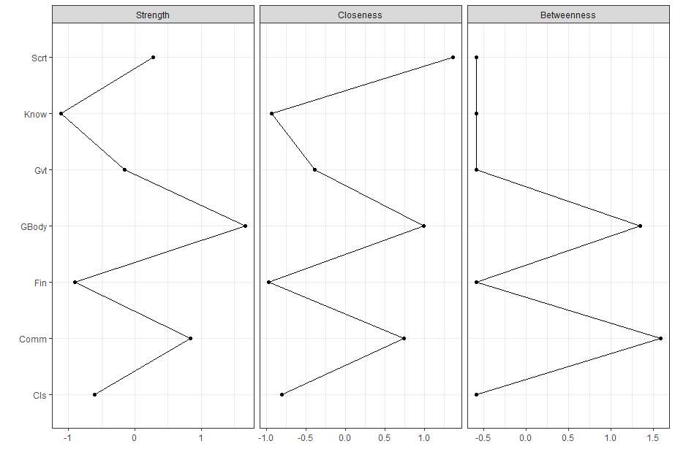
Figure S1. Centrality indices of the overall network.

1.2 Network stability
Network stability was tested by using R-package bootnet (Epskamp, Borsboom, & Fried, 2018). The non-parametric bootstrap was used to estimate the 95% confidence intervals of the edge weights, and the correlation-stability for strength centrality based on the case-dropping subset bootstrap was used to evaluate the stability (a value above 0.25 is considered moderate stability, while 0.5 is considered strong stability, see Epskamp et al., 2017).
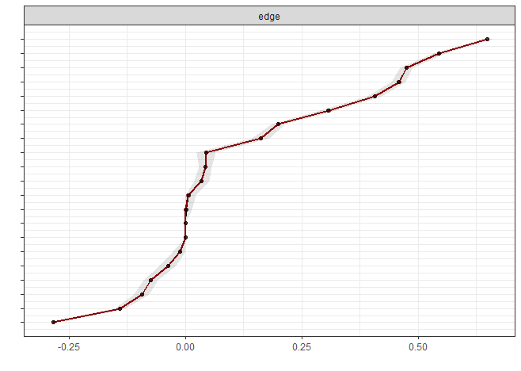
Results suggested that the 95% confidence intervals were relatively small (see Figure S2) and the correlation-stability coefficient for strength centrality was 0.75, which exceeded the recommended threshold of 0.50 for a strong stability. This suggested the findings are accurate and stable.
Figure S2. The bootstrapped confidence intervals of all edge weights.

2. FGL network analysis
2.1 FGL networks across 11 countries
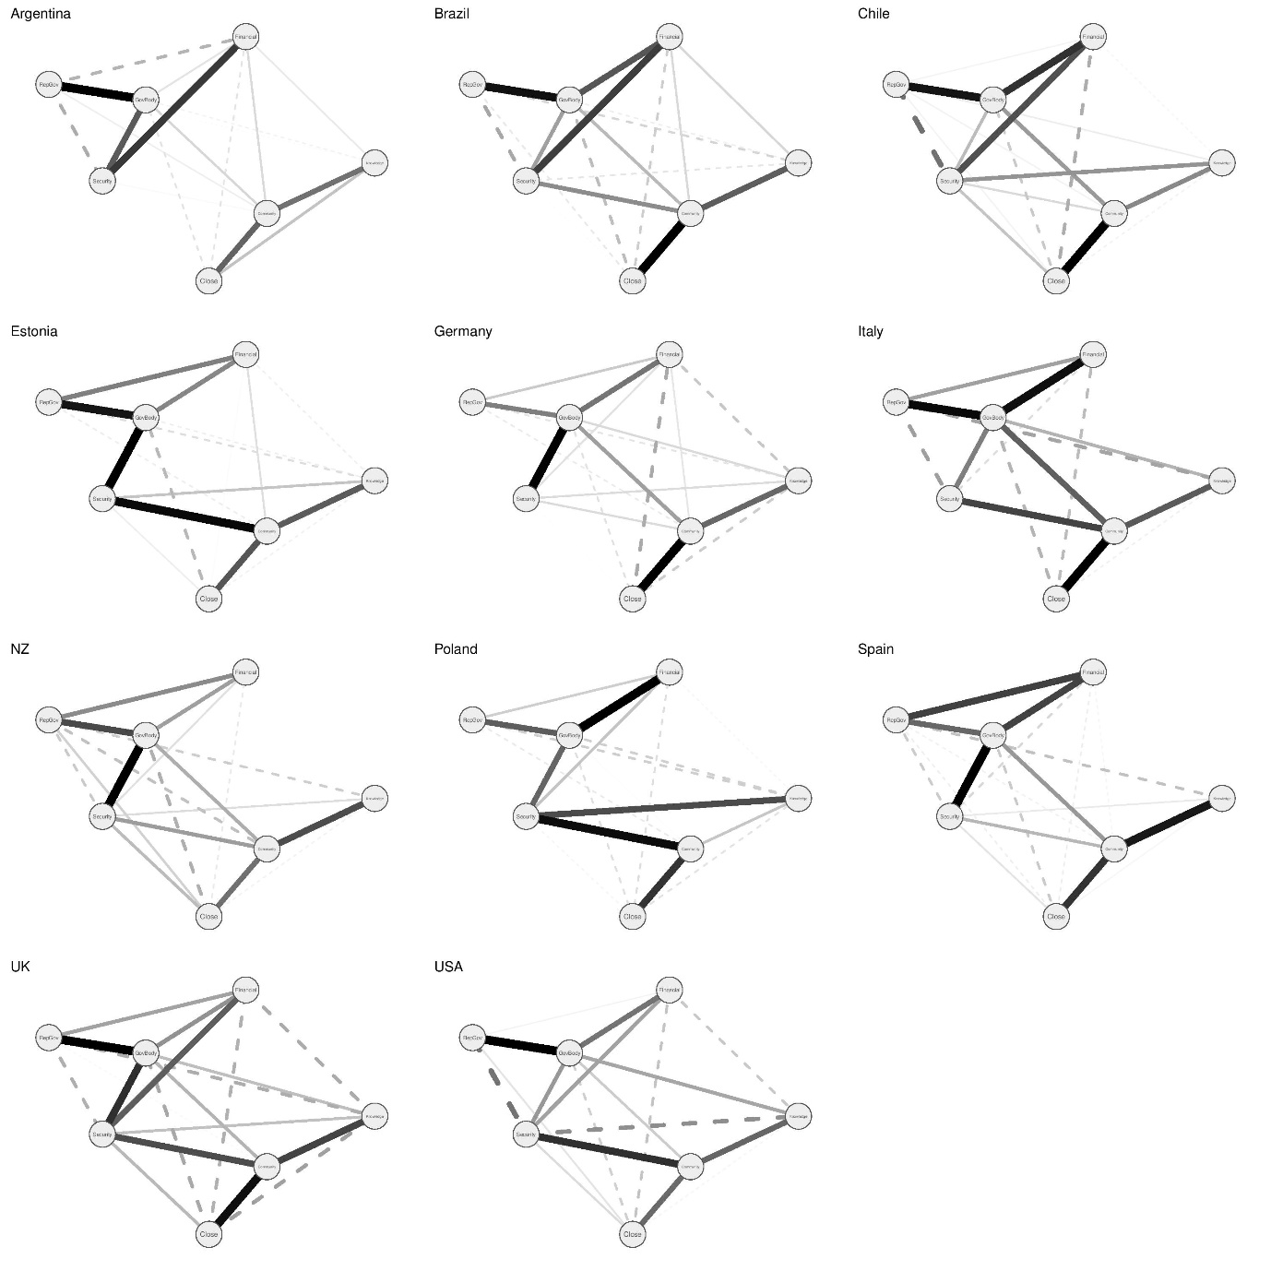
Figure S3. FGL networks across 11 countries. A thicker edge indicates a stronger relationship between two nodes. A solid edge indicates a positive relationship while a dashed one indicates a negative relationship.

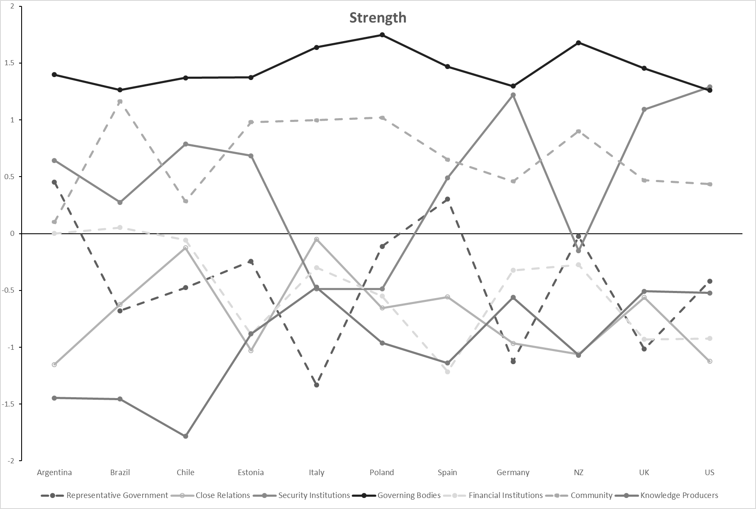
2.2 Centrality index of the FGL model
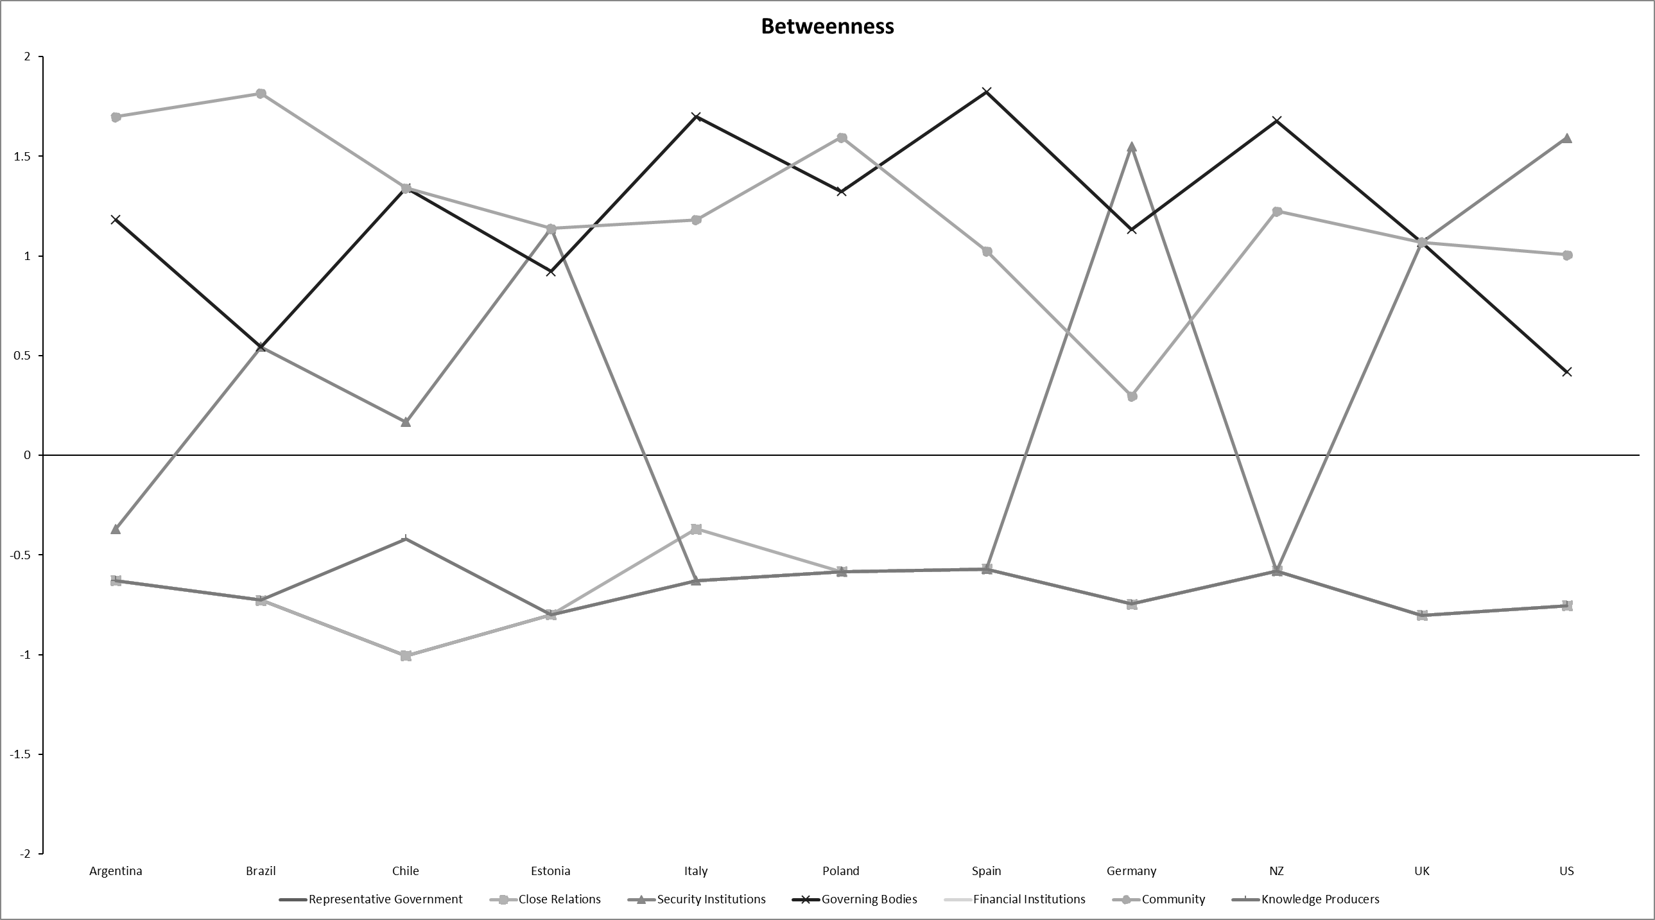
Figure S4. Strength centrality of FGL networks
Figure S5. Betweenness centrality of FGL networks

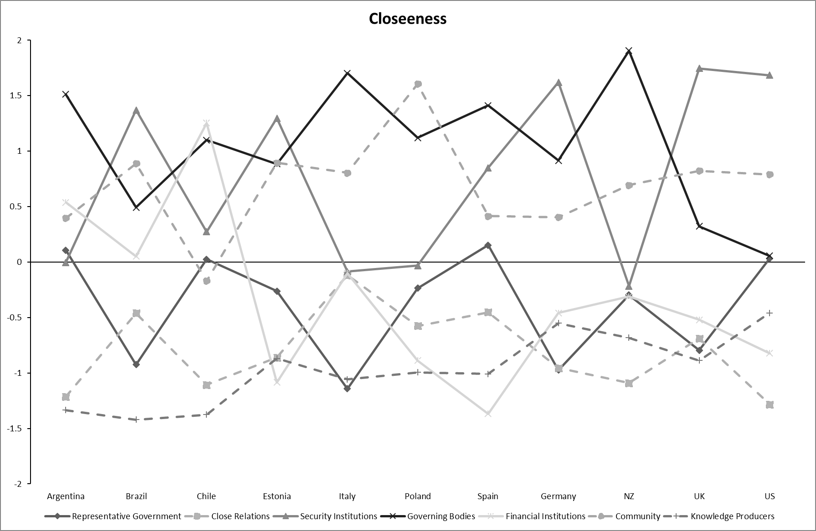
Figure S6. Closeness centrality of FGL networks

3. Alternative network analysis based on the mean scores
To ensure the robustness of our findings, an alternative network was estimated using the mean scores instead of the factor scores on the pooled overall sample. Results (Figure S7) showed a very similar network, with different types of trust grouped into two clusters centre around social and political trust, respectively, and cross-cluster associations were found between trust in governing bodies and security institutions on the one hand, and trust in community on the other hand. Centrality indices (Figure S8) suggested trust in governing bodies and trust in community had relatively high centrality, which is consistent with the findings using factor scores.
Figure S7. Overall network based on the mean scores
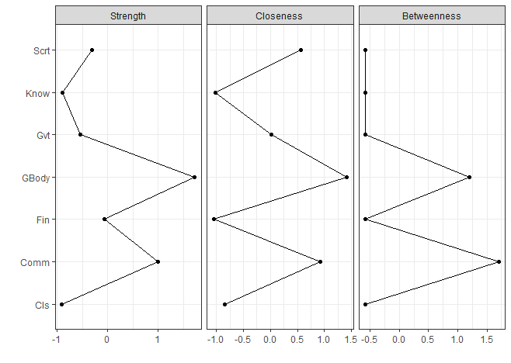
Figure S8. Centrality indices of the overall network based on the mean scores

