THE CLASSIFICATION OF HILL COUNTRY VEGETATION FROM HYPERSPECTRAL IMAGERY
Cushnahan, T.A., Yule, I.J., Grafton, M.C.E., Pullanagari, R. and White, M.
New Zealand Centre for Precision Agriculture, Massey University,
Palmerston North 4442, New Zealand
Email: t.cushnahan@massey.ac.nz

Abstract
Remotely sensed hyperspectral data provides the possibility to categorise and quantify the farm landscape in great detail, supplementing local expert knowledge and adding confidence to decisions. This paper examines the novel use of hyperspectral aerial imagery to classify various components of the hill country farming landscape. As part of the Ravensdown / MPI PGP project, “Pioneering to Precision”, eight diverse farms, five in the North and three in the South Island were sampled using the AisaFENIX hyperspectral imager. The resulting images had a 1m spatial resolution (approx.) with 448 spectral bands from 380 – 2500 nm. The primary aim of the PGP project is to develop soil fertility maps from spectral information. Images were collected in tandem with ground sampling and timed to coincide with spring and autumn seasons. Additional classification of the pasture components of two farms are demonstrated using various data pre-processing and classification techniques to ascertain which combination would provide the best accuracy. Classification of pasture with Support Vector Machines (SVM) achieved 99.59% accuracy. Classification of additional landscape components on the same two farms is demonstrated. Components classified as non-pasture ground cover included; water, tracks/soil, Manuka, scrub, gum, poplar and other tree species. The techniques were successfully used to classify the components with high levels of accuracy. The ability to classify and quantify landscape components has numerous applications including; fertiliser and farm operational management, rural valuation, strategic farm management and planning.

1.0 Introduction

1.1 Farm Landscapes
New Zealand hill farm landscapes often have extremely complex and varied networks of vegetation both within pastures (Kemp & Lopez, 2016) and in the wider environment. Meat, fed on pasture species, is the primary production output from most hill country farms. Of critical importance to production therefore, is the forage yield from pastures. A primary component of yield estimation is pasture area. In other farm environments this might just be a matter of measuring the boundary of a paddock but hill farms often have large areas, within the paddock, where other vegetation has established or areas that were never cleared for grazing. Understanding current production enables optimal management of the resources and informs decision making around pasture improvement. A considerable amount of research has been carried out to assesses, the other component of forage yield estimates, forage and crop quality parameters (Biewer et al., 2009; Mariotto et al., 2013; Pullanagari et al., 2013; Zhao et al., 2007). Products are available to monitor pasture production such as the C-Dax pasture meter (King et al., 2010), although the use of such equipment would be problematic on steep terrain. Little work has been carried out on quantification of actual farm pasture, or other farm vegetation areas at the farm scale. For yield estimation we need both area and condition (Strahler et al., 1986). A primary reason for much of the variability of hill farm vegetation is the variability, and severity, of the terrain which also hinders or precludes collection of data. Such constraints favour the use of remote sensing techniques.

1.2 Remote sensors
Remote sensing is the collection of data without the need to make contact or take physical samples directly (Campbell & Wynne, 2011). Remote sensing applications require a mechanism for data capture. Standard photographic cameras, an example of remote sensing, collect light in three bands; blue (450-495 nm), green (495-570 nm) and red (620-750 nm), which are combined to create a colour image. Multispectral sensors typically have 5-10 bands which collect light from the visible and beyond into the Near Infrared (NIR), in discrete portions of the spectrum. Hyperspectral sensors by contrast can have hundreds of contiguous narrow bands stretching through the visible and NIR into the Short Wave Infrared (SWIR) (Mariotto et al., 2013).

1.3 Remote sensor platforms
The sensor requires a platform to work from. For larger areas, such as many hill farms, unmanned aerial vehicles (UAV’s) are not practical due to limitations in flight time, payload capacity, spectral resolution of available equipment and general issues around reliability. A range of satellites offer numerous options for image acquisition of land based targets but they also can have limitations in spatial or spectral resolution. For example free imagery from NASA’s Landsat 8 satellite has 11 discrete bands from 430 nm to 1250 nm with a 30m multispectral spatial resolution (U.S.G.S., 2017). The AisaFENIX hyperspectral aerial imager, can collect 448 or more contiguous bands measuring reflectance in wavelengths from 380 nm to 2500 nm with a 1m spatial resolution (Specim, 2013). This increased spectral resolution enables identification of a greater range of materials (Goetz et al., 1985). Hyperspectral data provides better vegetation classification results than multispectral data and their narrow bands allow for selection of bands and creation of narrowband indices for a range of biophysical and biochemical properties (Galvão et al., 2011).
In this paper hyperspectral imagery of two hill country farms are classified in order to produce a map of vegetation distribution on each. The first example deals with the need for highly accurate pasture mapping to inform a range of on-farm decision processes. The second adds a number of additional components for water, pine, Manuka, gum, poplar and open soil or tracks to the classification. These maps are likely to become more and more important in farming, to at first plan and later to justify, management decisions.

2.0 Materials and Methods
The classification work was carried out on imagery from Patitapu and Ohorea Stations both located in the North Island of New Zealand. Patitapu is a 2,600 ha. sheep and beef station located about 25km southeast of Eketahuna in the Wairarapa region. Ohorea is a 5,420 ha station located on state highway 4 about 12km south of Raetihi.

2.1 Image acquisition
An AisaFENIX hyperspectral sensor manufactured by Specim (Finland) was used to obtain imagery for the two hill country farms. Methods for data collection, georectification and atmospheric correction were identical to those of Pullanagari et al. (2016).

2.2 Data Pre-Processing
Four standard pre-processing steps were used; each was assessed for their effect on the classification results.

2.3 Data-Processing and Image Classification
Pixel based classifiers attempt to assign each pixel to a class regardless of its neighbour. Given that each pixel is an individual measurement, the approach seems valid. Pixel based classification has a long history in remote sensing and was the first widely accepted and practiced method for classification. The methods used in this paper are pixel based classifiers.

Support Vector Machines (SVM)
SVM were intended for binary classification applications and as such are considered one of the best ‘out of the box’ classifiers. SVMs are an adaptation of the maximal margin classifier which selects a hyperplane for classification. It defines the optimal separating hyperplane that is furthest from the training observations. The margin is the distance between the hyperplane and the nearest training observations. The nearest training observations are the support vectors (James et al., 2013; Vapnik, 1995).

2.4 Pasture Classification
Regions of Interest (ROI) were selected, from the Patitapu image, to represent the two desired classes within the image; pasture and non-pasture. The non-pasture ROI included elements that were not pasture including trees, bush, tracks, buildings, bare soil and water. The pasture class contained grassed pasture only.
ROI for training the classification were collected from the true colour image. Table 1 lists details of ROI collected for pasture classification. Each pre-treatment was classified using both a linear Support Vector Machine (SVM) classifier and Mahalanobis Distance (MD). The training ROI were used as class definitions. All pre-processing and classifications were carried out using ENVI image analysis software.

2.4.1 Accuracy Testing
Prior to the classification a second set of ROI (Test) were collected from across the entire image. These additional ROI were not used for classification but held for accuracy testing when the classification was complete.
Table 1: ROI collection statistics for Patitapu image. ROI for classification training and accuracy testing are listed with ROI and pixel count. The pixel count is the total number of pixels collected in the associated ROI.
Patitapu (Spring) | Training | Test | Training | Test
 | (ROI) | (ROI) | (Pixels) | (Pixels)
Pasture | 14 | 999 | 4,762 | 39,186
Non-pasture | 24 | 789 | 3,631 | 31,981

2.5 Vegetation Classification
Regions of Interest (ROI) were selected, from the Ohorea image, to represent each of the desired classes within the image. The twelve desired components were pasture, pine trees, Manuka, tracks & open soil, water, shadow, poplar 1, poplar 2, gum, rush, bush/scrub and other trees.

3.0 Results

3.1 Patitapu Pasture Classification
Classification accuracy is measured by summing the number of correctly classified pixels and dividing by the total pixels collected. The classification of Patitapu (figure1) achieved a 99.11% accuracy when identifying pasture from non-pasture, other statistics from the classification are summarised in Table 2. Pre-processing method had little impact on overall accuracy. This accuracy may result from the strength of the SVM as a binary classifier or from the detail carried in the hyperspectral data.
Table 2: The accuracy and associated statistics for the pasture classification of Patitapu.
 | SVM Classification Accuracy for Patitapu
 | Overall Accuracy (70534/71167) |  |  | 99.11%
 | Kappa Coefficient |  | 0.982
 | Ground Truth (Pixels)
Class | Pasture | Non-Pasture | Total
Unclassified | 0 | 0 | 0
Pasture | 39156 | 603 | 39759
Non-Pasture | 30 | 31378 | 31408
Total | 39186 | 31981 | 71167
 | Ground Truth (Percent)
Class | Pasture | Non-Pasture | Total
Unclassified | 0 | 0 | 0
Pasture | 99.92 | 1.89 | 55.87
Non-Pasture | 0.08 | 98.11 | 44.13
Total | 100 | 100 | 100
Class Error | Commission | Omission | Commission | Omission
 | (Percent) | (Percent) | (Pixels) | (Pixels)
Pasture | 1.52 | 0.08 | 603/39759 | 30/39186
Non-Pasture | 0.1 | 1.89 | 30/31408 | 603/31981
Class Error | Producer | User | Producer | User
 | (Percent) | (Percent) | (Pixels) | (Pixels)
Pasture | 99.92 | 98.48 | 39156/39186 | 39156/39759
Non-Pasture | 98.11 | 99.9 | 31378/31981 | 31378/31408

Figure 1: SVM classification map for the spring survey at Patitapu Station. The callout displays the level of detail in the classification which was able to distinguish even small pockets of pasture amongst the bush.

3.2 Vegetation Classification
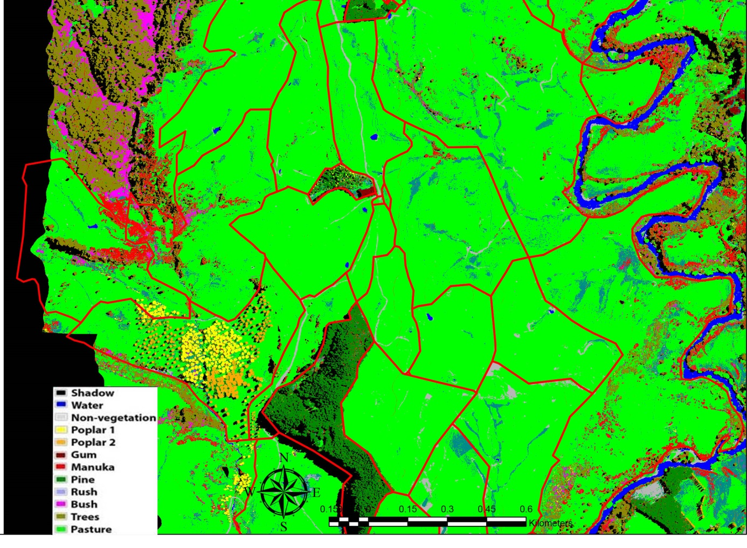
Figure 2: Segment from the 12 class classification of Ohorea Station. The black area to the west was a missing part of the survey image and/or outside the survey area.
The classification of 12 components from the Ohorea image (figure 2) showed some variability with regard the accuracies (figure 3). All but three classes had accuracies above 90%. Manuka, Scrub and Rush had accuracies of 75%, 42% and 61% respectively. However these categories are most difficult to separate due to their mixing with elements from the other categories. The scrub category had the lowest of all the accuracies but the majority of the inaccurate classification of this component was for trees (31%) that are mixed through the scrub. This may be a result of an inaccurate classification or from the selection of incorrect ground truth pixels from the image. Ground truthed data collected from the farm was supplemented with image based collection, especially in difficult to reach areas. The process worked very well for the majority of image components.

Figure 3: Graph of accuracies for each component from the Ohorea Station image.
Table 3: Confusion matrix of classifications for Ohorea Station.
Table 4: Classification error statistics for Ohorea Station. Error of commission are where the classifier classified a pixel as class X when it was not X. Error of omission is where the classifier failed to classify a pixel as class X when it was X.

Table 5: Classification accuracy statistics for Ohorea Station.
Producer accuracies are calculated by dividing the number of correctly classified pixels (from table 3) in a given category by the number of training set pixels used for that category. User accuracies are calculated by dividing the number of correctly classified pixels in a given category (table 3) by the total number of pixels that were classified in that category.

4.0 Discussion
The mapping of these hill farming areas has only been carried out to coarse levels. The New Zealand Land Cover Database (NZLCD) maps a series of vegetation classes for the whole country using satellite imagery with a 30m spatial resolution (Thompson et al., 2003). The improvement in map detail achievable for small areas with 1m spatial resolution AisaFENIX imagery is considerable.
Hyperspectral data also provides better vegetation classification results than multispectral data and their narrow bands allow for selection of bands and creation of narrowband indices for a range of biophysical and biochemical properties (Galvão et al., 2011).
The very high accuracies are most likely a combination of the hyperspectral information and fine spatial scale both of which have allowed the separation and classification of components. The reduced accuracy seen in some components, particularly bush, will be improved with more, or better, ground truth data but this can be difficult to collect when the areas in question are dense bush which are often in steep or otherwise inaccessible locations. The original purpose of the survey was to link pasture measurements to soil fertility, however this work demonstrates the utility of the technology for solving other problems for farmers. The full utility of this form of mapping will only be realised when it is made available to farmers and farm consultants but there is clear scope for its use as a tool to inform stock management, fertiliser placement via precision application, carbon stock monitoring and rural valuation. This form of mapping in conjunction with standardised measurement and valuation tools such as those suggested by Grafton et al. (2016) could enable comparison of management techniques to improve the industry as a whole.

5.0 Conclusion
This study suggests high accuracies for vegetation classification are possible at the farm scale which has the possibility to drive and inform many on farm and ancillary industry decisions.
Mapping of vegetation in these areas, to this level of detail or accuracy has not been possible until recently. The access to hyperspectral imagery will allow future mapping of these complex environments in ever increasing detail as methods are developed to extract more of the detail carried in the spectra.

Acknowledgments:
The authors would like to thank Ravendsown Limited and the Ministry for Primary Industries for their support of this PhD studentship through the PGP Project: Pioneering to Precision.
https://www.mpi.govt.nz/funding-and-programmes/primary-growth-partnership/primary-growth-partnership-programmes/pioneering-to-precision-application-of-fertiliser-in-hill-country/

6.0 References
Biewer, S., Fricke, T., & Wachendorf, M. (2009). Development of Canopy Reflectance Models to Predict Forage Quality of Legume–Grass Mixtures. Crop Science, 49(5), 1917-1926.
Campbell, J.B., & Wynne, R.H. (2011). Introduction to Remote Sensing: Guilford Press.
Galvão, L.S., Epiphanio, J.C.N., Breunig, F.M., & Formaggio, A.R. (2011). 17 Crop Type Discrimination Using Hyperspectral Data. Hyperspectral remote sensing of vegetation, 397.
Goetz, A.F.H., Vane, G., Solomon, J.E., & Rock, B.N. (1985). Imaging Spectrometry for Earth Remote Sensing. Science, 228(4704), 1147-1153. doi:10.1126/science.228.4704.1147
Grafton, M.C.E., Willis, L.A., Mcveagh, P.J., & Yule, I.J. (2016). Measuring Pasture Mass and Quality Indices over Time Using Remote and Proximal Sensors. Paper presented at the 13th International Conference on Precision Agriculture, St. Louis, Missouri, USA.
James, G., Witten, D., Hastie, T., & Tibshirani, R. (2013). An Introduction to Statistical Learning (Vol. 112): Springer.
Kemp, P., & Lopez, I. (2016). Hill Country Pastures in the Southern North Island of New Zealand: An Overview. Paper presented at the Hill Country Symposium. Grassland Research and Practice.
King, W., Rennie, G., Dalley, D., Dynes, R., & Upsdell, M. (2010). Pasture Mass Estimation by the C-Dax Pasture Meter: Regional Calibrations for New Zealand. Paper presented at the Proceedings 4th Australasian Dairy Science Symposium.
Mariotto, I., Thenkabail, P.S., Huete, A., Slonecker, E.T., & Platonov, A. (2013). Hyperspectral Versus Multispectral Crop-Productivity Modeling and Type Discrimination for the Hyspiri Mission. Remote Sensing of Environment, 139, 291-305.
Pullanagari, R.R., Kereszturi, G., & Yule, I.J. (2016). Mapping of Macro and Micro Nutrients of Mixed Pastures Using Airborne Aisafenix Hyperspectral Imagery. ISPRS Journal of Photogrammetry and Remote Sensing, 117, 1-10. doi:http://dx.doi.org/10.1016/j.isprsjprs.2016.03.010
Pullanagari, R.R., Yule, I.J., Tuohy, M.P., Hedley, M.J., Dynes, R.A., & King, W.M. (2013). Proximal Sensing of the Seasonal Variability of Pasture Nutritive Value Using Multispectral Radiometry. Grass and Forage Science, 68(1), 110-119. doi:10.1111/j.1365-2494.2012.00877.x
Specim. (2013). Asiafenix Vnir/Swir Hyperspectral Imager User Manual Ver. 1.7. In S.I.L. SPECIM, Finland (Ed.), (1.7 ed.): SPECIM.
Strahler, A.H., Woodcock, C.E., & Smith, J.A. (1986). On the Nature of Models in Remote Sensing. Remote Sensing of Environment, 20(2), 121-139.
Thompson, S., Gruner, I., & Gapare, N. (2003). New Zealand Land Cover Database Version 2. Illustrated guide to target classes. Ministry for the environment, Wellington.
U.S.G.S. (2017). Landsat 8. Retrieved from https://landsat.usgs.gov/landsat-8
Vapnik, V.N. (1995). The Nature of Statistical Learning Theory: Springer-Verlag New York, Inc.
Zhao, D., Starks, P.J., Brown, M.A., Phillips, W.A., & Coleman, S.W. (2007). Assessment of Forage Biomass and Quality Parameters of Bermudagrass Using Proximal Sensing of Pasture Canopy Reflectance. Grassland Science, 53(1), 39-49.

